[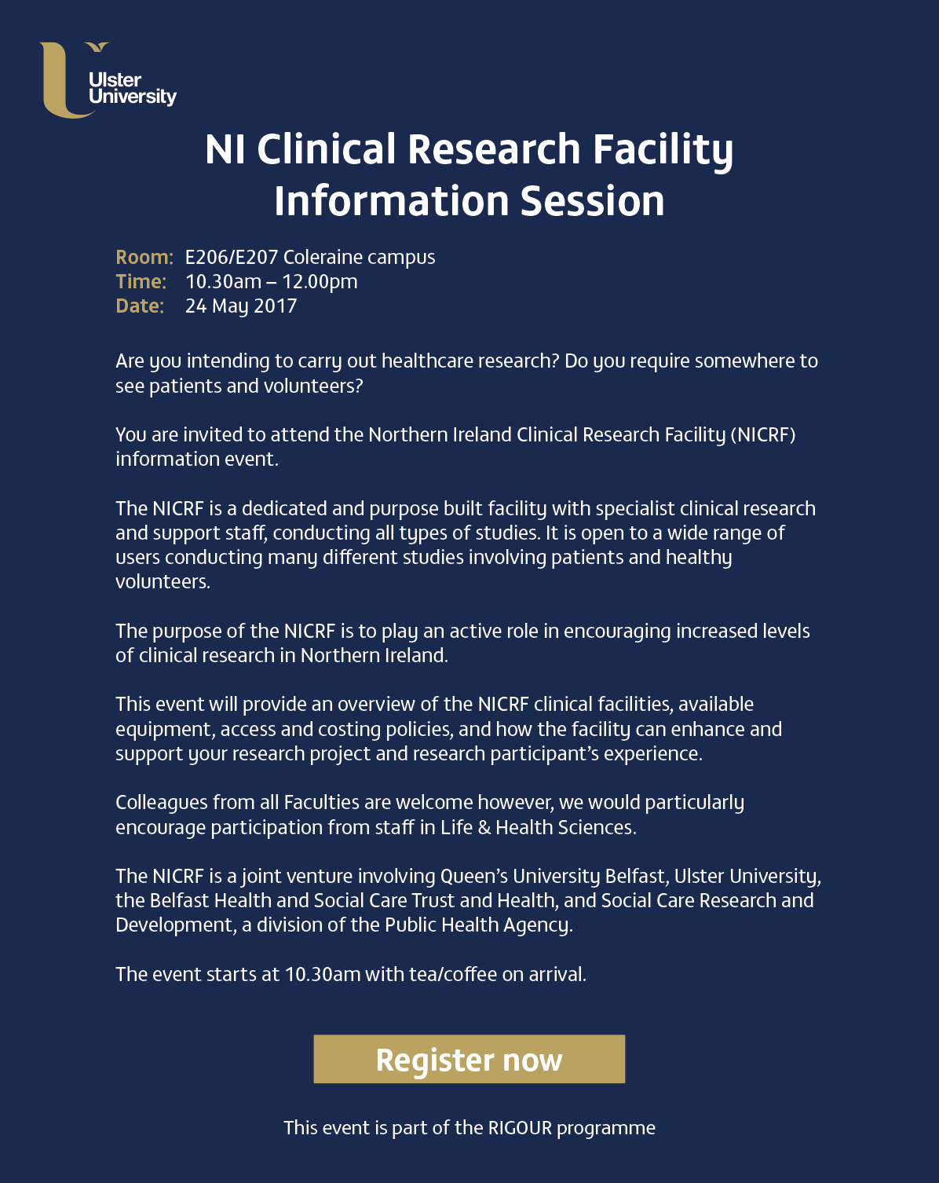](https://getinvited.to/knowledge-club/ni-clinical-research-facility-information-session/)