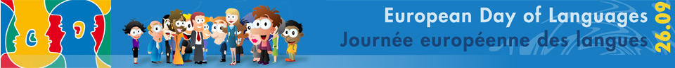
Hello! Can you guess which language these words are in? Write your answer in the spaces provided. Use the options in the box below to help you!
- Ciao Italian
- Hallo Dutch/German/Afrikaans
- Hej/Goddag Danish
- γεια σαςγεια σας(geia sas) Greek
- Olá Portuguese
- ہیلو (Assalam Aleykum) Urdu
- Hujambo Swahili
- Helô Welsh
- Tere Estonian
- Ahoj Czech
Greek Swahili Italian Dutch/German/Afrikaans Estonian
Portuguese Danish Urdu Welsh Czech

Can you find 10 languages spoken in Europe in the wordsearch below? Write your answers in the spaces provided.
1 Greek
2 Slovenian
3 Mandarin
4 Turkish
5 Irish
6 English
7 Polish
8 Urdu
9 Croatian
10 Spanish
H | C | U | C | E | R | H | S | F | M
J | S | R | R | C | T | U | N | E | A
E | H | I | O | D | Y | L | O | S | N
S | S | S | L | A | U | G | P | H | D
C | I | L | M | G | T | A | S | A | A
S | L | O | V | E | N | I | A | N | R
N | O | E | M | I | R | E | A | Q | I
H | P | G | S | I | G | O | C | N | N
N | V | H | S | I | K | R | U | T | Z
G | R | E | E | K | H | O | X | I | W

