Interpreting and Navigating TurnitinUK Similarity Reports

**Significance of matches within similarity reports**

Plagiarism is a matter of academic judgement. Similarity reports should not be used as a sole determinant of plagiarism, but be used to aid lecturers to identify potential cases of plagiarism. The decision to deem any work to be plagiarised should be made only after careful examination of both the submitted paper and the indicated sources, taking into account all other evidence and the intent of the student. Students should be made aware that plagiarism can often be detected without the aid of TurnitinUK’s originality checking service.

**Overall Similarity Percentage**

It is likely that work produced by students, at undergraduate level, will have some commonalities, as they are often writing on similar topics, using recommended texts. As a result, a similarity report will be expected to contain some matches and no percentage thresholds should be used in the evaluation. The overall percentage match figure should be viewed with caution as it might not provide a true representation of the academic integrity of the work. For example, in a large document, a very small overall percentage may contain significant matches. Conversely, single page documents with a high similarity index may not indicate plagiarism. A document with a zero or small percentage match may indicate a lack of referencing of other sources.

**n.b.** Some resources are not available to the TurnitinUK database therefore lecturers should continue to use their own expertise to detect a suspected case of plagiarism.

**Matches to other student work**

The TurnitinUK database comparison will identify all commonalities with submitted work, including students’ submissions across institutions; the similarity report will show you from which institution the matches have come. Matches to other student assignments can be a result of both authors taking common extracts from the same source as opposed to one student copying from the work of another student, or collusion.

**Allowing students to view similarity reports**

The University promotes a formative and preventative use of TurnitinUK as a means of encouraging students to write, paraphrase and cite correctly. The option to make reports accessible in advance of the deadline and the option to resubmit are available when you set up a TurnitinUK assignment. More information on this is available in the **Creating a TurnitinUK assignment** information sheets. Before set up, check the preferred practice for your School with your School/Programme Coordinator or DE. School procedures for summative use of TurnitinUK must reflect the principles of parity and transparency.

**Accessing the Similarity Report**

Percentage of Document which matches TurnitinUK Sources

1. To view the similarity report click on the coloured square or Similarity percentage in the assignment Inbox

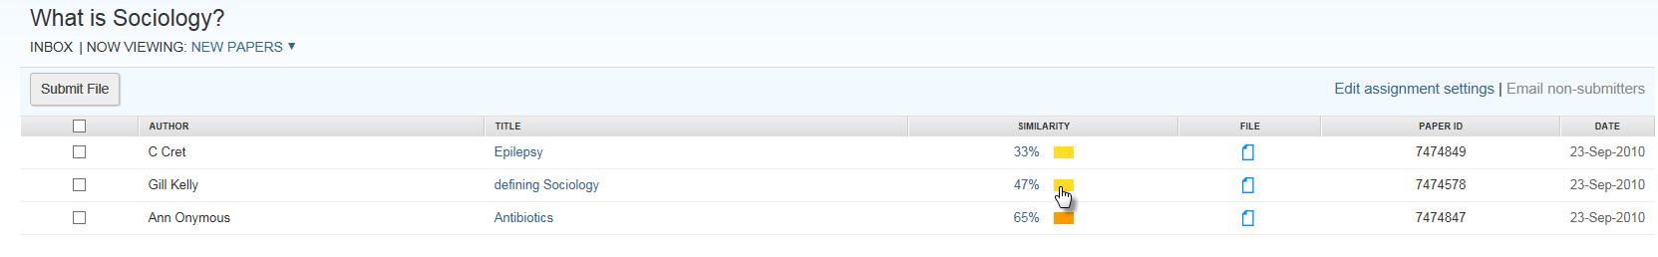

Figure 1 Accessing the Similarity Report

**Navigating to the Match Overview in the Document Viewer**

Percentage of Document which matches TurnitinUK Sources

1. The first screen has a red tool bar on the right of the assignment script with options for viewing the similarity report. It is usual to **click on the red number and view the Match overview first**.

Navigate to next assignment

Navigate to previous assignment

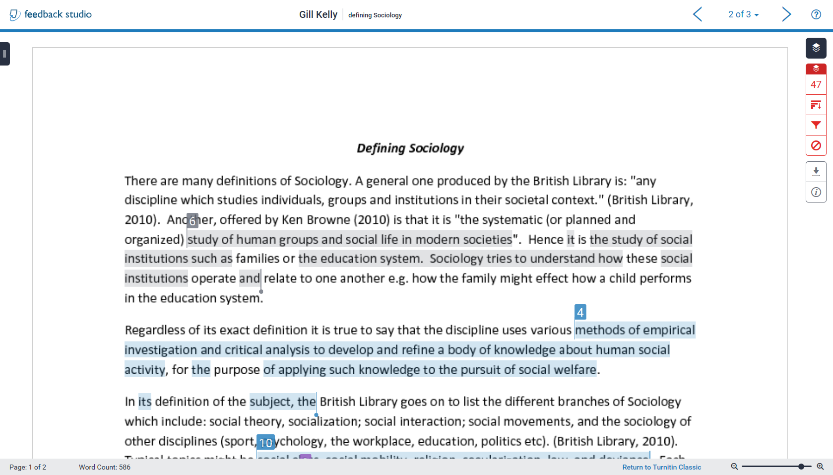Figure 2: The Document Viewer initial view

Click here for **Match Overview**

Click here to see **script information** such as submission time and wordcount

Click here to **download** similarity report view, script, or student submission receipt

Click here to **all sources** in Turnitin database which match an item

Click here to **filter** matches

Click here **view excluded matches**

**Viewing the Match Overview Screen**

Navigate to previous assignment

Navigate to next assignment

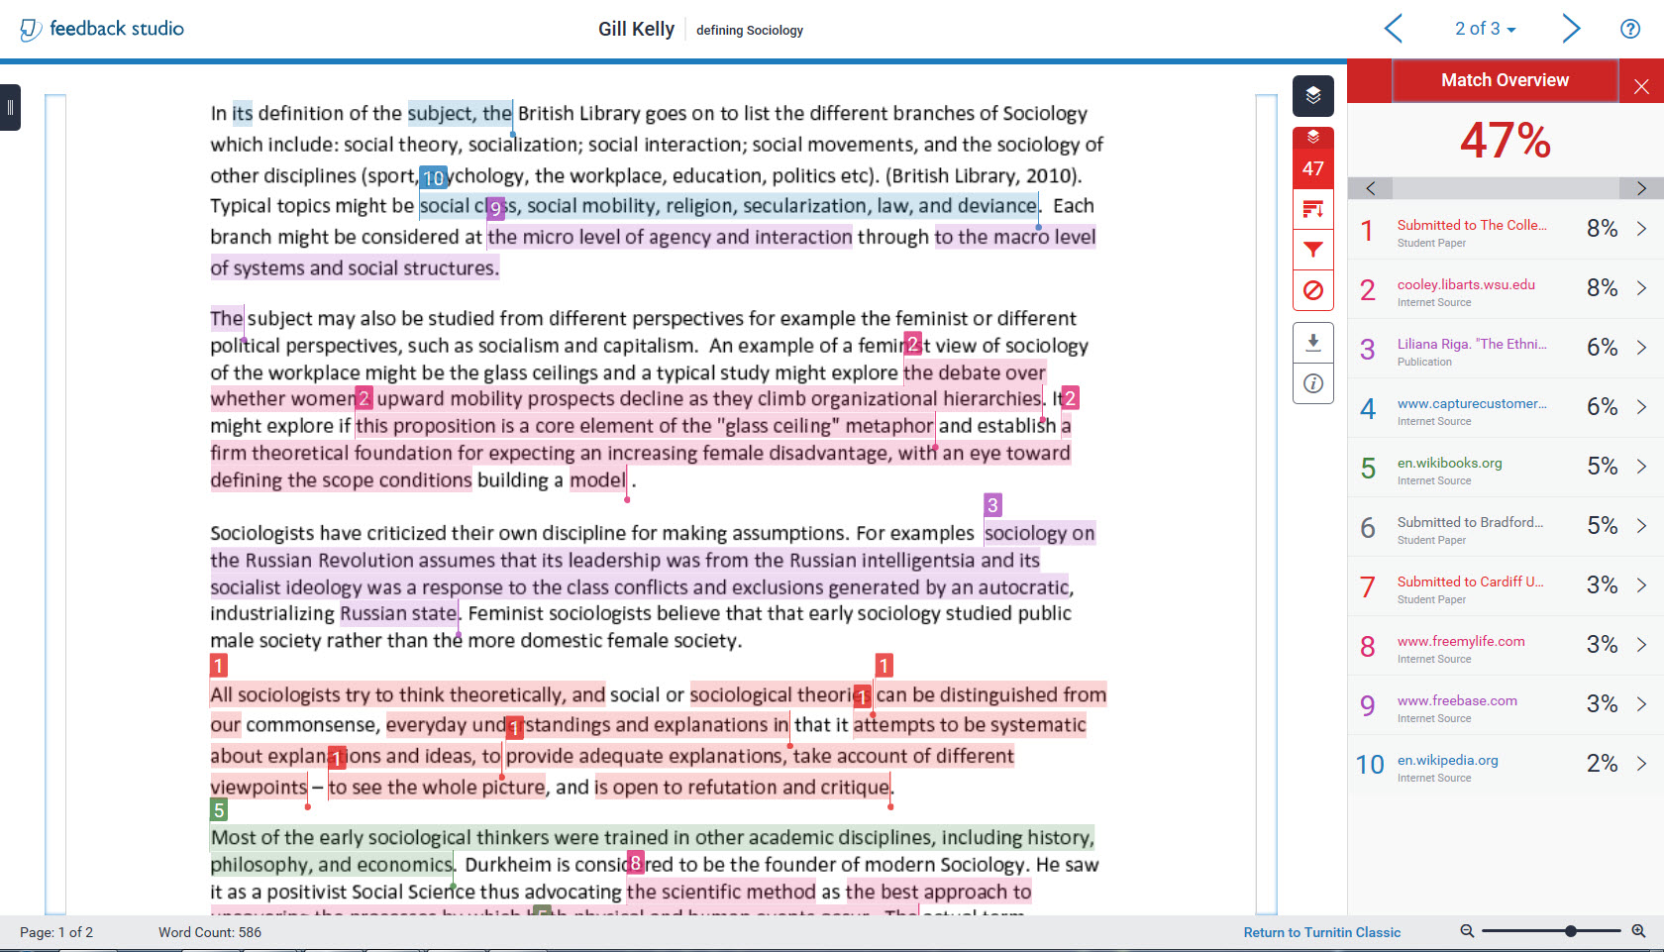

Total percentage of extracts in the assignment which match the listed source

Overall percentage of assignment which matches Turnitin sources

Matches to each source are numbered and colour coded

Click on a number to bring the associated source matches to the top of the document screen

View “old style” report

Scroll bar

Figure : The Match Overview Screen

**Examining all the matches to a particular source**

Percentage of Document which matches TurnitinUK Sources

1. To examine all the matches to the first source click on that source in the side bar (Figure 4).

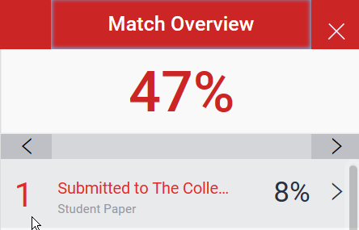

Click on the right arrow to step through each match to this source in turn

Figure 4: First match in side bar

1. A grey Match bar will appear above the first source match. Click on the **right arrow** of the bar to step through each match to the source you selected and a detailed comparison with the source text will appear above each match in the assignment window (Figure 5).

View matches in the context of the full Source Text

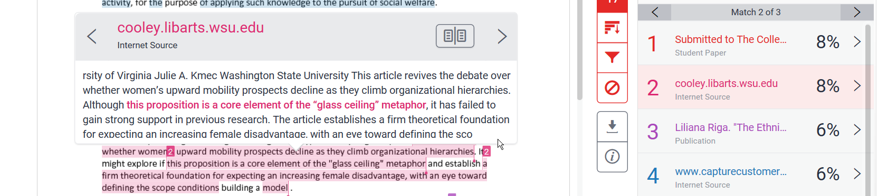

Figure 5: Match bar and detailed comparison: here the second match to the second source is shown in the source text window.

1. To view all the matches to the source in the context of the full source text click on the book symbol in the source text window.
2. 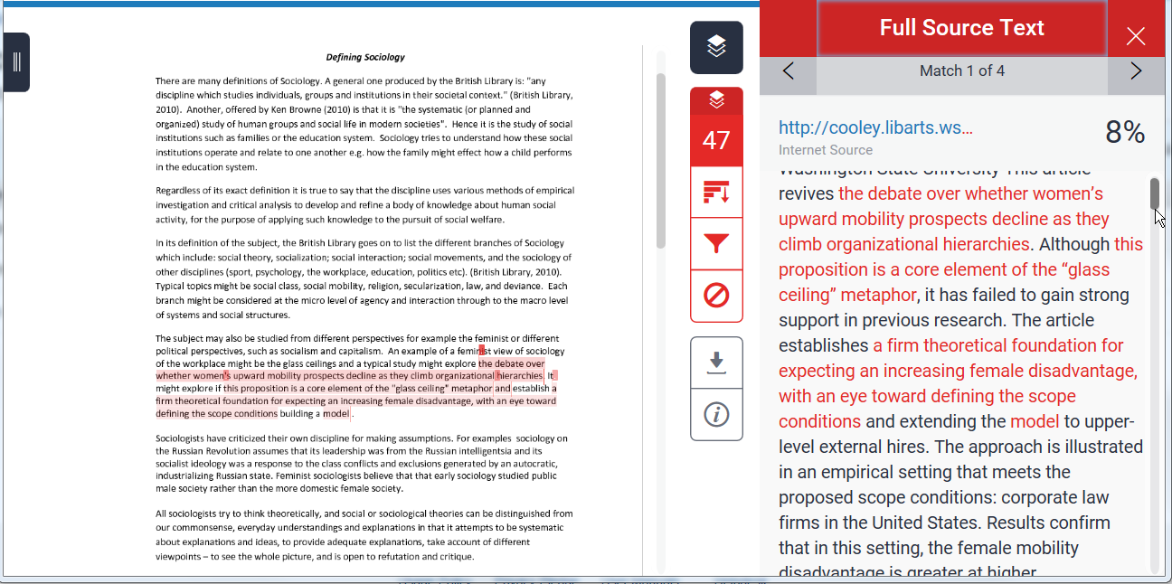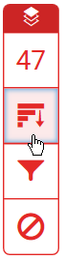The student’s assignment will appear on the left with the relevant text highlighted. The original source will be displayed on the right, with the corresponding text highlighted in red. (See figure 6).

Figure 6: seeing all the matches to a single source in the context of the Full Source Text

**To view Underlying Sources**

1. TurnitinUK will list the source which incorporates the strongest match within the match overview but it may also find other sources that match the same text and these can be seen by looking at the Match Breakdown. To do this click on the grey arrow to the right of the total match percentage for that source.

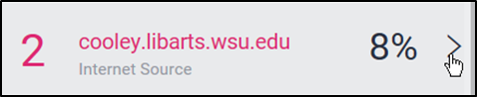

Figure :Accessing the Match breakdown

1. You may wish to view all the sources in the Turnitin database which match the assignment, to do this click the all sources button



Figure : The All sources button

**Eliminating matches to sources**

1. In some cases, matches may be the result of an assignment mistakenly being uploaded more than once, either by the tutor, or the student. The result may be that matches highlighted are in fact the same piece of work. It is possible to exclude the duplicated match from the report. (See figure 9 &10).

It is important to note the difference between matches to a duplicate assignment which should be excluded, and matches to work by the same author that has been reused to fulfil requirements of a different assignment, which should not.

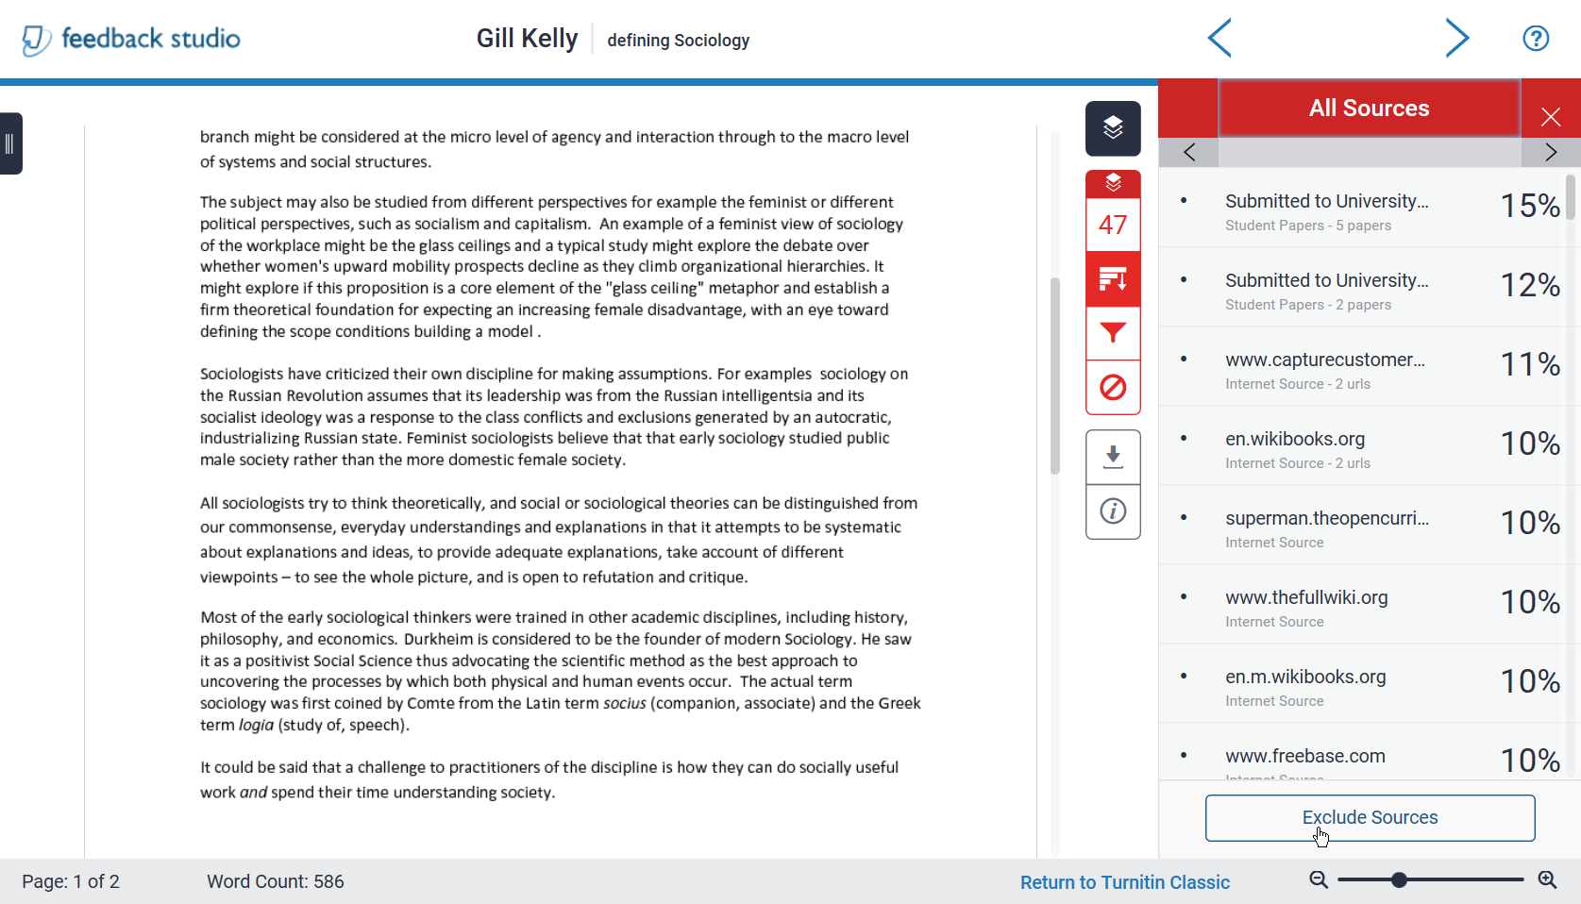

Figure : The Exclude Sources button in the All Sources view

1. If there are a number of matches you can select those you wish to exclude. (See figure 10).

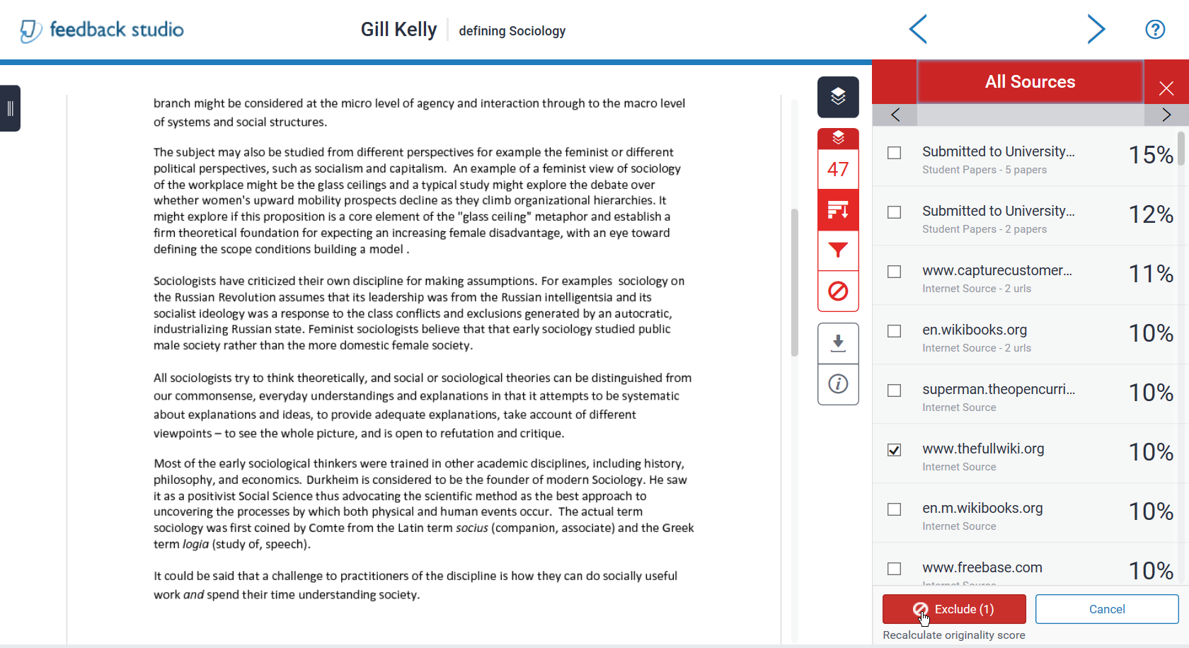

Figure 10: Excluding selected sources

**Restoring excluded Sources**

1. To restore excluded sources click on the ‘Exclude and Restore Sources’ button.

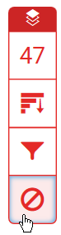

Figure 11 The Excluded Sources Button

1. Select the sources you wish to restore and click on the ‘Restore’ button. To return all excluded sources click the ‘Restore All’ button. (See figure 10). To close the Excluded Sources Panel click on the X at the top right corner of the panel.

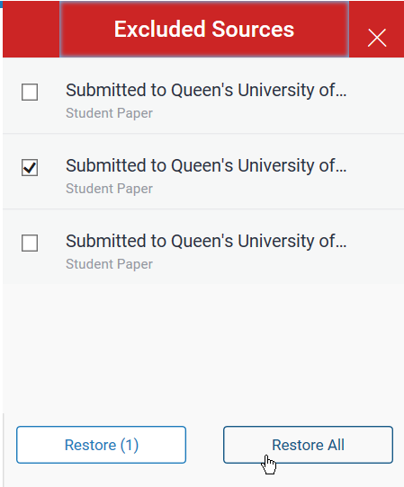

Click here to close the Excluded Sources panel

Figure 12: Restore excluded resources

**Using the filtering functionality**

1. Click on the View/edit filters and settings symbol at the bottom right hand side of the screen which appear as a funnel (See Figure 13).

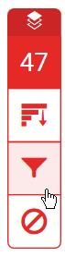

Figure 13: View/edit filters and setting symbol

1. Click ‘Exclude Quotes’on the Filters and Settings side panel to exclude quotations (Figure 14).

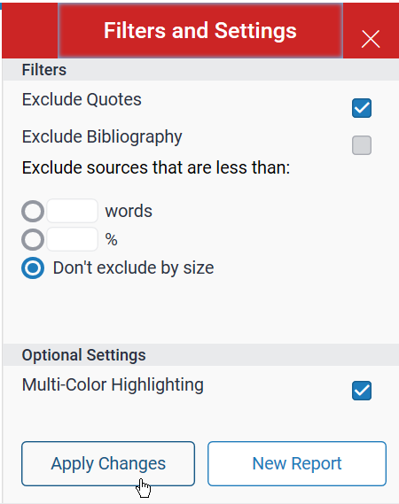

Figure 14: Excluding the quotations

1. Click on ‘Apply Changes’ at the bottom of the panel.
2. The Similarity Index should decrease.
3. Matches to bibliography and small matches with a word limit of up to 10 may be excluded in the same way.

You are advised **NEVER** to exclude small matches on a percentage basis