Student Instructions for Setting up Your Account from Your Welcome Email
Warning: Each Turnitin account must be assigned a unique email address in the Turnitin system. Users who have previously created a Turnitin account at Queen’s must log in with the email address and password originally provided which will be your Queen’s student email.
Your instructor will add you to the Turnitin class, you will receive an e-mail asking you to create a Turnitin password. If you have received a welcome email from Turnitin, this confirms that your instructor has added you to their class, allowing you to begin submitting papers to your assignments.
Note: If you believe that an instructor has added you as a student, but you have not received a welcome email from Turnitin, please check your spam or junk folder. Alternatively, contact your instructor to check that your email address has been typed correctly.
To access your Turnitin account, please follow the instructions below.
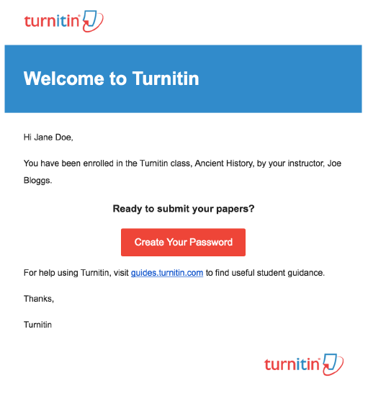
1. Click the Create your Password button from your Turnitin welcome email.
2. To create your password, enter your queen’s email address (this must be the same email address to which your Turnitin welcome email was sent), along with your last name or family name.
3. Click Next to continue.
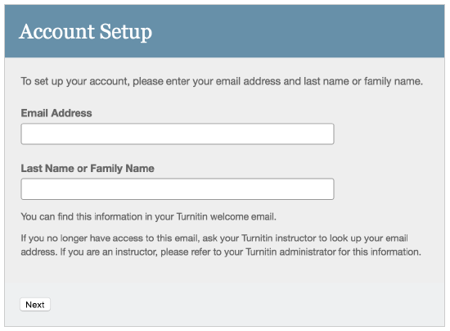
4. Turnitin will send you an email to validate your account, with the subject: Set up your Turnitin Account. Return to your email inbox, ensuring you check your email client's spam or junk folder for this email.
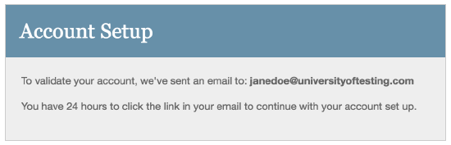
5. Follow the instructions in your email to finish setting up your Turnitin account. This will direct you back to Turnitin's account setup pages.
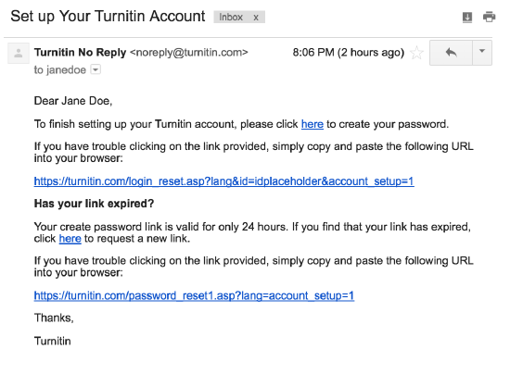
Note: The create password URL contains a unique ID and will expire if you fail to click it within 24 hours. If your create password link is no longer working, click the link under Has your link expired? to request a new email.
6. Enter and confirm your new password. Your password must be between 6 and 12 characters, containing at least one letter and one number.
7. Click the Create Password button to finish the account setup process. Alternatively, click Cancel to abort.
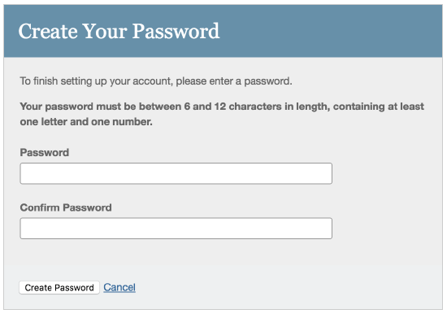
8. Your account setup is now complete; an email will also be sent to confirm this setup. You can now log in to Turnitin to set your security question and answer and begin using the service.
9. Click the Log in Now link.
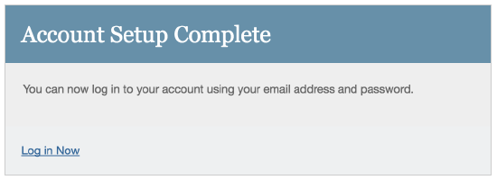
10. Using your email address and newly created password, enter this information in the login fields provided.
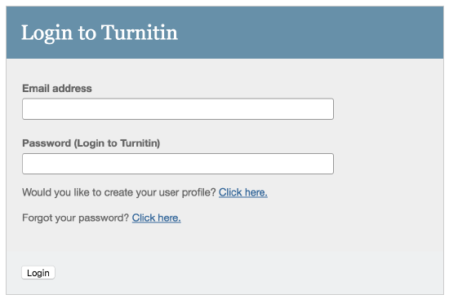
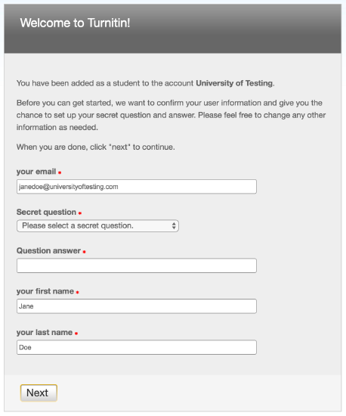
Please note that after login, you must not change your name and email address details: these have been drawn from QSIS and set out by your School in the way it wishes your details to appear in the system. Non Queen’s emails cannot be authenticated, submissions from non-Queen’s email addresses will not be recognized as submissions.
Do not change your details from how they have been entered by your School.
12. Please select a security question, then enter an answer in the fields provided. This will be used in the event that you need to reset your password.
13. Click Next to continue.
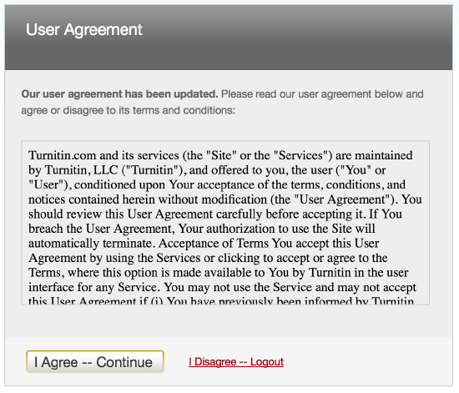
14. You then have the option to Click the I Agree -- Continue button to accept Turnitin's user agreement and enter the Turnitin service.

