UG &PGT Formative Methodology: Student submits several times and can view originality reports
This is a step by step guide for staff in setting up a class, with an associated assignment, using TurnitinUK Originality Checking Service. The guide will then show you how to enrol your students into the class.
These instructions are for those who have already signed up to TurnitinUK. If you have been sent an email from the Turnitin system with a temporary password follow the instructions to sign up and then use this handout.

Step 1: Going to the TurnitinUK Site
- Open the internet browser (e.g. Windows Explorer or Firefox)
- Enter the url www.TurnitinUK.com into the browser address field.

Step 2: Logging In
- Ensure that the Languages selection reads English (United Kingdom). Choose Log In
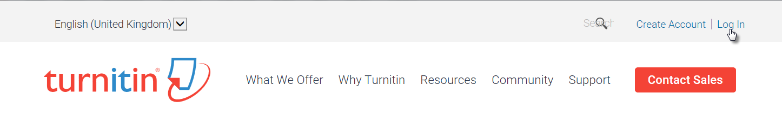
Figure 1: TurnitinUK Home Page

- Enter your QUB email address and password (your password is the same as the one you entered when creating your profile).

Step 3: Setting up a ‘Class’
(Note: within TurnitinUK ‘class’ equates to a module within the University)

- Once you have logged in your instructor homepage will appear (see Figure 2)
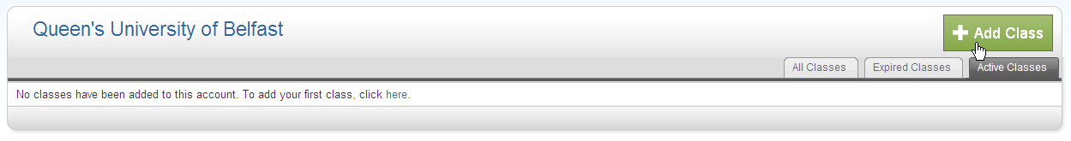
Figure 2: Instructor Homepage
- Click on the ‘Add Class’ button to create a new class. A new screen will appear (see Figure 3 overleaf)
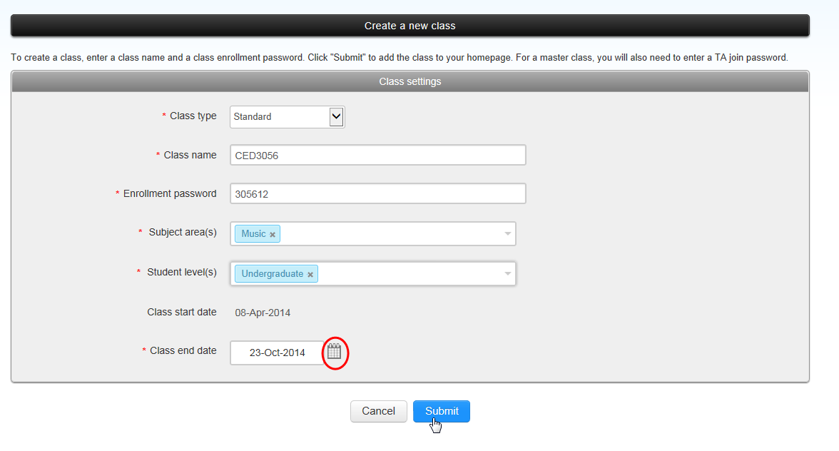
Please choose the closest area to your discipline
Figure 3: Create a New Class
- In the ‘Create a New Class’ screen the following details must be entered:
  - The class type must be selected as ‘Standard’.
  - Enter a class name of your own choosing (which should be meaningful to the student, e.g. the name of the module).
  - Enter an enrolment password (see the information box below).
  - Enter the subject area
  - Enter the student level
Note: Make a note of the password to give to the students later
- Enter a class end date by typing in the information or by clicking the calendar beside the date.
Note: This should be beyond the last possible date for submission of assessments to the module (consider late submissions).
- Click Submit.
What is a Class ID and Password?
The Class ID and Password are designed to be used where the students enrol themselves in a Turnitin Class. For security reasons Queen’s is no longer using this system. Later in this process you will enrol the students yourself.
You will be required by Turnitin to complete the password field.

- A new window will appear with the acknowledgement that you have created a new class and a unique class ID will be automatically allocated.
(Note: If you are using Firefox it will be necessary to allow popups from the site). Click on continue to close this screen.
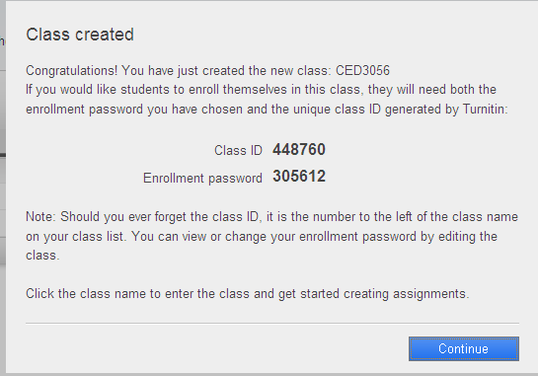
Figure 4: Confirmation Screen of Successful Creation of Class
.
- Once you have closed the notification window you will be brought to your instructor homepage which now contains the ‘class’ or module you have created. Click on the name of the class that you have just created.
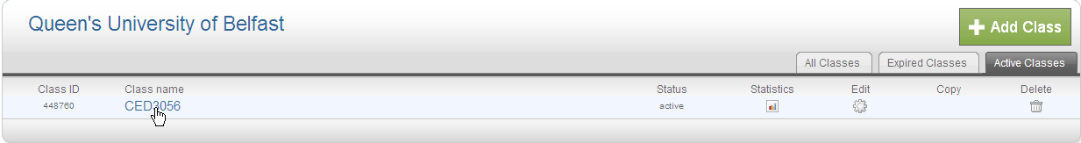
Figure 5: Instructor Homepage
Step 4: Creating an assignment
- This will bring you to the homepage for that class or module. You will need to click the ‘Add Assignment’ button. (See Figure 6 overleaf)
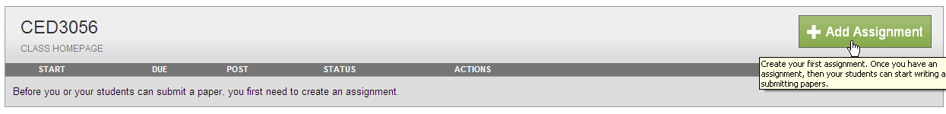
Figure 6: Add Assignment Button

- The next screen that appears will be the ‘New Assignment’ page. Add an assignment title. (Where you have more than one assignment ensure that it is easy for the students to distinguish between them).
- Select a start date, from which students will be able to view and submit the assignment, by selecting from the drop down menu.
- Select a due date from the drop down menu.
- Open the ‘Optional Settings’ button at the bottom of the page.
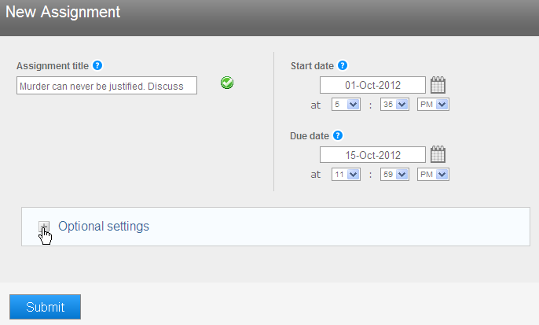
Figure 7 New Assignment Page - Assignment names and dates
- Additional options will now be displayed below the selections you have just made and you should set them as displayed in the following figures. This will enable you to create an assignment whereby the student can upload their assignment several times up to the due date. They can view each originality report as they are produced (one every 24 hours).
- You should put all submission instructions in the box provided
- Allow submissions after the due date, in case you need to grant any extensions.

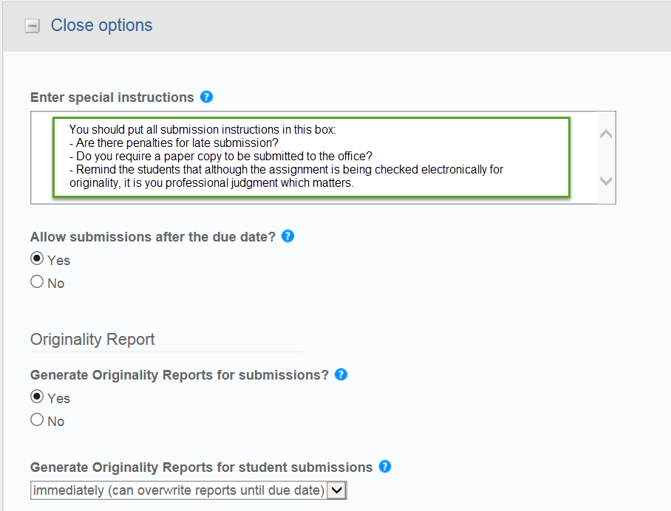
Figure 8: New Assignments Page – Options - part 1
- The next set of options relate to what is shown on the originality report. You are advised to include bibliographic and quoted materials as well as small matches.
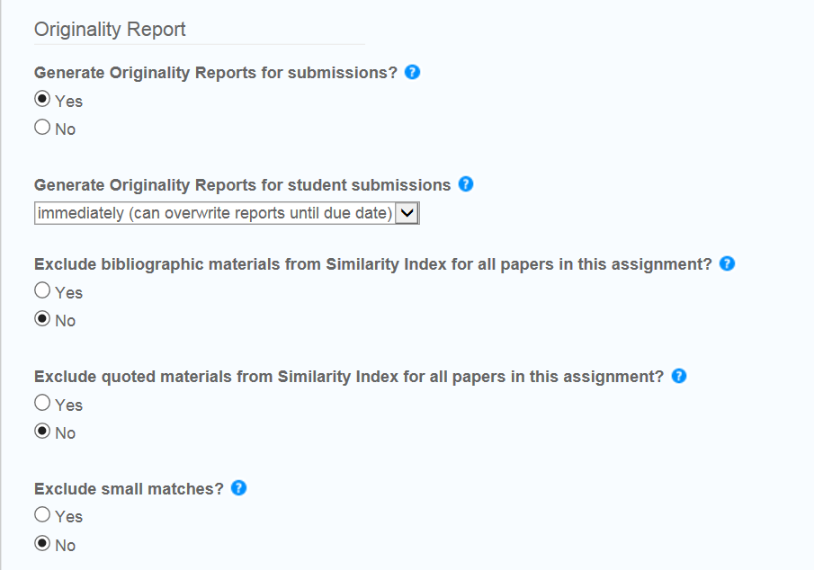
Figure 9: New Assignment Page - Options - part 2
- Allow the students to see the originality reports so that they can see where they might be considered to have ‘lifted text’.
- If it is your School’s policy, choose enable anonymous marking.
- Submit the papers to the repository so that they can be used as a basis for future comparison.
- Click Submit’ at the bottom of the screen.
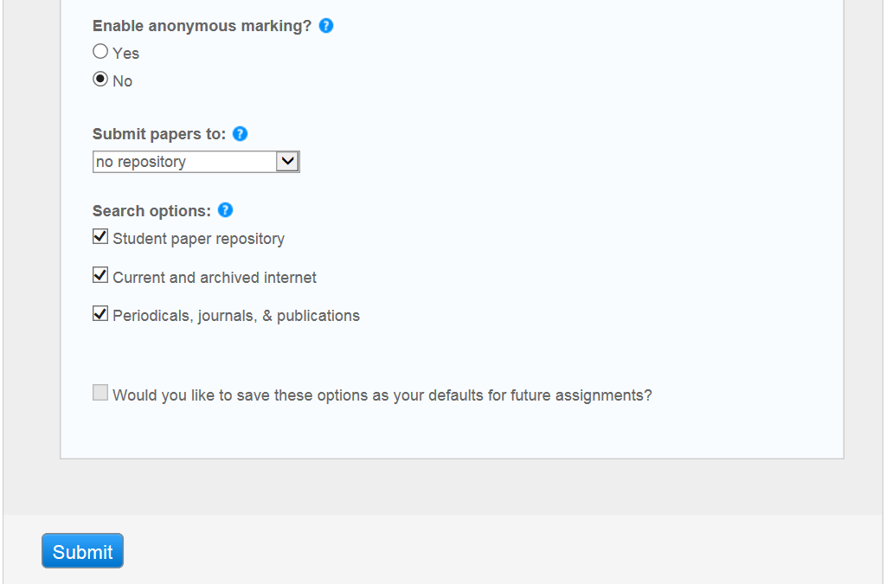Figure 9: New Assignment Page - Options - part 3

Step 5: Viewing the inbox
- When you go to your class homepage your assignments will be displayed. Click on the ‘view’ button to view the inbox for that assignment.
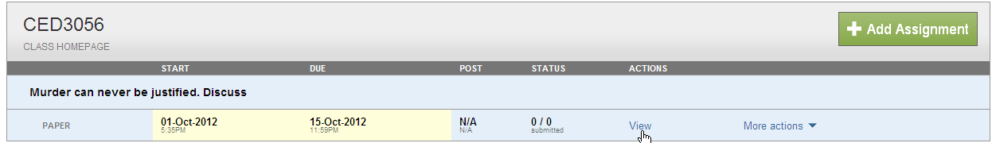
Figure 10: Class Homepage
- Future student submissions to this assignment will appear in the inbox.
- You will need to enrol all of the students in the class for them to be able to submit to the assignment.
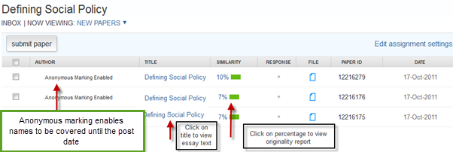
Figure 11: Class Page Inbox

NOTE: You are reminded that for copyright reasons your school should have collected written permission from the students before uploading any assignments on their behalf.
Step 6: Enrolling the students
In order to enrol your students in the Class you should have a Word, Excel, or plain text file of Student: Forename, Last Name and Queen’s email address. This information is available from the QSIS system. You should have a note of the file’s location as you will be asked to browse for it as part of the upload process.
n. b. Students are required to use their Queen’s email as a username in Turnitin as these are the only accounts which Queen’s can verify. You should not accept submissions from other email addresses.
- When you go to your class homepage click on the Students tab.
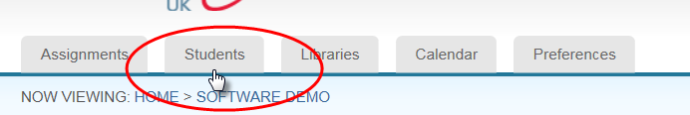
Figure 12: The Students Tab

- Click on the Upload Student List button.

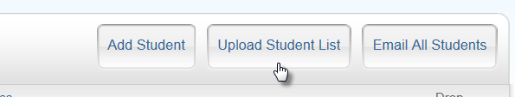
Figure 13: The Upload Student List button
- Browse for your student list file
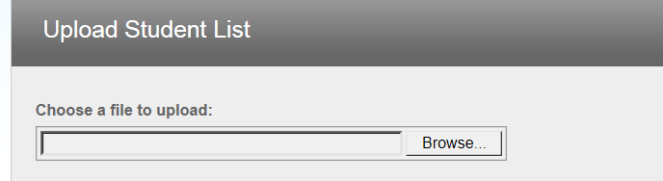
Figure 14: Browsing for the student list file
- Once you have selected the file, click on Upload List.

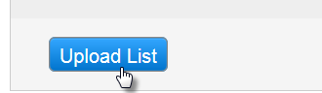
Figure 15: the Upload list button

- You will be asked to confirm that the data is correct – check that you have the name data in the correct fields.

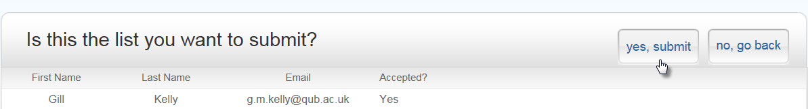

Figure 16: Confirm submission data
- Your upload will be confirmed. The students will receive an email to confirm that they have been enrolled in your class.
If this is the students’ first use of Turnitin they will need to complete their registration. The Student Instructions for Setting up Your Account from Your Welcome Email will take them through this process step by step. You are advised to download these instructions for the CED Turnitin website and make them available to your students.

