PG Methodology Supervision - Setting up a class and then an assignment and revision assignment with TurnitinUK Originality Checker
This is a step by step guide for staff in setting up a class, with an assignment attached to it, using TurnitinUK originality checking service. The instructions further explain how to set up the submission of a subsequent draft of the same piece of work. These instructions are for those who have already signed up to TurnitinUK. If you have been sent an email from the Turnitin system with a temporary password follow the instructions to sign up and then use this handout.

If you have forgotten your password, use the Reset Password button. Step 1: Going to the TurnitinUK Site
- Open the internet browser (e.g. Windows Explorer or Firefox)
- Enter the url www.TurnitinUK.com into the browser address field.

Step 2: Logging In
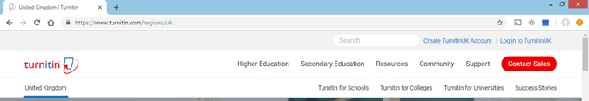
- Ensure that the location is English (United Kingdom). Choose Log In

Figure 1: TurnitinUK Home Page
- Enter your QUB email address and password (your password is the one you entered when creating your profile).
Step 3: Setting up a ‘Class’
In this context you can think of a class as a folder which is open for a set period of time to accept a series of dated submissions.
n.b. Generally a supervisor’s PhD students enrol, submit drafts, and complete at different times, and so these instructions assume you will need to make an individual class for each student.
- Once you have logged in, your instructor homepage will appear. Click on the ‘Add Class’ button to create a new class. (see Figure 3 below)
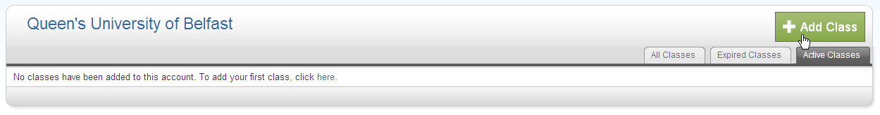
Figure 3: Instructor Homepage

- In the ‘Create a New Class’ screen the following details must be entered:
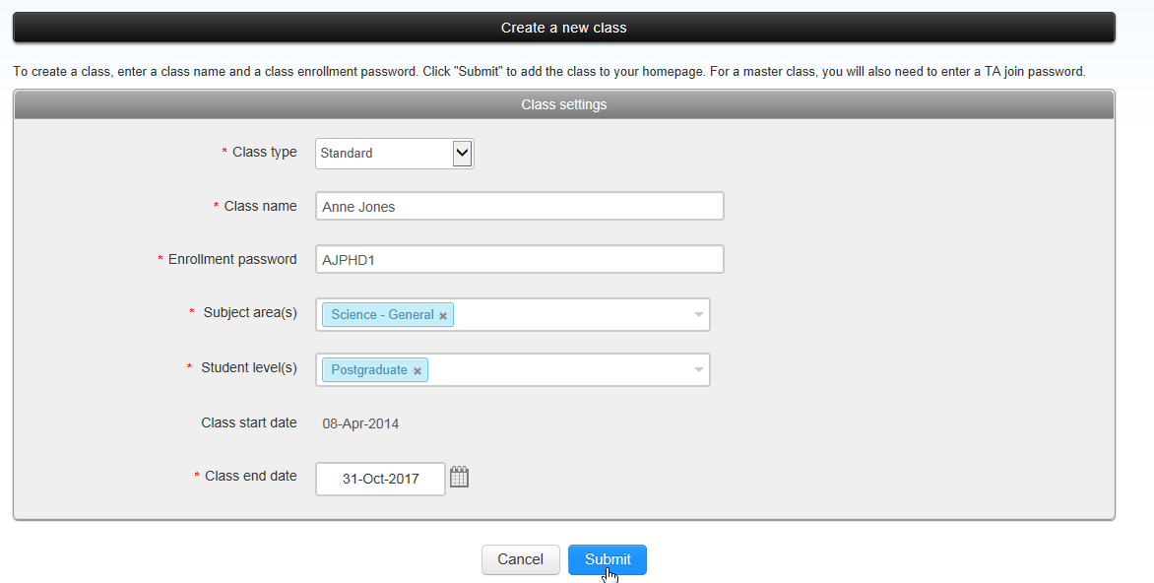
Please choose the closest area to your discipline
Figure 4: Create a New Class
- The Class type must be selected as ‘Standard class’.
- Enter a Class name of your own choosing (which should be meaningful to the student, e.g. The name of the PhD student. Students only have access to classes in which they are invited to enrol.)
- Enter an Enrolment password (bearing in mind that you will be issuing this to your student).
- Enter a class end date by typing in the information or by clicking the calendar beside the date. nb: this should be approximately two months later than the anticipated submission date – it is possible to repeatedly extend this if required.
- Click Submit.
- A new window will appear with the acknowledgement that you have created a new class and a unique class ID will be automatically allocated. nb: it may be necessary to allow popups from the site.
- n.b. Make a note of the class ID and enrolment password to give to the student later. (Figure 5)
- Click on ‘Continue’ to close this screen.
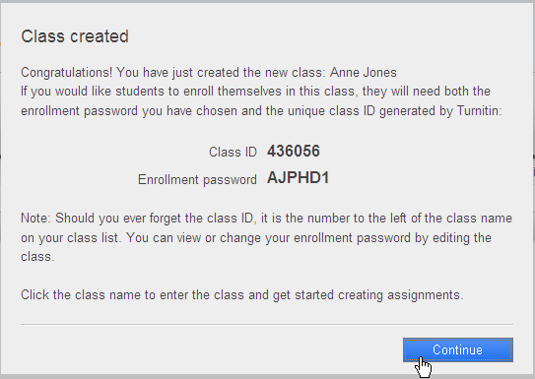
Figure 5: Confirmation Screen of Successful Creation of Class

- Once you have closed the notification window, you will be brought to your instructor homepage which now contains the ‘class’ you created. Click on the name of that class. (Figure 6).
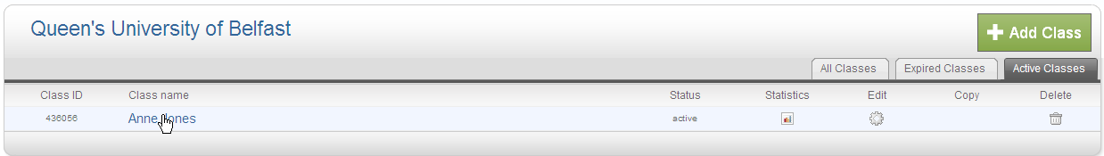
Figure 6: Instructor Homepage
- Email your research student and give them both the class ID and the enrolment password so that they may use this information to enrol in the class in order to submit to the assignment areas that you are about to create.
Step 4: Creating an Assignment
When you create an assignment it is a bit like creating a drop box or submission area for the student. You will make an assignment for an early draft of each chapter that the student should submit to Turnitin.

- You should now be on the homepage for the student’s class. You will need to click the ‘Add Assignment’ button (Figure 7).
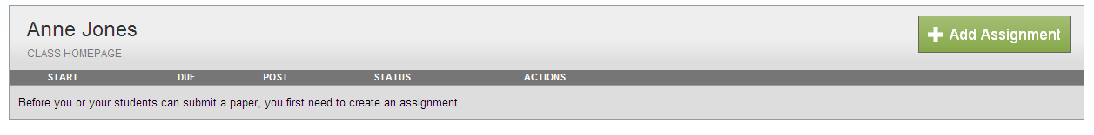
Figure 7: Class Homepage

- The next screen that appears will be the ‘New Assignment’ page. Add an assignment title which is clearly identifiable for the student (perhaps the “differentiation document” or “literature review”).
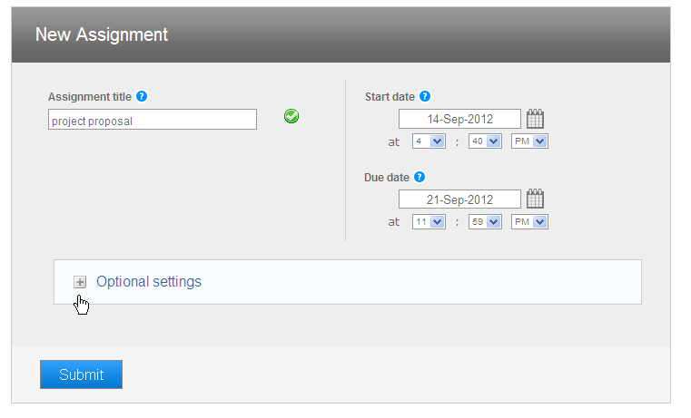
Figure 8: New Assignment Page - Assignment names and dates

- Select a Start date when the assignment will be made available for the student to view by selecting from the drop down menu.
- Select a Due date from the drop down menu.
- Open the ‘Optional settings’ button at the bottom of the page. (Figure 8)
- Additional options will now be displayed below and you should set them as displayed (Figures 9,10,11). This will enable you to create an assignment whereby the student can only upload their document once.
- Allow submissions after the due date, in case the student is not ready in time.
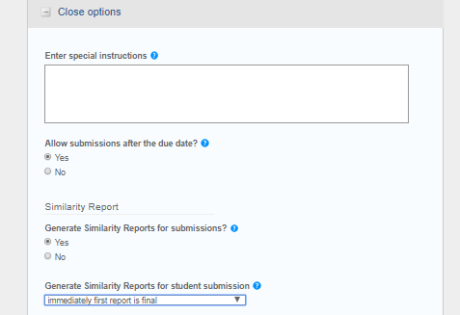
Figure 9: New Assignment Page – Options part 1

- The next set of options relate to what is shown on the originality report (Figure 10). You are advised to include matches to bibliographic materials and quotations.
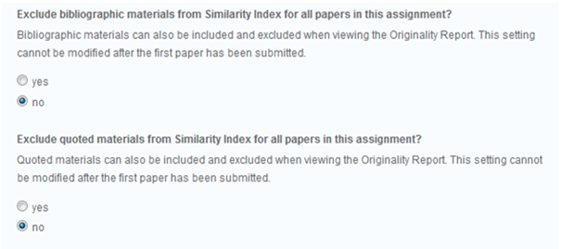
Figure 10: New Assignment Page - Options part 2

- If you wish, you can eliminate some small matches automatically. Do this on word count but NEVER by percentage
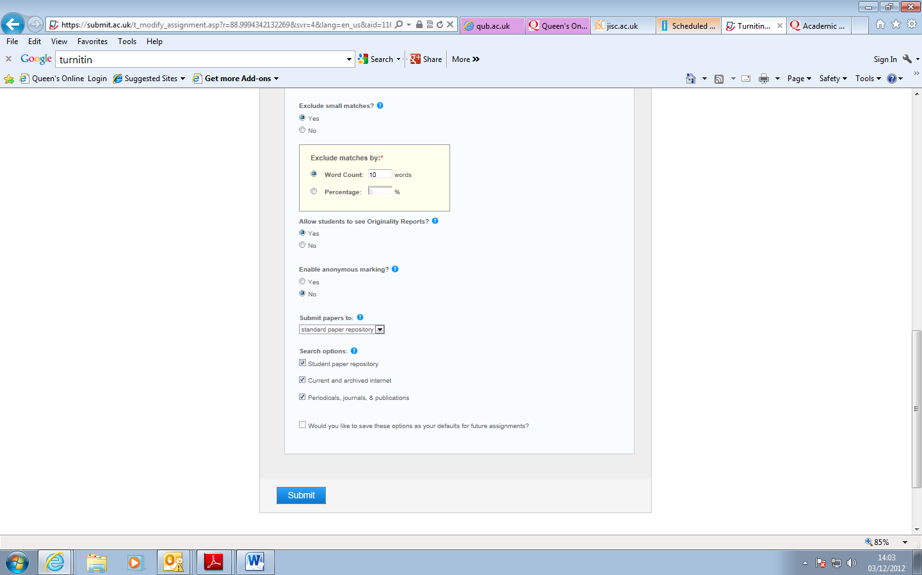
Excluding matches of up to 10 words can prevent some insignificant matches

Figure 11: New Assignment Page - Options part 3

- Next, allow the students to see the originality reports so that they can see where they might be considered to have “lifted text”.
- Anonymous marking is not relevant in this context.
- Submit the papers to the ‘standard paper repository’ so that they can be used as a basis for future comparisons (unless one of the exceptions covered in the Guidelines FAQ document applies).
- Click ‘Submit’ at the bottom of the screen
- You will now see the new assignment displayed within the class (Figure 12).
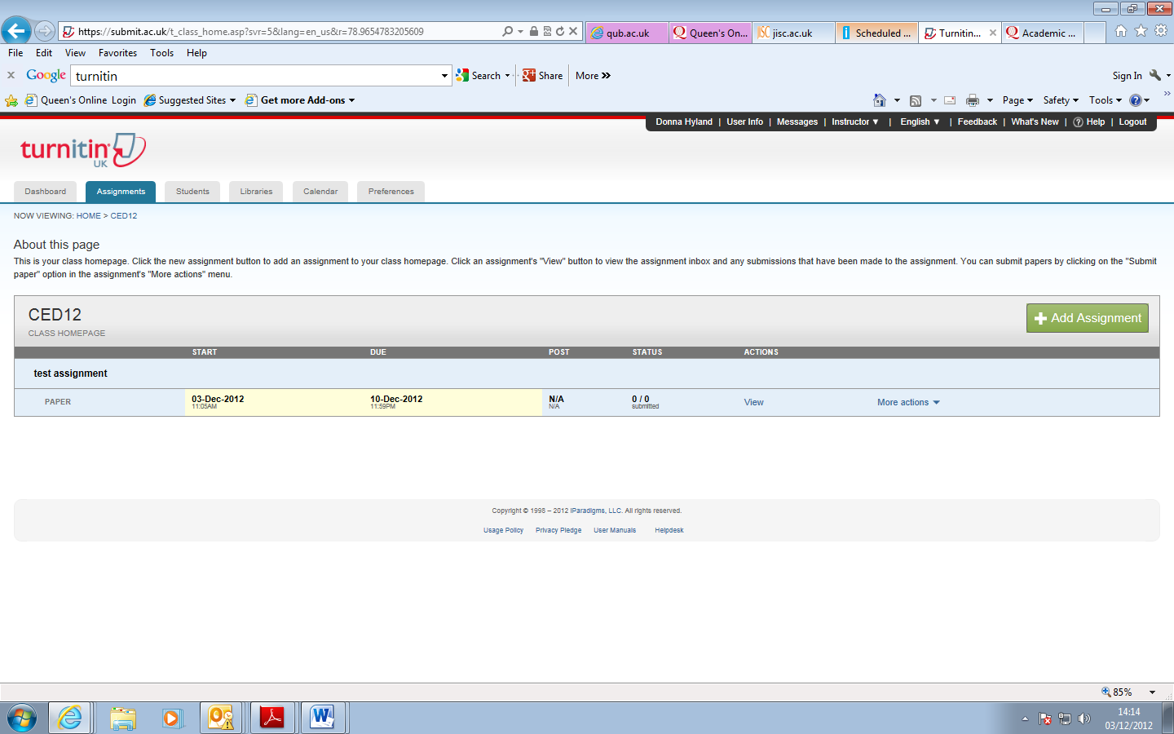
Figure 12: Class Homepage - Assignment list
Once the student has submitted the early draft, it is envisaged that you will view the on screen originality report together the student, to discuss the appropriateness of the matches. See the handout on viewing the originality report.

Step 5: Creating the Revision Assignment
When the student has the chapter near to completion it is possible to create an opportunity to resubmit the revised chapter without it being compared to the original (which may be substantively similar).

- Click the ‘Add Assignment’ link. ( Figure 13)
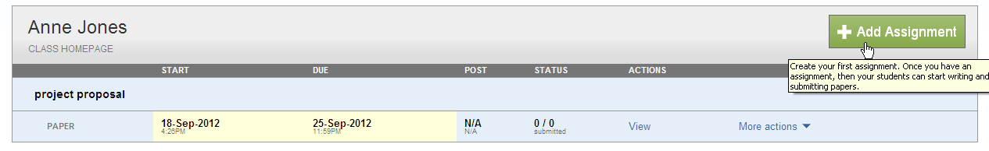
Figure 13: Class Homepage - Add assignment
- Select ‘Revision Assignment’ from the assignment type screen (Figure 14).
- Click on ‘Next Step’.
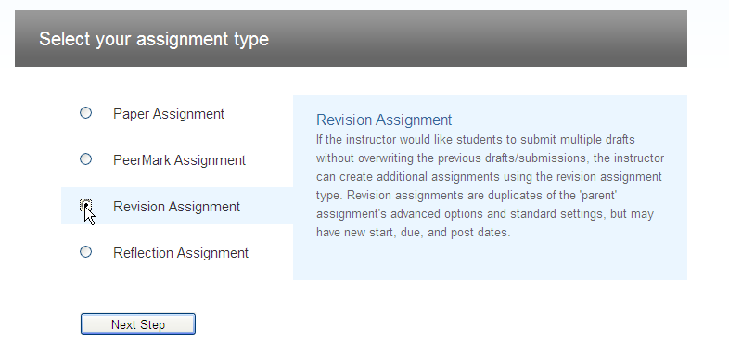
Figure 14: Assignment Type
- Select the assignment that you made previously from the “based on paper assignment” drop down menu (Figure 15 over).
- Adjust any of the dates and times if required.
- Select ‘on due date’ to generate originality reports on due date.
- Choose ‘no’ from the ‘allow students to see originality reports’ menu.
- Click submit. (Figure 15).
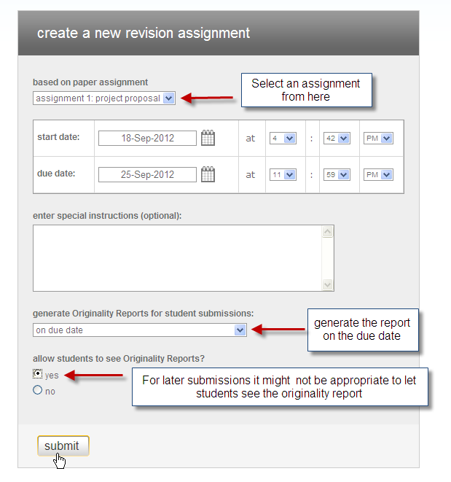
Figure 15: Create a New Revision Assignment Screen
- You will now see the revision assignment displayed within the class underneath the original assignment (Figure 16).
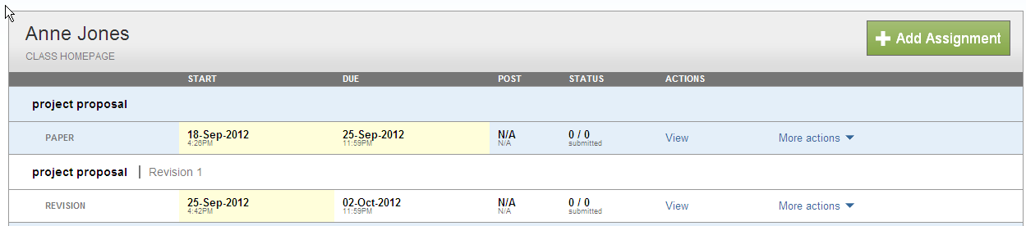
Figure 16: Class Homepage
Note: Revision assignments are always named ‘Revision 1’ and ‘Revision 2’ by default.
Step 6: Replicating this set up for other students
If your discipline has a standard set of chapters that are to be put through Turnitin at set time intervals it is possible to replicate the set-up which you have created for further students.
- First create a class for the new student as in Step 3.
- In the new class, click on the Libraries tab, (Figure 17)
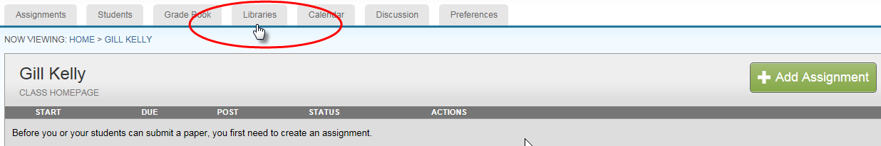
Figure 17: the Libraries Tab
- In the Assignments Library, select the assignment set for the “template” student class in the drop down list. Select which assignments you wish to replicate and click Import (Figure18).
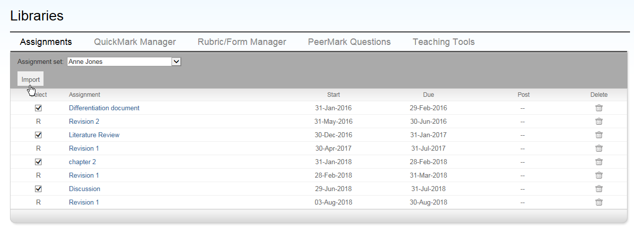
Figure 18: Importing the assignments from an assignment set 1
- You can reset the dates of the first assignment in the list but the remaining dates should be set by editing the assignments individually. To do this choose More actions> Edit settings for each assignment including the revision assignments.
Step 7: Viewing the inbox
- The student submission to this assignment will appear in the inbox.
- When you go to the class homepage the assignments (student chapters) will be displayed. Click on the ‘View’ button to view the inbox for that assignment. ( Figure 17)
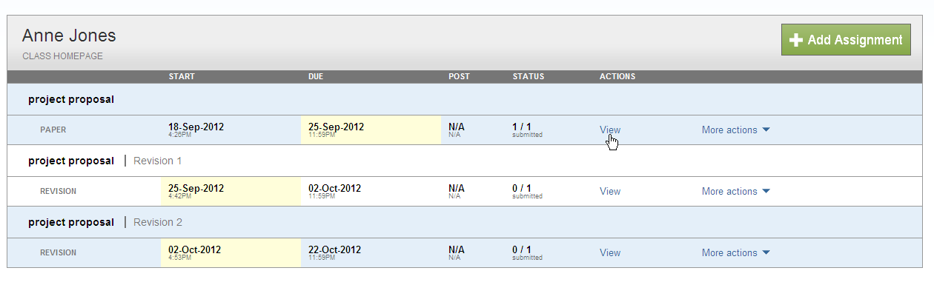
Figure 17: Class Homepage – Assignment list
- From here you can either download a draft of the student chapter or view the originality report (see the further handout on this).
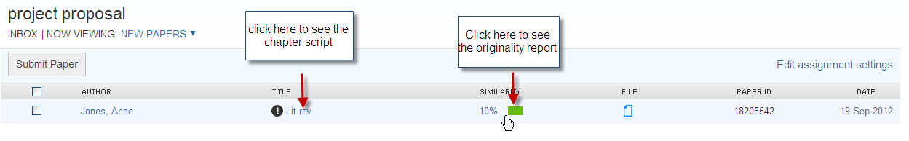
Figure 18: Class Inbox – View button

Please note: you are reminded that for copyright reasons you should not upload student assignments yourself unless you have written permission.

