 | ACTION | PROCESS FOR UG/PGT STUDENT WITHDRAWALS
1 | Complete UG/PGT Withdrawal Request Form | Access the UG/PGT Withdrawal request form via the SharePoint site. (Please note recommended browser is Internet Explorer).  - International Students [question 5 on UG/PGT form]  The International Student Support Office will be notified of any processed requests for international students to be withdrawn or put on a leave of absence.  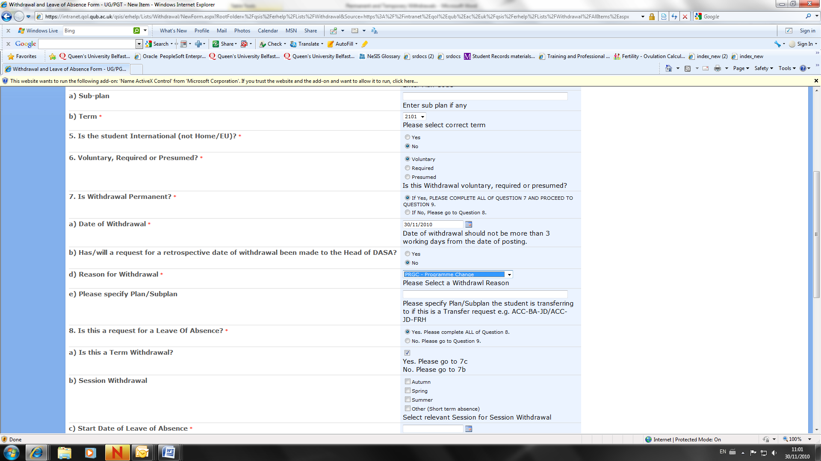  - Voluntary, Required or Presumed [question 6 on UG/PGT form]  Indicate if the withdrawal request is voluntary (initiated by the student), required (Student Progress Committee decision/other), or presumed (student has registered but has not been in attendance for some time and has not responded to communications).  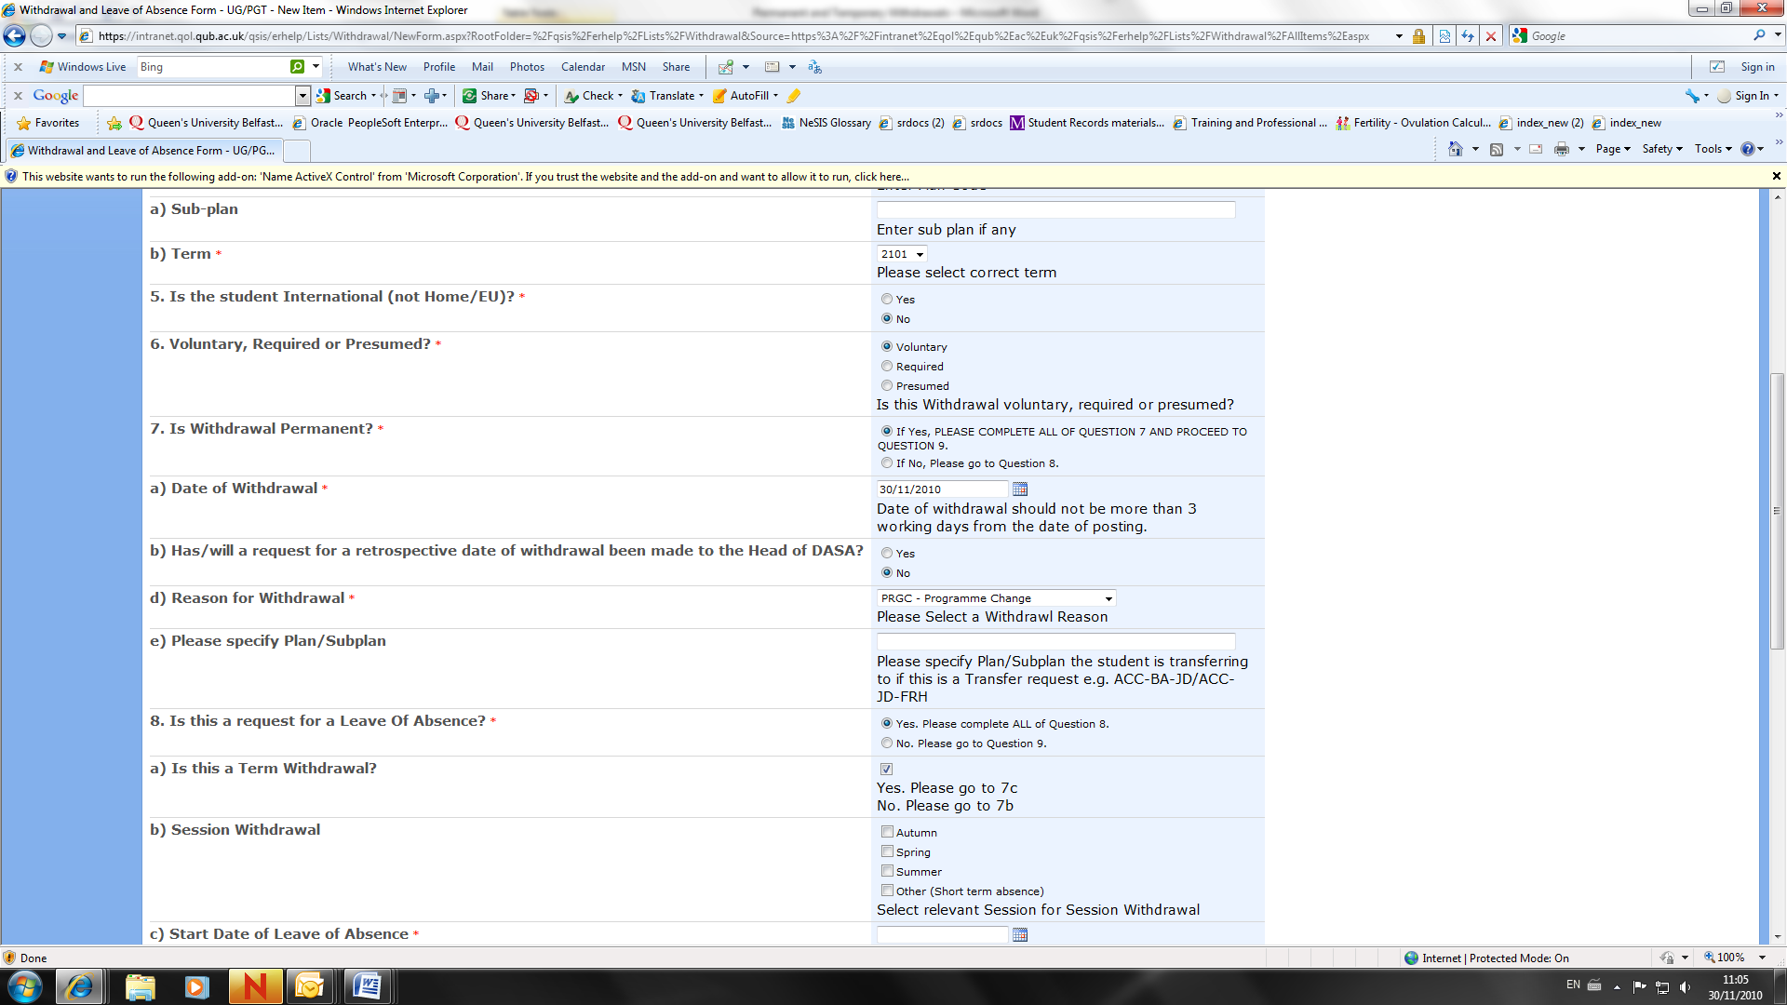  - Date of withdrawal [question 7 (a) on UG/PGT form]  The request form submission date will be taken as the formal date of withdrawal. Retrospective withdrawals in excess of 3 working days before the submission date will require supporting documentary evidence, authorisation from the Head of School/School Manager and approval secured from the Director of Academic and Student Affairs.  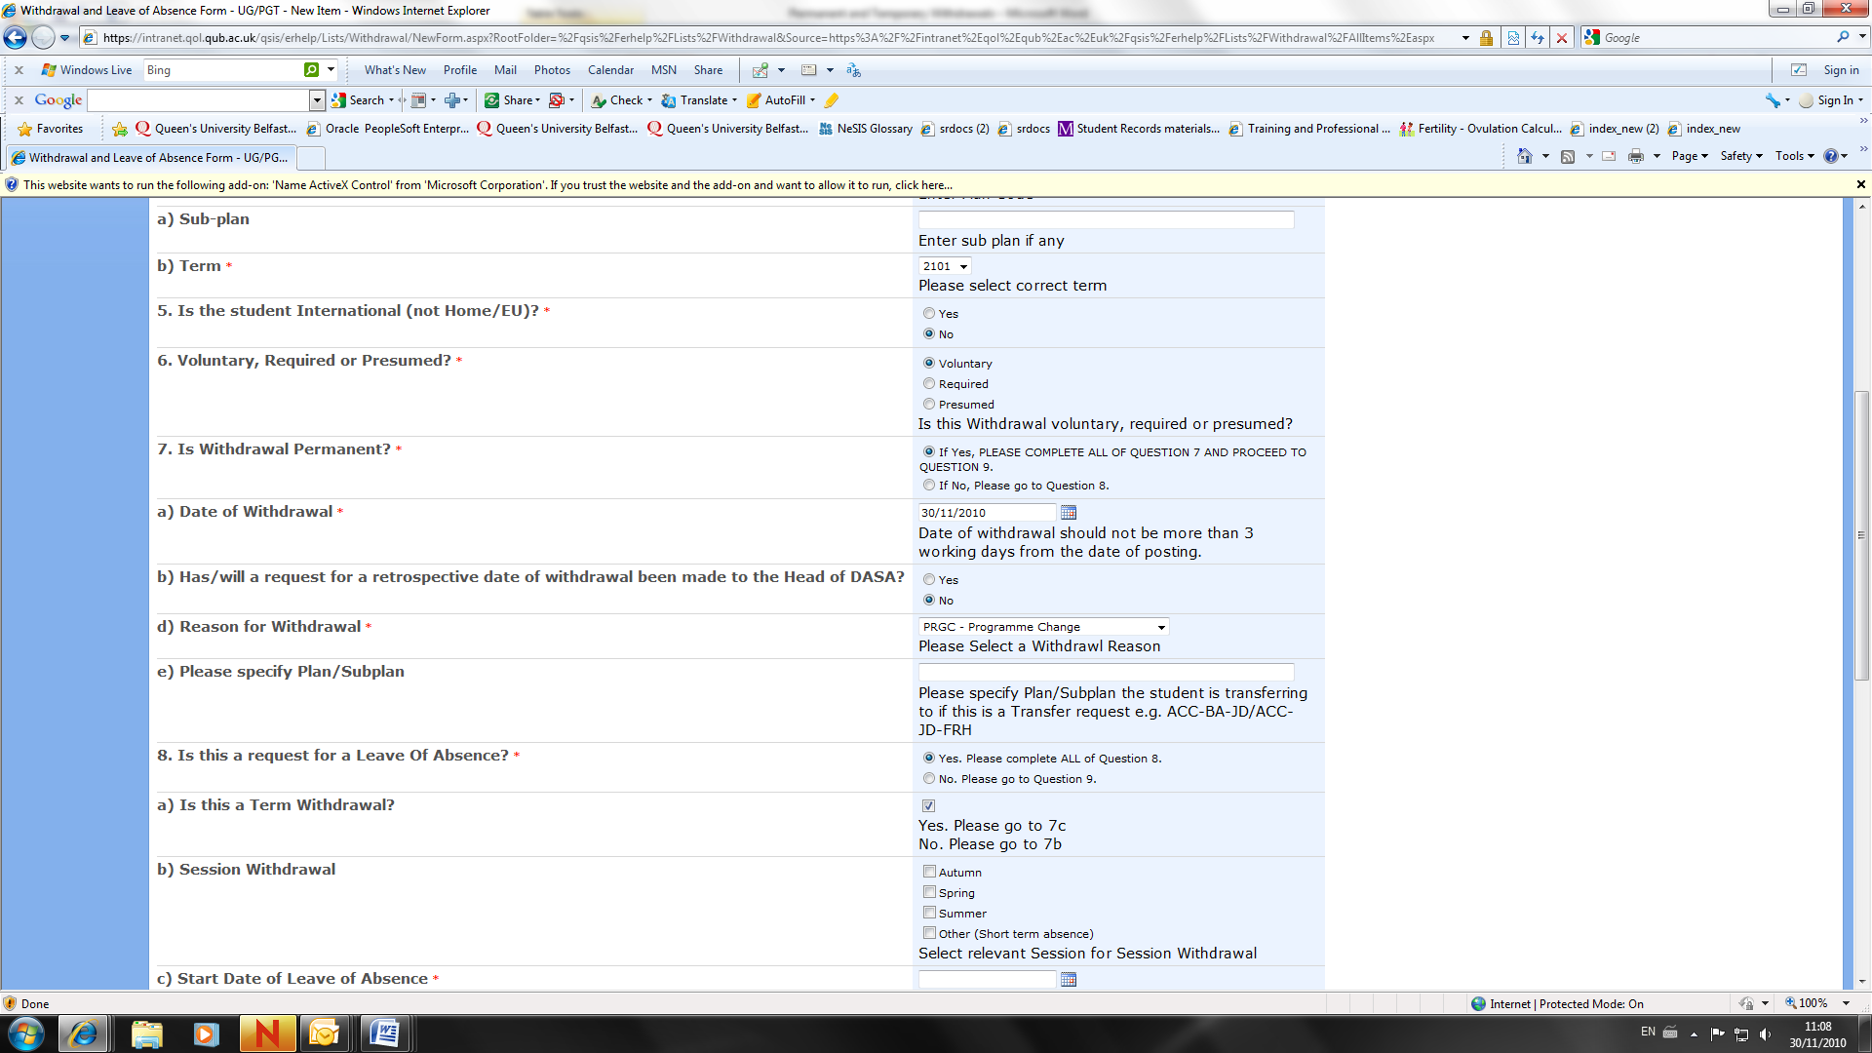  4. Exams [question 10 on the UG/PGT form]  If a Term or Session withdrawal is processed the student will be dropped from all enrolments and will not be registered for examinations. Should they wish to sit exams, please tick Yes and process a Leave of Absence.  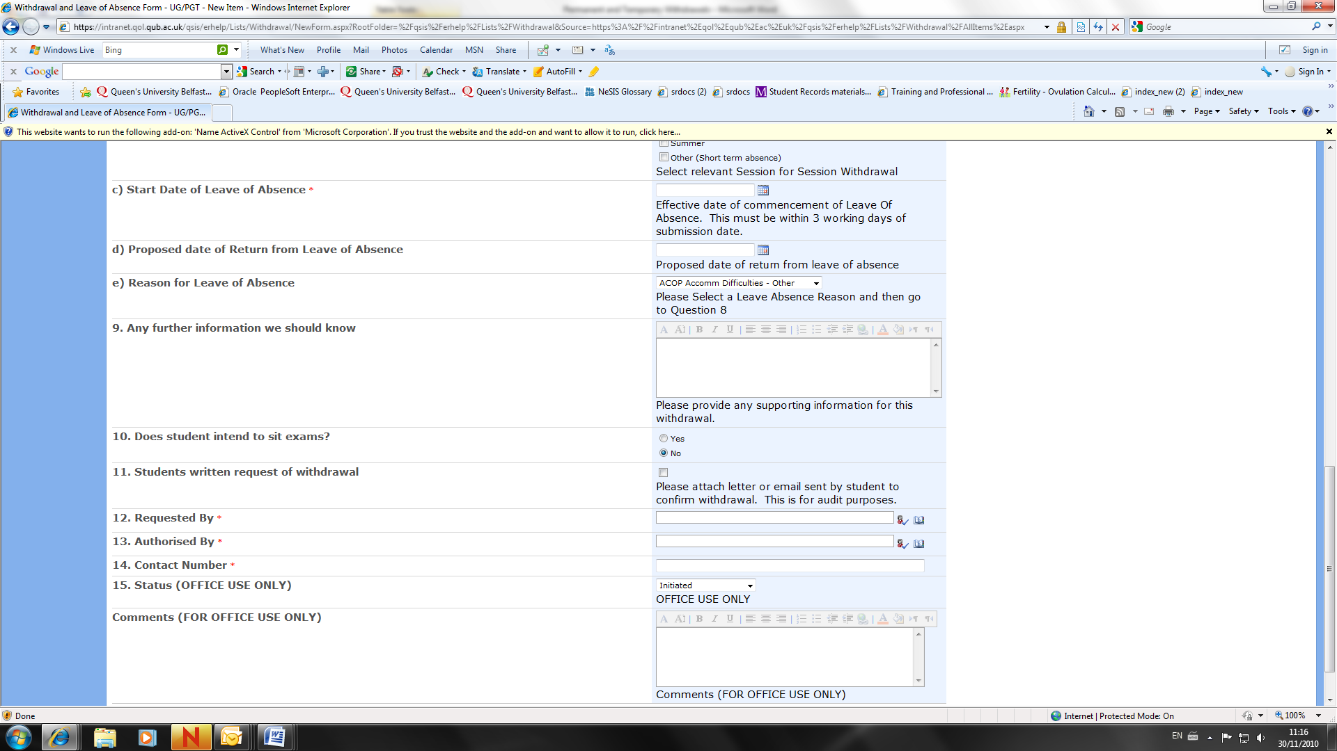  - WADM Program Change [question 7 on UG/PGT request form]  Under Reason for Withdrawal select Program Change and enter new Plan/Subplan details.  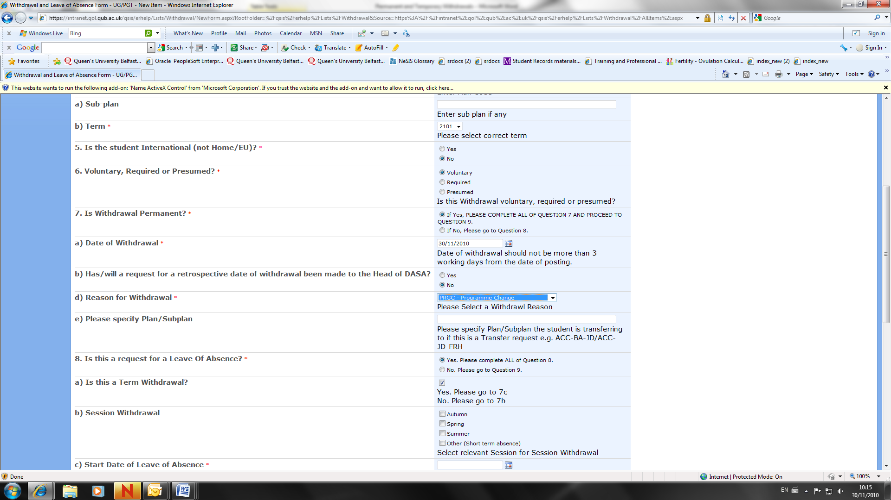

CONTACT INFORMATION:
Academic & Student Affairs
Tel: 02890 975003
Email: dasa@qub.ac.uk

Student Records
Tel: 02890 97 2727
Email: s.records@qub.ac.uk

International Student Support
Tel: 0289 097 3899
Email: iss@qub.ac.uk

