ESTATES DIRECTORATE

CAMPUS DEVELOPMENT: KEIR/ASHBY/LENNOXVALE
THE WEEK AHEAD, 14 December 2015

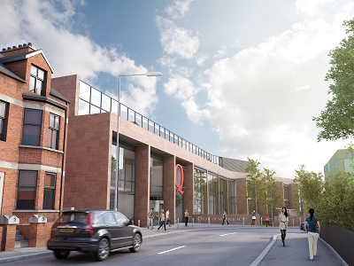
See below for information on what’s happening during the week beginning Monday 14 December.

Remodelling of the Bernard Crossland Building (BCB) to create 21st century facilities for Computer Science. Click here to view a fly-through video tour of how the new building will look.

New Biological Sciences building on the former Science Library site. Click here to view a time lapse video of the demolition of the Science Library.
These projects are part of an investment of £350m in buildings and facilities over the next ten years to support world-class research and education – for more information click here.

The Estates Directorate will do everything possible to manage the impact of the works and we hope that they do not cause you too much inconvenience. If you have any comments regarding noise, please contact us on ext. 1033 or email estates@qub.ac.uk.

Description of Works | Possible Impact
BCB (Completion September 2016)
Contractor deliveries to site | Site access is being manned by Contractor’s staff during working hours.
Roof construction | Some noise and vibration from manoeuvring machines and pneumatic tools and hammers.
Erection of external cladding
Installation of Mechanical and Electrical systems
New Biological Sciences Building (Completion Summer 2018)
Demolition of former Science Library | Pedestrian shortcut between Chlorine Gardens and Lennoxvale remains closed until completion of the project in summer 2018.  Parking restrictions in place on Lennoxvale.  Noise and vibration from demolition work (this is constantly monitored).  Any comments regarding noise, please contact us on ext. 1033 or email estates@qub.ac.uk.

