ESTATES DIRECTORATE
CAMPUS DEVELOPMENT: HEALTH SCIENCES CAMPUS
THE WEEK AHEAD, 14 December 2015
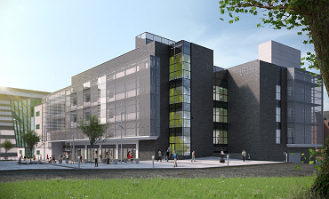
See below for information on what’s happening during the week beginning Monday 14 December in the:
Wellcome-Wolfson Building, Centre for Experimental Medicine
Health Sciences Building
The University is investing £350m in schemes to support world-class research and education across the campus over the next ten years – for more information click here.
The Estates Directorate will do everything possible to manage the impact of works and we hope that they do not cause you too much inconvenience. If you have any comments regarding noise, please contact us on ext.1033 or email estates@qub.ac.uk.

Description of Works | Possible Impact
Wellcome-Wolfson Building
Alterations to Levels 1, 2 and 3 tea points | Some limited noise from strip-out and use of hand tools.
Creation of additional nitrogen storage | Works limited to goods entrance. Deliveries not affected.
Health Sciences Building (Completion March 2016)
Refurbishment of areas on Level 3 | Noise from strip-out and refurbishment works

