Contents
Car Park Management System 2
Introduction 2
Car Park System Operation 3
Logging onto the System 5
Add A New Vehicle 7
Request a Permit 8
Creating a Visitor Permit 9
Creating an Annual Permit Request 13
Transfer of Permit to Another Car Owned by You 16
Cancel a Permit 18
Check Position on Waiting List 19
Permits issued from a Waiting List 20

Car Park Management System

Introduction

The previous car parking system has been replaced by a cloud-based solution which is now available to use. Although the process is relatively similar to the previous system there are a few elements that have changed and users should review this document before making any changes to their details. Please note that all vehicles either owned by the user or for visitor permits requested by the user are displayed against the user details.
The most significant change is the fact that permits are now associated with one vehicle only. This does not impact on the users ability to use a different vehicle (provided they are correctly registered on the system) but it does impact if a user decides to change a registered vehicle. If a user decides to delete their previous vehicle this could impact on their current permit. DO NOT delete a vehicle if it has a current annual permit associated with it. If you need to remove this vehicle and replace it with another, please ensure that you transfer the permit to the new vehicle before you delete the existing vehicle.

Car Park System Operation

When the user logs onto the system for the first time they are expected to change their password. This is a requirement because when the previous system was checked the majority of users had continued to use the default password which could have resulted in some data being compromised.
The process to change your password is relatively straightforward.
When you access the site, the following screen will be displayed.
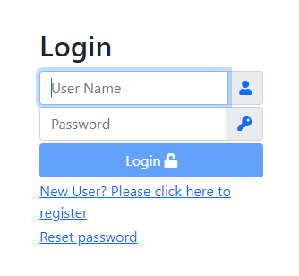
Press the 'Reset' password option and the following screen will be displayed.
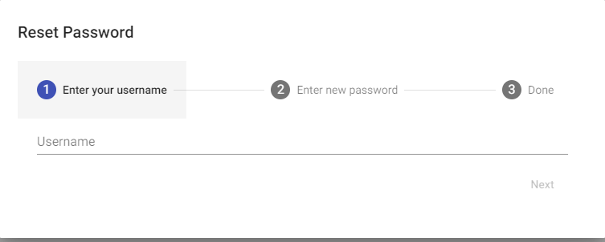
Enter your Username (usually your staff number) in the first section. Then press the 'next' option button.
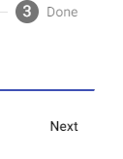
When this is completed, an email will be sent to your email address containing a verification code and the following screen will be displayed.

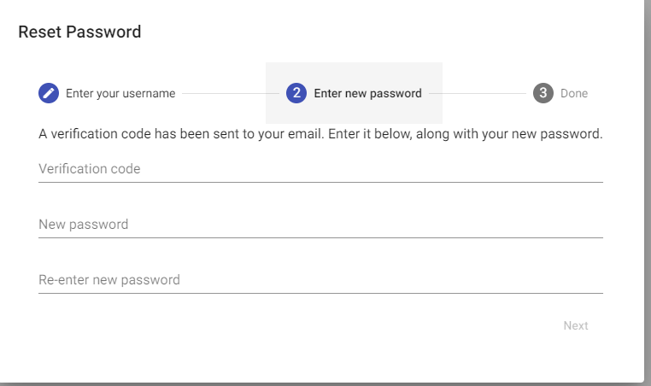
Enter the verification code then create a new password and re-enter this new password. When all the relevant fields have been completed press the 'next' button. Provided all the details entered are correct you will now be able to access the system using your username and the new password. This process can be re-used as required if the user forgets their password in the future.

Logging onto the System

The first screen a user will see is the login page. This will allow users already registered to login to their account with their username and password.
An unregistered user will be able to create a new account by pressing the ‘Register’ option and following the instructions on screen.
Once a registered user has logged in they will see the following screen.
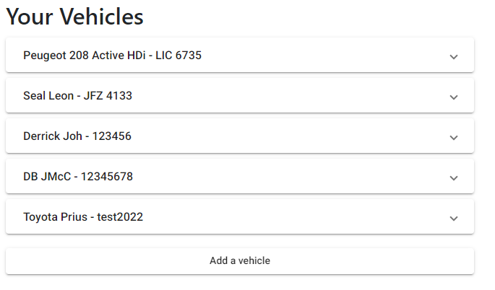
The list of vehicles on this screen will be the vehicles currently registered to the user and any vehicles that they have made a visitor request for, in respect of visitor parking.
Selecting the Peugeot 208 vehicle will display the following screen showing the visitor permits issued for this vehicle as visitor and annual permits. As can be seen only one Annual permit for the Ashby has been issued.

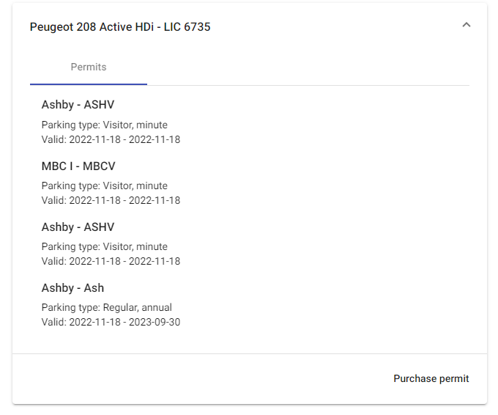
Permits can only be issued for vehicles which the user has registered on the system, therefore if a user wants to either add another vehicle for themselves or for a visitor they must add the new details before a permit request can be made. To do this the user must press the ‘Add Vehicle’ option.

Add A New Vehicle

The following screen will then appear, and the vehicle details can be added as required.

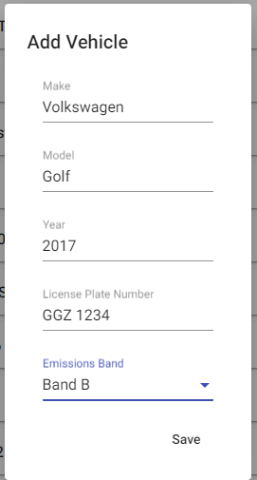
When the user saves this information, they are returned to their list of vehicles as shown previously.

Request a Permit

The user selects the appropriate vehicle.
Using the arrow at the right-hand side of the vehicle details the following screen will be displayed for the selected vehicle.
Choosing the ‘purchase permit’ option presents the user with a new screen where they can request a new annual permit, or a visitor permit for the selected vehicle.

Creating a Visitor Permit

In order to create a visitor permit the user must add the vehicle details for the person visiting. This is completed in the same manner as adding a new vehicle for the user. Once the vehicle details have been added to the system the user can request a visitor permit as shown below.
When the following screen appears press the drop-down arrow on the permit type.
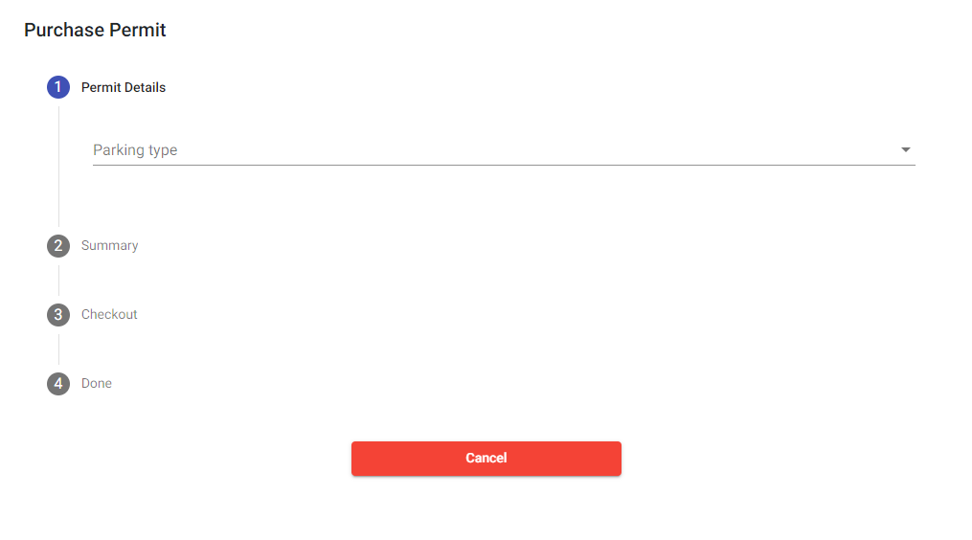
The following screen will now appear.
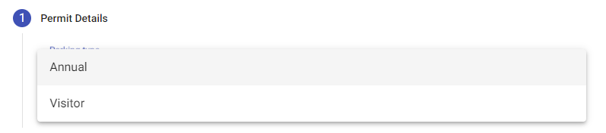
Select the visitor option as shown below to get a list of visitor car parks.
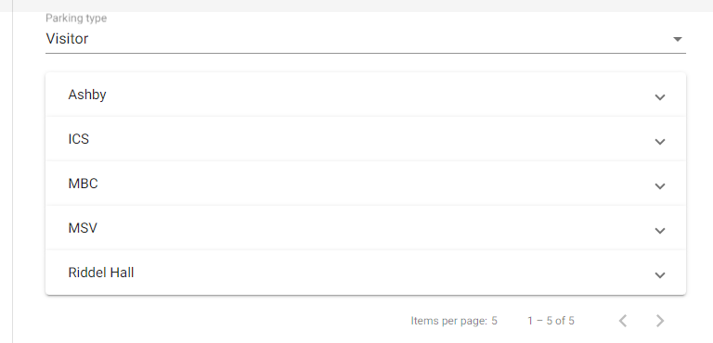
Select the appropriate car park using the down arrow at the right-hand side of the car park name.
Select the calendar by clicking on the date icon at the right had side of the text ‘Permit Start Date’.
Choose the date required.
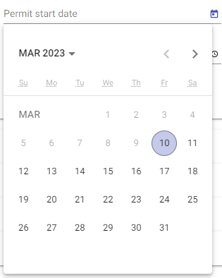
Select the start time for this permit by pressing on the clock icon at the side of the following screen.
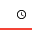
The current default is in 30 mins slots. If additional time is required press the +30 minutes option as required until the correct time is reached. If the time is extended beyond what is required, it can be reduced by pressing the -30 button until the correct time is displayed.

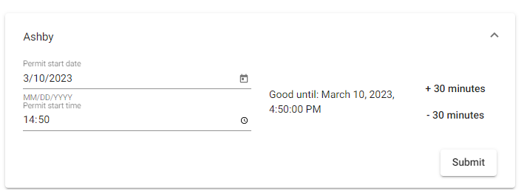
In the instance above the permit is valid between 2.50pm and 4.50pm on 10th Mar 2023.

When the user presses ‘submit’ the following screen will be displayed.

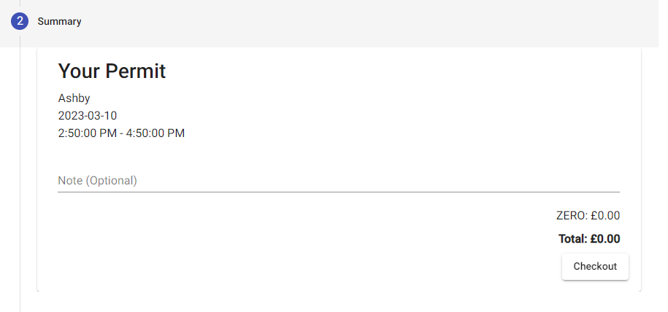
Press the 'Checkout' button and the following message will be displayed.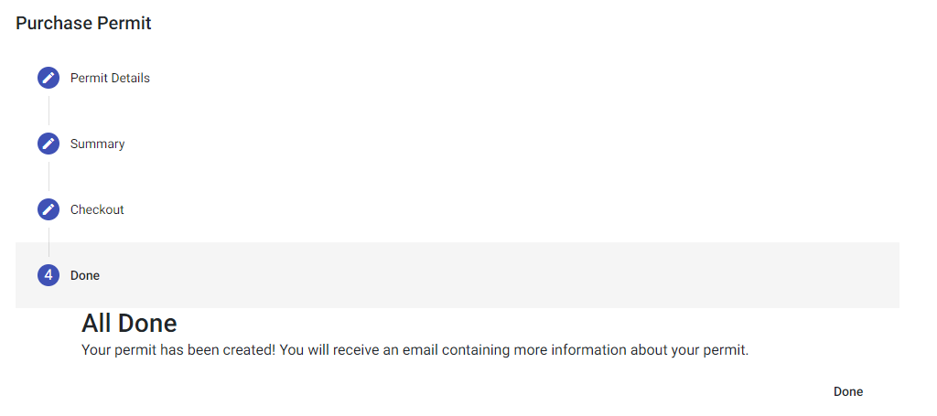
Press ‘Done’ to return to your list of vehicles.
At this point an email will be sent to you with details of the permit for the visitor, as shown below, which can be emailed to the visitor for display during their visit.

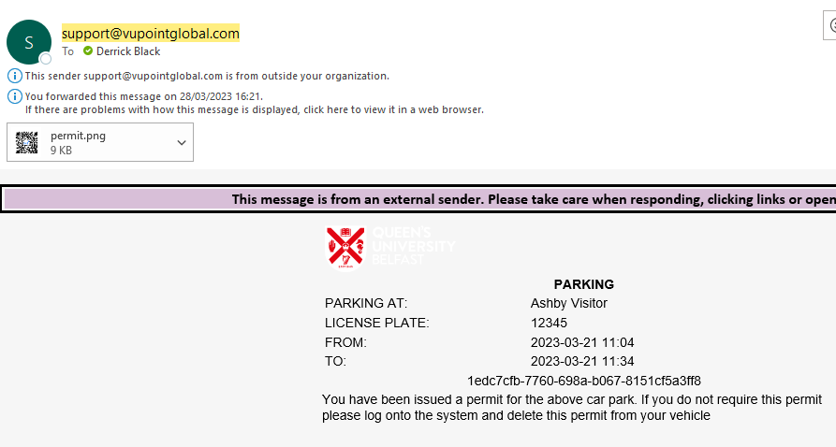

Please note that the visitor will have to print the QR code attached to this email and this print-out must be displayed on the relevant car while the vehicle is parked in one of the approved car park’s visitor spaces.

Creating an Annual Permit request.

Annual permits run from 1st November each year until the 31^{st of} October the following year. As a result, no matter what date you request the annual permit the end date will always be October of the car park year.
The process for an annual car park request is similar to that for a visitor permit with a few minor changes.
To request an annual permit, select the appropriate vehicle and press the ‘Purchase Permit’ button.
Select the ‘Annual’ option from the list of permit types
A list of annual car parks will be displayed. This list shows the first 5 records, but the remainder of the available car parks can be found by using the left and right arrow buttons to navigate to the next list of car parks.
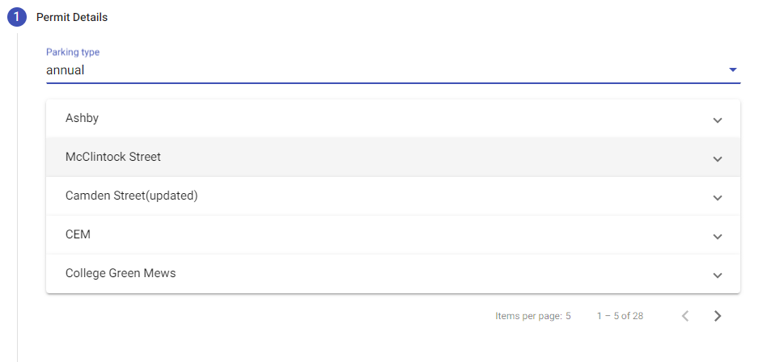
To expand this list the user can change the number of car parks displayed on each page or they can use the right and left arrow keys “<” “>” at the bottom of the page to move across the available car parks.

Select the car park you required.
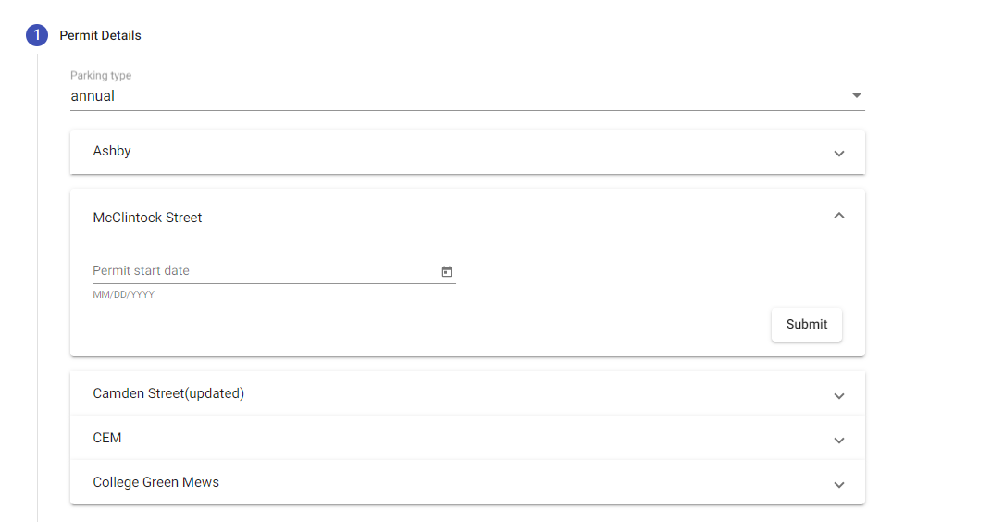

Select today’s date.
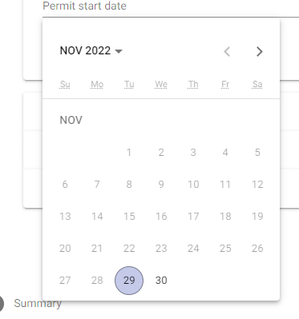
Then press the ‘submit’ button.
The cost of the permit based on the car selected is now displayed.
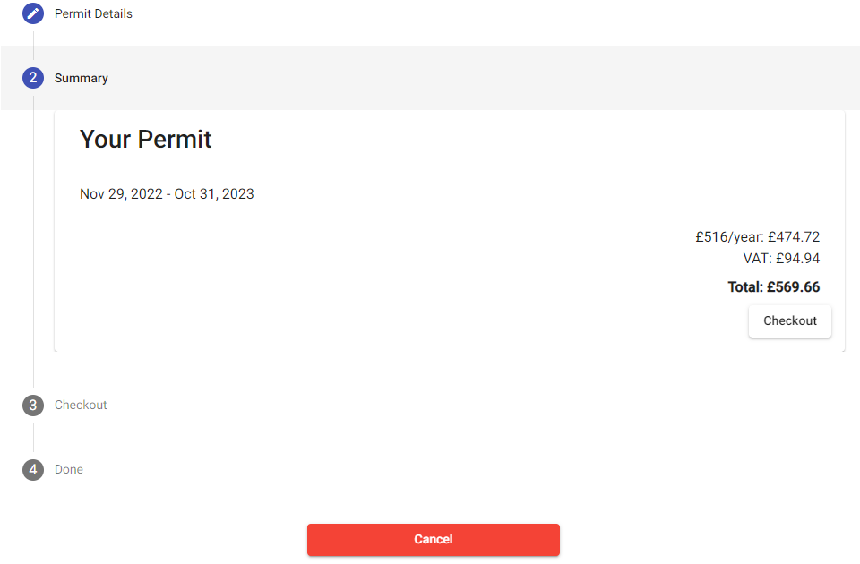

The user can either cancel this request or select the ‘Checkout’ option to send a request for a permit for this car park. Requests are sent to the administrator of the car parking system who can approve the request, if a space is available, or else it is placed on the current waiting list for the car park selected.

If the user selected the ‘checkout’ option, the following screen is displayed.

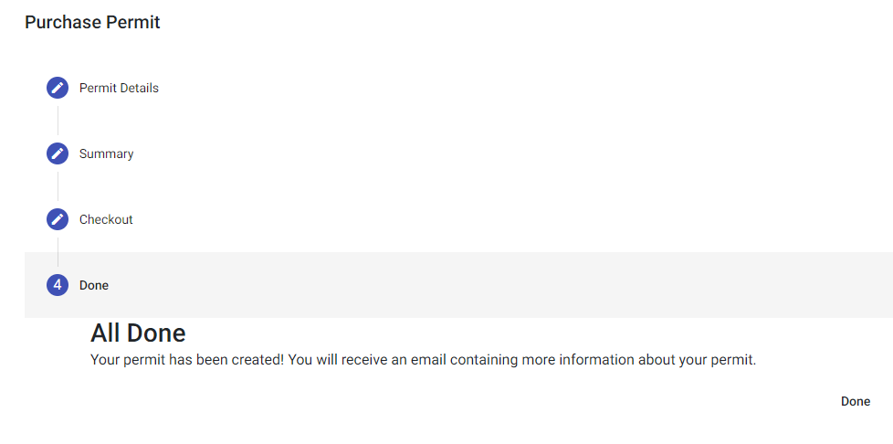
Press the ‘Done’ button to return to the list of your vehicles.

Transfer of Permit to Another Car Owned by You

It is possible for a user to transfer an annual permit from an existing vehicle to another vehicle if, for example, the user purchases a new car. The process of transferring the permit is described below. If, after the transfer has been completed, you require a reprint of your permit with the new vehicle details, please email parking@qub.ac.uk and a reprint will be provided.
Select the vehicle with the current permit from your list of vehicles.
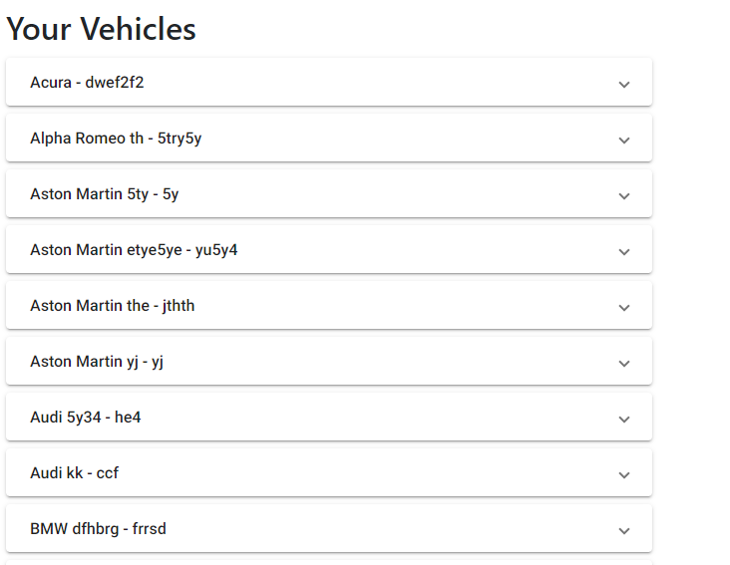
Press the down arrow on the right-hand side of the required vehicle.

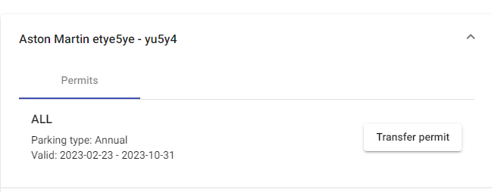
When you have selected the correct vehicle press the ‘Transfer Permit’ option. The following screen will be displayed,
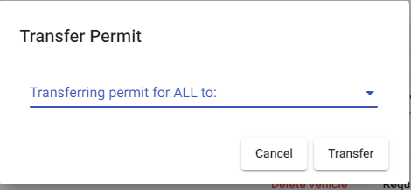
Note the term ALL in the text above does not me that all permits will be transferred but rather this is the code of the car park that you have your permit for. For example, it may say MNS or MB1 instead of the term ALL where MNS is for the Main Site Car Park and MB1 is the Medical Biology Centre main car park
Press the down arrow after the label “Transferring permit for ALL to:” to reveal a list of your current cars.
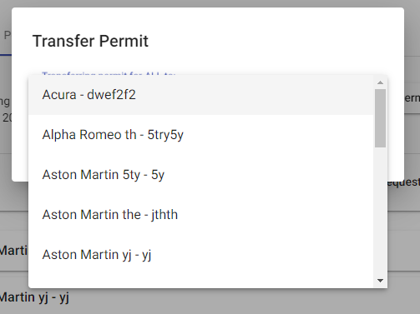
Select the car required. In the example below the Aston Martin has been selected.
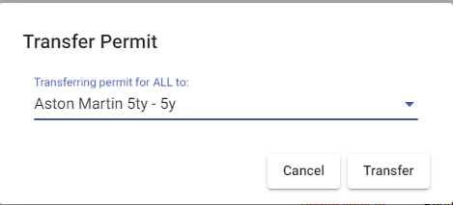
You can now either cancel the transfer, if you selected the wrong vehicle for example, or you can transfer the permit to this car by pressing the ‘Transfer’ option.

The permit has now been transferred to the required vehicle.

Cancel a Permit

A user can cancel a permit at any time using the ‘Cancel Permit’ option for that specific ‘Delete Permit’ option.

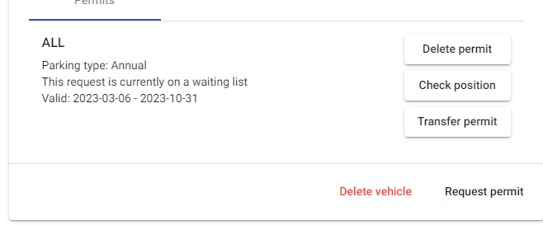
In the case shown above the request is awaiting approval on the waiting list for the ALL-Parks car parking space. The user can delete this request / permit by pressing the appropriate Delete Permit button. Please note if you have multiple permits, you must press the ‘Delete’ button associated with the permit you wish to delete.
When the user presses the ‘Delete Permit’ option they are asked to confirm if they want to continue the delete process.
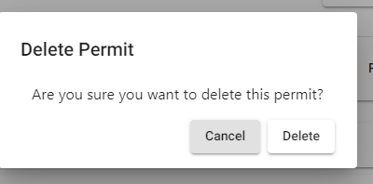
If the user wants to continue, press the ‘Delete’ option as shown otherwise press the cancel option.
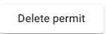

Check Position on Waiting List

A user can check their position on any particular car park waiting list by selecting their vehicle, opening the screen and then pressing the ‘Check Position’ option.

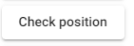
The following message will be displayed at the bottom of the screen.
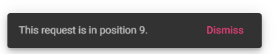
When the user is finished, they should press the ‘Dismiss’ option on this display.

Permits issued from a Waiting List

When a space becomes available in a car park the Administrator of the car park system will issue a permit to the user who is at the top of the list. This permit will be valid from the date of issue. Users will be informed by email that a permit has been issued to them in a specific car park. If the user decides that they do not want this permit it is their responsibility to log onto the system and delete the permit as described above. If the permit is required and is not deleted payment for the use of the car park will commence immediately.

