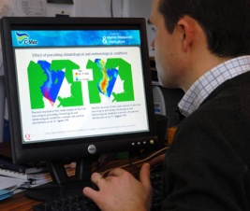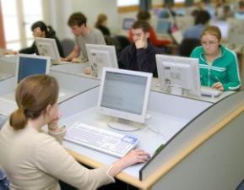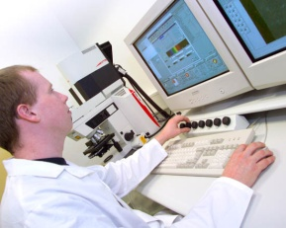

The hazards associated with Display Screen Equipment (DSE) are often underestimated. But poor ergonomic design, poor posture and insufficient rest breaks from DSE work can cause discomfort or on occasion lead to chronic disorders which can affect both home and work life.

The University recognises that the majority of staff will use DSE whilst at work and is committed to minimising the risks arising from DSE use. The University will provide suitable equipment, workstations, free eyesight tests and if required corrective glasses for DSE users.

Information on correct DSE use is provided at Staff Induction and at the General Safety Training Courses held throughout the year for Managers, Supervisors and Clerical Staff.
An on-line training course on correct DSE use is also provided through the link below.
Completing any of these courses will enable you to carry out your own DSE Self-Assessment to identify any problems. In addition your School/Department should also have its’ own DSE Assessor who will be able to help you.

The University Display Screen Equipment Policy sets the standard which all Schools / Departments and users of DSE are expected to follow. The following guidance notes provide information on how the requirements of the Policy can be met.

