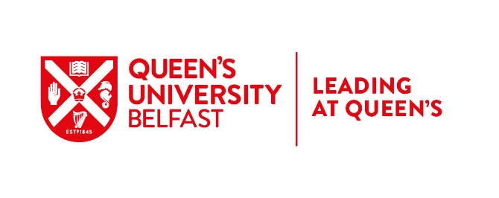
CONNECTED LEADERS 2 - LEADERSHIP DEVELOPMENT PROGRAMME

GUIDANCE NOTES AND APPLICATION FORM

- Programme Overview
One of the key commitments in the People and Culture Strategy, People First is to build the skills, confidence and capacity of our leadership community. To enable this, we launched the Leadership and Management Framework in April 2019 which clearly defines the responsibilities, skills and behaviours involved in being a leader at Queen’s. The Framework underpins and informs all of our leadership development activity across 5 key areas – Self Leadership, Vision Leadership, Collaborative Leadership, Providing Direction and Managing.
Our Connected Leaders 2 leadership development programme, aligned to our leadership and management framework, is designed to support participants to be effective in their current role and prepare for future challenges.
The programme uses a combination of six development days; peer support via Action Learning Sets, individual support via 1:1 Coaching (optional), and self-directed learning via pre-work, reflection and impact presentation, to explore the core leadership responsibilities and behaviours as indicated by the Queen's Leadership and Management Framework. See Appendix 1 below for key programme dates.
Recognising professional development, the programme offers an optional ILM Level 5 Award in Leadership and Management.
- Target Audience
Level 2 is aimed at leaders aligned to the corresponding level in our Leadership and Management framework - those staff who have leadership responsibility for a team(s) or a particular area of work or specialism that’s strategically important. Rather than concentrating on the grade of staff at each level, the Framework considers the reach of the work, and the scope of leadership responsibility and sphere of influence associated with the role. Staff at level 2 will have more leadership responsibility and their work might be more far reaching in terms of strategic impact, than staff at level 1. Sample roles include Managers reporting to a Head of Department, Senior Administrators, Professional Specialists such as Finance or HR Business Partners, Senior Technicians, Co and Principal Investigators and Module or Subject Leads.

3. Submitting an Application
3.1 Supporting Information
Before you apply, ensure that you read all Connected Leaders 2 information on our website and please ensure that you hold all dates in your diary at time of application.
3.2 Director/Head of School Endorsement
If you are considering applying, please arrange time to talk to your manager about your development goals and career aspirations, so they can fully support you. In addition, your Director or Head of School’s endorsement will be required on the application form.
In advance of meeting with your manager it is recommended that you take time to review Level 2 of the Leadership and Management Framework so that you can discuss with your manager, where you are on your leadership journey, your strengths, the areas where you need to develop, and how the programme will meet your development and career goals.
3.3 Application Close Date
Applications should be submitted to Organisational Development at stafflearning@qub.ac.uk by 5pm on Wednesday 20 January 2021.

Application for Connected Leaders Level 2 Leadership Development programme.

SECTION 1: ABOUT YOU
Surname:
First Name:
Staff No:
School/Directorate:
Email:
Job Title:

Section 2: Information to Support Your Application
Please detail briefly your leadership responsibilities in your current role. (as per point 2 in Guidance Notes)
Please detail briefly what you hope to achieve by participating in the Connected Leaders 2 programme at this particular point in your career.
Please detail the value and impact that your participation in the programme will bring to your school/directorate
Connected Leaders Level 2 offers an optional ILM level 5 Award in Leadership and Management. Please check the box if you wish to complete the programme with ILM accreditation. Note that opting for the ILM award requires the completion of 2 assignments.
I confirm that I am committed to attend and participate fully in all programme elements

Section 3: Director/Head of School Endorsement
Surname:
First Name:
Job Title:
Email:
Please outline briefly below why this is an appropriate development option for this applicant at this time.
I confirm that I have discussed with the applicant the commitment required for this programme and that participation in this programme is in alignment with their development needs. I am committed to supporting the applicant’s participation in all programme events

Applications should be submitted to your Organisational Development by 5pm on Wednesday 20 January 2021.

Appendix 1 – Programme Overview and Timetable

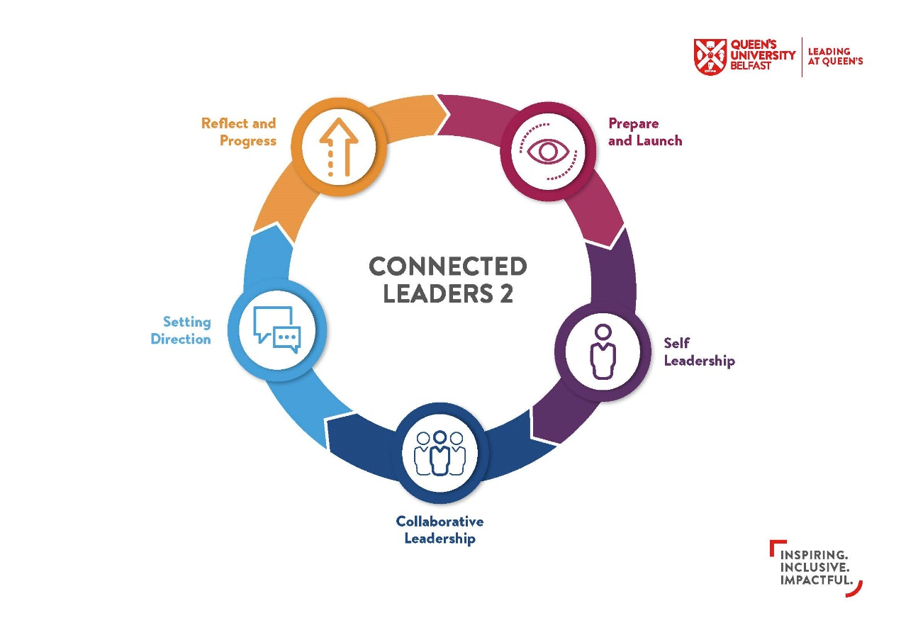
Event | Date
Module 1: Prepare and Launch - Introduction to Leadership at this level | Wednesday 3 March (1 day)
Module 2 - Who am I as a Leader? | Monday 29 & Tuesday 30 March (2 days)
Module 3 - Taking a Wide View | Tuesday 4 & Wednesday 5 May (2 days)
Module 4 - Supporting ourselves through Skills Building | Thursday 27 May (1 day)
'Impact' Event: Reflect and Progress | Friday 11 June (0.5 day)

