Equal Pay Audit
Queen's University Belfast is at the forefront of gender equality and a recognised leader in equality initiatives.
We currently hold two Gold, eight Silver and five Bronze Departmental Athena SWAN Awards and a Silver Institutional Award.
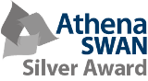
We support the principle of equal pay for work of equal value and recognise that we should operate a pay system that is free from bias and is based on merit.
Equal Pay Audit 2017
We carry out an Equal Pay Audit (“Audit”) every three years and our latest Audit is provided below.
The Audit looks at basic and total pay for staff within the University and we analyse this information by gender, disability, ethnicity and community background.
It is important to note that any pay gaps identified within the Audit do not necessarily mean that one group of staff is being paid less for carrying out the same work or work of equal value. These gaps can be attributed to a number of factors.
Below is a summary of the key findings from our latest Audit. Please note that basic pay is the pay reflected in an employee’s terms and conditions whereas total pay includes overtime and additional payments made in addition to someone’s basic pay.
Key findings
The Audit shows that we are continuing to make positive steps in dealing with equality in pay across its grades across the organisation.
Overall the Audit showed that the University is in line with trends in the higher education sector. The mean gap between male and female staff continued to decrease, both in relation to basic salary (down 3.6% from 2009) and in total salary (down 3.7% from 2009).
The gap is primarily attributable to the structure of our workforce, namely we have more males in senior positions and more females in lower grades.
It is positive that across all pay grades, except in the Professoriate, there are no significant pay gaps in the basic pay of employees. In analysing the potential reasons for the gap at Professorial grades we find the only gap is at Range 2 of that grade.
Our latest Equal Pay Audit shows that we have made a significant improvement in reducing the gender pay gap at Professoriate Range 2, over the last year or so. However, we appreciate that there is much more to do.
In Queen's, there are 3 categories of non-academic staff – clerical, operational and technical.
Our Audit shows that there is no significant gap in either clerical or technical roles. However, within operational roles, there is a pay gap between male and female staff only in grades 2, 3 and 4. These roles normally can access overtime and shift allowances and it is believed that a higher proportion of men are receiving such payments.
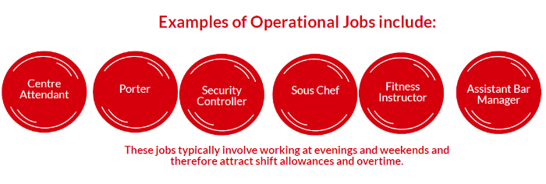
The Audit also reveals a positive gap in favour of our staff from ethnic minority backgrounds. There are also some gaps when looking at the pay of staff with disabilities or long term medical conditions. However, in some grades there are positive gaps in favour of staff with disabilities. The gaps might be explained by the low numbers of staff in some grades who have declared a disability or long term medical condition, in addition to varying lengths of service.
‌The Audit also reveals we have no overall pay gap in relation to the community background of our staff. Where gaps do exist in favour of one or other community this can be explained by the length of service in those post.
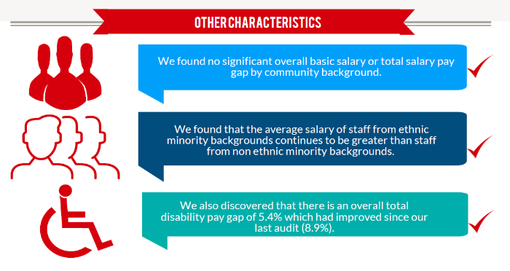
Taking Action
Dealing with pay gaps requires careful analysis and a commitment to engagement with our staff. We are committed to further reducing any gaps and ensuring equality in pay.
- To address the identified pay gaps, we have already established a dedicated project group and action plan to address the pay gap within the Professoriate (Range 2).
- To address the identified pay gaps, we will engage with our staff to develop ways to reduce the pay gaps in Operational Grades 2, 3 and 4. It is expected that this will include identifying any barriers for staff accessing overtime and shift allowances.
- We will continue to develop a wide range of positive, equality, diversity and inclusion initiatives (such as Athena SWAN) throughout the University to promote equality throughout the University.
- We will screen our policies procedures to identify and provide training to combat any unconscious bias.
- We will monitor and report our progress regularly to senior management within the University.
- We will publish the results of our next Equal Pay Audit in 3 years (2021).
- We will share this information with our key stakeholders including representatives from the Trade Unions and the Equality Commission for Northern Ireland.

Further information, including detailed analysis and other recommendations are contained within the QUB Equal Pay Audit

