Will Pitner
Visiting Researcher School of Chemistry and Chemical Engineering
I began working at Queens University Belfast as a postdoctoral researcher in the School of Chemistry and Chemical Engineering, in Queen’s University Ionic Liquid Laboratories (QUILL) Research Centre. When my fellowship ended in 2004 I took up a position with Merck in Darmstadt Germany as the manager of their ionic liquids research laboratory to support their new ionic liquids product line. Merck was a founding member of QUILL which is how the Merck representatives got to know my work and character.
I worked at Merck until 2010 when I suffered a serious illness showing the symptoms of neurological damage which include frequent seizures, peti mal seizures, serious partial paralysis, and vision loss. Rather than remain in Germany without support, I decided to return to my home in Mississippi in order to recuperate and continue physical rehabilitation under the care of a neurologist. When my condition stabilized, and my flat in Belfast had been renovated to accommodate my use of a wheelchair, I applied to the UK border agency and was granted the right to return as a resident of the UK.
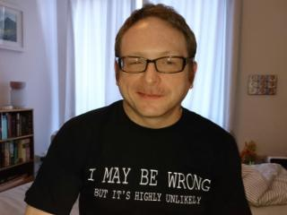
When I settled back in Belfast I contacted the QUB Academic Committee, requested and was granted a position as a visiting researcher in QUILL, with the topic of developing new standard reference electrodes for the use in green electro synthesis in ionic liquids. My part in this project is to review the scientific literature to determine what is the current state of the art for reference electrodes being used in ionic liquids. For my research, I have been given access to the QUB online electronic library resources including current research journals. Having online access means that I can work from home rather than arrange for frequent transport to the University. To further help me overcome difficulties in working on this project the University Disability Support Fund provided me with accessibility software to help me overcome my paralysis and sight loss so I could work with computers. The three pieces of technology provided are Dragon Naturally Speaking (Voice recognition software or speech to text.), JAWS (a screen reader that converts text to speech), and J-Say which acts as a bridge between the two. Essentially J-Say confirms that a spoken command has been actioned by providing audio feedback. It also echoes back dictated text to ensure what the user is dictating is accurate. Because this software was complex to install properly and learn how to use, I have been working closely with the Cedar Foundation both for proper installation as well as training in its use.
‌‌I am extremely grateful to QUILL, the Library, and the Equality and Diversity Unit, they all have been understanding and supportive of my need for assistance, they have provided the assistive technology and access that I need to work on this project.

