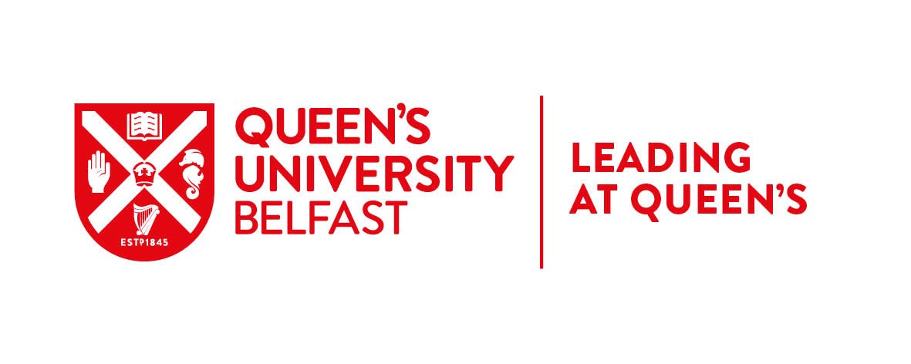
CONNECTED LEADERS 1 - LEADERSHIP DEVELOPMENT PROGRAMME

GUIDANCE NOTES AND APPLICATION FORM

- Programme Overview
One of the key commitments in the People and Culture Strategy, People First is to build the skills, confidence and capacity of our leadership community. To enable this, we launched the Leadership and Management Framework in April 2019 which clearly defines the responsibilities, skills and behaviours involved in being a leader at Queen’s. The Framework underpins and informs all of our leadership development activity across 5 key areas – Self Leadership, Vision Leadership, Collaborative Leadership, Providing Direction and Managing.
Connected Leaders 1, the first of our new leadership development programmes, is designed to support participants to be effective in their current role and prepare for future challenges.
The programme uses a combination of four development days; three peer coaching sessions, self-directed learning, and reflection, planning and action via a learning journal to explore the core leadership responsibilities and behaviours as indicated by the Queen's Leadership and Management Framework. See Appendix 1 below for key programme dates.
Recognising professional development, the programme offers an optional ILM Level 3 Award in Leadership and Management.
- Target Audience
Level 1 is aimed at leaders aligned to the corresponding level in our Leadership and Management framework - those leaders who would plan and supervise the work of others within their own area or staff who may not have line management responsibility but who may lead (projects or resources or a particular area of work) at this level. Staff may be new to the leader role and/or may have had little or no formal management training.
- Submitting an Application
3.1 Supporting Information
Before you apply ensure that you read all Connected Leaders 1 information on our website and please ensure that you hold all dates in your diary at time of application.

3.2 Manager Endorsement
If you are considering applying, please arrange time to talk to your manager about your development goals and career aspirations, your manager’s endorsement will be required on the application form.
In advance of meeting with your manager it is recommended that you take time to review Level 1 of the Leadership and Management Framework so that you can discuss with your manager, where you are on your leadership journey, your strengths, the areas where you need to develop, and how the programme will meet your development and career goals.
3.3 Application Close Date
Applications should be submitted to your Faculty/Director’s office by Friday 27 September and a copy sent to stafflearning@qub.ac.uk.

Application for Connected Leaders Level 1 Leadership Development programme.

SECTION 1: ABOUT YOU
Surname:
First Name:
Staff No:
School/Directorate:
Email:
Job Title:

Section 2: Information to Support Your Application
Please detail briefly your leadership responsibilities in your current role. (as per point 2 in Guidance Notes)
Please detail briefly the reason why you wish to participate in the Connected Leaders 1 programme at this particular point in your career.
Connected Leaders Level 1 offers an optional ILM level 3 Award in Leadership and Management. Please check the box if you wish to complete the programme with ILM accreditation. Note that opting for the ILM award requires the completion of 2 assignments.
I confirm that I am committed to attend and participate fully in all programme elements (events, modules, peer coaching sessions, completion of development plan and learning journal).

Section 3: Manager Endorsement
Surname:
First Name:
Job Title:
Email:
Please outline briefly below why this is an appropriate development option for this applicant at this time.
I confirm that I have discussed with the applicant the commitment required for this programme and that participation in this programme is in alignment with their development needs. I am committed to supporting the applicant’s participation in all programme events

Applications should be submitted to your Faculty Office/Director’s Office by Friday 27 September 2019.

Appendix 1 – Programme Overview and Timetable
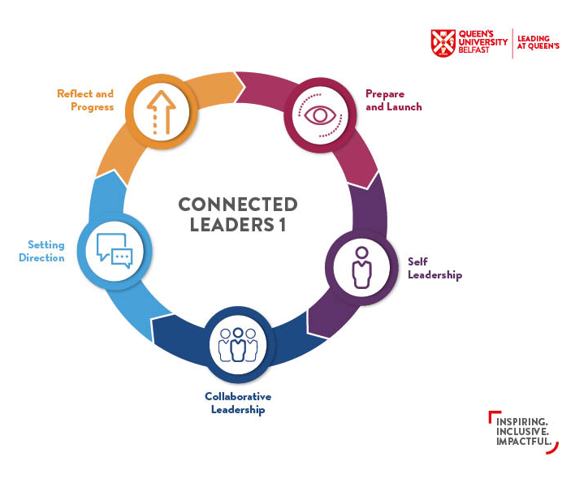
Event | Date
Prepare and Launch | Friday 15 November 2019 (AM)
Module 1 - Self- Leadership | Wednesday 4 December 2019 (Full day)
Module 2 - Collaborative Leadership | Tuesday 28 January 2020 (Full Day)
Module 3 - Setting Direction | Wednesday 4 March 2020 (Full Day)
Module 4 - Reflect and Progress | Thursday 28 May 2020 (AM)
Peer Coaching Session 1 | Wednesday 15 January 2020 (AM) OR  Thursday 16 January 2020 (AM)
Peer Coaching Session 2 | Monday 10 February 2020 (AM) OR  Wednesday 12 February 2020 (AM)
Peer Coaching Session 3 | Wednesday 1 April 2020 (AM) OR  Thursday 2 April 2020 (AM) OR  Friday 3 April 2020 (AM)

Three half-day Peer Coaching sessions will be an integral part of the programme. Delegates will be allocated to a group for peer coaching and the specific dates will be communicated to successful applicants as soon as possible after they have been selected.

