Connect Task Portal: Online User Guide

Objective

This User Guide is designed to provide information to managers and staff on how to use the online Connect Task Portal.

Purpose of the Portal

This Connect Task Portal has been created for the dual purposes of supporting managers with specific tasks during the COVID-19 crisis and enabling staff members to make best use of their time, skills and knowledge in contributing to university work. It also provides staff with the opportunity to experience and develop in other areas beyond their immediate area of work.

- How to Login to the Task Portal

1.1 To access to the Task Portal, log on to Queen’s Online with your username and password.

The Web Address for Queen’s Online is https://home.qol.qub.ac.uk/default.aspx

The Task Portal can be found under the Administration section on Queen’s Online.

The screenshot below shows where the Administration section and Task Portal can be located on Queen’s Online.

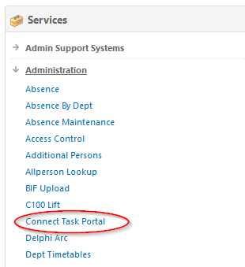

1.2 Click on the Task Portal tab which will direct you to the Portal Interface. The Portal has three sections for Administrators, Managers and Staff.

- The top section is for Administrators who can view all tasks on the Portal.
- The second section is for Managers who can create and view tasks.
- The third section is for Staff who can view available tasks on the Portal.

The screenshot below shows the Task Portal interface.
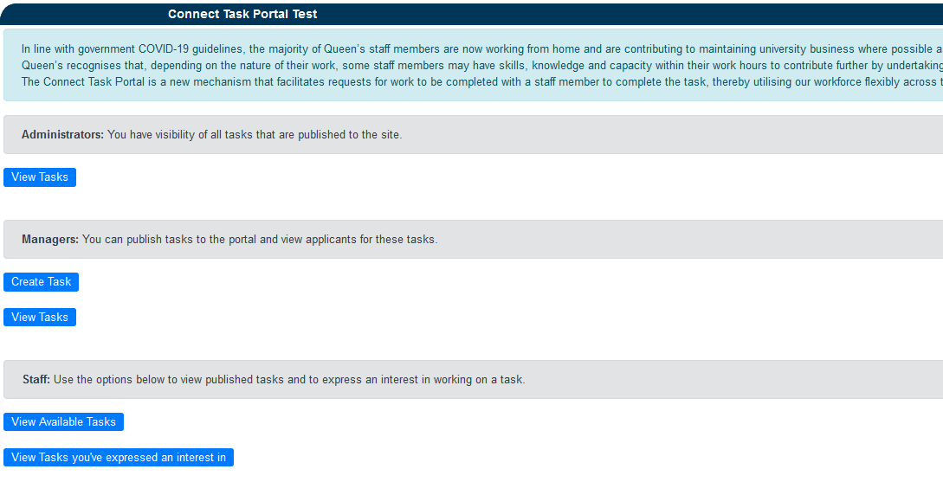

- Administrators

This portal has been established to enable managers in business areas to publish tasks that they are having difficulty completing in the current environment. Administrators have visibility of all tasks that are being published to the site.

(a) Functions

View all available tasks
View applicants for tasks
View numbers who have withdrawn from tasks
View Tasks
2.1 If you are an Administrator and want to view all tasks that have been registered on the Portal, you can access this information by clicking on the blue View Tasks button.

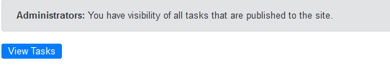

2.2 Click on the View Tasks button. By clicking on the View Tasks button, you will be directed to an interface where you can view information on all of the tasks, including status, start and end date of the duties, including the number of applicants and the numbers of applicants that have withdrawn on the interface.

The screenshot below demonstrates what the interface looks like.

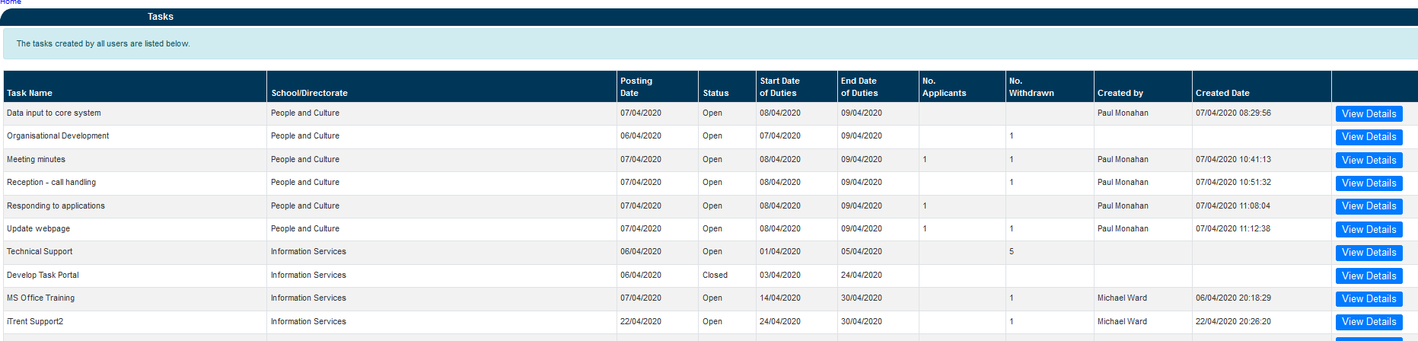

2.3 To view the details on a post, click the blue View Details button.

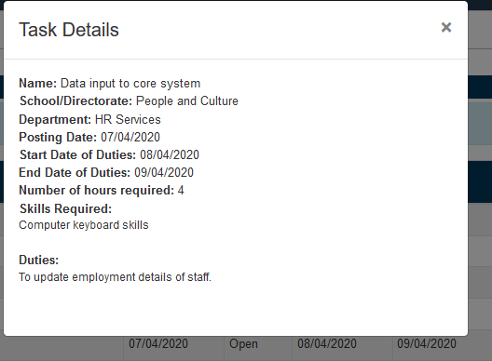

You will be able to view a summary of details on the task, including name, location, start and end date, number of hours and skills required and duties.

Staff

This portal is to help match staff who currently have some capacity in their working day with short term task requirements, managers will deal with expressions of interests in the order they are received, and remove the task when a suitable match has been made.

(a) Functions

(i) View available tasks
(ii) Express interest
(iii) Withdraw interest

3.1 If you are a member of staff, you can view available tasks on the Portal by clicking on the blue View Available Tasks button.

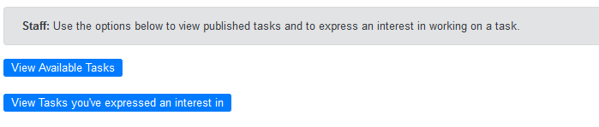

3.2 When you click on the View Available Tasks button, you will be directed to the next screen where you can find a list of available tasks and the school/directorate in which they are located. To get further information on the each of the tasks, click on the corresponding blue View Details button.

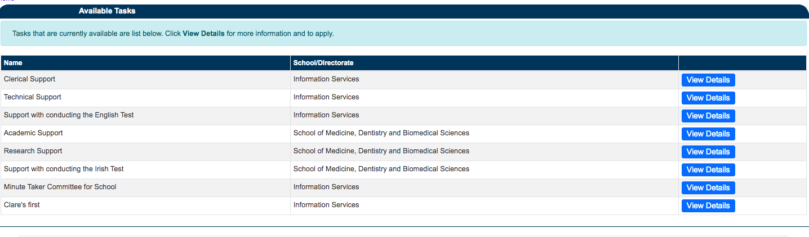

By clicking on the View Details button, you will be able to view further details including the type of task, location, start and end date of duties, the number of hours and skills required to complete the task, as well as a summary of duties. The screenshot below provides an example of the information you will be able to access.

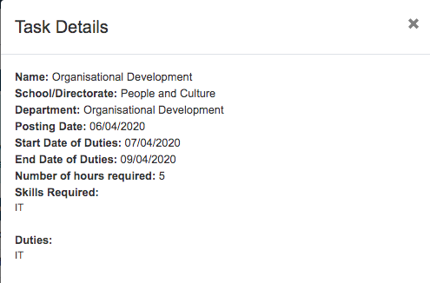

3.3 To apply for a task, you must complete a short statement and tick the box to confirm that you have discussed this with your line manager before you can express an interest in the task.

To submit your expression have click on the green Express Interest button.

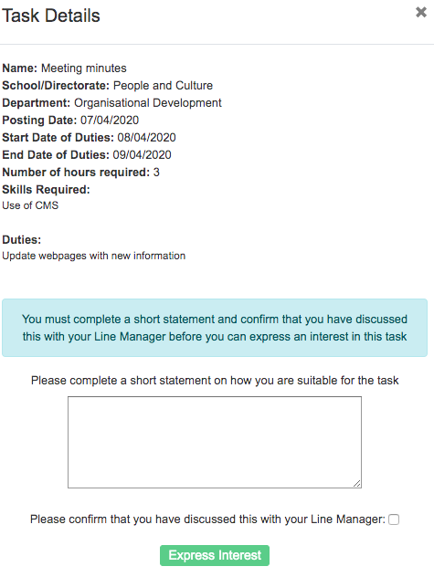
3.4 You may have expressed interest in a task but now no longer have the capacity to undertake the task. To withdraw your interest in a task, click on the red Withdraw Interest button

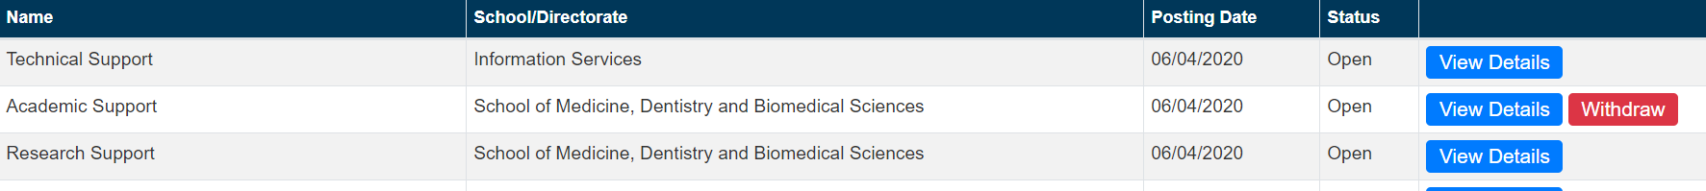

3.5 The portal has a function that enables you to view tasks that you have expressed an interest in. To view, click on the blue View Tasks you’ve expressed an interest in in button.

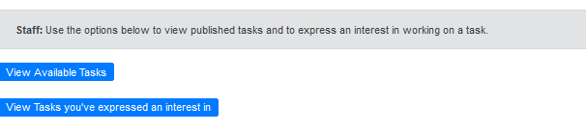
Managers

Managers use the Task portal to highlight workplace tasks that they are having difficulty completing in the current environment. As a manager you will add tasks to the portal, providing details of the task including skills required and the expected duration. These tasks will then be viewed by Queen’s staff who can express an interest in completing specific tasks.

In addition, managers may have team member(s) with some capacity, they can view the tasks in the portal as per staff, see section 3.2, and discuss opportunities with their team members, encouraging them to express interest as appropriate.

How to create a task

4.1 Go to the Managers section of the portal.

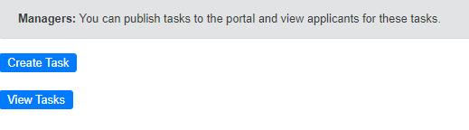

Click on Create Task and you will see the screen below. Insert the details of your specific task.

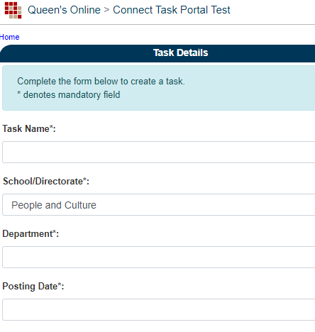

4.2 You then outline the specific duties and the skills required to successfully complete the task. Also, you are asked to give details of the start and required completion dates, with the expected number of hours.

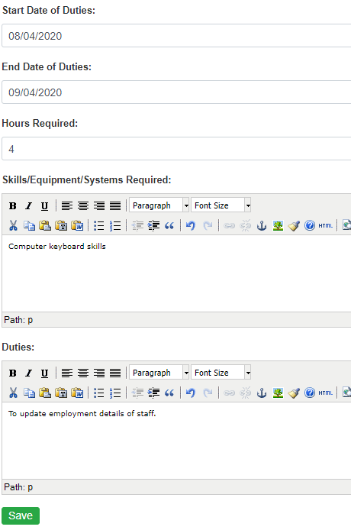

4.3 Confirm details and click on Save and you will see confirmation that task has been saved.

4.4 Return to the homepage by clicking on Connect Task Portal or the back key.

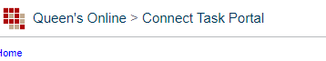

4.5 On the Managers section click on View Tasks and you will see a list of the tasks you have added.

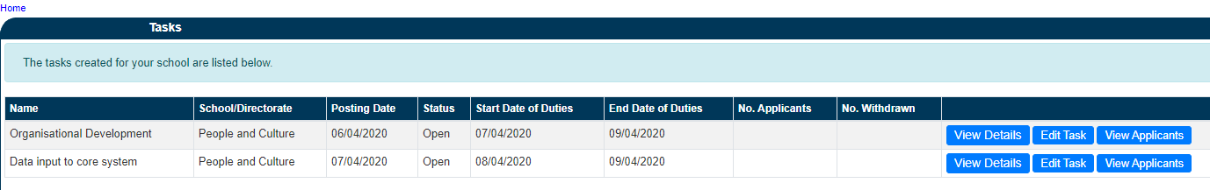

4.6 Selecting View Details will show the information you have input. If you need to amend these details click on Edit Task. When staff have applied for a specific task you can view there details by selecting View Applicants.

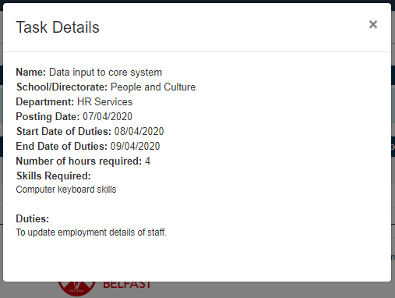

5. Other Resources

Seconding and Volunteering Guidance
Guidance for Managers and Staff

