Win11 Mapping Q:\ to StaffDFS with Window Explorer

If the Q drive is mapped any other way than displayed below, please follow these instructions to remap on Windows 11 Operating System.



Right click This PC and click Disconnect
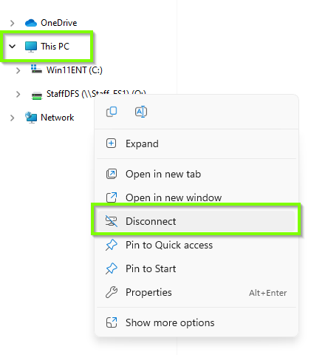

Then right click This PC and click Map network drive…

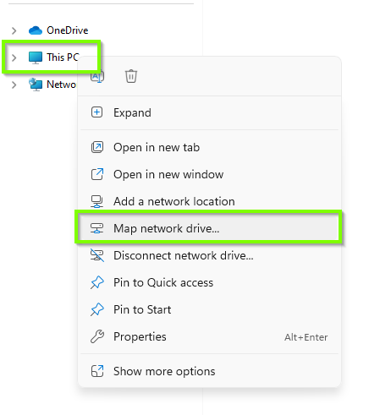

Select the Q: from the drop down for the Drive:

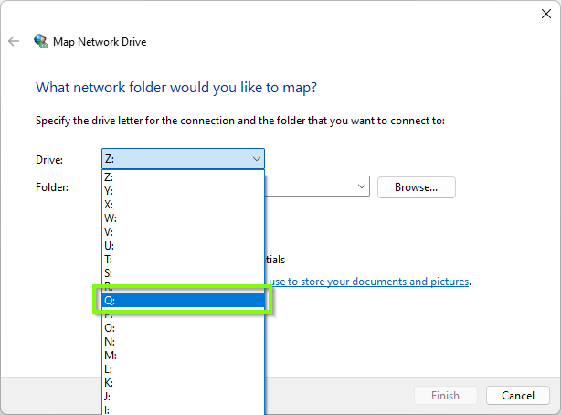

Enter the folder path as follows and click Finish:

\\ads.qub.ac.uk\StaffDFS\

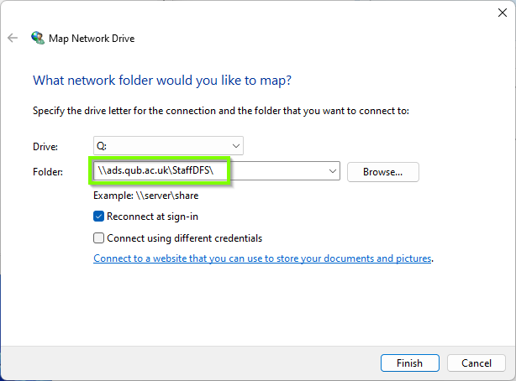
Your Q:\ drive mapping should now appear as follows:

