Special Collections & Archives has 3 rooms available for filming and photography at The McClay Library (Reading Room, Seminar Room and CS Lewis Room). To make a preliminary enquiry please email Special Collections & Archives specialcollections@qub.ac.uk or complete the Filming Enquiry Form
For news or unusual filming requests please contact Library Office directly library@qub.ac.uk
Special Collections Reading Room, floor 1.
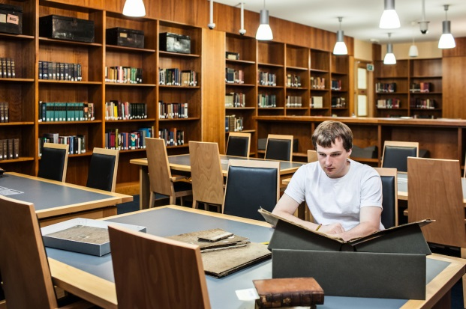

CS Lewis Reading Room, floor 1
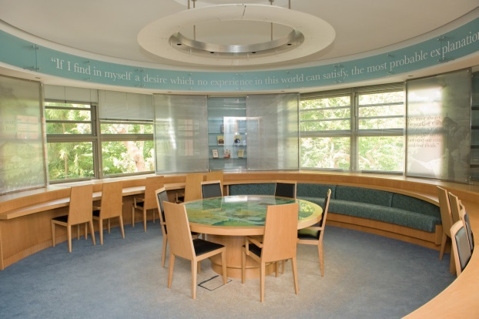
Primary source materials at Special Collections & Archives
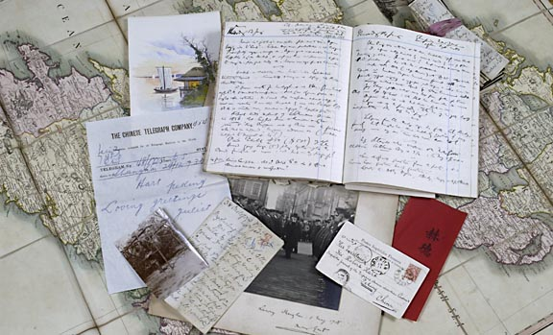

A preliminary meeting with Special Collections & Archives to determine the suitability of the room(s) is required. Please contact specialcollections@qub.ac.uk for an appointment.
All bookings are subject to compliance with Terms and Conditions.

Charges

1. Special Collections & Archives, McClay Library charges a site location fee of £300.00 + VAT at 20% for up to three hours only (morning or afternoon), with a charge for running over time (per hour or part thereof) £50.00 + VAT at 20%; in excess of 4 hours incurs a daily rate (09.00-17.00) of £600.00 + VAT at 20% This fee addresses
(i) the reproduction rights set out in (2) below (including preparation and licence of 4 x high resolution still shots, rates for additional stills to be agreed)
(ii) additional staff costs
(iii) support from Special Collections & Archives, The McClay Library
2. Reproduction rights included within Location Fee include: 1 broadcast or retail medium; 2 transmissions; 10 days catch-up service; 2 years and single country. Reproduction rights required above and beyond these rights should be outlined in the detailed enquiry form and are subject to additional fees to be negotiated with the Library. Please speak with Special Collections & Archives about this for further information.
Please note that items to be filmed may require rights clearance, this is not the responsibility of Queen’s University Library staff.
3. The rate for filming will apply from the time you arrive at The McClay Library to the time you leave the premises. Only in exceptional circumstances will we negotiate an hourly rate different to the standard rate.
4. Cancellation less than 48 hours before filming is due to commence will be liable for an administration fee of 50% of the total fee agreed.
5. Filming can only take place in The McClay Library during hours agreed in advance, and not before 09.00 or after 17.00; rooms are subject to availability.

How to apply for permission to film and record at Special Collections & Archives, McClay Library

1. Requests for filming must be made in writing, a Filming Enquiry Form is available for your convenience (available online at link), a completed form should be emailed or sent to:
Special Collections & Archives, McClay Library, Queen’s University Belfast, 10 College Park East, BELFAST BT7 1LP
Email: specialcollections@qub.ac.uk

2. Requests must be made at least 5 working days before you wish to film. This allows Library staff time to check the condition and availability of rooms, the collection item(s), curator(s) and ensure they will be available on the day.

3. The following information must be included with your request:
- Reasons for requesting access to film in The McClay Library - as a location, an interview setting, its collections, etc
- A list of the Special Collections & Archives staff you wish to interview, and/or the external experts or presenters you wish to bring to the Library
- A list of the Special Collections & Archives Library locations where you wish to film
- The total number of people in your film crew (including presenters and interviewees)
- The filming date(s) you propose. (Please also provide alternative dates, as your chosen date may not be available)
- Anticipated arrival and filming times, including set up and wrap time
- Title and location references of collection items you wish to film*

Please note: We do not provide free research support. It is your responsibility to research and provide location references for the collection items you require. Special Collections & Archives staff will be pleased to discuss collection materials in advance.
*Location references for books and journals can be found in the Library Catalogue which can be accessed online at: www.qub.ac.uk/lib
Manuscript listings are available online: https://www.qub.ac.uk/directorates/InformationServices/TheLibrary/SpecialCollections/Manuscripts/

4. Items must be ordered at least 5 working days in advance via Special Collections & Archives.
No additional documents can be ordered or provided on the day of filming.

Administrative Process
Once we have approved your request to film, we will inform you. You must then complete and return the Permission to Film Request Form and provide the following paperwork:
- An Application to Undertake Work will be required for any project which involves potentially hazardous lighting, construction, or other high risk production elements
- A risk assessment (specific to location)
- A copy of your insurance policies providing evidence of Employers Liability insurance £10m in aggregate and Public and Products Liability insurance £5m each occurrence
- A list of equipment that you will be bringing onto the premises, including all lighting and particularly any electrical equipment that needs to be plugged into the power supply. This equipment should be PAT tested and certified safe to use
- A list of all crew members (including presenters and interviewees) attending the shoot so that we can issue Library Passes. Crew members not listed cannot be issued with a pass on the day, and will not be allowed on site. You must advise the Special Collections & Archives of any last minute changes as soon as possible
- A list of vehicles (registration number, make, type, colour) which require entry into the University grounds, for parking and security clearance. Crews must vacate the premises before 21.00 for evening shoots.
Parking Permits must be requested in advance and cannot be guaranteed, parking is subject to availability
Please Note: If your equipment cannot be carried and you require flat route access, please let us know in advance.
2. Additional information may be requested, depending on the nature of the shoot. If it is required, it will be brought to your attention at an early stage of your application.
3. When the Permission to Film Request Form for The McClay Library is approved, we will issue a Location Agreement. This agreement will incorporate the terms and conditions that apply to filming at Special Collections & Archives, The McClay Library. Filming can only commence once the Location Agreement has been agreed and signed by all parties.

Please Note: Special Collections & Archives Reading Room operates under CCTV surveillance, access to Special Collections materials and the Reading Room is under the usual terms and conditions, details of which are available online
http://www.qub.ac.uk/directorates/InformationServices/VisitingSpecialCollections/ReadingRoom/

FILMING AND PHOTOGRAPHY IN THE LIBRARY– TERMS AND CONDITIONS

All bookings are subject to compliance with these terms and conditions.
1. Filming / photography is restricted to Monday-Friday 09.00- 17.00, it must be supervised by Library staff
2. No disturbance will be permitted during the examination period, including the weeks leading up to examinations
3. Any movement of stock, furniture or equipment and details of the filming / recording / photography of books and journals will be agreed in a preliminary communications with Special Collections & Archives staff
4. Bookings must be confirmed at least 5 working days in advance. Cancellations or postponement of filming / recording / photography without a minimum of 48 hour notice will incur a penalty charge of 50% of the charges
5. Full disclosure of the intended purpose of filming / photography must be submitted in writing prior to the agreed schedule. Special Collections & Archives, The McClay Library reserves the right to refuse permission to individuals and/or organisations if deemed prejudicial to the interests of the University
6. Special Collections & Archives requires individuals or production companies to organise indemnity cover for personal injury or damage to the property arising from filming / photography
7. Food and drinks are strictly forbidden in the Special Collections & Archives Reading Room
8. Payment of the charges in full must be settled within one month of invoicing
9. Images of the Library must be credited ‘By kind permission of Queen’s University Belfast’

Charges for filming / recording / photography in the Library

- Up to 3 hours (morning or afternoon) £300.00 + VAT at 20%
- Charge for running over time (per hour or part thereof) £50.00 + VAT at 20%
- In excess of 4 hours incurs a daily rate (09.00-17.00) £600.00 + VAT at 20%

Charges for taking photographs in the Library for a period of up to 3 hours

- For commercial use £400 + VAT at 20%
- Charge for running overtime (per hour or part thereof) £50 + VAT at 20%
- In excess of 4 hours, charges to be discussed with Library staff

