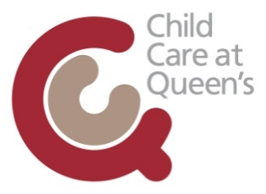

Comments and Complaints

Queen’s University Belfast Childcare Services welcome any comments parents may have on any aspects of the provision for the children in their care. Comments help the Management Team and Staff and ensure the views and opinions of parents are considered in the development of services and are acted upon when appropriate.
If a parent/carer has a comment/complaint regarding the provision, attitude of staff or quality of care their child receives, they should bring it to the attention of the Management Team who will endeavour to resolve the issue. If the parent/carer does not receive a satisfactory outcome or if the problem re-occurs, the parent/carer should put the complaint in writing. The Management Team will take action to address the issue and the parent/career will be informed of the outcome.
If the parent/carer feels unhappy with the outcome and feels the issue should be taken further, they should contact the registering Social Worker:
Andrea Annett, Tel: 028 95 042811

