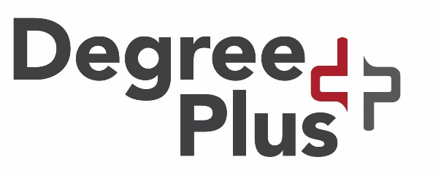
Route B Application Form

Question 1: Your Details, Degree Plus Activity and Evidence
Name: | Student Number:
Queen’s Email Address: | Application Date:

Question 2: Which Route B Activities did you undertake? 2 (min) to 3 (max) required for Route B
Activity | Evidence* Attached
1.

2.

3.

*See Application checklist on the next page for examples of acceptable evidence.

Question 3 (750-1000 words):
With Reference to 2 of your Route B activities, and using the STAR approach, reflect on:
- at least 4 of the 12 Degree Plus Skills that you utilised and developed across both activities.
- You should also reflect on 1 other skill that you plan to develop further to enhance your employability.
Note: The 12 Degree Plus Skills and the STAR approach to reflecting on developed skills are shown at the end of this application form.

Application Portfolio Checklist: Please ensure that you have included all 3 of the following:

- Completed Application Form
- Evidence for each Route B activity. Evidence will not be returned; examples include:
- A signed and dated letter on headed paper from a person in a position of responsibility indicating duration of period of work or activity (such a committee or voluntary work).
- A reference or a copy of payslip from a part-time job. Please note that any sensitive data e.g. National Insurance Number, or monies received is to be blanked out by candidate.
- Relevant scanned documents, screenshots and/or photographs e.g. for Erasmus
- A CV & Cover Letter
Note: Guidance on CVs and a cover letter for Degree Plus has been attached to this form.

Please note that the CV & cover letter is to be produced for the purposes of Degree Plus accreditation only. Its acceptance is not an indication of its suitability for any specific job or other applications you may make in the future. See www.qub.ac.uk/careers and CV advertised appointments and workshops at www.qub.ac.uk/myfuture for further guidance.

Applicant Agreement: By Signing in the space below, you are agreeing to both statements:
Statement 1: I confirm that I have undertaken the above activities in person and in full. The account provided reflects my personal experience and I understand and accept that where any plagiarism is detected my application will be rejected.
Statement 2: Any personal data included in your DegreePlus Route B application (including sensitive personal data) will be processed in accordance with the Data Protection Act 1998. All data is held securely by Careers Employability & Skills and will be treated confidentially. The information provided will be shared with relevant Careers, Employability & Skills staff and member(s) of the DegreePlus marking panel.
Your data/Queen’s email address may be used to contact you individually or as part of a group/batch email with event information updates and further invitations or news. It may also be used for a range of activities including the promotion of other relevant careers opportunities available, notification of DegreePlus information/outcomes or other careers and employer events in future.
Data will not be disclosed to external organisations, other than those acting as agents for the University on career-related projects. Under the terms of the Data Protection Act 1998 you have the right to object to the use of your data for the above purposes. If you wish to exercise this right, please notify us in writing detailing your objections.

I confirm statement 1 and agree that my personal information can be shared, as stated in Statement 2 above;

Candidate signature: Date:

Submission Instructions:

- Please email your application, CV & cover letter plus any scanned or photographed evidence to degreeplus@qub.ac.uk. Application deadlines are shown on www.qub.ac.uk/degreeplus

12 Degree Plus Skills
Cognitive/intellectual skills, such as:
- Problem solving: Ability to analyse issues, identify barriers and offer/implement potential solutions. This may involve prioritising tasks, coping with complexity, setting achievable goals and taking action. It may also involve innovation at relevant points.
- Applying subject knowledge and understanding: potentially from the degree pathway.
Professional attributes/attitudes such as:
- Communication skills: the ability to communicate effectively in a range of professional contexts (both orally and in writing).
- Teamwork: the ability to work with others in a team, to communicate, influence, negotiate, demonstrating adaptability/flexibility, creativity, initiative, leadership and decision-making.
- Interpersonal skills: includes ability to engage with and motivate others, sensitivity, global and cultural awareness, moral and ethical awareness and the ability to adjust behaviour accordingly.
- Leadership skills: leading other individuals or groups through a set of complex decisions as part of goal achievement within projects or significant and challenging activities.
Technical skills such as:
- Utilise modern technology: associated with work place or work-related activity.
- Information technology skills: includes ability to learn, apply and exploit relevant IT programmes.
Business and organisational skills such as:
- Business operational skills/ Commercial awareness: understanding of relevant commercial, marketing, management and/or financial processes/principles. Awareness of differences in organisational cultures and practices.
- Business communication skills: Written, verbal and/or online.
Language Skills and Cultural Awareness

- Proficiency in foreign languages: developed through courses or overseas experiences.
- Cultural awareness/intelligence: and the ability to implement this in a variety of multicultural contexts.

STAR Approach to Evidencing Skills for Employers
- Describe the significant situation/challenge that you faced
- Explain how you approached the Task – i.e. what did you have to achieve/do?
- Specify the Actions that you took (and the reasons for your choice of action)
- State the Results (outcomes/impacts) of your actions? – Achievements, benefits, learning points for next time.

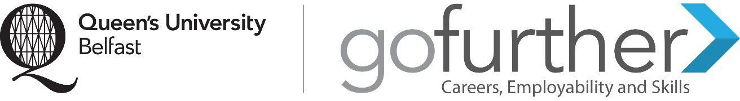

Note on Degree Plus CV & Cover Letter
Please note that the CV & cover letter is to be produced for the purposes of Degree plus accreditation only. Its acceptance is not an indication of its suitability for any specific job or other applications you may make in the future.
For guidance on producing and tailoring a CV & Cover Letter, you can book into a one-to-one appointment with a Career Consultant or attend CV/application workshop by booking via www.qub.ac.uk/myfuture. Information on CVs and Cover Letters is also provided on www.qub.ac.uk/careers.

Example of a Structure for a Cover Letter to accompany a CV produced for the purpose of Degree Plus Route B.

Letter Heading: Include your address, date and the address of the organisation you are applying to (in this case, the Degree Plus Team at Queen’s University Belfast).

First paragraph
- Why you are writing the letter
- State which Degree Plus Route you are applying for
- How you heard about the Award/where you saw it advertised
- Note that you have enclosed your CV for consideration as part of the Award

Second paragraph
- Why you want to gain the Award
(Be specific, tailor cover letters to the award – just as it would for a job or course you may apply to)

Third paragraph
- Summarise the main skills you gained through your Degree Plus activities (match to the skills associated with the Degree Plus Award)

Last paragraph
- Indicate how you are looking forward to receiving a response
- Thank the team/organisation/employer for their time

