Ijeab – Freepik
Connected Learning using Teams
A Guide for Students
Updated: 3/9/2020

Welcome to Connected Learning
Teams is used widely around the University for teaching, meetings, and collaboration. It is part of the Office365 platform and is freely available to all staff and students, along with other Office apps at https://office365.qub.ac.uk/.
A course administrator will set up your access to modules so that you can participate in learning activities just as you would in-person.

Contents

Getting Started 2
Get Teams 2
Install the Teams App 3

Using Teams 4
Open a Team 4
Become Familiar with the Team Panel 4
Join a Meeting 5
Interacting 6
Sharing Files or Desktop 7

Teamworking and Breakout Rooms 8
Secondary Meetings (Breakouts) 8
Ways to Initiate a Secondary Meeting 9
Call Someone 9
Meet in a Team or Channel 10
Invite Someone 12
This resource was produced by Christopher Brown, School of Psychology
Getting Started

You will need:
A PC with Google Chrome or Microsoft Edge Installed, and a working microphone/headset.
or
A PC, Mobile or other device with the Teams application installed.

Get Teams
If you have been asked to take part in a Teams meeting for a tutorial or other activity, then you will need to use Microsoft Teams.
Teams is freely available to you as part of Office365. To access it, visit: https://office365.qub.ac.uk/ and sign in as usual with your student number and password:
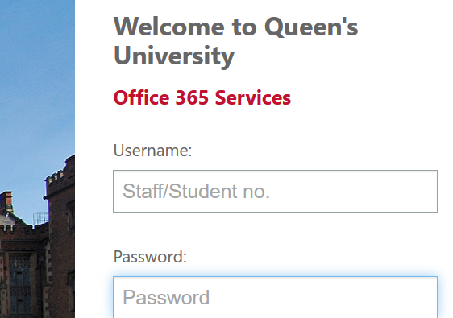
You will arrive at your Office365 homepage and shown a list of apps that are available to you. Open Teams: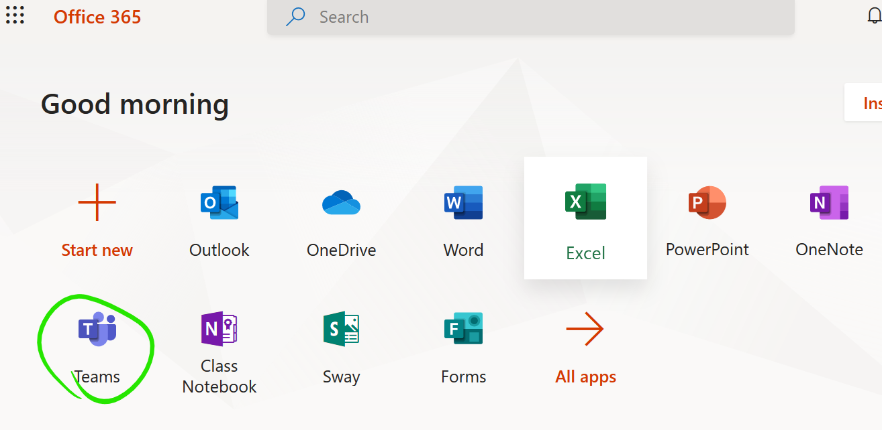
Install the Teams App
Teams functions just as well in the browser as it does on the desktop, but there are some advantages to installing the desktop app, the main being that you don’t have to leave your browser open to receive notifications and content, instead it will always be available via the Teams tray icon:
If you want to install teams as a desktop application, then you can do so via a link in the browser app.
Click the options button in the top-right of the screen, then choose “Download the desktop app”.
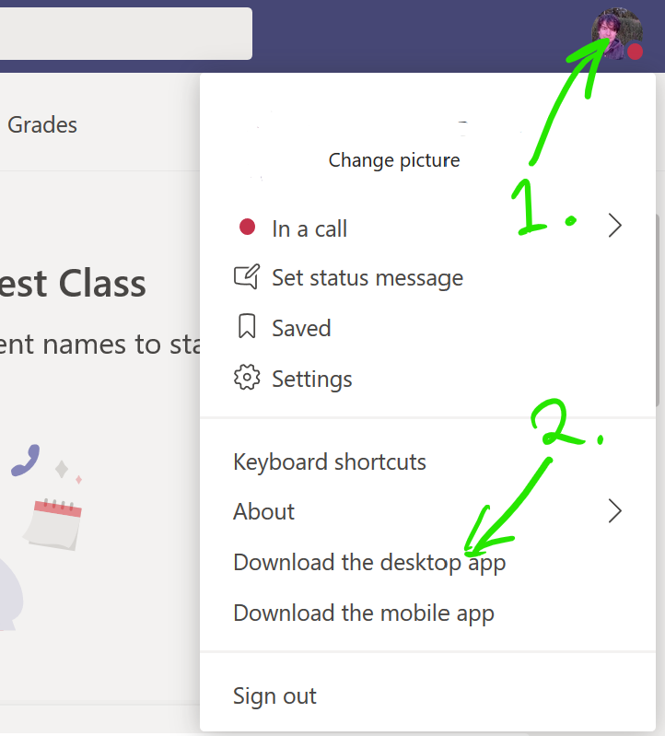
Note that you can opt to download the mobile app if you prefer. Microsoft Teams is also available in the Google Play Store and Apple App Store.
Once installed, you will log in with your usual QUB credentials. You may be asked to do this multiple times the first time you use it.

Using Teams
Classes or modules are set up as teams, which are simply groups of people who can meet, share files, and post notes in a common space.

Step 1 – Open a Team
- Open Teams, either by the desktop app or in your browser.

- Open the main Teams panel with the button on the left menu and see the list of teams you belong to. Open the team for the module you are teaching, in this example we use the fictional module PSY5050:
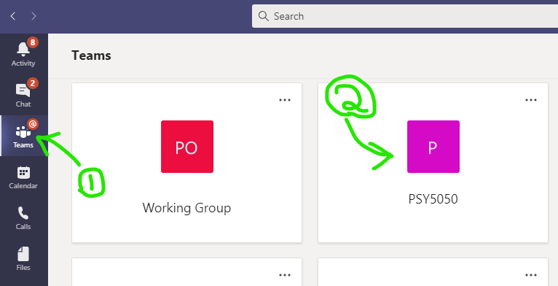
Step 2 – Become Familiar with the Team Panel
All teams have a main channel, called “General”, where meetings are started and conversation can be posted, as in this example:
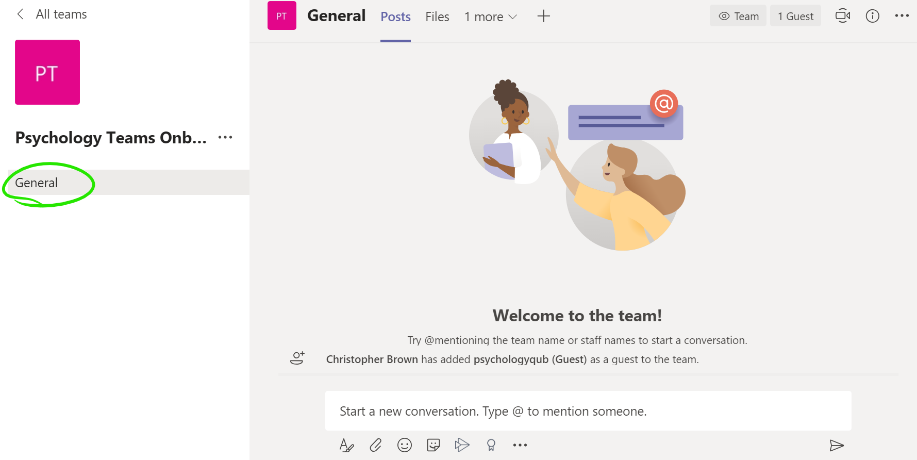
There can be other channels too, but we are only using the main General channel for now. Note that the above screen is showing Posts, which is the default place to start. Text and attachments can be posted here, and they will be visible to all members of the team. If you start a meeting, members will see a link to it here as well.
Notice the Files tab. This section is a more organised place to share files, and often a tutor will place files used in a lecture in this section.
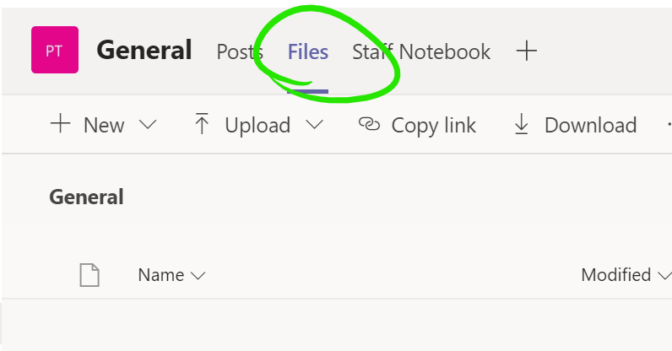

Step 3 – Join a Meeting
Your tutor will start a meeting inside the module general channel, so you should visit it and be ready at the start time.
Sometimes the meeting is scheduled in advance and you will se an entry for it in the main team panel, and it will be synchronised to your Outlook (which also gives you a link and a join button) . Whether scheduled or not, the meeting can always be joined from the main panel.

Once the meeting starts, you will see a join button, which you should click:
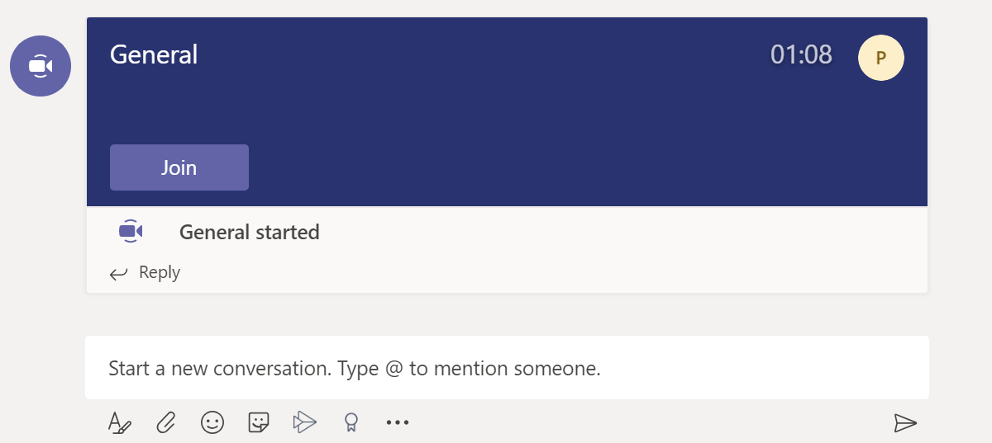

Step 3.1 - Interacting

Raise Your Hand

Two main ways of accepting interactions have become established. The first option is the Raise your hand button:

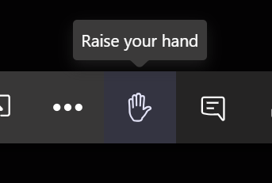
If you raise your hand, you are indicating that you have a question or comment, and you should wait for the tutor to ask you to speak. They will see that your hand is raised in a list of participants. Once you have spoke, you should click the icon again to lower your hand.

Leave a Comment

The next option, which tends to be more common, is that participants leave a question or comment in the meeting conversation window. Open it with the Show conversation button:
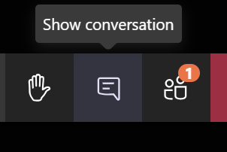
How interactions are handled is up to the presenter and they will usually make it clear to you which they prefer.

Step 3.2 - Sharing Files or Desktop

You may be asked to demonstrate files. The share button lets you share your desktop, a specific window, or files (from your OneDrive). Most often, sharing the desktop is used, as in this example:
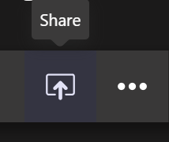
Next click Desktop, and note the option to include audio:
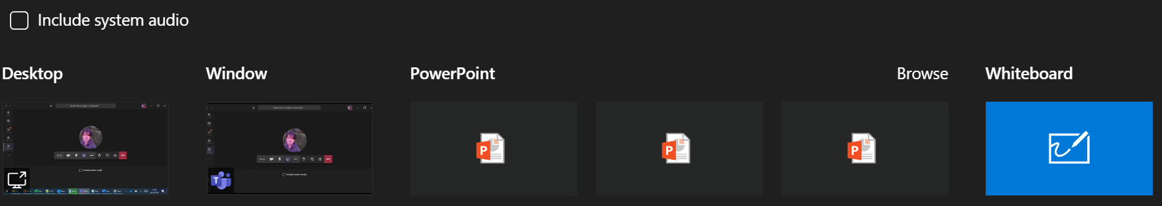
The inclusion of audio (other than current microphone audio) in the share requires that Include system audio be ticked. This is useful if you are playing back a video file or some other source that has sound.

Teamworking and Breakout Rooms
Sometimes you may be asked to work in groups, which you can do in a secondary meeting, often referred to as a breakout room.

Step 1 – Secondary Meetings (Breakouts)
A secondary meeting (breakout) is simply a separate meeting taking place at the same time as another. In Teams, there is no distinction between a meeting and a breakout, they are the same thing and have no special rules for creating them.
NOTE: Microsoft have announced that a dedicated Breakout Rooms feature will be released in an Autumn 2020 update to Teams.

- You can have a separate meeting by creating one in the usual way, where one group member simply invites the others. There is no need to leave the main meeting, it will continue on hold, appearing on the main Teams meeting panel:
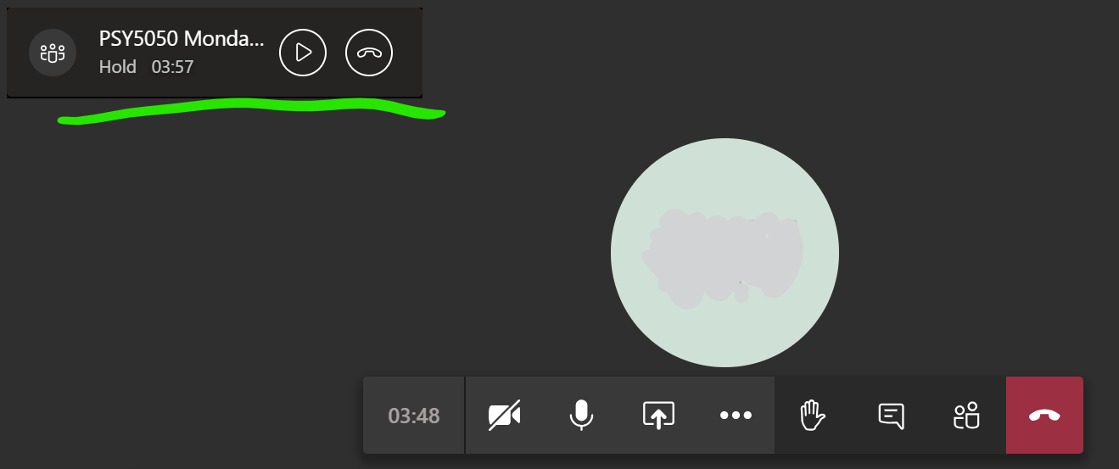
- Resume the main meeting with the play button, which will then place you on hold in the other meeting, allowing you to switch between both.

Quite often you will be asked to go to a breakout room, or have a secondary team meeting to discuss something or work together, with instructions to come back to the main meeting after an amount of time to present your work.

Step 2 – Ways to Initiate a Secondary Meeting
There are no special rules for creating a secondary meeting. These are some common ways, and your tutor will usually advise you:

Method 1 – Call Someone
Whether already in a meeting or not, you can make another meeting call via the Calls panel. Open it from the left-hand menu, you may need to select the More added apps button first:
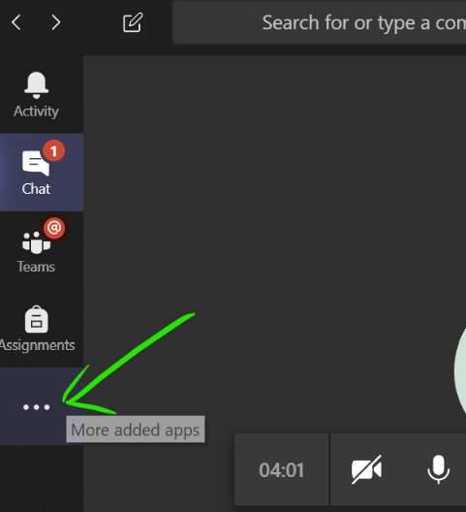
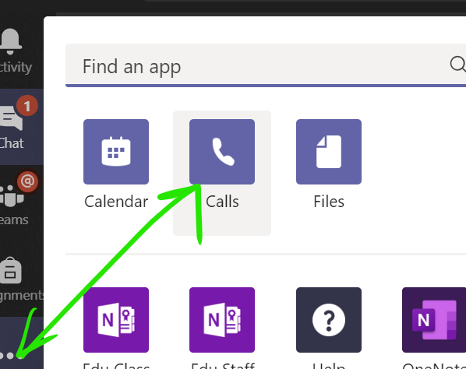
The Calls panel lets you call as many users as you like, or you can invite others to join once the meeting has begun. Select Make a call, then enter the names of the people you would like to call in the box and press the voice or video call button as preferred:
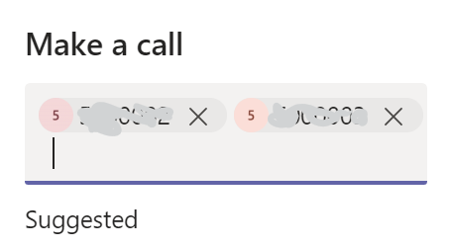
The other members of the group can accept the call, with video or voice, and the main tutorial meeting will continue with hold as described in the previous step.

Method 2 - Meet in a Team or Channel
This approach is more suitable if the members of the subgroup are known in advance, especially if they will be meeting regularly, e.g. for group work.

Visit an Existing Channel
Often groups or breakout rooms will have been set up for you already. You could be assigned to one in advance, or you could be asked to enter one during the teaching session.
In this example module, there are various channels under the main General Channel:
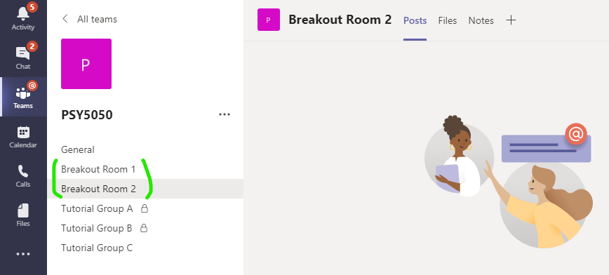
Any channel could be used for a breakout, but in this case, 2 rooms have been set up for that purpose. The tutor will ask you to divide up and enter a room. Simply open the corresponding channel to enter it. One person should use the meet now button to begin the secondary meeting, while the other members join it.
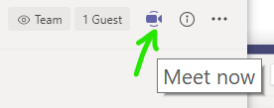
The secondary meeting can be put on hold by re-joining the main meeting, and vice versa.

Create Your Own
You can create your own team, or channels in teams that you own. The process of creating a team is the same for any user, where from the main All teams panel, the Join or create team button is used. The user gives the team a name and adds users to it. Note how the main meeting in still in session, as a floating box, after clicking through to the All teams section—creating the team in advance is better, but not necessary since it can be done on-the-go as we see:
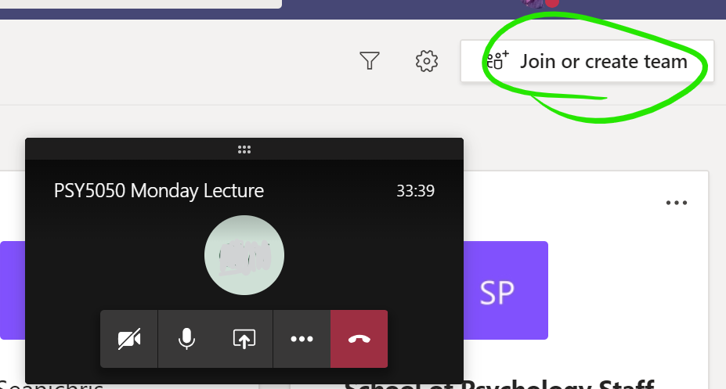
Of the available team types, Other is the most suitable, although any of them will do:
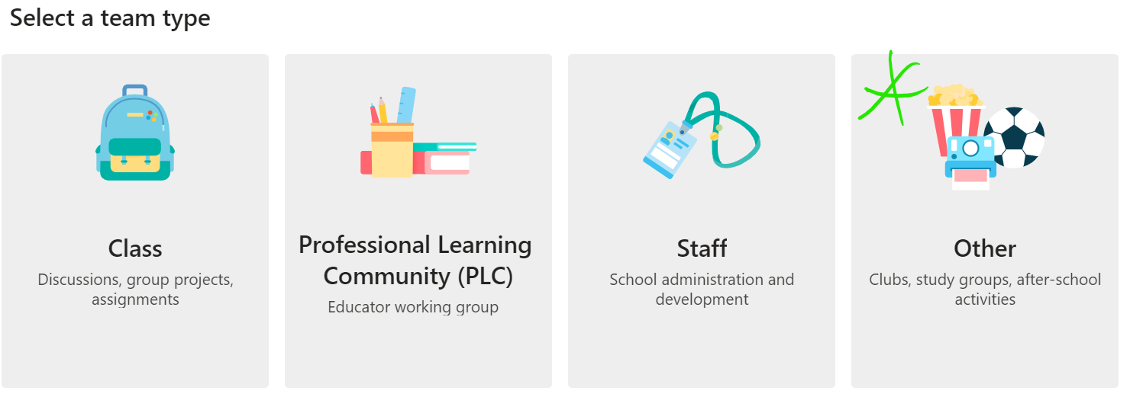
Once a team or channel is created and has users, open it and use the meet now button, which may be on the conversation panel, or the top-right:
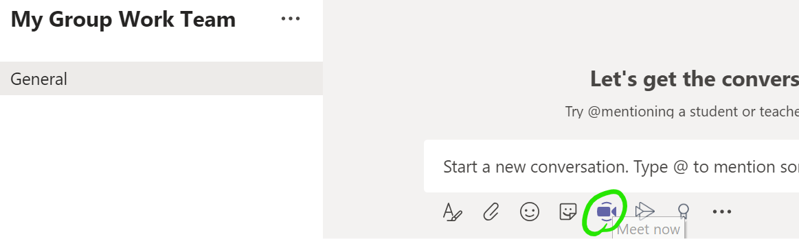

Additionally: Invite someone…
…to your already open meeting by clicking the Show participants button and enter a name in the Invite someone box:
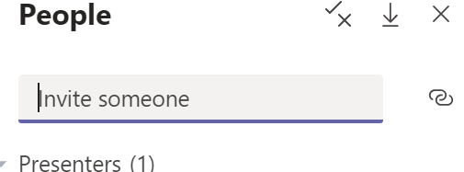
TIP: Invitations can be to anybody, that means a student group could even invite the tutor, or another supervisor, to join their meeting. The same hold functionality applies, so your other open meetings will be held for you and you can change between them as needed.

