Connected Learning using Teams
Essentials for Guest Users
Updated: 3/9/2020
Ijeab – Freepik
Welcome to Connected Learning at QUB
Teams can be used to deliver live presentations suited to teaching, and is used widely around the University for lectures, tutorials, training, and seminars. Different video conferencing solutions offer the same core functionality, but with some variation in their presentation and features.
As a guest lecturer, an administrator will have taken care of much of the setup for you, including creating a class and adding users. Guest users avail of most of the features that standard members do, with a few exceptions. This guide covers the common approach to lecturing with a guest Teams account with no special software or previous experience required.

Contents

Getting Started 2
Invitation Email 2
Start Teams 3

Lectures and Tutorials in Teams 4
Opening a Team 4
Become Familiar with the Team Panel 5
Start a Meeting 6
Accepting Interactions 9
Sharing your Desktop 10

Teamworking and Breakout Rooms 11
Secondary Meetings (Breakouts) 11
Ways to Initiate a Secondary Meeting, Student Perspective 12
Call Someone 12
Meet in a Team or Channel 13
Invite Someone 15
This resource was produced by Christopher Brown, School of Psychology
Getting Started
You have been invited to participate in Connected Learning at Queen’s, which uses Microsoft Teams as a core component. You will receive an invitation email asking you to join Teams as a guest.

Step 1 – Invitation Email
- Once added to a team as a guest, or invited to a meeting, you will receive an email asking you to open Teams:
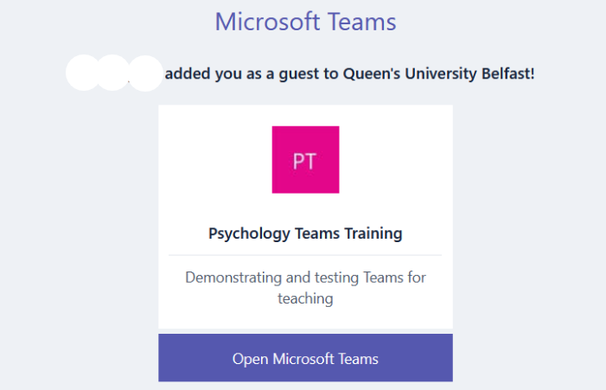
- If you don’t have one already, you will be prompted to create a Microsoft account, which you should do:
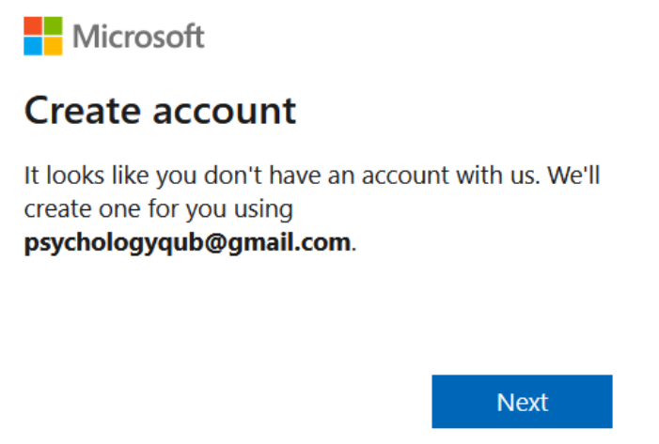
- Continue adding the necessary details and create a password. Make sure you keep the password handy; you will need it to log in to QUB Teams from now on.

- You will need to verify your email address. Go back to your email account, open the email sent by Microsoft and retrieve the verification code which you should enter to continue:

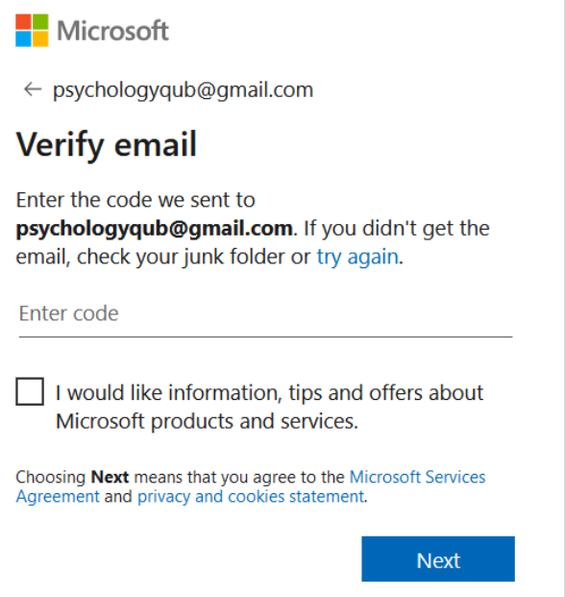
- Finally, accept the conditions and your account is ready.

Step 2 – Start Teams
You are ready to begin using Teams. You have the option of installing a desktop app or continuing in your browser. The guest experience is the same in either and this guide uses the browser option. Any up-to-date browser such as Chrome, Firefox or Edge can run Teams.
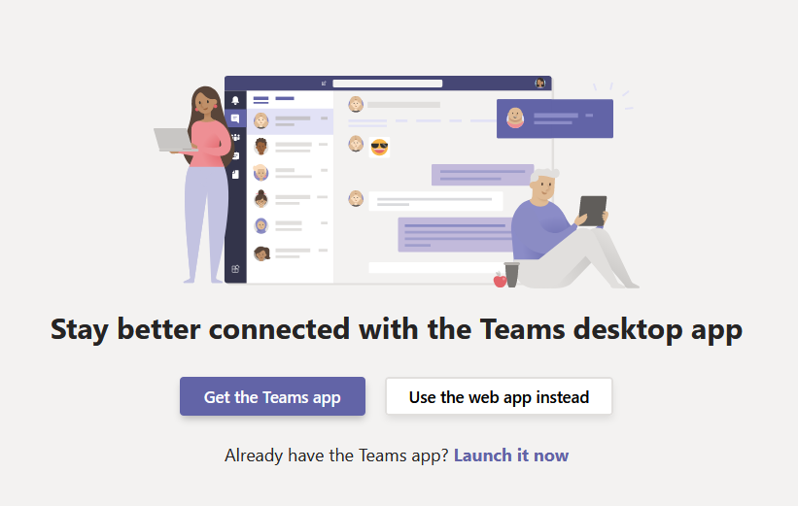
Lectures and Tutorials in Teams
Lectures and Tutorials are both conducted as meetings, but usually a tutorial is more interactive, with greater engagement from students.
Because guest members can’t change meeting permissions for participant devices and sharing, the difference is exercised through etiquette rather than settings. In some cases, such as for seminars, an administrator may set up and configure specific participant settings to control the features that can be used.
Objectives:
- Open a team.
- Become familiar with the features.
- Start a meeting that students can join.
- Accept interactions from students.
- Share your screen.

Step 1 – Opening a Team
Classes are set up as teams, which is simply a group of people who can meet, share files, and post notes in a common space. Guest lecturers don’t need to create teams, this has been done for you and students have been added.
- Open Teams, either by the desktop app or in your browser. Make sure you are logged in using the email address that was used to register you.

- Open the main Teams panel with the button on the left menu and see the list of teams you belong to. Open the team for the module you are teaching, in this example we use the fictional module PSY5050:
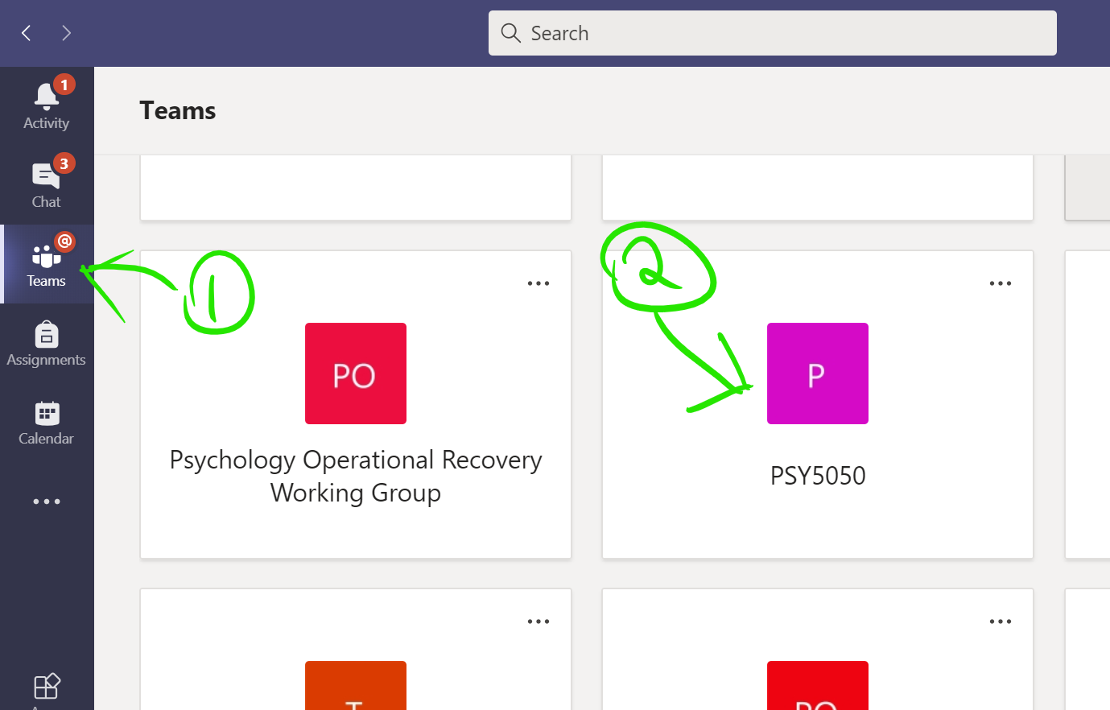
Step 2 – Become Familiar with the Team Panel
All teams have a main channel, called “General”, where meetings are started and conversation can be posted, as in this example:
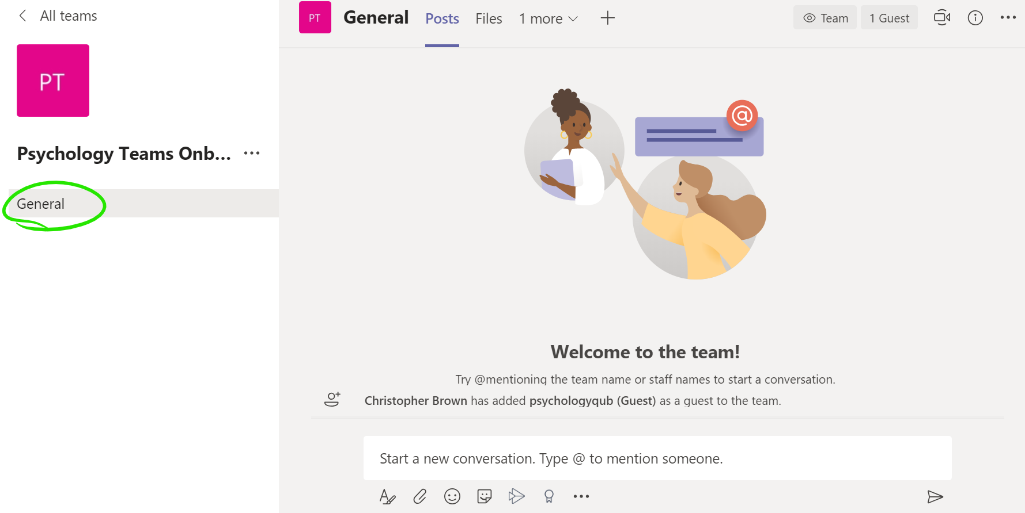
There can be other channels too, but we are only using the main General channel. Note that the above screen is showing Posts, which is the default place to start. Text and attachments can be posted here, and they will be visible to all members of the team. If you start a meeting, members will see a link to it here as well.
Notice the Files tab. This section is a more organised place to share files with students, simply drag and drop files that you would like to share.
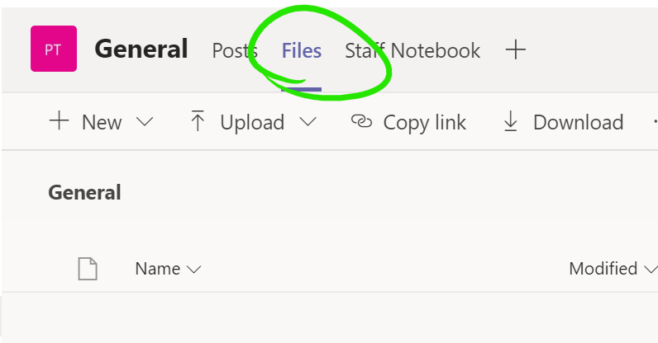
Note the meeting button, a small icon on the top-right that you will be using to start meetings:
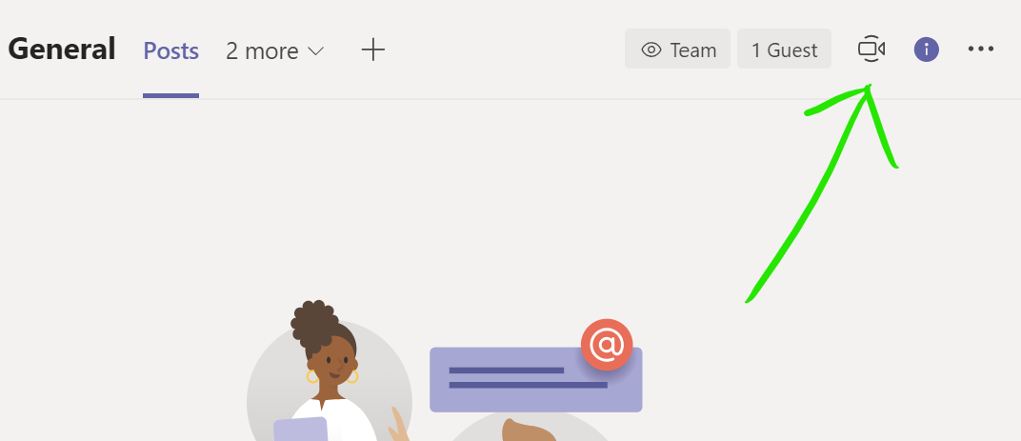

Step 3 – Start a Meeting
As for any meeting, you should ensure that your Computer, Webcam and Microphone are tested and appropriately located.
As a guest user, you won’t schedule a meeting the way a QUB user would, as you don’t have calendar integration. Instead, you will visit the team at the appointed time and start the meeting manually using the meeting button.

- Open the team as described in the previous step, and find the meet now icon on the top-right of the panel:
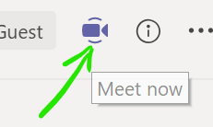
- Press the button and the meeting will be almost ready to start. Give the meeting a suitable title so that your students are clear what it is, then press the Meet now button on the bottom bar to begin the meeting:
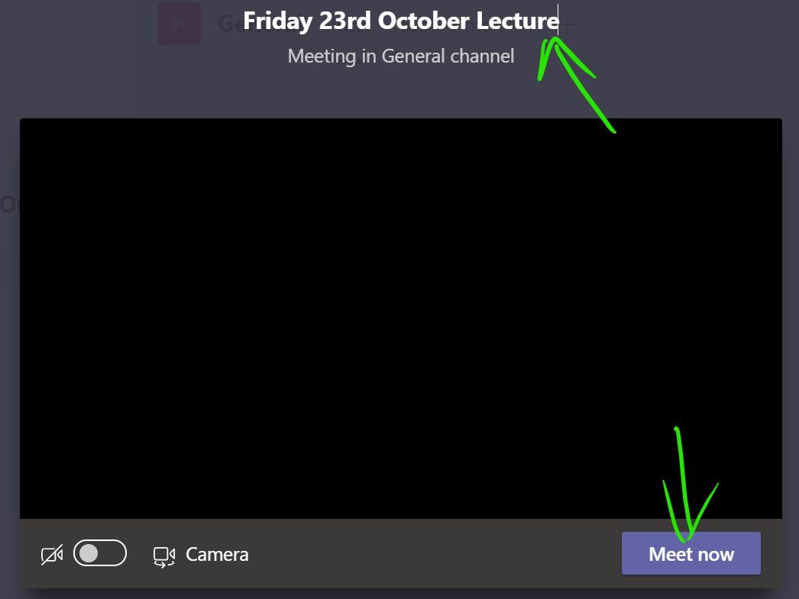

- Students will begin joining the meeting after you start it. Cick the show participants button to view a list of all attendees.

- The Mute all button is found beseide the Currently in this meeting label, and only shows if there are 3 or more participants. It mutes students, but they can turn their microphones on again if they need to speak. The mute option is more usful for larger classes where some students may have forgotten to begin as muted:
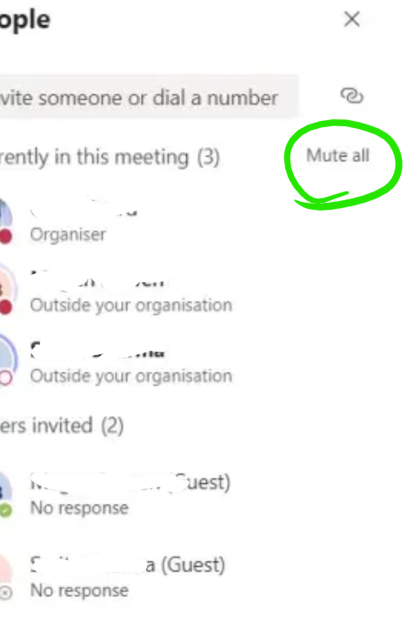

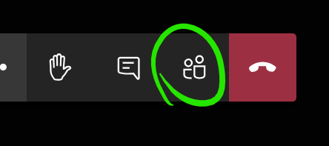

- Students visiting the main team panel will see that a meeting has started, and a Join button will let them access the meeting:
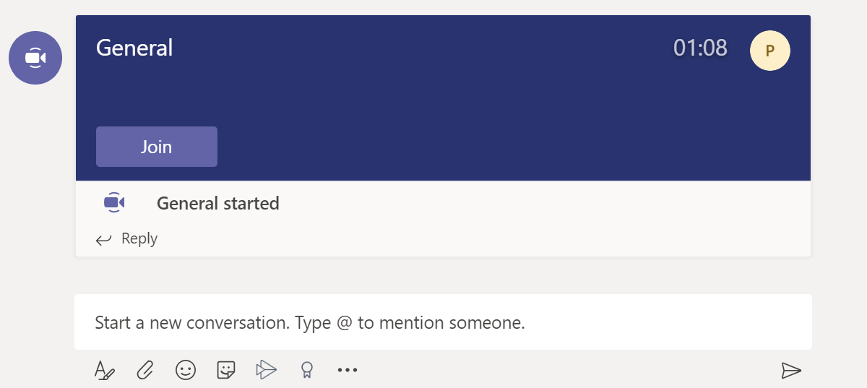
Students are aware of how to access meetings and will expect to join online lectures in this way. Administrators should email students in advance of lectures to notify them of the time and include a link to the team.
Step 3.1 - Accepting Interactions

Raise Your Hand

Two main ways of accepting interactions have become established. The first option is the Raise your hand button:

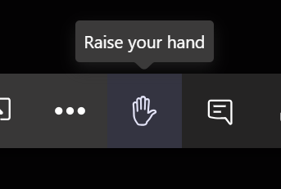
Participants who have raised a hand are indicating that they have a question or comment. They are listed by name in the main meeting panel, and in the participants panel with a hand icon:

Leave a Comment

The next option, which tends to be more common, is that participants leave a question or comment in the meeting conversation window. Open it with the Show conversation button:
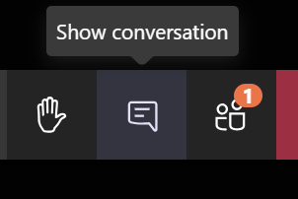
How interactions are handled is up to the presenter and should be stated at the beginning of the lecturer if it is not already clear to students. Having an assistant to moderate the conversation can be useful for very large classes.

Step 3.2 - Sharing your Desktop

Share your desktop via the Share button. This lets you broadcast your current display so that you can show slides or files:
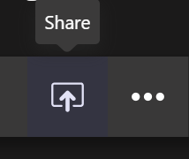
Next click Desktop, and note the option to include audio:
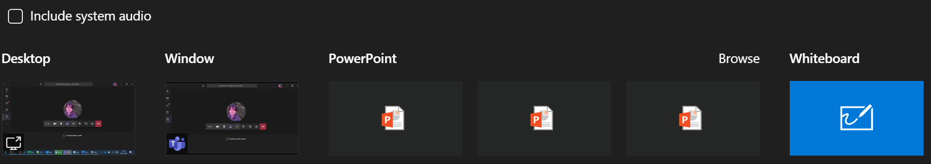
The inclusion of audio (other than current microphone audio) in the share requires that Include system audio be ticked. This is useful if you are playing back a video file or some other source that has sound.

Teamworking and Breakout Rooms
Sometimes it is useful for students to work in groups, which they sometimes do using their own teams, or simply through ad-hoc meetings.
As a guest, some of these next features are unavailable to you, such as calling, but they are available to students.

Step 1 – Secondary Meetings (Breakouts)
A secondary meeting (breakout) is simply a separate meeting taking place at the same time as another. In Teams, there is no distinction between a meeting and a breakout, they are the same thing and have no special rules for creating them.
NOTE: Microsoft have announced that a dedicated Breakout Rooms feature will be released in an Autumn 2020 update to Teams.

- You can have a separate meeting by creating one in the usual way, where one group member simply invites the others. There is no need to leave the main meeting, it will continue on hold, appearing on the main Teams meeting panel:
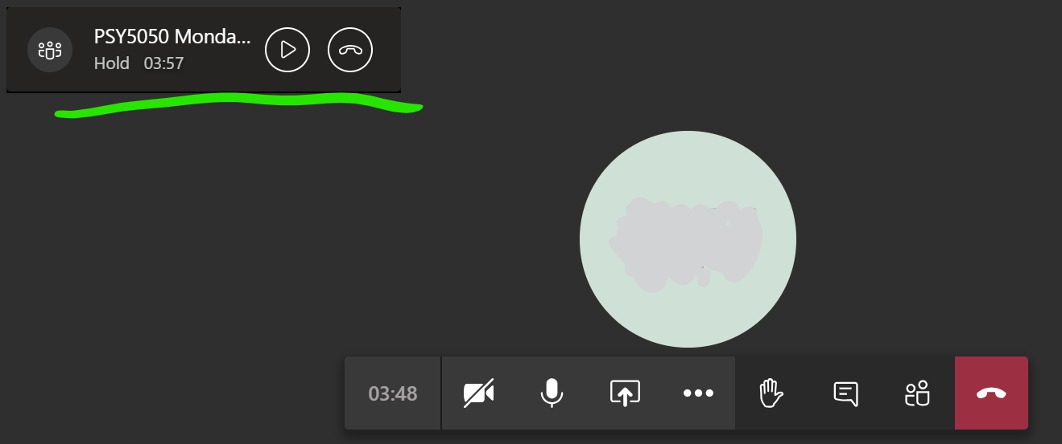
- Resume the main meeting with the play button, which will then place you on hold in the other meeting, allowing you to switch between both.

Students can carry out separate discussions or teamwork in a subgroup. Likely scenarios would include having them discuss a topic, with instructions to return to the main meeting after a certain time to present findings.

Step 2 – Ways to Initiate a Secondary Meeting, Student Perspective
There are no special rules for creating a secondary meeting. These are some common ways, and the tutor will usually advise.
As a guest lecturer, an administrator will usually set up breakout rooms for you as channels, as outlined in the Visit and Existing Channel section of Method 2. The channels (rooms) are available to all participants, including the tutor, so you can enter and leave ongoing meetings as needed. It is usually up to the tutor to ask students to divide into groups and enter a specific room, asking them to return after a fixed time.

Method 1 – Call Someone
Whether already in a meeting or not, you can make another meeting call via the Calls panel. Open it from the left-hand menu, you may need to select the More added apps button first:
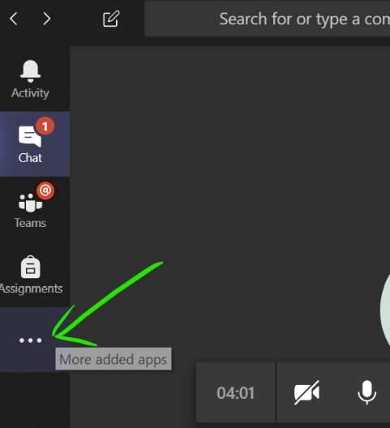
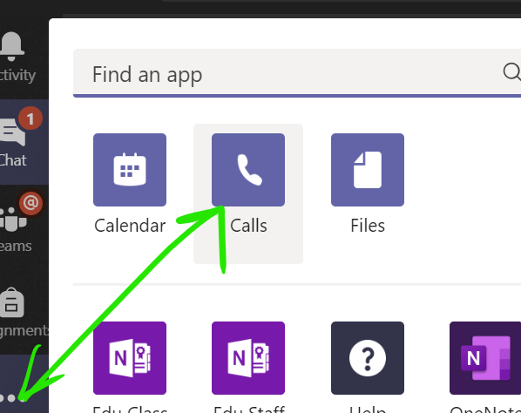
The Calls panel lets you call as many users as you like, or you can invite others to join once the meeting has begun. Select Make a call, then enter the names of the people you would like to call in the box and press the voice or video call button as preferred:
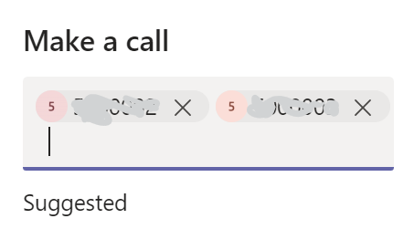
The other members of the group can accept the call, with video or voice, and the main tutorial meeting will continue with hold as described in the previous step.

Method 2 - Meet in a Team or Channel
This approach is more suitable if the members of the subgroup are known in advance, especially if they will be meeting regularly, e.g. for group work.

Visit an Existing Channel
Often groups or breakout rooms will have been set up for you already. You could be assigned to one in advance, or you could be asked to enter one during the teaching session.
In this example module, there are various channels under the main General Channel:
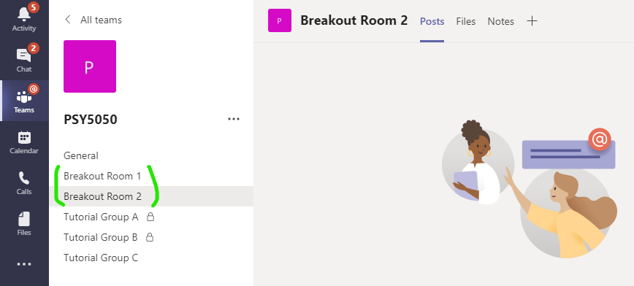
Any channel could be used for a breakout, but in this case, 2 rooms have been set up for that purpose. The tutor will ask you to divide up and enter a room. Simply open the corresponding channel to enter it. One person should use the meet now button to begin the secondary meeting, while the other members join it.
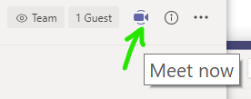
The secondary meeting can be put on hold by re-joining the main meeting, and vice versa.

Create Your Own
You can create your own team, or channels in teams that you own. The process of creating a team is the same for any user, where from the main All teams panel, the Join or create team button is used. The user gives the team a name and adds users to it. Note how the main meeting in still in session, as a floating box, after clicking through to the All teams section—creating the team in advance is better, but not necessary since it can be done on-the-go as we see:
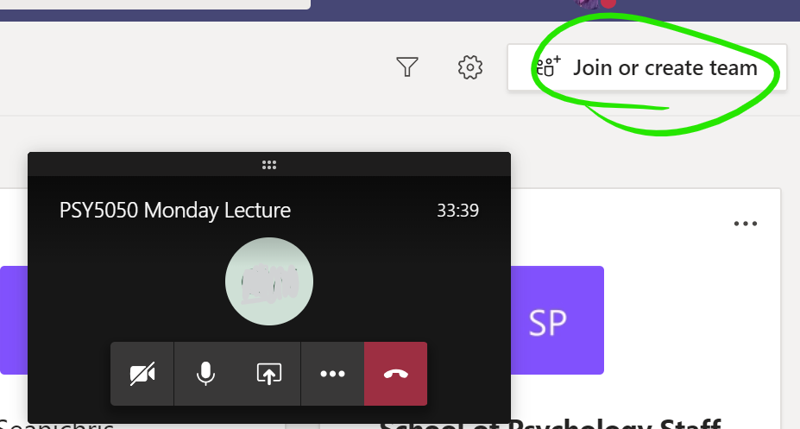
Of the available team types, Other is the most suitable, although any of them will do:
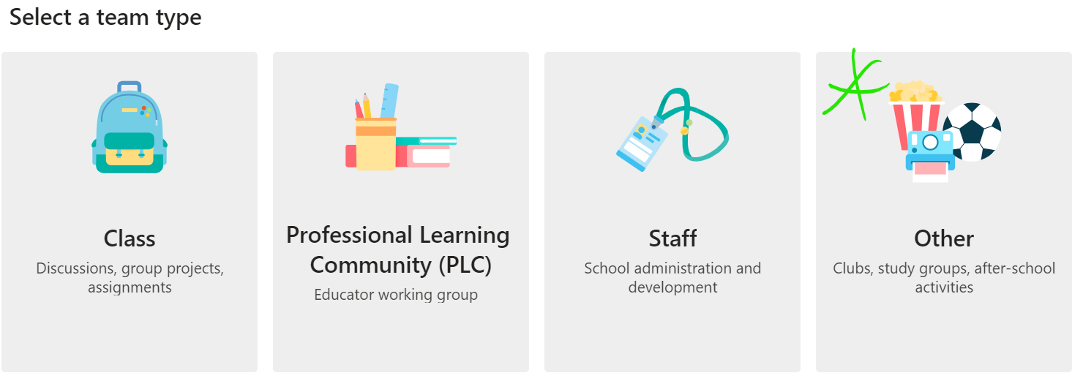
Once a team or channel is created and has users, open it and use the meet now button, which may be on the conversation panel, or the top-right:
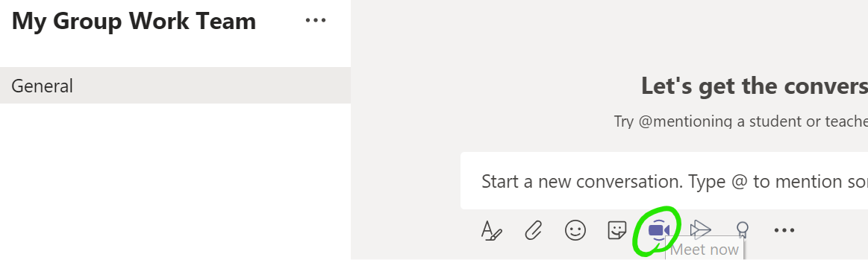

Additionally: Invite someone…
…to your already open meeting by clicking the Show participants button and enter a name in the Invite someone box:
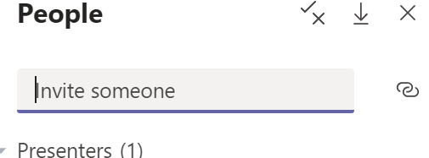
TIP: Invitations can be to anybody, that means a student group could even invite the tutor, or another supervisor, to join their meeting. The same hold functionality applies, so your other open meetings will be held for you and you can change between them as needed.

