Connected Learning using Teams

Guide for Teachers and Demonstrators

Updated: 29/9/2020

**Contents**

**Introduction 3**

**Lectures in Teams 4**

Setting Up a Class 4

*Add Links and Content to Canvas 6*

Scheduling Lectures 10

Delivering the Lecture 11

*Accepting Interactions 13*

*Sharing Presentations, Files and Desktop 14*

*Recording a Lecture 16*

*Take Attendance 17*

**Tutorials in Teams 18**

Setting Up Tutorial Groups 18

Schedule Tutorial Meetings 20

Deliver the Tutorial 21

*Secondary Meetings (Breakouts) 21*

*Create Breakout Rooms 22*

*Ways to Initiate a Secondary Meeting, Student Perspective 23*

*Sharing and Collaborating 26*

*Take Attendance 26*

**Seminars in Teams 27**

Schedule the Seminar 27

Manage and Moderate the Seminar 28

*Recording a Seminar 29*

**Other Facilities 30**

Informal Waiting Rooms 30

Lobbies 31

Interactive Screen Sharing (Remote Control) 33

**External Users 34**

As Meeting Invitees 34

As Guest Team Members 34

Via Additional Persons 36

This resource was produced by Christopher Brown, School of Psychology

**Introduction**

Teams can be used to deliver live presentations suited to teaching, and is used widely around the University for lectures, tutorials, training, and seminars. Different video conferencing solutions offer the same core functionality, but with some variation in their presentation and features.

No matter what video solution you use, there will always be a little overhead in setting up a suitable structure of classes or groups. Luckily, Teams lets you do this in advance, and with recurring schedules. Planning how you want to deliver your teaching will make it much easier to facilitate in Teams.

Other than general meetings, there are 3 main uses of Teams in teaching: lectures, tutorials, and seminars. Lectures focus on presentation, while tutorials have a greater level of audience participation, and may even require simultaneous meetings of subgroups (sometimes called breakout rooms). Seminars are a type of lecture but may include presenters and participants from outside of the organisation, referred to as an *external user*.

This guide offers a structured approach to connected learning using Teams, tailored to the teaching methods you are already familiar with. Once familiar with these processes, the few organisational steps to get up and running take only minutes.

**Lectures in Teams**

Let us look at delivering a standard lecture in Teams. The objectives are to:

* Set up a class.
* Schedule the lecture to recur.
* Add links and content to Canvas.
* Present video to an audience, without participation from students (that will be covered later).
* Demonstrate slides and other files.
* Share files and notes to students on-the-go.
* Record the lecture for future use.
* Collect attendance.

**Step 1 - Setting Up a Class**

NOTE: Work has been completed by Information Services to automate the creation of teams for modules, complete with the appropriate staff and student membership. Therefore, this step may not be necessary, although it is still relevant as an approach to create a related team as opposed to reflecting the module directly.

There are various ways of setting up a group and inviting them to Teams. A logical approach is to add every student of a module to a team—this may seem like a lot of work for a large class, but remember it only has to be done once at the start of term, and it is actually quite quick in Teams since the students are on QUB’s Active Directory.

1. Begin by creating a new team from the main menu and make it of type *Class* when prompted, this example will use the fictional module code PSY5050 as its title:

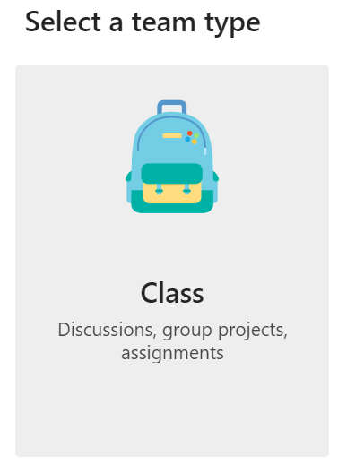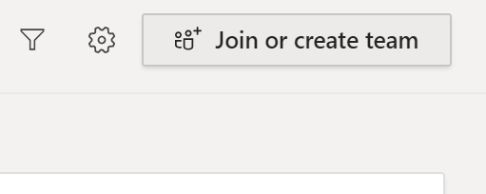

1. Add students to the team (or skip this for now and do it later). Adding students is a one-by-one process, but it can be done quickly by pasting in a student number or email address:

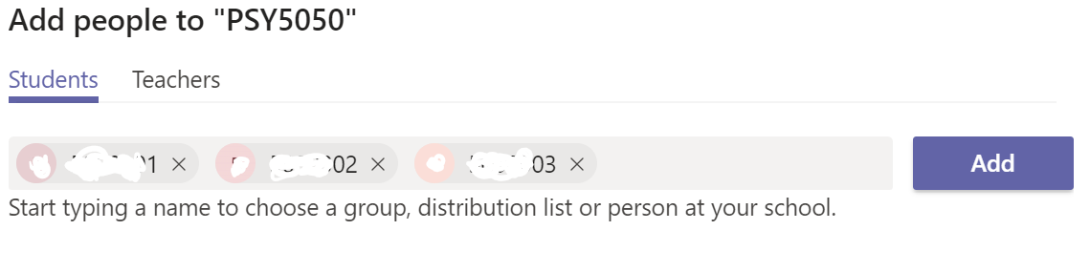

Click *Add* when you are done.

1. Add additional teachers in the next tab if you like. As the creator of the team, you are automatically a teacher.

You now have a team for your module. As well as being used for video, the team is a useful tool where you can chat, post files, and share notes.

Teams can be subdivided into channels—we will look at this later for tutorials—and the top-level channel containing everyone is called “*General*”. Note that you can manage the team by clicking its options, which allows you edit membership, channels, and other elements:

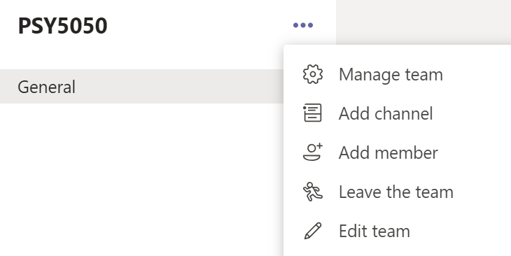

**Step 1.1 - Add Links and Content to Canvas**

Canvas is the University’s main teaching platform, and students are familiar with it as the central hub for learning activities. Adding Teams links to Canvas is a great way to keep the student experience consistent and ensures they can access their team quickly.

Course Calendar

The Canvas course calendar is an ideal place to add a link to a team:

1. Open Canvas and navigate to the course calendar.
2. Create a new calendar entry for your Teams lecture, tutorial, or other event, or edit an existing one:

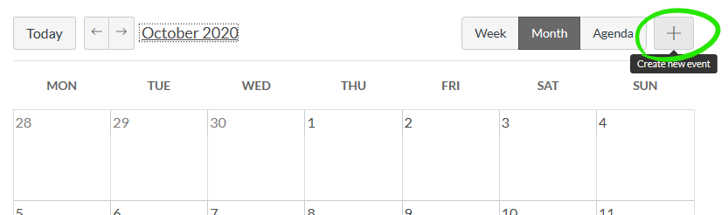

1. In the *Edit event* panel, give it a suitable name, set the time, and choose the module it relates to in the *Calendar* dropdown (each module has its own calendar). Select *More options* to open the full event details:

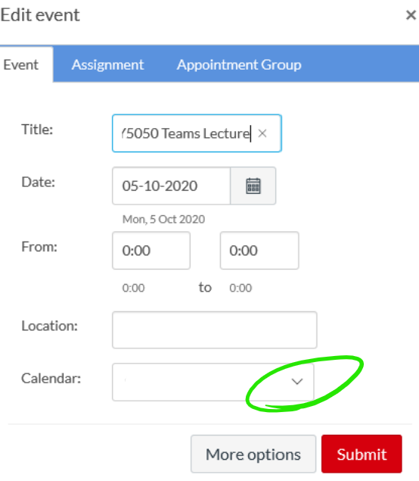

1. Leave Canvas open and switch back to Teams where we will copy the PSY5050 team. Open the options for the team then choose *Get link to team*. Copy the resultant link and return to Canvas:

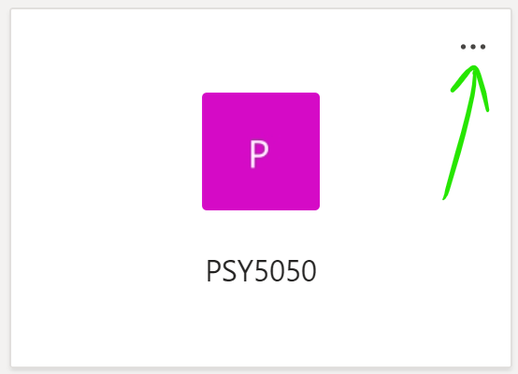

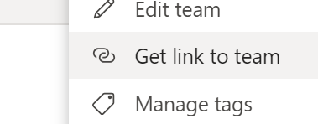

1. Enter a suitable description into the calendar event details in Canvas. Use the rich text editor to paste in your Teams link:

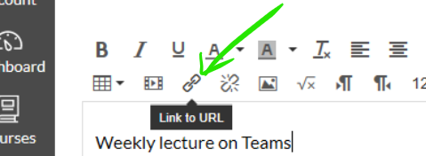

Content Page Including Video

Creating a page for each lecture in Canvas will make it even easier for students to quickly access Teams and is great for outlining the formats being used for teaching. If you record the lecture as detailed in this guide, the page is a perfect place to embed the video straight from Microsoft Stream.

1. Create a Canvas page as you would usually for the module lecture. In its description, include a link to the team as described above. Refer to you Canvas support materials if you need guidance on how to do this.
2. Canvas supports the embedding of video from streaming sources. If you have recorded you lecture (in advance, at the time, or both) you can add it to your page using an embed link from stream.
3. Lectures recorded via Teams are saved to Microsoft Stream, accessible via your Office365 apps. Find them in the *My content* section:

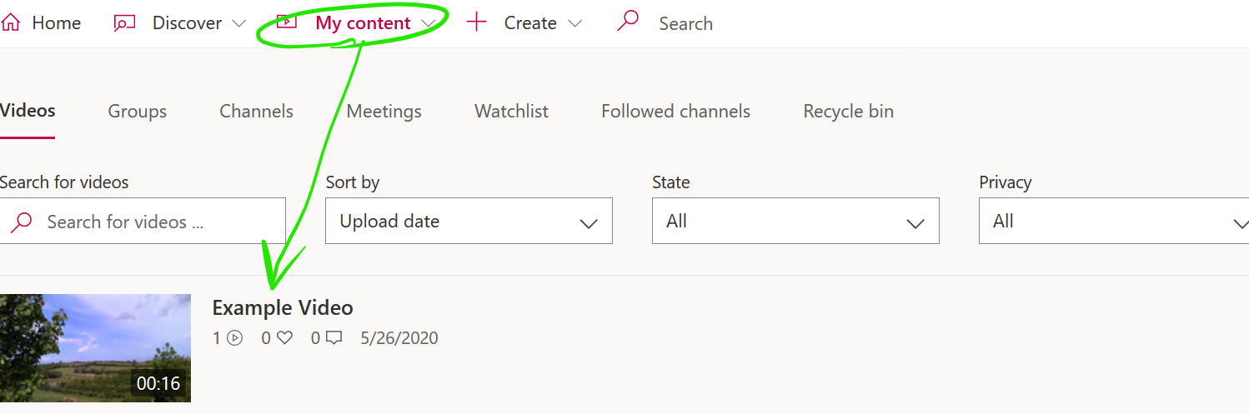

1. Open the video, click the *Share* button and select the *Embed* tab to find the iframe code used for embedding your video on a web page:

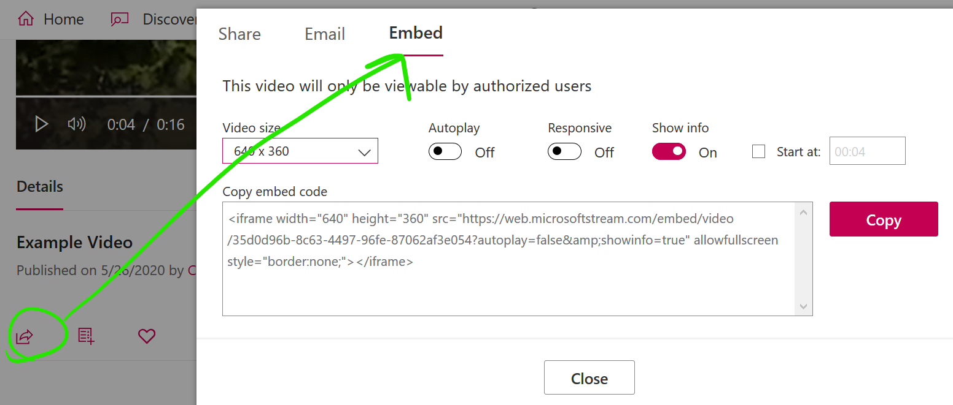

1. For the students of our module to be able to view the embedded video, we need to give them permission (since Stream videos are private until shared). In our example, we are sharing it with members of the PSY5050 team:

* Select the *Add to group/channel* icon:

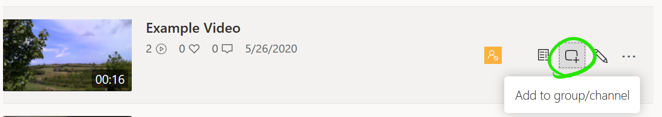

* Begin typing the name of the channel you want to share with, and click the channel when it is found:

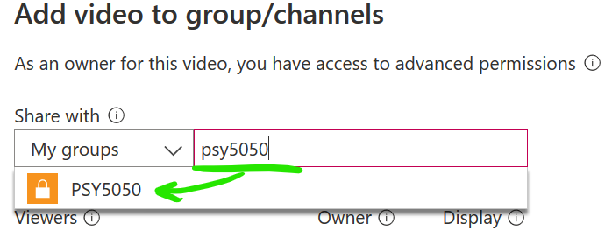

* Click *Save* to finish.

Note: Module team names created by Information Services have the format **Module-PSY5050-…** Make sure you don’t omit the *Module-* bit, as the lookup is sensitive.

**Step 2 - Scheduling Lectures**

While there are various ways to start a Teams meeting, the most organised approach is to schedule it in the calendar. The entire class can be invited as a channel, and the event will automatically appear in both the Teams and Outlook calendars for all invitees.

1. Open the Teams calendar from the menu on the left and choose *New meeting*.



1. Give the meeting a suitable title, set the date and time of the first one, and set up recurrence if applicable.
2. Rather than choosing individual invitees, invite a channel (which can be the main group of all students, or a subgroup), in this example we use the *General* channel of all PSY5050 students:

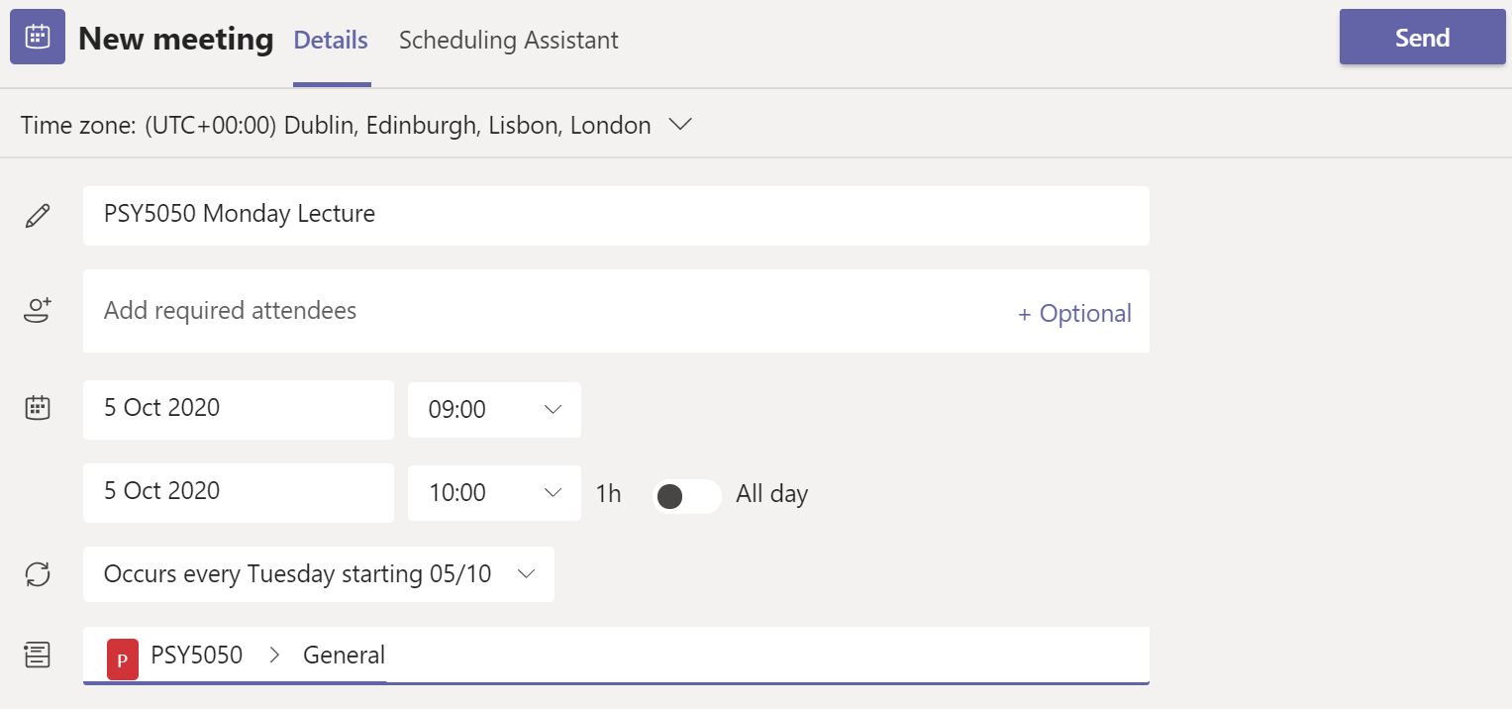

The recurring lecture is now scheduled, and all students have received an email notification and a Teams/Outlook calendar entry.

**Step 3 - Delivering the Lecture**

As for any meeting, you should ensure that your Computer, Webcam and Microphone are tested and appropriately located. In general, a lecture does not feature audience participation. Unlike a tutorial, lectures are given to large groups and it is generally preferable to set all students to invisible and mute, and without the ability to screen or file share. We will configure our example lecture accordingly, but we will also look at how discussion can be invited following a virtual hand-raise or comment posting.

1. Open the scheduled lecture from the Teams calendar, which brings up the same screen used to create it.
2. Click the ellipsis under the title and select Meeting options:

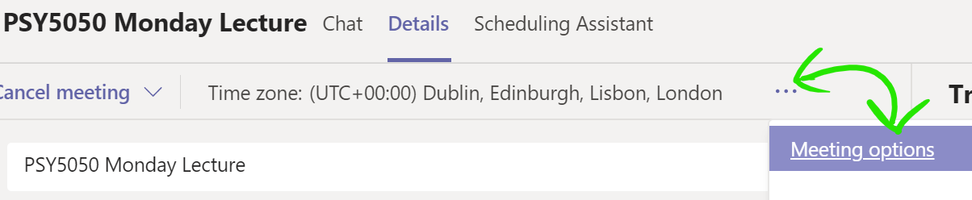

1. The link opens an Office365 webpage which may require that you log in with your QUB credentials. The option we are interested in is “*Who can present?*” which we will set to either *only me* or *specific people* (which could be a co-lecturer, or other presenter) and save the change:

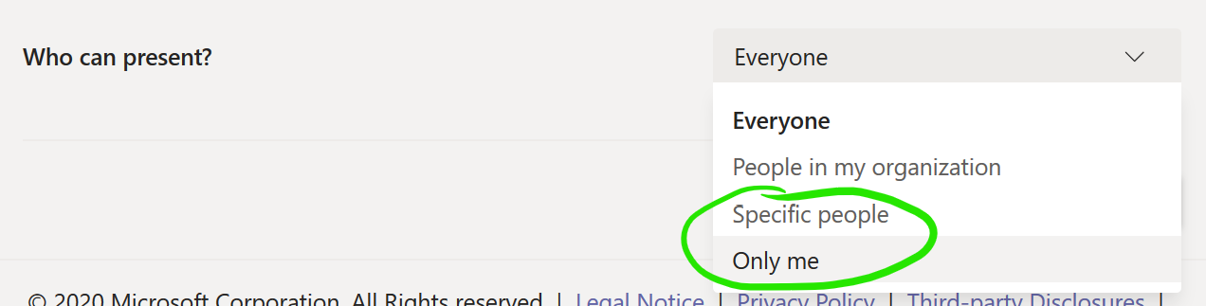

1. Muting and disabling video is done when the lecture commences. Click the options ellipsis on the main meeting bar, and choose “*Turn off incoming video*” to disable every video stream but your own:

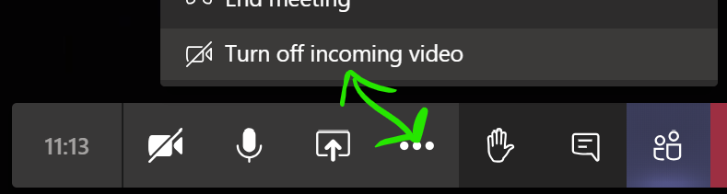

1. Cick the *show participants* button to view a list of all attendees where you can mute them individually or all together. The *Mute all* button is found beseide the *Currently in this meeting* label, and only shows if there are 3 or more participants:

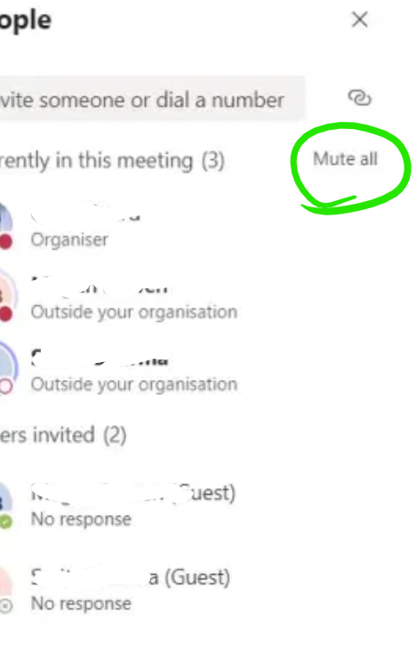

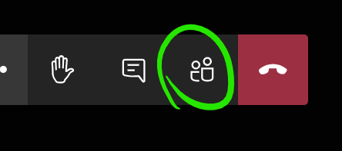

*Note that participants can unmute themselves. Lecture etiquette generally means this is not a problem, but if it needed to be controlled then a lecture co-host or postgraduate student could do so.*

**Step 3.1 - Accepting Interactions**

Raise Your Hand

Two main ways of accepting interactions have become established. The lesser-used option is the *Raise your hand* button:

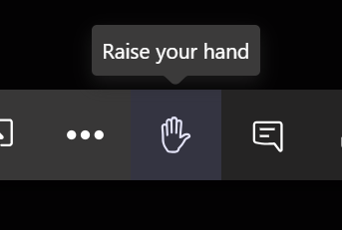

Participants who have raised a hand are indicating that they have a question or comment. They are listed by name in the main meeting panel, and in the participants panel with a hand icon:



Leave a Comment

The more common practice is that participants leave a question or comment in the meeting conversation window. Open it with the *Show conversation* button:

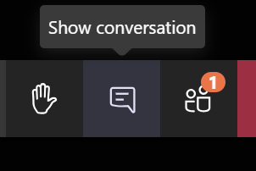

*How interactions are handled is up to the presenter and should be stated at the beginning of the lecturer if it is not already clear to students. Having an assistant to moderate the conversation can be useful for very large classes.*

**Step 3.2 -** **Sharing Presentations, Files and Desktop**

Meeting organisers or participants designated as presenters (remember, we disabled presenting for students in step 3) can share content during a meeting. This is done via the Share button:

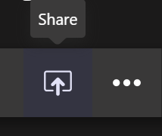

Sharing options include Desktop, Window, PowerPoint, and Whiteboard, with scope to link to more Office365 apps. PowerPoint is supported natively and will automatically list recent files if they are synched to OneDrive. The *Browse* button can be used to select a file from your device instead.

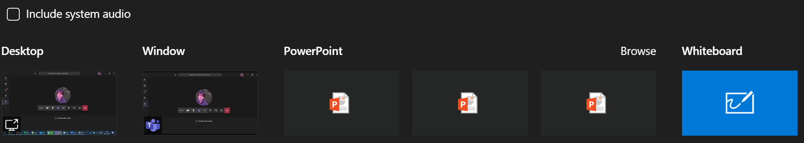

Window or Desktop effectively means any file type can be displayed. Note that inclusion of audio in the share requires that *Include system audio* be ticked.

Whiteboard is a freehand drawing space, used in place of a conventional whiteboard and marker. It is more useful if you are using a touch device with stylus.

Files

Files can be shared as attachments in the meeting chat (conversation button). You can share files to the team (or channel) outside of the lecture as well. Module resources should be distributed via the Canvas VLE, but you could supplement this with additional materials shared with channels of the team. This will be more relevant when working with subgroups, i.e. additional channels you create to reflect tutorial or other working groups, this example shows only the *General* channel:

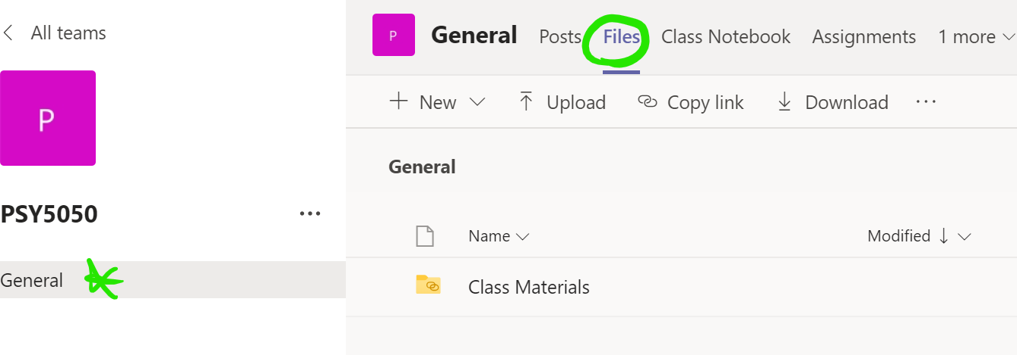

**Step 3.3 - Recording a Lecture**

You can record a lecture in Teams by selecting Start recording from the options:

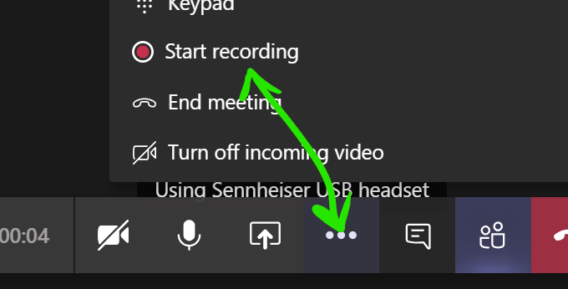

TIP: *You do not need to have any participants to record a lecture, you could conduct a meeting with no one else present as a convenient way of recording a lecture for later download by students. You can still use Teams features such as PowerPoint presentation, and that content will be recorded too.*

Saved Video Files

Recordings are saved to Microsoft Stream, an application included with Office365. Stream lets you download, share or stream video files. Access it from the [QUB Office365 homepage](https://office365.qub.ac.uk/), where you will find it under *All Apps*.

Your saved videos are listed under *My content* -> *Videos*:

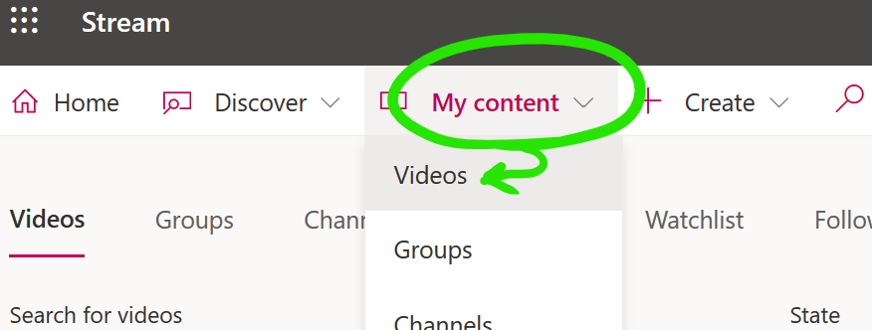

Videos can be viewed in or downloaded from Streams. There are many more options available, such as sharing, streaming, and embedding. See the Learning section on the Stream homepage if you are interested in learning more.

**Step 3.4 - Take Attendance**

Teams has a very useful feature where a spreadsheet of attendance can be generated with a single click. To do this, select *show participants* and see the download button at the top, allowing you to generate and save a list of attendees:

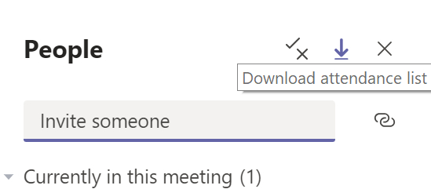

By default, the CSV file generated will be saved to the *Downloads* folder of your computer, unless you specify another location.

*If you intend to collect attendance, do so at an appropriate time during the lecture, once everyone has joined. You cannot generate the list after closing the meeting.*

**Tutorials in Teams**

Tutorials are less formal and more interactive than a lecture, usually with a much smaller group. We will examine how to conduct a tutorial in Teams, with the assumption that the fundamentals of a Teams lecture are already understood. The objectives are to:

* Set up tutorial groups.
* Schedule the tutorials.
* Meet without the constraints of a lecture.
* Collaborate using sharing tools.
* Share files with a specific group.
* Allow students to meet ad-hoc for working in small teams (breakout).
* Collect attendance.

**Step 1 - Setting Up Tutorial Groups**

As with lectures, there are many ways to set up a group to facilitate a tutorial. We focus on the structured approach of creating channels (subgroups) within the module team that we created in the previous section.

1. Open the team create for the module previously, in this example it is PSY5050. Select the options menu and add a new channel:

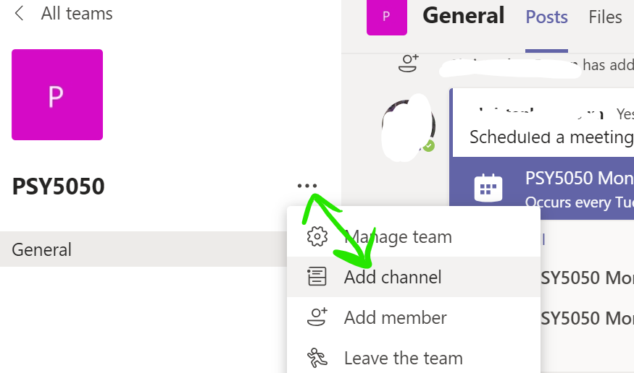

1. Give the channel a suitable name, here we are using *Tutorial Group A*. We only want members of a tutorial group to have access to their own group, so the privacy option should be set to *Private*:

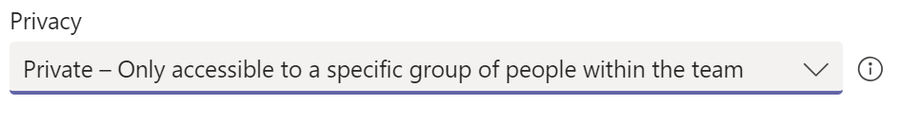

1. On the next screen, add the students that will belong to the group—remember to click *Add* when finished. If you would like to designate other people as teachers, you can do so in the Teacher tab, the user must first exist in the main PSY5050 team, though. You can always add or remove students and teachers later in the options.
2. Create additional channels for any other tutorial groups, we now have two groups in the PSY5050 module. Each one will be given a different scheduled meeting time:

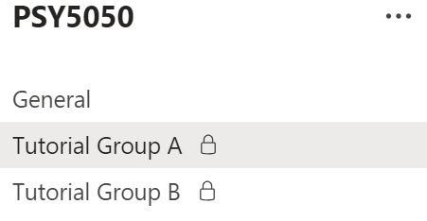

TIP: *You can create as many channels as you like. They are a good way of organising smaller teams for group projects. Remember—students can create teams too, so they can work with teams outside of the module you created if they like. As the Team owner for the module, only you can create channels within it.*

**Step 2 - Schedule Tutorial Meetings**

Niggle: *It is not currently possible to schedule the meeting of a private channel in the Teams calendar. This feature is in development with Microsoft and is expected in the next academic term. In the meantime, a simple workaround will do*:

To meet, open the channel, see the conversation panel, and select the *Meet now* button to begin a meeting:

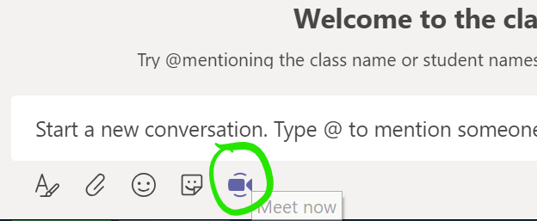

With this workaround, participants should open the channel to see the *Join meeting* option. If you want to schedule it, you will need to set up a normal Outlook meeting invitation, which you can set to recur. You can include a link to the team, although the student will need to enter the tutorial group channel from there. To get a link to the team, open the team options, and select *Get link to team*:

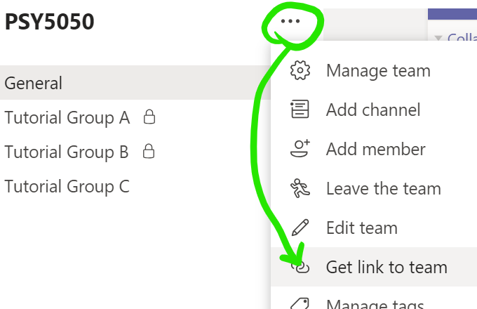

**Step 3 - Deliver the Tutorial**

A tutorial is just like a normal meeting in Teams. It is best if the option to restrict presenters is not used, since students should be able to share content or desktops if required. Given the relatively small group sizes, this should be easily managed, but you can always establish the hand-raising or comment etiquette of lectures if appropriate.

**Step 3.1a** **– Secondary Meetings (Breakouts)**

A secondary meeting (breakout) is simply a separate meeting taking place at the same time as another. In Teams, there is no distinction between a meeting and a breakout, they are the same thing and have no special rules for creating them.

NOTE: *Microsoft have announced that a dedicated Breakout Rooms feature will be released in an Autumn 2020 update to Teams.*

1. A student should have a separate meeting by creating one in the usual way (see step 3.1b), where one group member simply invites the others. There is no need to leave the main tutorial, it will continue with the sub-users on hold, appearing on the main Teams meeting panel:

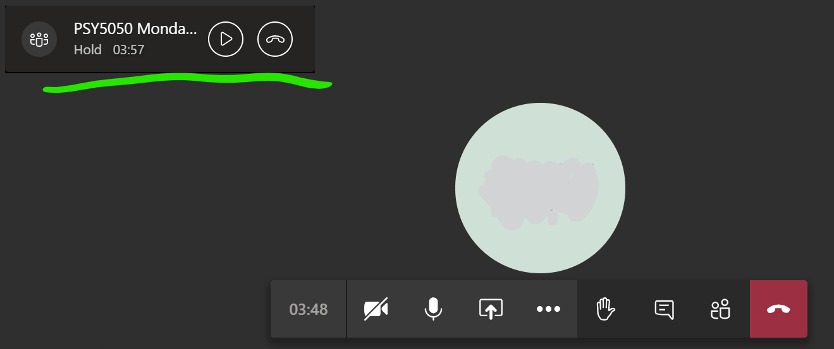

1. Resume the main meeting with the play button, which will then place the sub-user on hold in the other meeting, allowing them to switch between both.

*Students can carry out separate discussions or teamwork in a subgroup. Likely scenarios would include having them discuss a topic, with instructions to return to the main meeting after a certain time to present findings.*

**Step 3.1b – Create Breakout Rooms**

A structured approach to breakout rooms is to create them in advance, in a quantity suited to the class size. They operate similarly to the tutorial group channels but are generally more dynamic and are all set up as standard, rather than private, channels. This means that any member of the overall team can enter or leave the channel and start a meeting in it.

1. A tutor or administrator creates a set of new channels, simply called “Breakout Room 1”, “Breakout Room 2” and so on. In our example module, let us suppose there are 12 students, and that groups of 6 are intended for breakouts. Two rooms are enough for this:

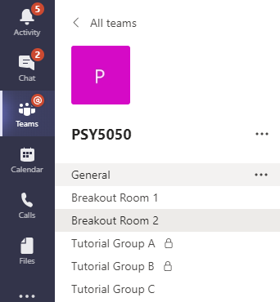

1. Rather than adding students, advise them at the time which groups they belong to, and ask each group to enter a different room.
2. Designate one person as the host of each group and ask them to start a meeting which the others can join. You can ask them to come back to the main meeting after a fixed time or visit their groups and join their meetings instead.
3. Freely enter and leave the meetings of other channels as you like. There is no need to stop the main meeting, you can continue it on hold and switch between several.

**Step 3.1c -** **Ways to Initiate a Secondary Meeting, Student Perspective**

There are no special rules for creating a secondary meeting. A user familiar with Teams will probably know how to do this without help, but it is useful to know the most common ways so that you can advise students. Here are two methods from the student perspective:

Method 1 – Call Someone

Whether already in a meeting or not, you can make another meeting call via the *Calls* panel. Open it from the left-hand menu, you may need to select the *More added apps* button first:

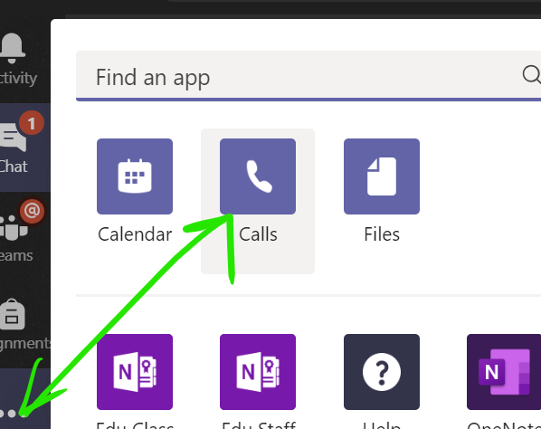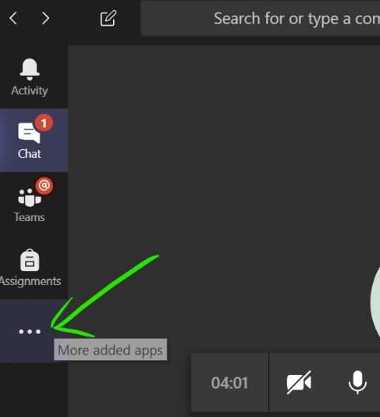  
The *Calls* panel lets you call as many users as you like, or you can invite others to join once the meeting has begun. Select Make a call, then enter the names of the people you would like to call in the box and press the voice or video call button as preferred:

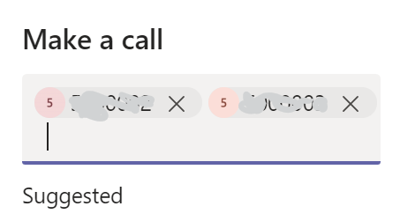  
The other members of the group can accept the call, with video or voice, and the main tutorial meeting will continue with hold as described in the previous step.

Method 2 - Meet in a Team or Channel

This approach is more structured and suits group work.

**Visit an Existing Channel**

Often groups or breakout rooms will have been set up for students already. They could be assigned to one in advance (typically applies to fixed groupwork teams), or they could be asked to enter one during the teaching session (dynamically, as described in 3.1b). In either case, they will enter the appropriate channel and begin a secondary meeting.

**Create Your Own**

Students can create their own teams, or channels in teams that they own. The process of creating a team is the same for any user, where from the main *All teams* panel, the *Join or create team* button is used. The user gives the team a name and adds users to it. Note how the main meeting in still in session, as a floating box, after clicking through to the *All teams* section—creating the team in advance is better, but not necessary since it can be done on-the-go as we see:

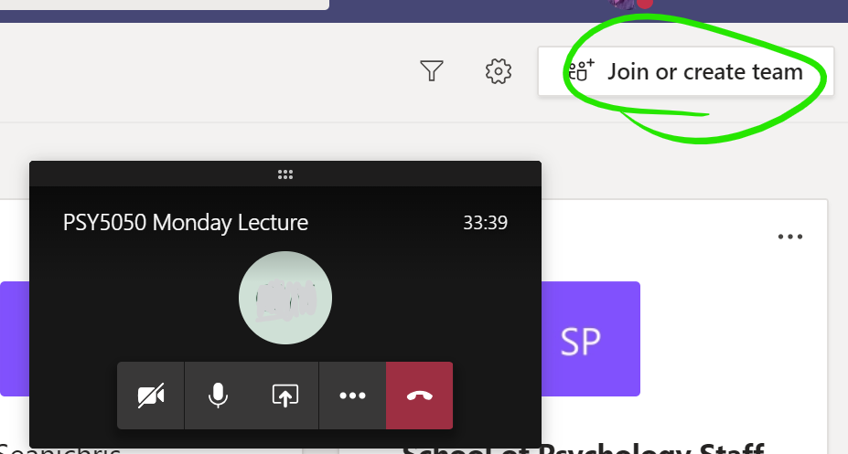

Of the available team types, *Other* is the most suitable, although any of them will do:

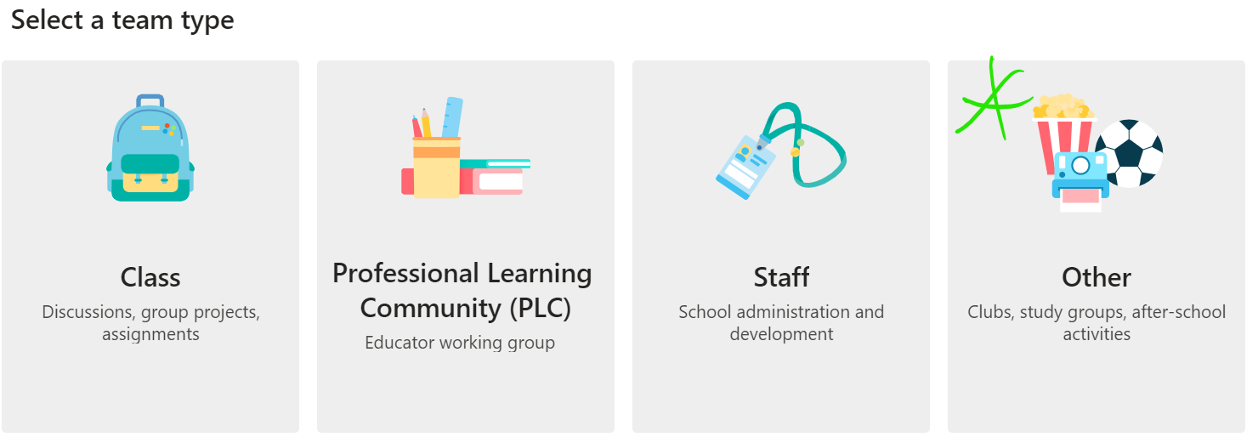

Once a team or channel is created and has users, open it, and use the meet now button:

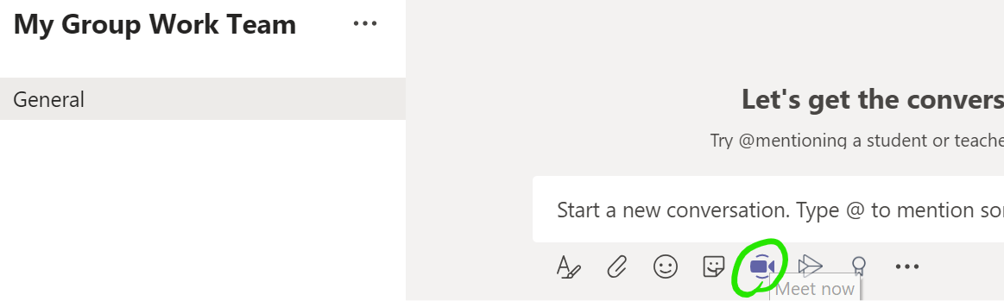

*With this method, students can operate a private team, and a tutor would be able to access it only by being included as a member, or by being invited to an active meeting.*

*Additionally:* Invite someone…

…to your already open meeting by clicking the *Show participants* button and enter a name in the *Invite someone* box:

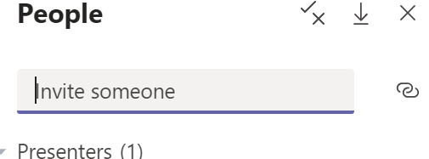

TIP: *Invitations can be to anybody, that means a student group could even invite you, or another supervisor, to join their meeting. The same hold functionality applies, so your other open meetings will be held for you and you can change between them as needed.*

**Step 3.2 -** **Sharing and Collaborating**

Share slides, file, and desktop views just as before. The difference between a lecture and tutorial is that now students will be allowed to share as well, since we did not restrict presentation permissions. This is done with the *Share* button as usual.

If you do need to change presentation permissions during the meeting, do so in the participants panel. Select the options beside any attendee name, and use the option to toggle presenter permissions:

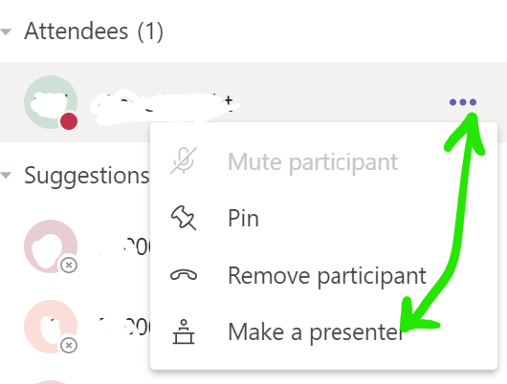

As with any team, files can also be posted outside of meetings in the main team panel. To limit the post to a specific tutorial group, simply open its channel and post there.

**Step 3.3 - Take Attendance**

Take attendance in the same way as a lecture meeting. Select *show participants* and see the download button at the top, allowing you to generate and save a list of attendees, noting that the CSV file will be saved to your computer’s *Downloads* folder by default:



*Remember to take attendance before the tutorial group meeting has ended.*

**Seminars in Teams**

Seminars are a type of lecture, conducted formally and usually with external users attending or presenting. We will look at how Teams can be used to give a seminar, with the assumption that the fundamentals of using it for lecturing are already understood. The seminar will be by invite, with no teams or channels created for it. The objectives are to:

* Schedule a recurring seminar that includes external users.
* Manage presenter permissions.
* Moderate the seminar.
* Record the seminar.

TIP: *While this section handles external users as invitees, they can also be guest members or even added to the Additional Persons system. Either way will allow membership of a team, and the use of most Teams features. See the External Users section for more information.*

**Step 1 - Schedule the Seminar**

There is no need to create a team or channel for a seminar, instead we go straight to the Teams calendar to set it up as a recurring meeting.

1. As before, create a new calendar meeting and give it an appropriate title.
2. Set dates and recurrence.
3. Note the *Invitee* section. We will use the *optional* invitees, although in practice there is no real distinction between required and optional, other than as a label. Add QUB users as normal.
4. Add external users by email address, note that the full email address should be entered, then the *invite user@email.com* option selected when it pops up:

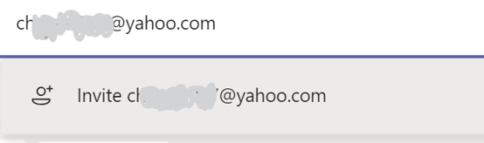

1. Finish adding users and save. You can always edit the calendar entry to add more users later.

**Step 2 -** **Manage and Moderate the Seminar**

A seminar is a formal meeting and usually a moderator (usually the person who created the meeting, known as the organiser) should be in attendance to answer or control comments or other participation. Teams allows up to 1,000 participants in a meeting.

Niggle: *Currently, meeting options to limit who can present (see Teams for Lectures section) are not available for external users as invitees. Microsoft do have this feature in their development plan, but in the meantime, we use a workaround.*

1. Enter the meeting options via the calendar.
2. Since external users are presenting, we will use a workaround to limit who can present. To begin, set the option for who can present to *Only me*:



1. Begin the meeting. Presenters and the organiser should aim to be present before the audience. The organiser, who has the *Who can present?* permission available to them, above, should then open the participants panel, and adjust the options for the guest presenter. Toggle the option to enable them to present, thus allowing them to share slides, files, and desktop:

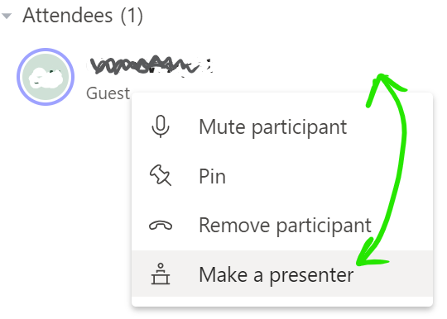

1. The moderator/organiser should mute all users other than the presenter as would be done for a lecture.

*In the unlikely event that an audience member unmutes repeatedly or otherwise disturbs the seminar, the moderator can remove the participant using the options menu. The moderator should manage hand raises and text comments as appropriate.*

**Step 2.1 - Recording a Seminar**

Record the seminar as described for lectures, using the *Start recording* option, the output will be saved to Microsoft Stream in your Office365 account:



**Other Facilities**

Teams can be used creatively to provide additional functionality. While not named specifically as features, the likes of breakout rooms (which have been covered already) and waiting rooms are quite possible.

**Informal Waiting Rooms**

Basic waiting rooms are achievable via the *invite* functionality of Teams which provides easy access to staff and students via the active directory. This feature can also be used by external users who have been added to a team as a guest user.

To remove a user, and invite them back:

1. With a meeting in progress, open the participants panel and find the name of the person you want to remove. Make sure they know to keep Teams on so that you can invite them back in.
2. Hover over the name so that the options icon can be selected and choose *Remove participant*.
3. Invite the user back in via the *Invite someone* box in the participant panel, or the *ask to join* option beside their name (if they are a member of the currently meeting team).

Using *invite*, you can type a name, student/staff number or QUB email address. The user will be prompted to join the meeting (as a Teams call):

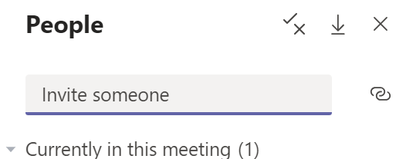

Using *ask to join*, is a convenient way to ask a member of a team who isn’t currently participating in the meeting, to join it:

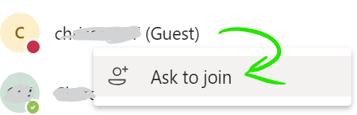

**Lobbies**

A more formal approach to waiting rooms is to use *Lobby* permissions. This allows the meeting organiser to control admission to the meeting, with participants queued in a lobby.

This facility is particularly useful for supervisors or demonstrators working with groups, since they can handle users one-by-one from the lobby.

1. With a meeting scheduled or in-progress, change the meeting options.

**(a) Scheduled** – Open the meeting details from the calendar or team conversation panel, and select *Meeting options*:

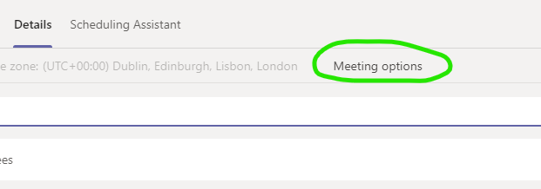

**…or (b) In-Progress** – Open the *Participants* panel and select *Manage permissions*:

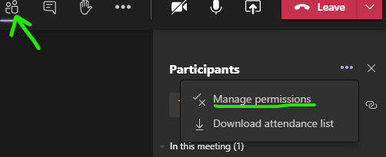

Tip for Demonstrators: *You can start a meeting in any channel you belong to, such as a module team or a tutorial group, using the “meet now” button. You can name the meeting when you start it – consider using your own name and something descriptive, so that your participants know which one to join.*

1. Edit the *Who can bypass the lobby?* option, setting it to *Only me*, then click *Save*. The *caller bypass* option will automatically switch off, which is fine:

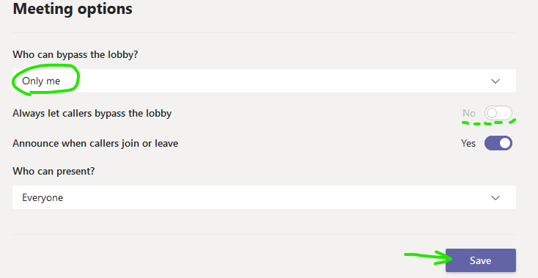

1. At this point, a user attempting to join the meeting will see a notification that someone will let them in soon, like this:



1. Your Participants panel will indicate those users waiting to join, which you can approve or reject:

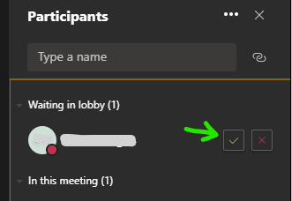

1. Right-click any participant to view the options where you can remove a user, ready to bring in the next one from the lobby.

**Interactive Screen Sharing (Remote Control)**

Teams allows one user to take control of another’s screen if it is being shared, and the screen owner allows it. This is sometimes referred to as remote control.

This feature is useful for supervisors or demonstrators since they can request control of a student’s screen to highlight issues or explain something.

1. A user shares their desktop as usual, with the meeting’s *Share* button followed by the *Desktop* button:

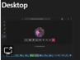

1. As the screen is shared with you, see the request access button on the meeting bar and press it:



1. The user sees a notification that you are requesting access, which they can approve or reject. If they approve the request, you will have control of their screen, which you can end at any time with the *Stop control* button. The sharing user has the option to stop control or sharing at any time too:



**External Users**

External users can use Teams. A little preparation and knowledge of the various approaches will help you deliver the best experience to them. An external user is anyone who does not have a QUB staff or student account, i.e. does not have a login for our Active Directory. We will look at the 3 main methods available to QUB users for including external users in Teams.

**As Meeting Invitees**

The lightest way to have an external user participate, is as a meeting invitee, with the invitation sent to their non-QUB email address. The email contains simple instructions for the user to join the meeting in their browser or the Teams app for PC or mobile.

An invited user does not belong to a team, so does not have access to files or other features of Teams. As a meeting participant, they can still share screens and use the general features of a Teams meeting. *See the Seminar section of this guide for more information on invitee access.*

Invite external users to a meeting via the Teams Calendar, in a scheduled meeting as usual:

* Add external users by email address, note that the full email address should be entered, then the *invite user@email.com* option selected when it pops up:



* Finish adding users and save. You can always edit the calendar entry to add more users later.

**As Guest Team Members**

The QUB instance of Teams has guest access enabled. This means that external users can be added to a team as a guest member and avail of most Teams functionality. They will need a free Microsoft account and will be prompted to use one.

Since they are not a member of QUB’s Office365, they will not be able to use its apps, and there are some Teams features that are unavailable to them. Should they need these features, or complete Teams access, they should be added to the Additional Persons system instead.

The main features that a guest cannot use are:

* Teams Calendar
* Scheduling Meetings (but a QUB user could do this for them)
* Apps Tab
* Advanced sharing, such as from OneDrive (but they can share their desktop)

Add a user as a guest via the team membership options, as you would for a QUB user:

1. Open the options for the relevant team, beside its name, and choose *add member*.

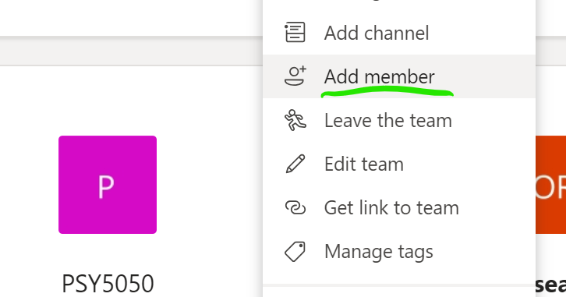

1. Click the option that appears asking to add the user as a guest.

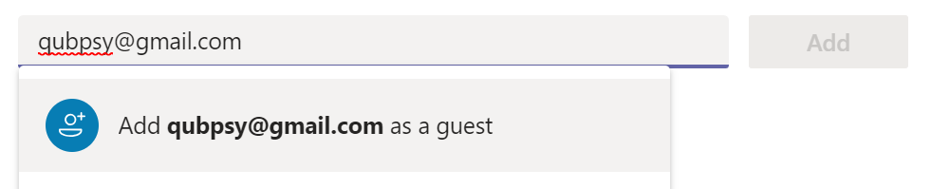

1. Click the Add button and wait a moment for it to resolve. You can close the dialogue if you have finished adding guests.

*The guest will receive an invitation to join the team, with simple instructions asking them to use a Microsoft account. If an institution email address was used (i.e. university or corporation) and that institution uses Office365, then they can join straight away with that account. If not, then they will be prompted to link their email address to a free Microsoft account.*

TIP: *Contact your guest early to confirm that they have joined successfully. The process is straightforward, but people have different levels of comfort with technology.*

**Via Additional Persons**

A user added to the Additional Persons (AP) system is effectively a staff member. They receive a staff number and can use Office365 and other QUB facilities if licensed to do so.

*An AP user can use Teams in the same way as a standard staff member, although they may not have a QUB mailbox. Without a QUB email address they can still use the Team calendar, but it won’t carry through to their Outlook calendar as it would for a standard user.*

Once a user has been added to Additional Persons and been issued their QUB credentials, you can request that they be licensed to use Teams and the Office365 platform.

To request licensing for Teams/Office365:

1. Eligible staff should be added to Additional Persons as usual, ensuring it is well in advance of the date they are due to work with us.
2. Once the staff number (which will begin with 26) is available, a SiteHelpDesk call should be logged, allow at least a week in advance if possible (although turnaround is usually same or next day): <https://it.qub.ac.uk/sitehelpdesk/>
3. Create the call with: *Call Type: Services*, *Category: Office365*, *Sub-category: Teams*
4. Add a subject e.g. *"Teams Access for Additional Persons User".*
5. In the description, ask that Teams (and Office365 generally if required) be enabled for the Additional Person users you have created, and give the staff numbers. Specify that Exchange mailbox is NOT required, unless that person has specifically requested a QUB email address.