DPEFY1
Queen’s University Belfast
DEGREE PLUS
Application for the Award of Degree Plus - Route A
Erasmus and University Exchange Study Placement: Full Year
This application form should be completed by students who have undertaken a full year Erasmus or University Exchange Study Placement

Section 1: Personal Details:
Name
Student Number
Course of Study
University School
Email |  | Telephone
Erasmus Host University
Erasmus Placement Dates

Section 2: Reflection on Personal and Career Development through Experience:
In this section we want you to show us what you have learned from your study abroad experience, how you have developed personal and employability skills and discuss the skills you have developed. You should focus on the non-academic benefits arising from your study abroad placement.
It may be helpful for you to think about your experience using the Kolb’s learning cycle below:
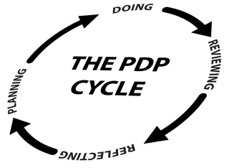
In writing about your experience demonstrate how you have learned about your own strengths and weaknesses, how you developed skills (state which skills you feel you developed and how), the impact of experience on your future career, this may be about career choice but may include material on, for example, features of your ideal job such as project work, working with others, working independently.
In order to be awarded the Degree Plus Award, candidates must clearly demonstrate the experience submitted has led to personal and career development; has facilitated the development of specified employability skills and has helped you to make plans for the future.
You should use the “Learning from my Degree Plus Experience” space below to provide an account of your experience and learning resulting from it. Your report should be approximately 1000 words in length.
Learning from my Degree Plus Experience

Please submit your application to the Global Opportunities Team
by email to: erasmus@qub.ac.uk
or by mail to: Global Opportunities Team
Careers, Employability and Skills
Student Guidance Centre
Queen’s University Belfast
Belfast BT7 1NN

