Fostering Achievement Awards

On Saturday, 15th October The Widening Participation Unit’s Outreach Officer Deirdre Lynskey alongside The Fostering Network NI hosted an event in the Whitla Hall, celebrating the successes and achievements of young people and children who have experienced care.
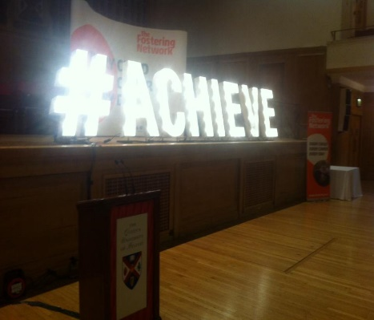
Despite the torrential downpours that day, around ninety young people (aged between 5-18 years) along with their families, carers and social workers came from across Northern Ireland to the award ceremony which was also attended by Queen’s University dignitaries. Vice-Chancellor Professor Patrick Johnston was in attendance and he kindly addressed the event and personally presented the young people with their awards recognising their achievement over the past year. These successes ranged from achieving swimming awards amongst the younger children to the successful completion of GCSE’s and A Levels amongst the young people.
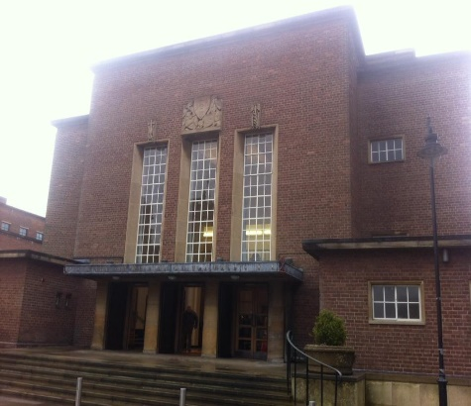
The event was also addressed by senior members and trustees of The Fostering Network as well as Queen’s University student Billy-Jo McDowell. Billy-Jo’s speech was particularly inspiring and she was also acknowledged during the event for her help assisting Deirdre Lynskey develop support initiates for Queen’s students who have experienced care, as well raising awareness within the university surrounding the issues Care experienced students face in Higher Education.
The awards ceremony concluded with a lunch and activities for the young people such as cake decorating and a participatory African drum circle delivered by ‘The Gathering Drum’.
The Widening Participation Unit would like to thank the Vice- Chancellor Professor Patrick Johnston, staff members, volunteers and most of all the attendees for making this awards ceremony a successful and memorable event for all.

