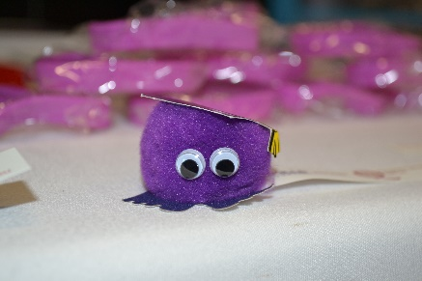
On Wednesday, 26th October The Widening Participation Unit team members Deirdre Lynskey (Outreach Officer), Patricia Hampson (Outreach Officer) Ryan Hughes (Graduate Intern) and Billy-Jo McDowell (Queen’s University Health and Social Care student) attended the ‘Tick The Box’ event hosted by The Fostering Network NI at The Waterfront Hall.
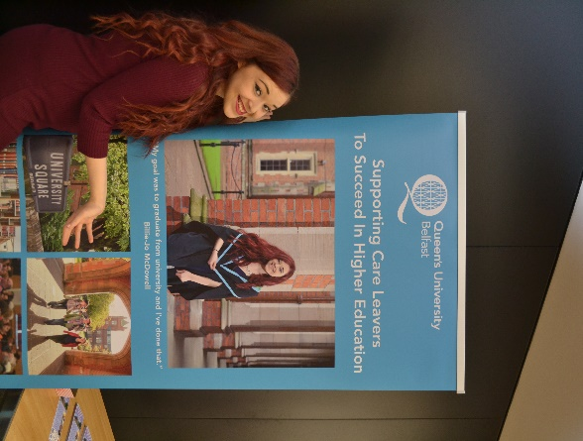
The ‘Tick The Box’ initiative aims to bring awareness to UCAS applicants who are care experienced to indicate on their applications that they are or have been looked after young people. The purpose of ticking the box is to ensure that potential universities can be aware that the applicant is a care experienced young person so they deliver all the levels of social and financial assistance care experienced young people are entitled to anonymously when they attend any university in the United Kingdom.
The event commenced at 10.30am, were different support agencies alongside Further and Higher Institutions set up stalls and met with young people who are care experienced. Furthermore, we also spoke with foster carers and social workers who are all working to support care experienced young people achieve their goals and academic potential within Further and Higher Education. This was followed by the showcasing of a new video by ‘Voice of Young People in Care Ltd (VOYPIC) alongside a Question and Answer session which involved The Widening Participation Unit’s Deirdre Lynskey as well as other leading voices in field.
We would like to thank everyone involved in hosting the event for inviting us and would to state that it is fantastic to see how partnership, collaboration and inter-organisation communication is making such a big impact on care experienced young people academic lives and get the most out of their Further and Higher Education experiences.
