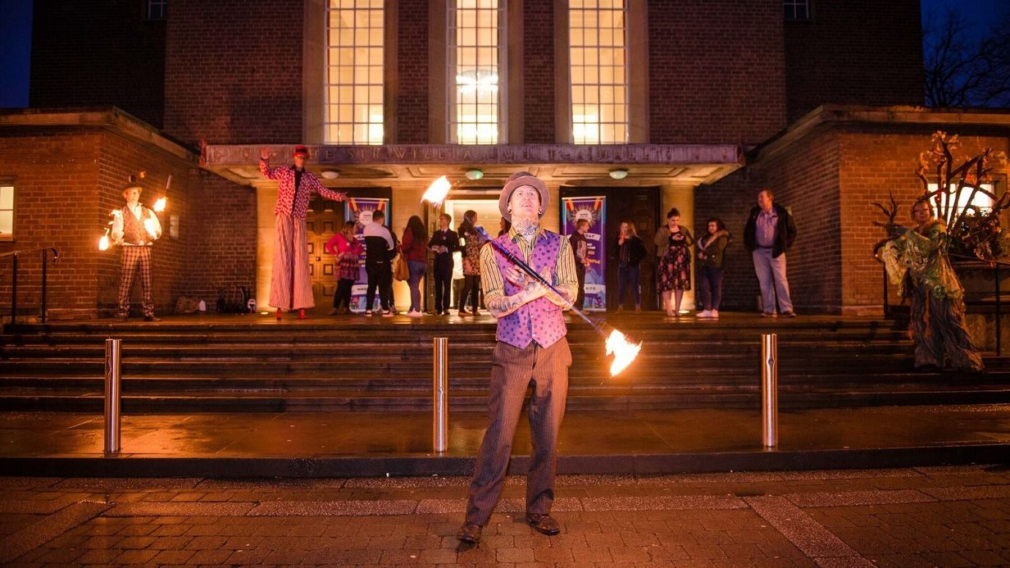
#CareDay 2017

‘Care Day’ is a joint initiative raising awareness of the rights and experiences of care-experienced children and young people between dedicated charities across the UK and Ireland under the ‘5 Nations, 1 Voice Alliance’. National charities involved include ‘Become’ in England, ‘Who Cares?’ in Scotland, ‘VOPIC’ in Northern Ireland, ‘EPIC’ in the Republic of Ireland and ‘Voices from Care’ in Wales.
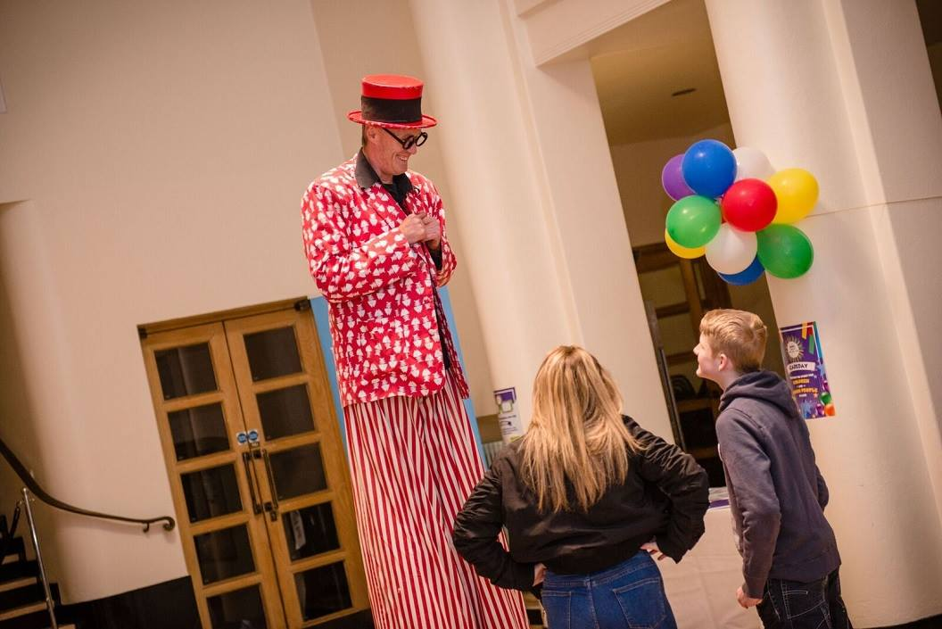
This year’s Care Day was held on Friday 17th February and was an opportunity for the people of the UK and Ireland to reflect on the childhood we as societies and institutions provide for child and young people in care or who are care-experienced. Furthermore, it is a time to contemplate the support provided to such children and young people to help them achieve their goals, dreams and to live successful lives. Care Day also provides us with a time to celebrate all the achievements of children and young people in care whilst also raising awareness and understanding of the issues they might face throughout their childhood and future beyond as young adults.
Here in Northern Ireland, Voice of Young People in Care (VOPIC) have undertaken incredible work supporting care-experienced children and young people since 1993 and Care Day was our opportunity here at Queen’s University Belfast to celebrate the achievements and those young people across Northern Ireland.
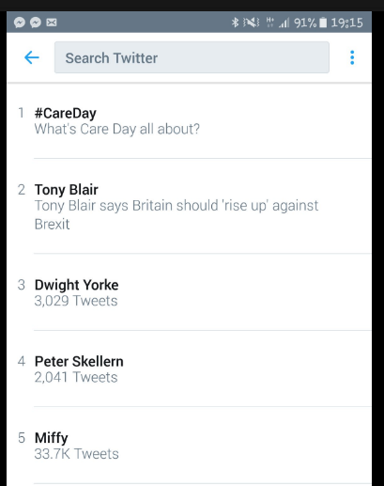
On Care Day, the Queen’s University Belfast’s Widening Participation Unit in conjunction with VOPIC asked staff and students at the university to wear purple on campus highlighting that will we all ‘see care differently’ and to help raise awareness of the campaign ‘LOOK, ACT, CARE’. This on-campus awareness campaign also was the precursor to our showcase event that evening called ‘The Care Factor’ held at the Whitla Hall.
The Care Factor event was an action-packed night of entertainment which included jugglers and fire-breathers, however the main event on the night was when a number of children and care-experienced young people, their carers and social workers showcased their x-factor talents by performing ‘rock-karaoke’ with the support of a live backing band flown over from England behind them on the main stage (some serious singing talent performed we must say!). We also all enjoyed a reception and there was also plenty of lovely food and beverages on the night of all to enjoy. Without a doubt the night was the Widening Participation Unit’s highlight of Care Day but we were also delighted to learn that the hashtag #CareDay was the UK and Ireland’s ‘number one trend’ on Twitter that day…. not surprising really considering how cool everyone involved in Care Day is!
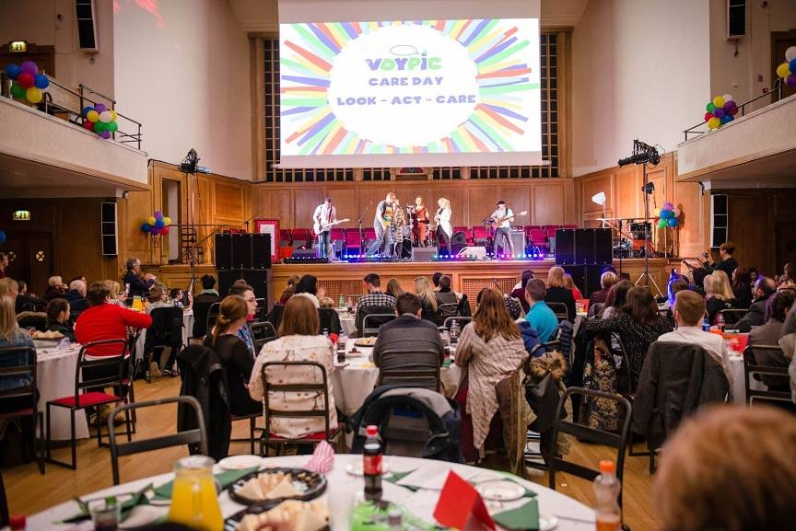
We would like to thank everyone involved who made Care Day possible here in Northern Ireland and across the UK and Ireland and for all the hard work everyone put into this great campaign. Finally, and most importantly, thank you to all the children and care-experienced young people, their carers and social workers for coming to The Care Factor and making the event a great celebration of all their individual and collective achievements and talents.

