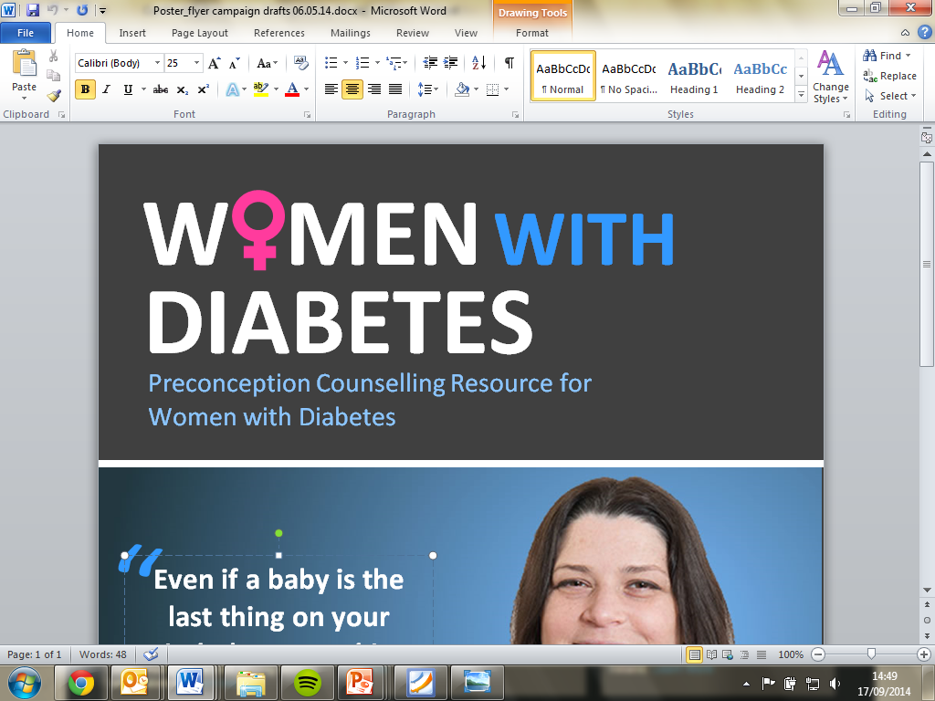
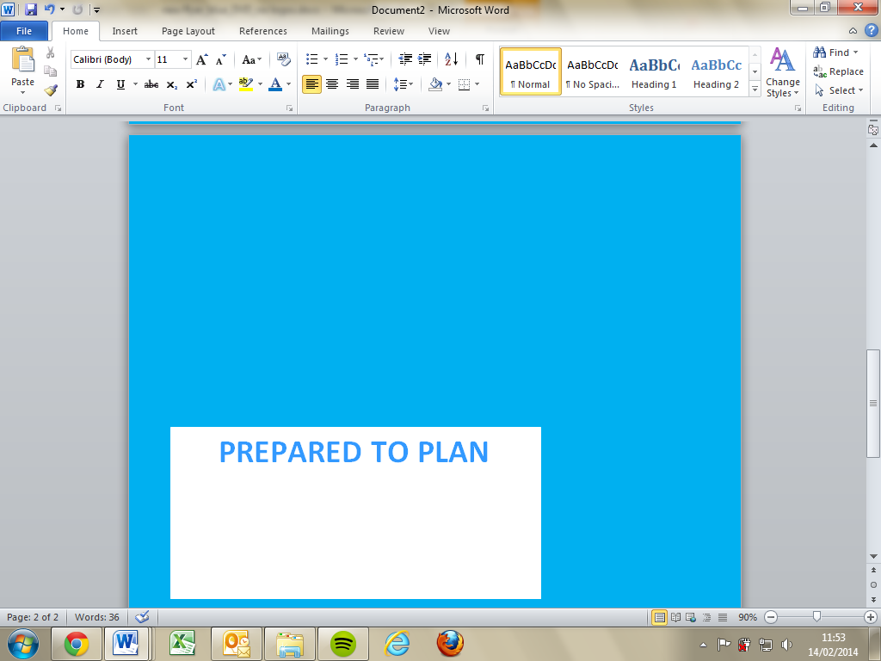

Certificate of Completion
This is to certify that

(Insert name)
Completed the full E-learning course on Preconception Counselling for W men with Diabetes

(Insert date)

