GETTING TO QUEEN’S UNIVERSITY BELFAST
Belfast is served by two airports, the George Best City Airport and Belfast International Airport.
BELFAST INTERNATIONAL AIRPORT CODE: BFS
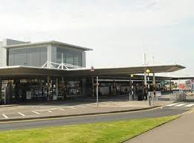
DISTANCE: 20 miles from Belfast City WEBSITE: www.belfastairport.com
By taxi: A taxi from the Belfast International Airport to Belfast City will cost approximately £35.00, but please check with the driver for an estimate before setting off. Only taxis approved by Belfast International Airport are permitted to use the taxi rank. A list of sample fares is displayed in the exit hall of the terminal building. A taxi share scheme to Belfast is available for those who wish to use it. For more information or to book a taxi please contact the Belfast International Airport Taxi Company on +44 (0)28 9448 4353 or visit http://www.belfastairporttaxis.com
By bus: The Airport Express Bus Service (Service 300) goes from the airport to the Belfast Europa Bus Centre, in the heart of the city. Currently a single is priced at £8.00 and a return costs £11.00. The timetable can be viewed on the Translink website. https://www.translink.co.uk/timetables
More info https://www.belfastairport.com/to-from
GEORGE BEST BELFAST CITY AIRPORT CODE: BHD

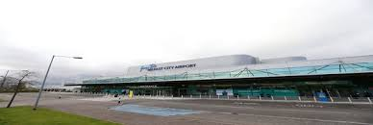
DISTANCE: 5 miles from Belfast City WEBSITE: belfastcityairport.com
By taxi: A taxi from Belfast City Airport to Belfast City Centre will cost approximately £10. Only taxis approved by Belfast City Airport are permitted to use the taxi rank. All fares are subject to a £2 surcharge. For more information or to book a taxi please call Value Cabs on +44 (0) 28 9080 9080 or visit the Value Cab website. (www.valuecabs.co.uk)
By bus: The Airport Express Bus Service (Service 600) goes from the airport to the Belfast Europa Bus Centre, in the heart of the city. A single is £2.50 or a return is £3.80. The timetable can be viewed on the Translink website. https://www.translink.co.uk/timetables
GETTING TO QUB BT1 ACCOMMODATION
You are staying in QUB BT1 accommodation, which is Belfast city centre and just a short walk from the main bus station, the Europa Bus Station.
Address: 78 College Avenue, Belfast, BT1 6BU
Take a virtual tour: https://www.qub.ac.uk/virtual-tour/?/accommodation/new-students-undergraduates/city-centre-accommodation-elms-bt1-bt2
Access to your accommodation: Students should check in at Reception where you will be issued with a fob which will allow access to your accommodation building, corridor and room.
If you have any queries in advance of arrival please email accommodationelmsbt1@qub.ac.uk

