Senate Election:
Guidelines on How to Vote
The process to elect two members of Academic Staff and two members of Support Staff to membership of Senate is underway.
As a member of Academic Staff, you are entitled to vote(*) for candidates within the Academic Staff constituency. The following Academic Staff nominations have been received:
- Dr Fred Currell
- Professor Michael Larkin
- Dr Dominic McSherry
- Professor John Morison
- Dr Renee Prendergast
- Dr Keith Steele
As a member of Support Staff, you are entitled to vote(*) for candidates within the Support Staff constituency. The following Support Staff nominations have been received:
- George Dunn
- Kevin Flanagan
- Liv Roberts
If you wish to view the candidates’ Supporting Statements, these can be accessed via www.qub.ac.uk/Home/ReconstitutionofSenate
(*) To be eligible to vote, you must have been in post on 1 October 2013 and hold appointments (including joint appointments) in duration for one year or more.
Voting will take place online and you can vote anytime between 21 November and midnight on 4 December 2013 – you will need access to a computer and you will also need a unique username and password to login to the Online Voting application.
What is my Username and Password?
Your username is your staff number. If you do not know your password, then you need to:
- Visit the Information Services Helpdesk, which is located on the ground floor in The Library at Queen’s. (Note: You must bring your staff card with you).
How do I Vote?
When you have your Queen’s username and password, you are then ready to cast your vote. Access to computer facilities and assistance with online voting has been made available in the following areas:

- The Library at Queen’s
- PEC offices
- All student computer labs
Login to your computer (Note: You can also login to a computer using your username and password in any of the Student Computer Centres on campus).
- Log in to Queen’s Online Open via the Queen’s homepage.

- You will be prompted for a username and password (see Figure 1).
Figure 1
Username and Password

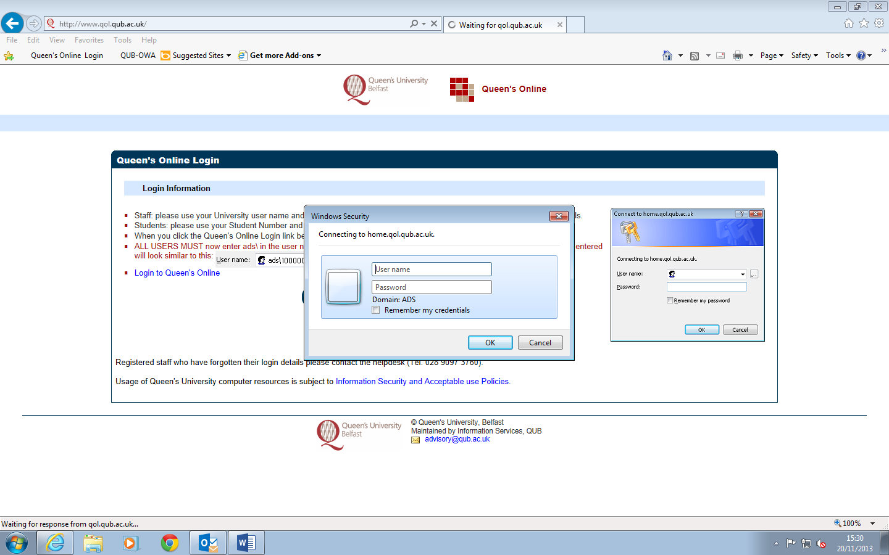

- In the Username field, you must type ads\ in front of your username (Note: your username is your staff number).

- In the Password field, type your password and click on the OK button. Your Queen’s Online homepage will be displayed (see Figure 2).
Note: If you have any problems logging in using your username and password, please contact the Information Services Helpdesk on ext: 3760.
In the My Services section (see Figure 2), under the heading Other, click on the Online Voting application.

Figure 2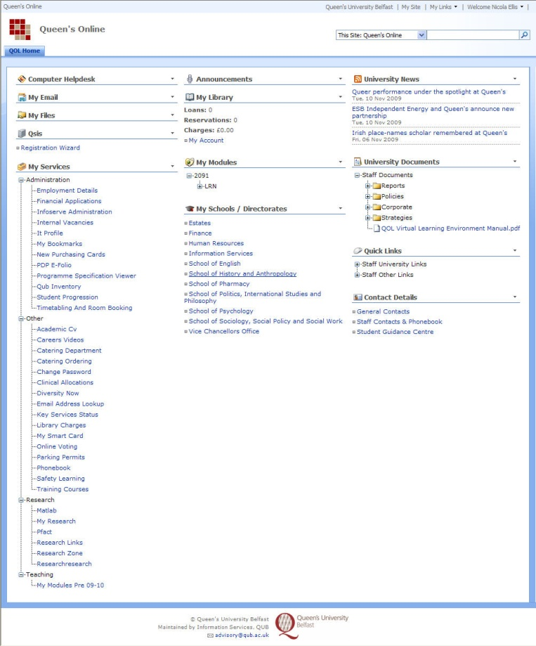
My Services
Online Voting

Online Voting

Vote Selection
Please select the election constituency in which you are eligible to vote.
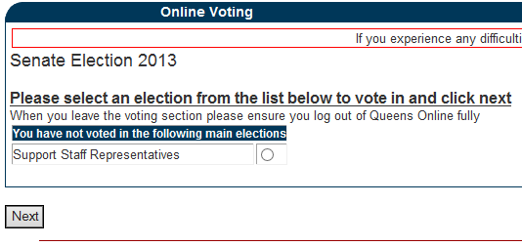

Vote Interface
The “ballot paper” is displayed, select the priority you want to assign to the candidates (the number of candidates determines the number of entries in the dropdown list). The order of candidates on the ballot is generated randomly each time the ballot is viewed.
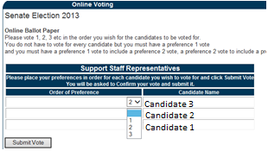
Vote Confirmation
Having chosen your preferences, the “ballot paper” is then displayed. Check that the vote is correct before submitting it or return to the Vote Interface and amend the vote.
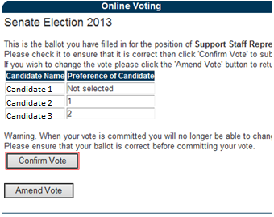

Vote Submission
This page commits the vote to the database. All votes are anonymous.
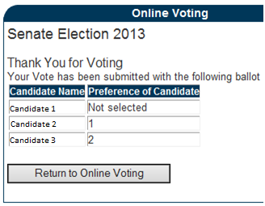
When you have finished voting, click on the drop down arrow beside your name on the top right corner of your Queen’s Online homepage and choose Sign Out.
- Log off the computer.
Note: If you have any problems accessing or using the Online Voting application, please contact Dominic Doherty ext: 3726.

