The Troubles and Beyond: Ulster Museum Visit
Summer School, 2019

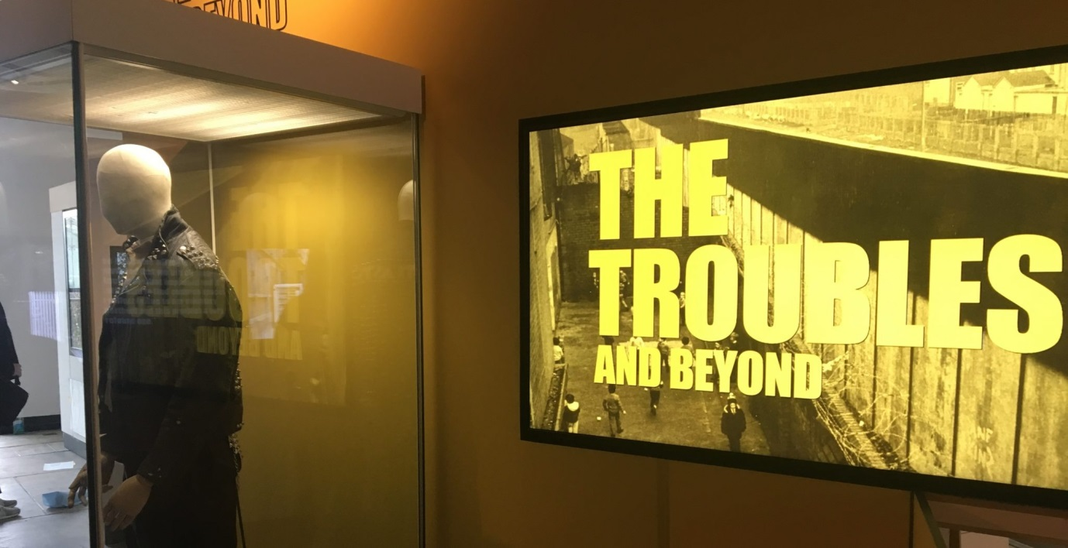
- What were you expecting from the new Troubles and Beyond exhibition?
  - If you are from QUB, did it make you think differently about the Troubles?
  - If you are not from QUB, do you understand the Troubles better than you did before you saw the exhibition?

- How did this exhibition compare with any other conflict or war exhibitions you have visited?

- What was the most surprising thing in the exhibition?

- What were some of the most moving aspects of the exhibition?

- What was missing from the exhibition?

- Did the exhibition ‘take a side’?
  - If so, which one, and how was it presented?
  - If not, what was the central message of the exhibition?

- What would you do differently if you were the curator of the exhibition?

