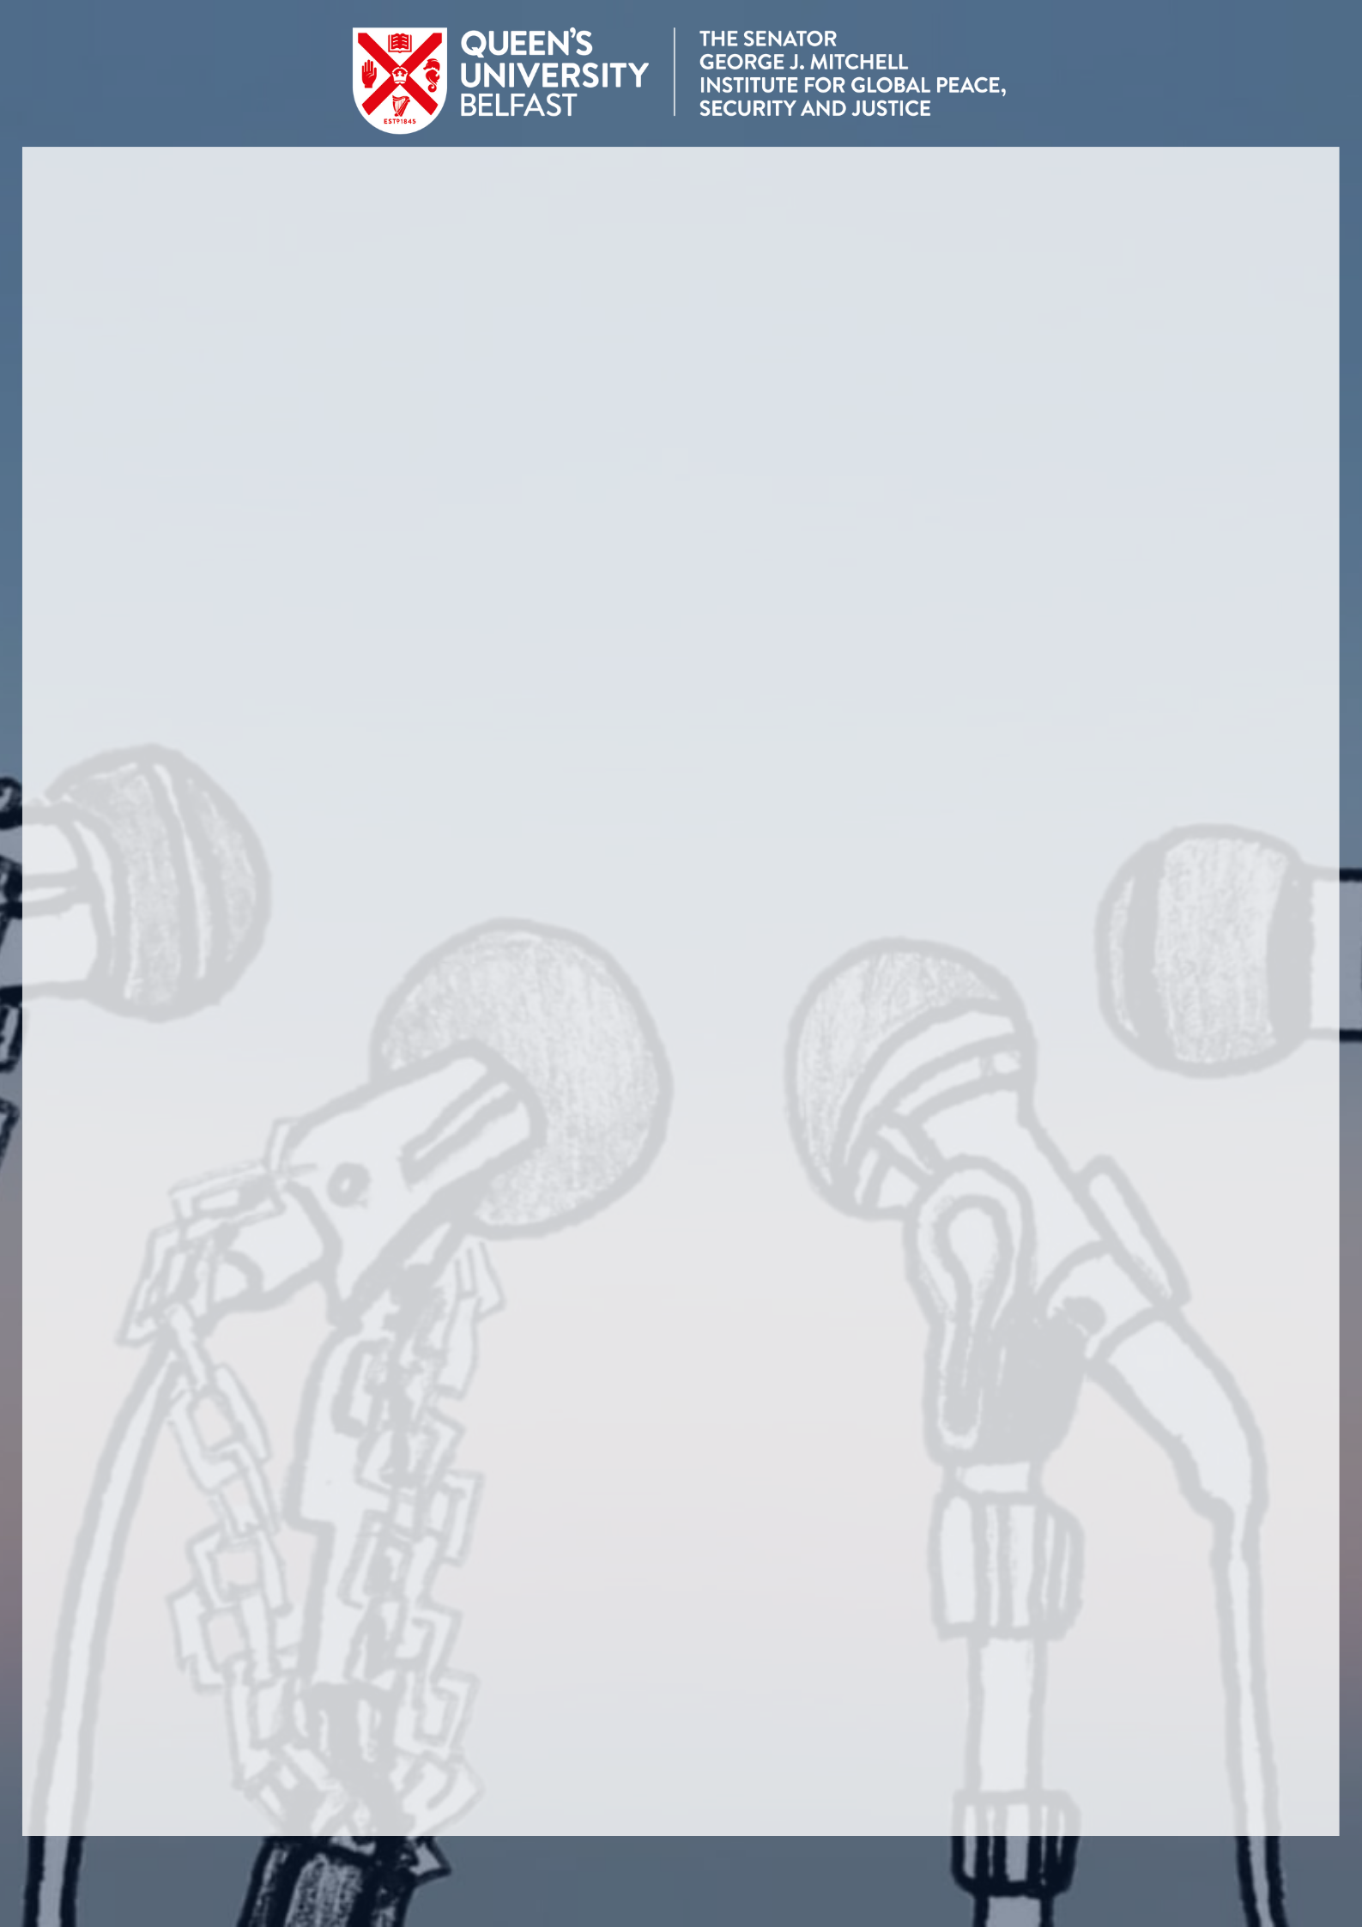
‘TRUE’ STORIES:
CONTESTING NARRATIVES OF VIOLENCE
VIRTUAL CONFERENCE PROGRAMME
MONDAY 25 MAY & TUESDAY 26 MAY 2020
INTERNATIONAL CONFERENCE
3PM-7PM CEST 2PM-6PM BST 9AM-1PM EST 7AM-11AM MDT 6AM-10AM PST
ROME LONDON NEW YORK COLORADO CALIFORNIA

Day 1
2:00 Brief Introduction
2:15 The role of narrative and language to facilitate understanding: An empirical reader-response study on narrative empathy
Dr. Carolina Fernandez-Quintanilla
2:45 Bus Tours on ‘Ireland’s Violent Frontier’
Matthew Gault
3:15 Remembering Experiences of Historical Institutional Abuse: The Centrality of ‘Voice’
Paula Shilliday
3:45 Conflict, Crisis, & Resolution: The Use of Diaries as a Tool For Peace
Savannah Olshove
Short Break
4:30 Keynote: Race and the Digital Divide

KEYNOTE SPEAKERS
Day 2
2:00 Brief Introduction
2:15 The Legacy of Gender in Northern Ireland
Elisa Cofini
2:45 Islam, Veiling & Political Agency: The Visual Performativity of Palestinian Female Suicide Bombers in U.S. Broadcast News Media
Dr. Matthew Kirk
3:15 Fairness, distortion and privilege: ethical challenges in reporting sexual violence in conflict
Janet H. Anderson & Benjamin Duerr
3:45 Media Coverage and Political Violence: Othering following Bloody Sunday
Hannah Smith
4:15 For Fox’s Sake: The Violent Impact of Anti-Immigration Narratives in Right Wing U.S. Media
David Mills
Short Break
5:00 Keynote: Walls of the Mind
Conclusion
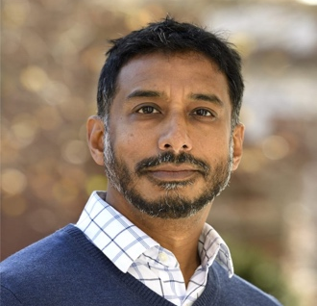
DAY 2
ANAND
PANDIAN
ACADEMIC, AUTHOR,
ETHNOGRAPHER

DAY 1
THEO
WILSON
ACTIVIST, SPEAKER,
POET, AUTHOR

