What are my Bank Account Details

A sort code is a 6 digit number that identifies your bank

Your bank account number is an 8 digit number

In your Banking App

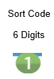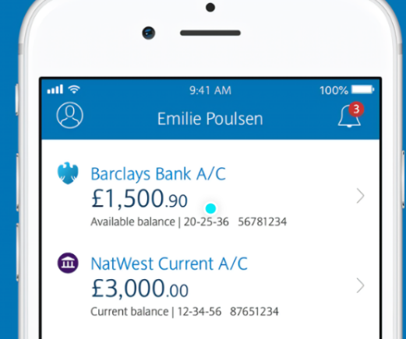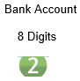

On Your Bank Statement
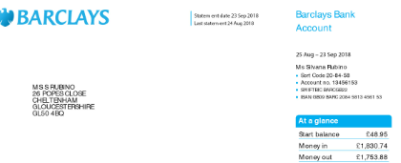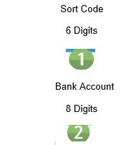

On your Bank Card

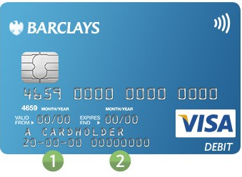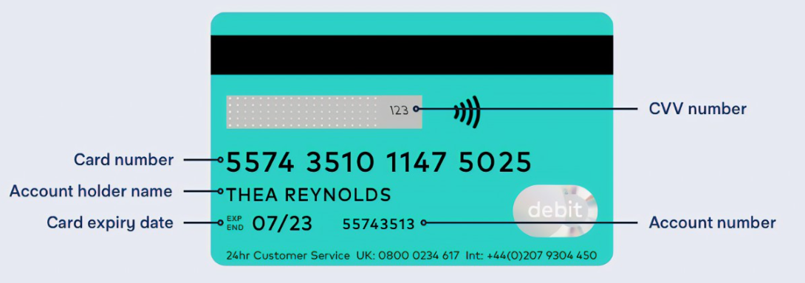

= sort code = bank account number

Some banks have it on the front and others on the back of the card.
If your bank account number starts with 0 please include all of these.

