Some essentials to get you started…

Queen’s BT1 Accommodation to Iceland Supermarket- 2 minute walk
Open 8am-7pm Mon-Sat & 1-6pm Sunday
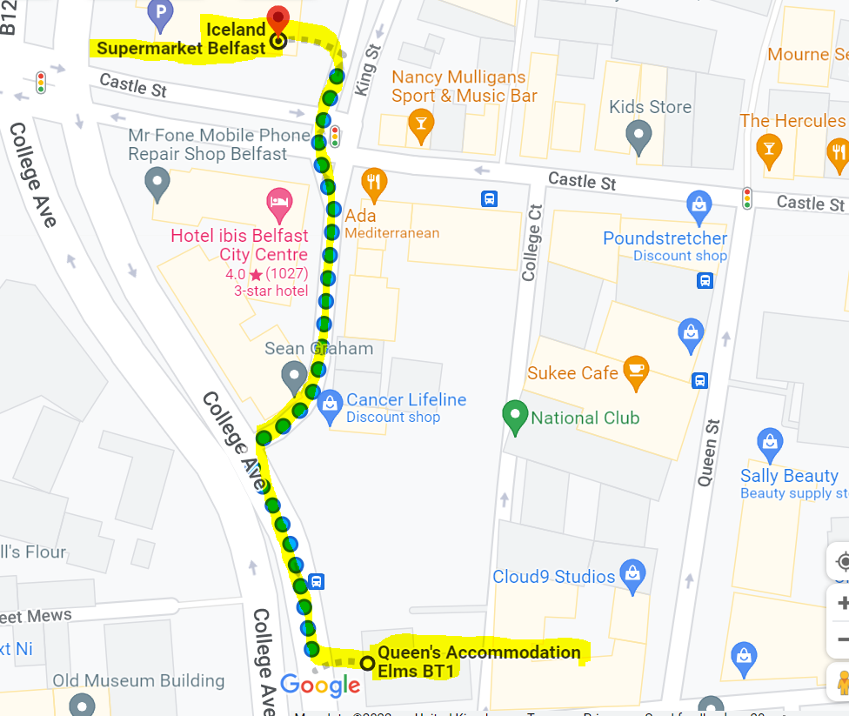

Queen’s BT1 to Tescos Supermarket- 4 min walk- Open 7am-11pm Mon-Sun
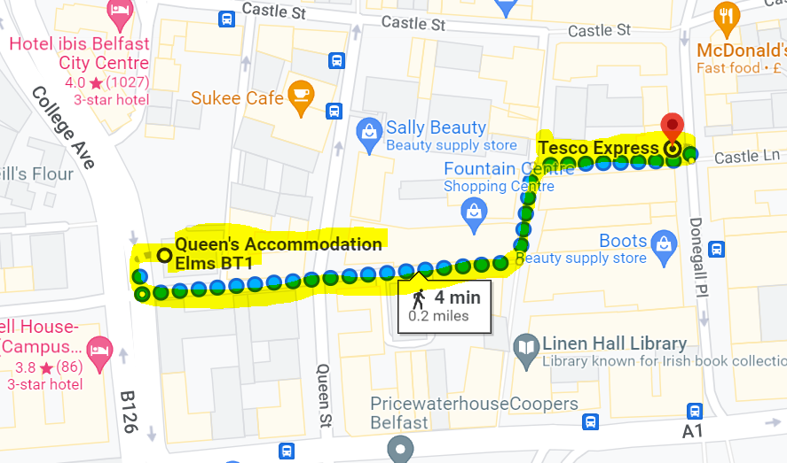
Pharmacies
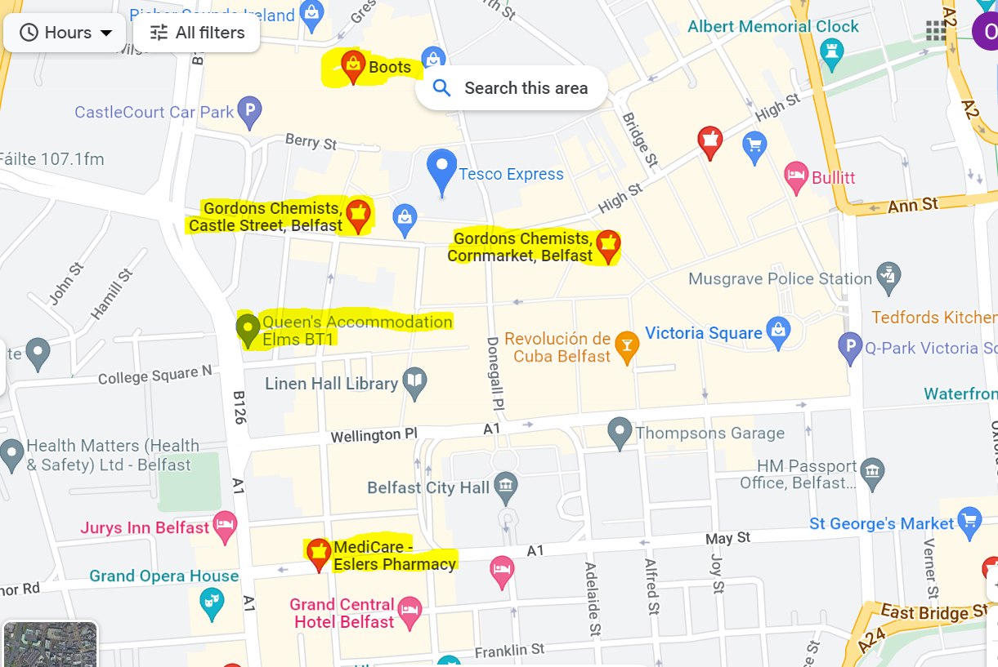

Coffee
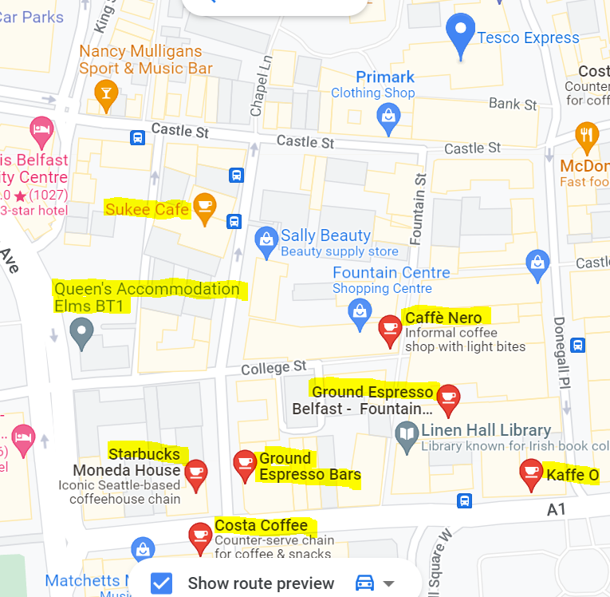
Visit Belfast- Official Belfast Tourist Information
Here, you can search for things to do and find out what’s on in Belfast and across Northern Ireland. Get information about Belfast hotels, accommodation, attractions, sightseeing tours, restaurants and bars, and be inspired by our Titanic heritage and Game of Thrones territory. Find out about getting here and download Belfast tourist maps. Or find out about the Visit Belfast Welcome Centre where you can pick up visitor guides and book tours and events tickets.
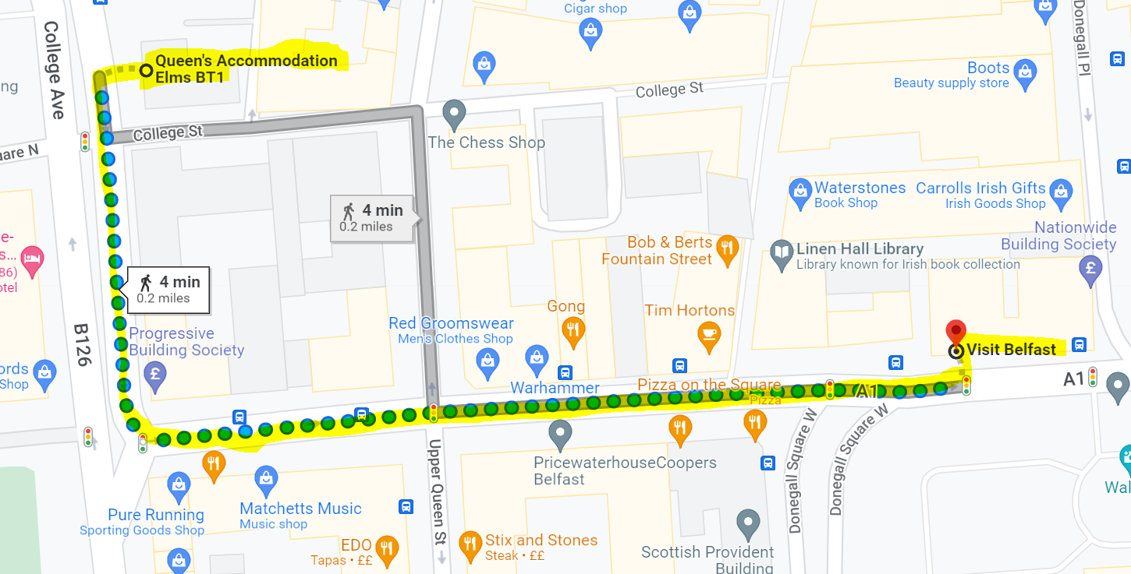

Queen’s University Belfast

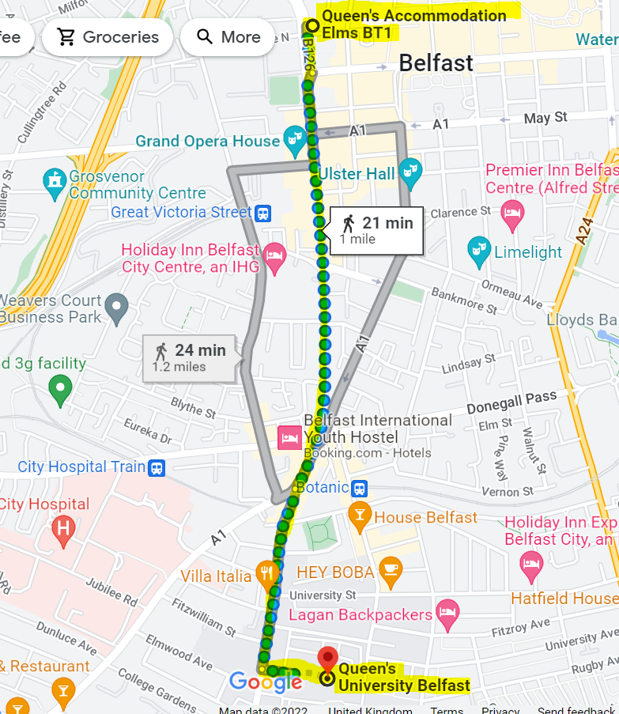

HEALTH & SAFETY
EMERGENCY SERVICES
The public emergency number (police, fire ambulance) in the UK is 999. Please note, the non-emergency number is for the Police Service of Northern Ireland (PSNI) is 101.
To do this from a University telephone, dial 028 9097 2222 to contact the University Control Room operator or 9-999 to contact Police, Fire and Ambulance services.
Click here for further information.

SECURITY
If you are concerned about your safety on campus please call the Security 24-hour number on + 44 (0) 28 9097 5099.
If you have been subject to a Criminal Incident (including hate crime, sexual assault, domestic violence etc.) please report via the following options:
• 999 (in an emergency), or 101 (non-emergency)
• 24 hour Domestic and Sexual Abuse Helpline on 0808 802 1414
• You can report anonymously or with details using our Report & Support website
COVID-19
Information for Students | Coronavirus (COVID-19) FAQs | Queen's University Belfast (qub.ac.uk)
WEATHER
The climate of Northern Ireland is influenced most by the Atlantic Ocean. As a result, it doesn’t have the extreme temperatures that other countries at similar latitude would have. A major warm ocean current called the North Atlantic Drift keeps sea temperatures mild too. Hills and mountains, mainly around the coast, shelter the rest of the island from strong winds coming off the ocean. However, the indented shape of the coastline and the presence of high ground introduce localised differences in temperature, cloud and precipitation.
Our weather can be unpredictable, so we like to discuss it! So while the weather can be changeable – it’s rarely extreme. But do prepare for rain, as it’s called the Emerald Isle for a reason.
As we head into winter daylight hours will get shorter. Sunday, October 30, 2022, 2:00:00 am clocks are turned backward 1 hour to Sunday, October 30, 2022, 1:00:00 am local standard time instead. Sunrise and sunset will be about 1 hour earlier on Oct 30, 2022 than the day before. There will be more light in the morning.
CURRENCY
Northern Ireland uses the £ pound sterling, the currency also in circulation in England, Scotland and Wales. In the Republic of Ireland the currency is Euro. Please note: Northern Ireland businesses do not accept Euros. A currency exchange service is available from the Ulster Bank, located beside the Student Guidance Centre, University Road.
ATMs are numerous and most credit/debit cards are accepted.
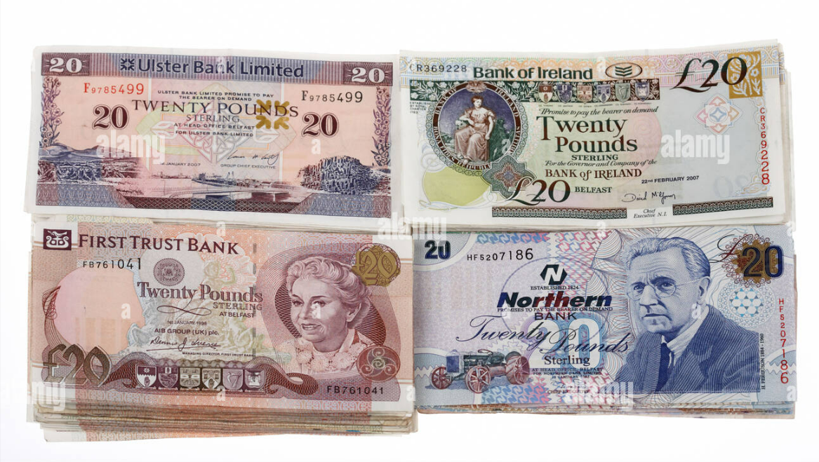
TOP TIP:
The 4 main banks in Northern Ireland issue their own £ sterling banknotes in addition to Bank of England notes, so be prepared for a variety of designs!
Electrical Adapters Plugs in Northern Ireland are three-pronged and the electricity supply is 240v.
POSTAL SERVICES
The most convenient Post Office near Queen’s BT1 accommodation is located at 16 Howard Street. There is also a Post Office opposite Queen’s main Lanyon building beside the Student Guidance Centre.
EXPLORING BELFAST
Belfast is one of Europe’s most friendly and fashionable regional capitals, described by Lonely Planet as a ‘must-see visitor destination’. The beauty is that it is all packed into a compact city that’s easy and safe to explore. Why not try a free walking tour or a free public tour of one of Belfast’s most iconic buildings, Belfast City Hall which first opened its doors in August 1906 and is Belfast’s civic building.
Queen’s University is located in the heart of Belfast, in the leafy Queen’s Quarter district, crammed with arts, culture and great food and drink establishments to suit every budget for visitors to discover!

BY BIKE
The Just Eat Belfast Bikes scheme has 47 docking stations and over 300 bikes located across Belfast, providing a low cost, convenient and sustainable way to travel about the city. We have two docking stations on campus: one opposite the Lanyon Building, and the other at the McClay Library.
Belfast Bikes enables you to collect a bike from one docking station and leave it somewhere else in town.
Further information can be accessed below: https://www.belfastbikes.co.uk/en/belfast/information/
PUBLIC TRANSPORT
Translink is the public transport provider in Northern Ireland and operates all buses and trains. For up-to-date timetable information you can contact them on: t: +44 (0) 28 9066 6630 www.translink.co.uk
BUS
The Metro serves the greater Belfast area and the rest of Northern Ireland is covered by Ulsterbus. There are regular bus services from Belfast City Centre to Queen’s University and return. The Metro 8A, 8B, 8C, 8D all run 7 days a week. The cost of this journey is £1.60 single but multi journey cards can be purchased online in advance at a discounted rate. See here for ticket information. For information on timetables visit here.
TRAIN
Trains from Belfast to Dublin depart from Lanyon Place Railway Station and the journey time is approximately 2 hours 10 minutes. To get to Lanyon Place Railway Station you can take a train from Botanic Train Station which is a 5-minute walk from the main University campus. As well as Dublin, NI Railways operates regular trains to Bangor, Larne, the seaside resort of Portrush and Derry / Londonderry. The stretch of railway line from Coleraine to Derry / Londonderry is justifiably regarded as one of the most beautiful in the world, with scenery including lush forest, waterfalls, cliffs and unspoiled beaches. Information on tickets and timetables can be found here.
TAXIS
A taxi is a handy way of getting around Belfast, particularly in the evenings. Some handy telephone numbers are below: Value Cabs: +44 (0)28 9080 9080 FonaCab: +44 (0)28 9033 3333. Taxis are metered.
PLANE
Belfast is serviced by two airports, with regular flights to other cities in the UK and continental Europe if you wish to explore further on your weekends. Most flights from Belfast to the rest of the UK take less than an hour, and if you book early in advance they are reasonably priced. Ryanair, Easyjet, FlyBe, Aer Lingus and British Airways are just some of the main airlines who fly in and out of Belfast airports. Flight times from Belfast: Amsterdam 1 hour 35 mins; Barcelona 2 hours 50 mins; Edinburgh 50 minutes; London 1 hour 20 mins; Milan 2 hours 25 mins; Paris (CDG) 1 hour 45 mins

THINGS TO DO
Check out the Visit Belfast website to discover tours, festivals, culture and entertainment in Belfast this month. https://visitbelfast.com/
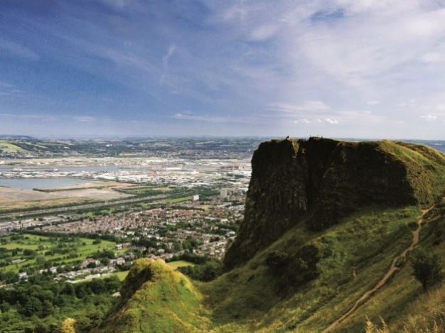
HIKE CAVEHILL
Cavehill Country Park is an iconic landmark situated in North Belfast, rising to 370m (1,207ft) to reveal stunning scenery with views across Belfast. Much of it is uphill, so if you want to discover the wonderful views best choose a sunny day and wear comfortable walking shoes! See if you can spot Napoleon’s Nose from a distance – the distinctive basaltic outcrop which resembles the profile of the famous emperor Napoleon, is said to have inspired the giant in Jonathan Swift’s Gulliver’s Travels.
ST GEORGE’S MARKET
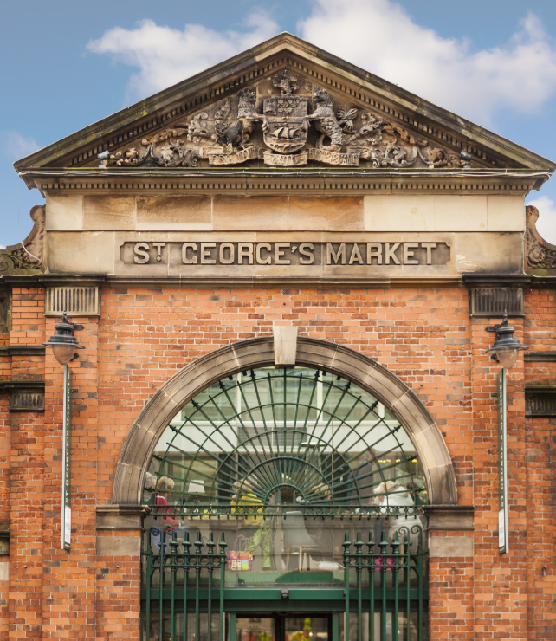
St George’s Market is the last surviving Victorian covered market in Belfast. There has been a Friday market on the St George’s site since 1604. As well as being home to some of the finest fresh produce, with customers travelling near and far to sample the delights of Friday, Saturday and Sunday markets, it has become one of the city’s most popular places to visit. The most popular being Saturday’s City Food and Craft Market, which includes local and international specialty foods, handmade crafts, flowers, local photography, pottery, glass and metal work. With a vibrant atmosphere and live music, it is one not to be missed!

VIEW FROM THE DOME
With panoramic views that stretch for miles across the city, the iconic Dome in Victoria Square Shopping Centre is a must visit when in Belfast!
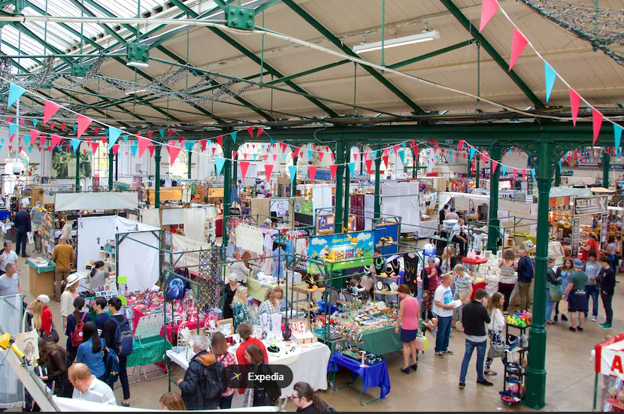
SAMPLE AN ULSTER FRY
Make sure you experience an Ulster Fry at least once! Queen’s students are particularly fond of Maggie Mays, an affordable café which has two sites in the Queen’s Quarter, one on Botanic Avenue and one at the foot of the Stranmillis Road.
HOP-ON HOP-OFF BUS TOUR
City Sightseeing Belfast with its panoramic open top double-decker red buses, offers you the opportunity to discover this attractive city from a preferential point of view. City Sightseeing Belfast 1 or 2-Day Hop-on Hop-off Bus Tour | GetYourGuide
GAME OF THRONES STUDIO TOUR
Step behind the scenes of The Seven Kingdoms at the official Game of Thrones Studio Tour. Benefit from optional transfers from Belfast or Dublin and prepare to experience the world of Game of Thrones like never before.

CRUMLIN ROAD GAOL
Visit Belfast’s infamous prison. Explore the jail’s cells, execution chamber and graveyard, as you learn about the prison's 150-year history.
TOP TIPS ON EATING OUT
Belfast is a city known for its wonderful food and has options to suit all budgets! Belfast has an amazing choice of restaurants and culinary experiences. From fresh seafood straight from the Irish shores and perfectly cooked outdoor grass-fed Irish steak to exciting healthy and vegan options.
Click here to see reviews of some of our finest eateries.
The average lunch (without drinks) costs approximately £8 per person. Dinner for two without wine in a mid-priced restaurant costs approximately £30. There are many restaurants and cafés nearby, and prices vary so you can choose according to your budget. The Botanic Avenue and Stranmillis areas near campus have many cafes and restaurants.
Check out www.visitbelfast.com/eat-drink and www.tripadvisor.co.uk/Restaurants

