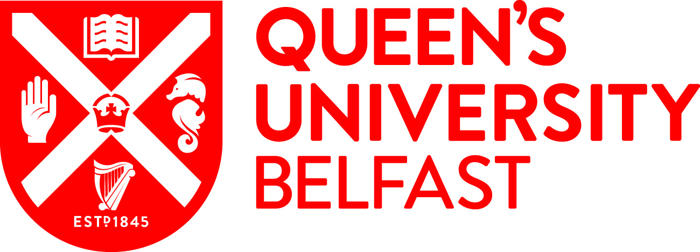
Faculty of Arts, Humanities and Social Sciences
Global Entrepreneurship Experience
Applications are invited from Queen’s undergraduate students in the Faculty of Arts, Humanities and Social Sciences to take part in:

Two-week session on Global Entrepreneurship and Innovation in
the University of Massachusetts Lowell, USA from
8 July to 19 July 2019

This programme is funded by Santander for two students and covers:
- Return flights to Boston
- 16 days of accommodation
- Meals
- Local transportation
- Weekend events and activities
Upon return from the programme, students must submit a report on their experiences and how the opportunity has benefitted them by 31 August 2019.
You can find more information on this exciting opportunity on the page 2 and at the link below:
https://www.uml.edu/msb/global-entrepreneurship/

TO APPLY PLEASE CLICK HERE TO COMPLETE APPLICATION FORM

The closing date is 12noon on Monday 18 March 2019
If you have any general queries please contact Lynda Mahon on l.davison@qub.ac.uk.

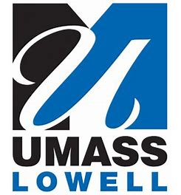

PROGRAMME DETAILS
There will be 2 sections running in parallel, with no more than 60 participants in each section. The Course is designed to help students understand the importance of entrepreneurship and innovation in today's global economy and to cultivate an entrepreneurial mind-set, will work in inter-disciplinary, multi-cultural environments exploring problem solving techniques, opportunities identification, business concept development and venture planning using standard business model framework and bringing ideas to reality.

The Course will require students to work on real life technological/social projects and evaluate their commercialization potentials and opportunities. Students will be required to explore opportunities on a global basis, thus will require to apply their own national and regional knowledge. Any venture is built on knowledge in multiple business areas such as engineering, marketing, operations, finance, etc. The class will consist of about 50% working on real life projects and rest will be specific topic discussions, case studies, exercises, guest entrepreneurs and field visits. Each project team will be of 5 participants with a balance between discipline, nationality and academic level. A Certificate will be awarded upon the completion of the workshop.

Entrepreneurship topics
- Essentials of Innovation and Entrepreneurship
- Business Model Generation, Lean Launchpad
- Customer Discovery and development
- Design Thinking, Innovation & Entrepreneurship
- Team Building and Leadership
- Market Research, Digital Marketing
- Making Presentations
- Financing New ventures

Field Visits
The Field Visits will include visits to technology companies such as MKS Instruments, iRobot, Wintress Control, Amazon; and visits to incubators including UMass Lowell (Innovation Hub), DifferenceMaker, UMass Maker’s Space and others in the Lowell area.
TYPICAL SCHEDULE
Day | Morning Activity | Afternoon Activity
Day 1 and 2: Arrive
Day 3 | Lowell Tour | Orientation/Introduction  Getting to know one another (Ice Breaker)
Day 4 | Welcome by the Dean  Essentials of Entrepreneurship & Innovation  Ideation and Class Exercise Instructions | Building and Managing Teams  Entrepreneurship process  Class exercises  Meet & Greet (social event)
Day 5 | Class exercises - presentation  Class Projects Instructions  Business Model Canvas | Market Research and Market Research resource  Group projects
Day 6 | Lean Launchpad  Design Thinking | Group Project
Day 7 | Digital Marketing  Innovation & Creativity Class Activities | Business Analytics: New Venture Opportunities  Group Project
Day 8 | Tech Companies Visits | Incubators visits (Lowell, Boston)
Day 9 and 10: Visit Boston and other weekend activities
Day 11 | Financing Ventures  Guest Entrepreneur | Group Projects
Day 12 | Venture Implementation and Management  Guest Entrepreneur | Group Projects
Day 13 | Making Presentations  IP and technology Commercialization | Group Projects
Day 14 | Building Entrepreneurial Persuasion Skills  Guest Entrepreneurs | Finalize presentations and report
Day 15 | Student presentations; Certificate Award Ceremony. Experience Survey (on-line)
Day 16 | Leave Boston or continue with Post-session activities and other sessions

