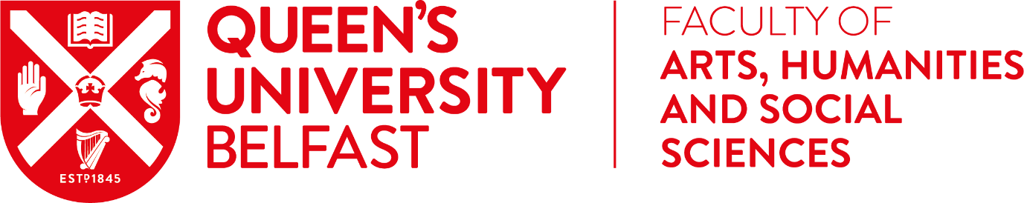

Continued from Welcome from AHSS Faculty Focus Newsletter – 30 September 2020

“As I reflect on the past six months, I am confident and excited about the year ahead. Yes, there will be challenges and we need to continue to prioritise staff wellbeing as we work together to undertake high quality teaching and research. There is also excitement about what we can achieve together and the difference we can make to those around us.

Every day in my new role I learn more about the work that is going on across the Faculty. I am extremely impressed by the quality of scholarship and staff focus on making a difference to society. AHSS is in a unique position to positively impact individuals and change lives, whether through direct interventions or indirectly through organisations and public policy. A priority for me is to further enhance the impact of our work, but fundamental in achieving this, is ensuring that we continue to undertake the highest quality of research. This is the foundation for the knowledge we share with students and the wider stakeholder community.

How we engage with our students is also critical in inspiring and nurturing the next generation of leaders in our society. A priority must be to support students to become resilient, responsible citizens who are personally, professionally and socially ambitious.

I trust that you and your families will continue to keep safe and well.”

Nola

