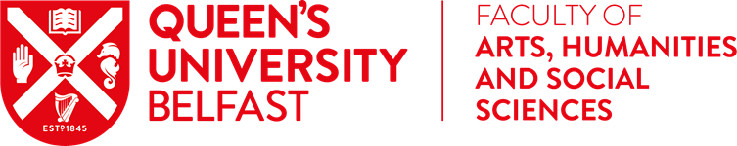

Continued from Nola’s Welcome

Academic life also continues with some notable successes in recent weeks. AEL have achieved Athena SWAN Bronze award, Seamus Heaney Centre Fellow, Anna Burns has been awarded the 26th Christopher Ewart-Biggs Literary prize for her novel *Milkman* with Professor Katy Hayward also awarded a further Ewart-Briggs prize for her Twitter account dealing with the implications of Brexit. In addition, Dr Alison Garden (AEL) has been awarded a UKRI Future Leaders Fellowship to work with the arts and cultural sector to produce an interdisciplinary social and cultural history of mixed marriage, or love across the divide, in modern Ireland. Of course, there are many other successes across the Faculty with first paper acceptances, book contracts secured, first keynote addresses given etc. All of these successes are notable milestones and recognition of the hard work that is undertaken. Congratulations!

As you are aware, AHSS undertook a survey of staff to better understand how you were managing Semester 1. There was an exceptional response to this survey and many of you spent considerable time providing detailed insight of the positives and negatives of blended teaching. This enabled us to have constructive conversations across the University, about technology, Canvas, digital learning support, track and trace systems, asymptomatic testing, greater use of online delivery in some subject areas and student and staff wellbeing. The voice of staff must be heard in all decision-making contexts. Again, I stress that my door is always open and you should feel free at any point to contact me if there are issues that you would like to discuss.

I am sure that over the next few months, we will continue to adapt to changing circumstances, whether personally or professionally. I will continue to work closely with your Head of School and will be visiting all School Management Committees in the next few weeks. Thank you for all of your efforts and please, take care of yourself and your loved ones.

Nola