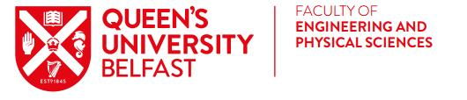
Beijing University of Chemical Technology, China
International Summer Programme July 2020

The Faculty of Engineering and Physical Sciences is sponsoring 10 students from the school of Chemistry & Chemical Engineering to participate in a two-week summer international programme at Beijing University of Chemical Technology (BUCT).

In 2020 the following summer programme is available:
- International Summer Camp for S & T Innovation:
* Stimulating the potential of innovation & Creativity
* Improving Scientific Literacy and Humanistic Literacy
* Expanding international vision & Experience Multiculturalism
* Improving Team Spirit and Practical Abilities
* Obtaining Scholarship Opportunities

Eligibility: Level 1, Level 2 and any Level 3 undergraduate integrated Masters Students in good academic standing on: Chemistry and Chemical Engineering degree programmes.

Final year students due to graduate in 2020, previous participants on Faculty EPS International Summer Programmes and non NI/UK/EU students are not eligible to apply.

Cost:
Sponsorship covers Accommodation, Tuition/Training fee, Company visits, Cultural trips, Airport Transport, visas and flights.
£500 student contribution required to ensure student commitment. Full payment required by 12 noon on Friday 20th March 2020.

Programme Dates:
- July 2020 (Exact dates TBC).
- Please allow extra time (2-3 days) for travel on either side of these dates.

Application Process:
Please email the following documents to k.walker@qub.ac.uk by 4pm on Friday 31st January 2020:
- Attached Application Form and Unofficial Degree Transcript (Students may access an unofficial copy of their academic record through Qsis: http://www.qub.ac.uk/directorates/sgc/srecords/YourStudentRecord/Transcripts/).
- Please save documents as a PDF using your name.
- Brief interviews for short listed students will take place. Students will be advised of the date and time. Successful applicants will be required to attend a pre-departure workshop in May 2020.

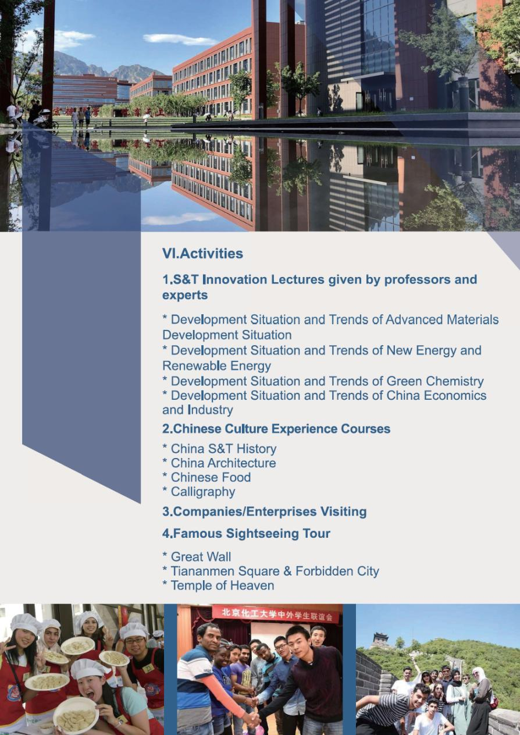
Beijing University of Chemical Technology, China
International Summer Programme 2020
APPLICATION FORM
All information supplied will be used to select Programme participants.
PERSONAL DETAILS:
Name: |  | Student No:
Degree Pathway: |  | Stage/Level:
Mobile Number: |  | Home Number:
QUB Email:
Address:
I wish to apply for Beijing University of Chemical Technology International Summer Camp for S & T 2020
(please circle as appropriate):
Yes | No

Please attach Unofficial Copy of Degree Transcript.
Please add the following information in support of your application:
Are you registered with Disability Services at Queen’s?
(please check x) Yes No

Do you have a disability, medical condition, mental health condition or learning difficulty which may require additional support arrangements at the host university?
(please check x) Yes No

If Yes, please provide details below:

Applicant Agreement and Permissions: In signing below, you are agreeing to both statements:
Queen’s University Belfast (“we”, “us” and “our”) is committed to protecting your personal data. The notice is addressed to students who participate in programmes facilitated by us, (“you” and “your”). This Privacy Notice tells you why we need to collect personal information about you, what we will do with it, and how we will look after it. It also tells you about your legal rights in relation to your Personal Data. If you have any questions about this privacy notice, please contact us. Further details are available at the following link: https://www.qub.ac.uk/directorates/sgc/careers/ImproveYourEmployability/CareerManagementandEmployabilityProgrammes/CESPrivacyNotice/
Signature: * ________________________________ Date: ____________________
*Please sign and scan form

Beijing University of Chemical Technology, China
International Summer Programme 2020
APPLICATION FORM
Please provide personal examples and specific evidence in answering the questions below:

Why should we choose you to represent Queen’s University on this programme? (max 250 words)

What is your motivation for participating in the Exchange Programme? (max 250 words)

What knowledge and skills would you expect to develop from the Exchange Programme? (max 250 words)

In what ways will you apply the learning experience after the Exchange Programme? (max 200 words)

