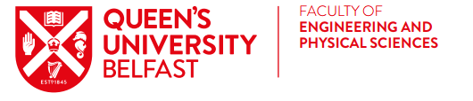
Beijing Institute of Technology, China
International Summer Programme 5th July – 1st August 2020

The Faculty of Engineering and Physical Sciences is sponsoring 20 students to participate in a four-week summer international programme at Beijing Institute of Technology (BIT).

In 2020 four programmes are available:

- Intelligent Vehicles and Electric Vehicles: Intelligent vehicles and electric vehicles program includes both the academic lectures in Electric Vehicles, Vehicle transmission, Intelligent Vehicle Demos areas, and also the practice of Transmission Disassembly, Intelligent Vehicle Demos in the labs. In addition, students will have the chance to work with BIT Formula I Team and visit Beijing Electric Vehicle Company.

- Chinese Language and Culture: Chinese Language intensive study program includes three integrated courses：Basic Chinese, Conversation, and Chinese Listening. Students will have more chance to practice their Chinese language skills in the local environment. This program also invites BIT Chinese students as the language partners during study. The extracurricular courses include Chinese Calligraphy/Brush Painting, Paper Cutting, Chinese Songs and Kungfu.

- Big Data Analysis: The summer programme includes lectures on basic principles, related technologies and typical case studies of big data analysis from different industries and fields. The programme also illustrates the on-line big data practice system based on public cloud to show the demand for talents in big data and common job positions. Students can understand the building of big data application system, master the basic technologies and methods of data analysis, and initially have the basic ability to conduct big data analysis by combining professional knowledge and domain knowledge.

- The Overview of 5G System Key Technologies and Applications: In the 5G System Overview Programme, students will have the opportunity to attend Academic lectures centred on 5G key technologies overview, 5G network architecture design, and 5G application scenarios. In addition to these lectures, experimental and practical teaching is also offered to students to be engaged in the lab work such as simulation experiments on the MATLAB platform. During the technology innovation training section, students will participate in related events such as company visits.
Eligibility: Level 1, Level 2 and any Level 3 undergraduate integrated Masters Students in good academic standing on any programme across the EPS Faculty.

Final year students due to graduate in 2020, previous participants on EPS Faculty International Summer Programmes and non NI/UK/EU students are not eligible to apply.

Cost:
Sponsorship covers Accommodation, Tuition/Training fees, Company visits, Cultural trips, Airport Transport, Visas and Flights.
£500 student contribution required to ensure commitment of students.
Full payment required by 12 noon on Friday 20th March 2020.

Programme Dates:
- Sunday 5th July – Saturday 1st August 2020
- Please allow extra time (2-3 days) for travel on either side of these dates.

Application Process:
Please email the following documents to k.walker@qub.ac.uk by 4pm on Friday 31st January 2020:
- Attached Application Form and Unofficial Degree Transcript (Students may access an unofficial copy of their academic record through Qsis: http://www.qub.ac.uk/directorates/sgc/srecords/YourStudentRecord/Transcripts/).
- Please save documents as a PDF using your name.
- Brief interviews for short listed students will take place. Students will be advised of the date and time. Successful applicants will be required to attend a pre-departure workshop in May 2020.

2020 BIT INTERNATIONAL SUMMER PROGRAMMES

BEIJING, CHINA

July 5 – August 1, 2020

GET INSPIRED AND JOIN THE MOST INNOVATIVE SUMMER PROGRAMME IN CHINA!
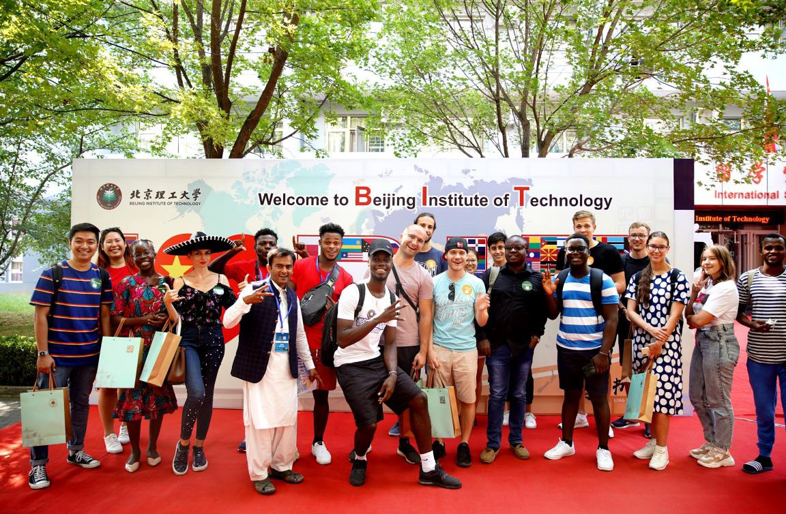

Program I: Intelligent Vehicles and Electric Vehicles Program II: Big Data Analysis
Program III: The Overview of 5G System - Key Technologies and Applications ProgramⅣ: Chinese Language and Culture

Top 10 University in Science and Engineering in China
389th QS World Ranking (2018)
Top 2 in Per Capita Research Funding Ranking in China (2018)
Top 10 in QS World Ranking in Employer-Student Connections (2019) Top 86 in QS World Ranking in Partnerships with Employers (2019) 9 National Key Laboratories
3300+ Faculty Number and Experts
27,000+Students
2500+International Students from 147 Countries

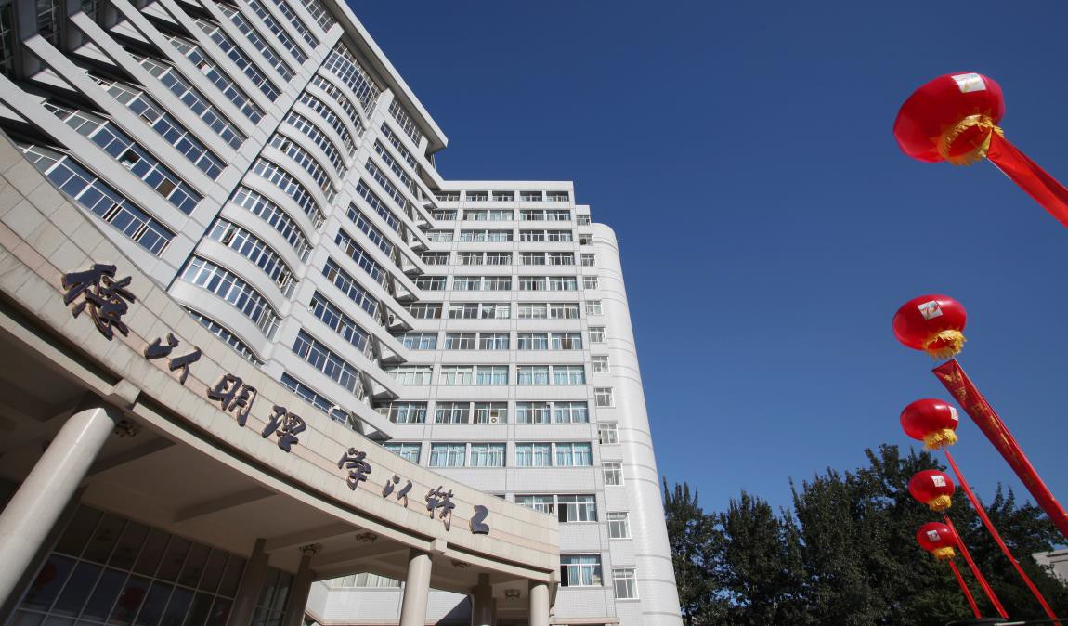

Beijing Institute of Technology (BIT) is a national key university with a focus on science and engineering, coordinated development of management and humanities. In the 2018 World University Rankings published by QS, BIT ranked 389th in the world, 76th in Asia and the top10 in science and engineering in China. It has been one of the key universities in China since the founding of New China and the first batch of universities which has entered the national “211 Project”, “985 Project” and the “Top A World-class University”.

INTRODUCTION
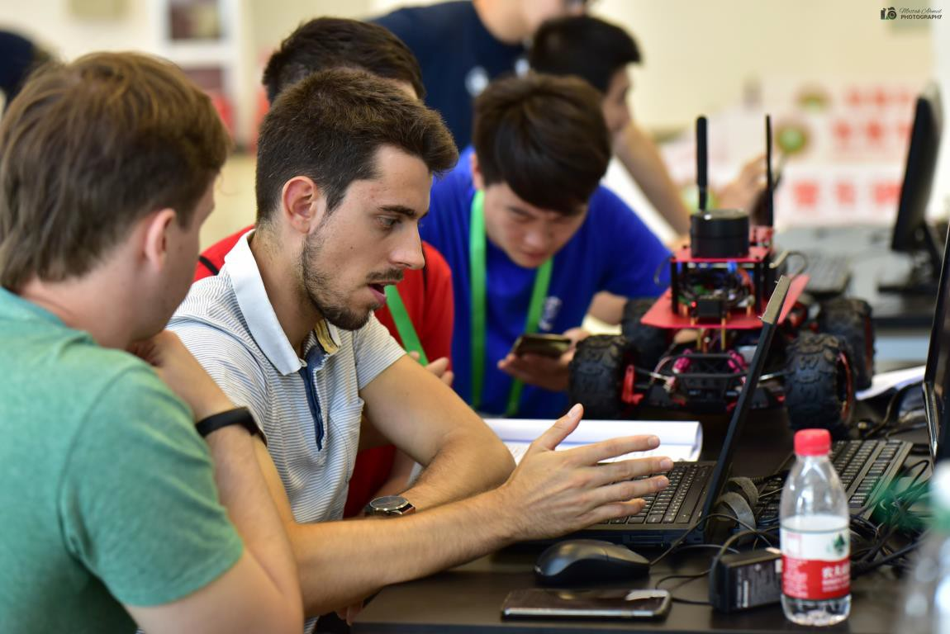
BIT international summer programmes provide students with the opportunity to experience Chinese campus life at one of China’s top universities. The programme lasts for 4 weeks from 5th July to 1st August, 2020 and a huge emphasis has been put on the quality of the lectures, professors and even participants who have confirmed quality of the curriculum to be the main reason for choosing us. There will be four programmes offered by BIT during summer, including Intelligent Vehicles and Electric Vehicles (Program I), Big Data Analysis (Program II), The Overview of 5G System - Key Technologies and Applications (Program III) and Chinese Language and Culture (Program Ⅳ). Students are welcomed to choose one of the programmes according to their interests and
academic background.

In addition, we would like to introduce you to the China's world-famous places, such as the Great Wall and the Forbidden City to explore more about Chinese culture. During the stay in Beijing, students will also make friends with BIT Chinese and international students. Professional curriculum drives interest among young people around the globe, who will collect lot of wonderful memories through studying, spending time together and traveling within organized field trips around Beijing.

Make your 2020 summer unforgettable! Join us at the best summer abroad programme in China! Let’s create digital future together!

Program : Intelligent Vehicles and Electric Vehicles (4 credits)

Introduction:
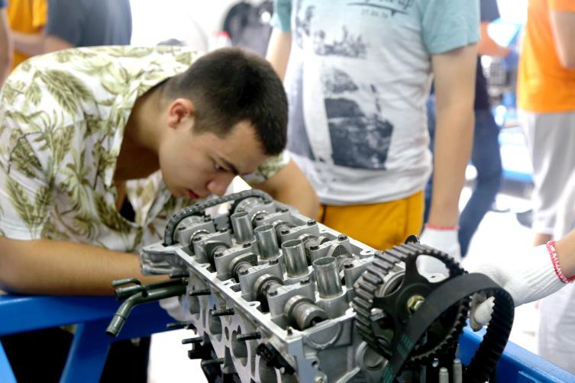
The School of Mechanical Engineering of BIT is a national leader in mechanical engineering in China. According to the China Discipline Ranking, conducted by China Ministry of Education (MOE), Mechanical Engineering at BIT achieves 2%-5% in the nation. In the Intelligent Vehicles and Electric Vehicles programme, students will have chance to learn the Academic lectures centered on renewable technology in China,
electric vehicles, off-road vehicles, vehicle aerodynamics and intelligent vehicle demos areas. Apart from these lectures, experimental and practical teaching is also offered to students to be engaged in the lab work such as assembling and disassembling engine and transmission. During the technology innovation training section, students will participate in related events such as company visit and work with BIT Formula I Team. In addition to these, we will provide the students with Chinese language learning and culture practices so that they will have a better understanding of China.

Highlight:
- Lectures on cutting-edge science and technology
- Lab practice
- Company visits
- Work with BIT student formula team
- Chinese Language Practice
- Historical Culture Tours

Qualifications
- Full time registered students
- Academic background in science and engineering

Skill Development
- Vehicle Performance Analysis
- Engine and Transmission Assembly
- Innovation Ability
- Problem-solving
- Group work

Program : Big Data Analysis (4 credits)

Introduction:
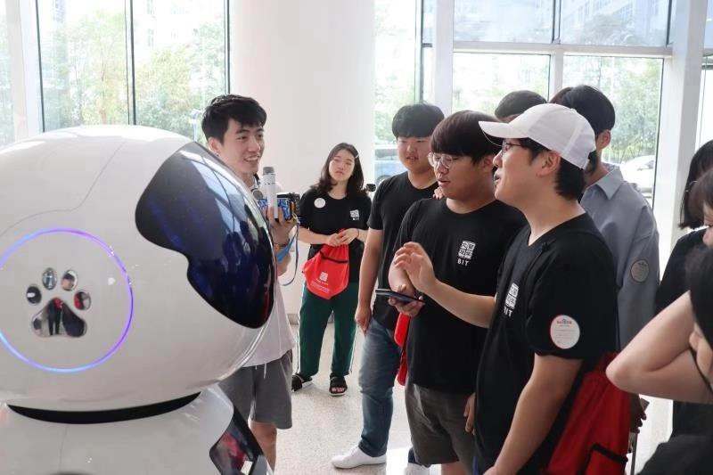
With the development of computing technology, and the development of Internet, Internet of Things, cloud computing and other technologies, information technology has clearly presented ternary fusion tendency of human, machine and material. Big data is increasingly affecting global production, circulation and distribution, consumption activities and economic operation mechanism, social lifestyle and national
governance capacity. What is big data? How to mine hidden value from data? How to learn and form the way of thinking of big data? Applying big data analysis technology to our study and work, helping us acquire new knowledge, and using the knowledge to improve our life and promote society's development, are the focus of this study. The summer programme includes the lecture on basic principles, related technologies and typical case study of big data analysis from different industries and fields. Combining with the online big data practice system based on public cloud to show the demand for talents in big data and common job positions. Through the programme, students can understand the building of big data application system, master the basic technologies and methods of data analysis, and initially have the basic ability to conduct big data analysis by combining professional knowledge and domain knowledge. Besides of these, students will have the chance to learn the basic Chinese Language and visit the culture spots.

Highlight:
- Lectures on big data analysis
- Lab practice
- Company visits
- Work with BIT students
- Chinese Language Practice
- Historical Culture Tours

Qualifications
- Full time registered students
- Academic background in science and engineering

Skill Development
- Programming in Python
- Data Analysis based on Hadoop tools
- Data Visualization
- Innovation Ability

ProgramⅢ: The Overview of 5G System - Key Technologies and Applications (4 credits)

Introduction:
The School of Information and Electronics is one of the popular colleges of BIT, focusing on mobile communication technology research. As the main direction of the development of the new generation of information communication, the fifth generation of mobile communication technology (5G) will penetrate into all fields of the future society, and build a comprehensive
information ecosystem with users as the centre. In the 5G System Overview Programme, students will have the opportunity to learn the Academic lectures centred on 5G key technologies overview, 5G network architecture design, and 5G application scenario overview. Apart from these lectures, experimental and practical teaching is also offered to students to be engaged in the lab work such as simulation experiments on the MATLAB platform. During the technology innovation training section, students will participate in related events such as company visit. In addition to these, we will provide the students with Chinese language learning and culture practices so that they will have a better understanding of China.

Highlight:
- Lectures on 5G science and technology
- Lab practice
- Company visits
- Chinese Language Practice
- Historical Culture Tours

Qualifications
- Full time registered students
- Academic background in science and engineering

Skill Development
- 5G Application
- Innovation Ability
- Communication skills
- Problem-solving
- Group work

Program : Chinese language and Culture (4 credits)

Introduction:
BIT provides the perfect opportunity for international students to get in touch with the traditional culture and history of China and brings students to the places of interest and natural scenic beauty. This programme includes three integrated courses: Basic Chinese, Conversation, and Chinese Listening. Students will have more chance to practice their Chinese language skills in the local environment. This programme also
invites BIT Chinese students as the language partners during study. The extracurricular courses include Chinese Calligraphy/Brush Painting, Paper Cutting, Chinese Tea Ceremony and Kungfu. Additionally, students will gain a deeper understanding of the past, present, and future of China through the historical Field trips to the Great Wall, the Forbidden City and the Summer Palace, etc.

Highlight:
- Chinese Kungfu
- Chinese Calligraphy
- Language partners with Chinese students
- Historical Culture Tours

Qualifications
- Full time registered students

Skill Development
- Chinese Language ability
- Cross-cultural communication
- Group work

Beijing Institute of Technology, China
International Summer Programme 2020
APPLICATION FORM
All information supplied will be used to select Programme participants.
PERSONAL DETAILS:
Name: |  | Student No:
Degree Pathway: |  | Stage/Level:
Mobile Number: |  | Home Number:
QUB Email:
Address:
I wish to apply for Beijing Institute of Technology International Summer Programme 2020
(please tick relevant programme below):
 | - Technical Programme: Intelligent Vehicles and Electric Vehicles
 | - Chinese Language Intensive Study
 | - Big Data Analysis
 | - The Overview of 5G System Key Technologies and Applications

Please attach Unofficial Copy of Degree Transcript.
Please add the following information in support of your application:
Are you registered with Disability Services at Queen’s?
(please check x) Yes No

Do you have a disability, medical condition, mental health condition or learning difficulty which may require additional support arrangements at the host university?
(please check x) Yes No

If Yes, please provide details below:

Applicant Agreement and Permissions: In signing below, you are agreeing to both statements:
Queen’s University Belfast (“we”, “us” and “our”) is committed to protecting your personal data. The notice is addressed to students who participate in programmes facilitated by us, (“you” and “your”). This Privacy Notice tells you why we need to collect personal information about you, what we will do with it, and how we will look after it. It also tells you about your legal rights in relation to your Personal Data. If you have any questions about this privacy notice, please contact us. Further details are available at the following link: https://www.qub.ac.uk/directorates/sgc/careers/ImproveYourEmployability/CareerManagementandEmployabilityProgrammes/CESPrivacyNotice/
Signature: * ________________________________ Date: ____________________
*Please sign and scan form
Beijing Institute of Technology, China
International Summer Programme 2020
APPLICATION FORM
Please provide personal examples and specific evidence in answering the questions below:

Why should we choose you to represent Queen’s University on this programme? (max 250 words)

What is your motivation for participating in the Exchange Programme? (max 250 words)

What knowledge and skills would you expect to develop from the Exchange Programme? (max 250 words)

In what ways will you apply the learning experience after the Exchange Programme? (max 200 words)

