**Senate Election:**

***Guidelines on How to Vote***

The process to elect one member of Support Staff to membership of Senate is underway.

As a member of **Academic Staff**, you are entitled to vote(*) for candidates within the Academic Staff constituency. The following Academic Staff nominations have been received:

* Dr Véronique Altglas
* Dr Léonie Hannan
* Prof Alan Jones
* Prof Peter Robertson

If you wish to view the candidates’ Supporting Statements and list of Proposers, these can be accessed via the [website](https://www.qub.ac.uk/about/Leadership-and-structure/Registrars-Office/University-Governance/ReconstitutionofSenate/).

(*) To be eligible to vote, you must have been in post on 1 October 2021 and remain in the constituency until the opening of the poll.

Voting will take place online and you can vote anytime between **22 November and midnight on 5 December 2021** - you will need access to a computer and you will also need a unique username and password to login to the Online Voting application.

**What is my Username and Password?**

Your username is your staff number. If you do not know your password, then you need to:

* Contact the Information Services Helpdesk, which is located on the ground floor in the McClay Library or via 028 9097 3760.

**How do I Vote?**

When you have your Queen’s username and password, you are then ready to cast your vote.

**Login** to your computer (**Note:** You can also login to a computer using your username and password in any of the Student Computer Centres on campus).

* Log in to Queen’s Online Open via the Queen’s homepage.
* You will be prompted for a username and password (see Figure 1).

**Figure 1**

Username and Password

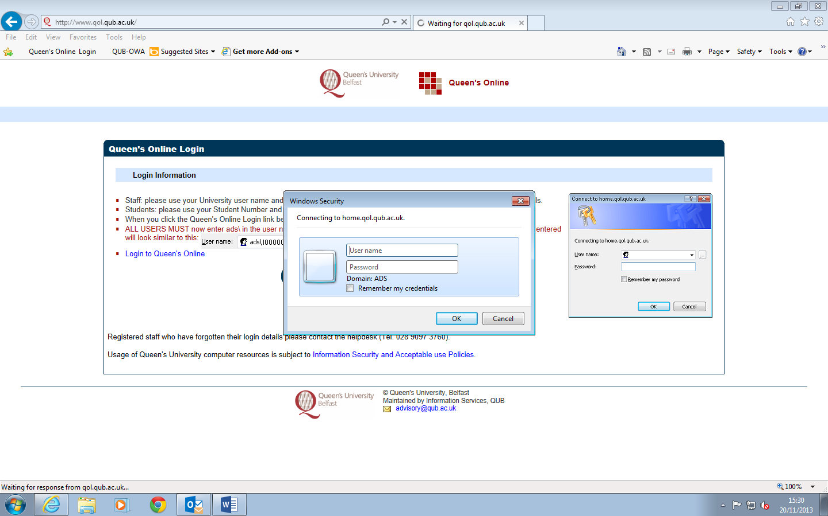

* In the **Username** field, you **must** type **ads\** in front of your username (**Note:** your username is your staff number).
* In the **Password** field, type your password and click on the **OK** button. Your Queen’s Online homepage will be displayed (see Figure 2).

**Note:** If you have any problems logging in using your username and password, please contact the Information Services Helpdesk on 028 9097 3760 (Internal ext. 3760).

In the **Service Applications** section (see Figure 2), under the heading **Other**, click on the **Online Voting** application.

**Figure 2**

Online Voting

Other

# Online Voting

# Vote Selection

Please select the election constituency in which you are eligible to vote.

# Vote Interface

The “ballot paper” is displayed, select the priority you want to assign to the candidates (the number of candidates determines the number of entries in the dropdown list). The order of candidates on the ballot is generated randomly each time the ballot is viewed.

**Vote Confirmation**

Having chosen your preferences, the “ballot paper” is then displayed. Check that the vote is correct before submitting it or return to the Vote Interface and amend the vote.

Vote Submission

This page commits the vote to the database. All votes are anonymous.

When you have finished voting, click on **circle** containing your initials, which will open a **drop down menu** beside your name on the top right corner of your Queen’s Online homepage and choose **Sign Out.**

* **Log off** the computer.

**Note:** If you have any problems accessing or using the Online Voting application, please contact Damien Corridan via email at [d.corridan@qub.ac.uk](mailto:d.corridan@qub.ac.uk).