How to record additional Training and Development:
Postgraduate Researcher (PGR)

Recording Training
All Graduate School training events are bookable through the University’s MyFuture platform:
https://qub-csm.symplicity.com/students
Any training you have booked through MyFuture and have attended will be automatically added to your training record early 2018 in the first instance, and on a regular basis thereafter. Should you require this to be completed earlier, for example if you are preparing for differentiation or APR please contact us at pg.skills@qub.ac.uk to discuss your requirements.
Research students can also record other instances of training and development on their training plan.
Recording external training and development
Maintaining your record of additional training:
- Log into Qsis
- Select the Research tile (Figure 1)
- Select PSTP Additional Training (Figure 2)
- Select PSTP Additional Training (Figure 3), arriving at the “PSTP Additional Training” screen.
This will allow you to enter new examples of additional training and development using the and/or to review your record of additional training.
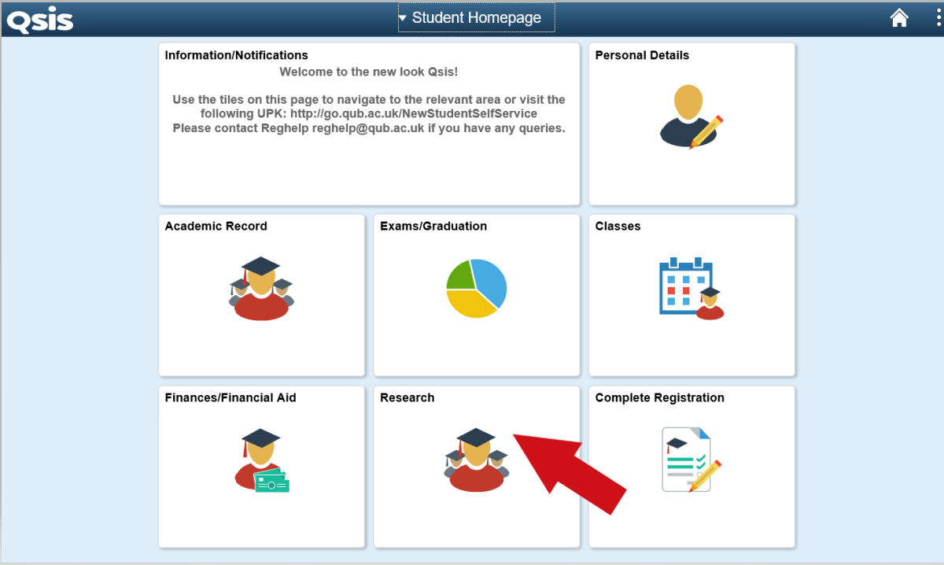
Figure 1. Select the Research Tile
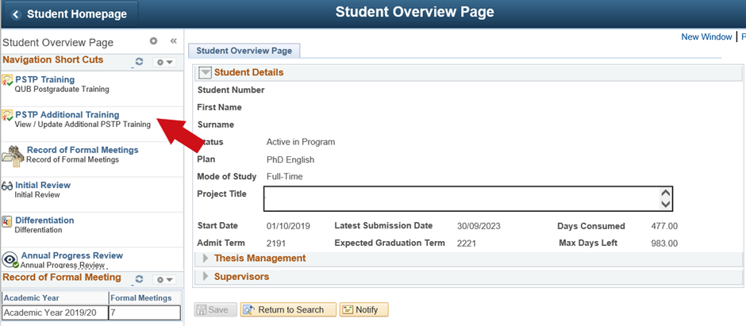
Figure 2. PSTP Additional Training

Adding new instances of additional training
To access the additional training input tool, choose ‘PSTP Additional Training’ from menu. Pressing the [ADD TRAINING] button presents the ‘Update
Additional Training’ screen (see Figure 3 below) from which new examples of additional training can be added.
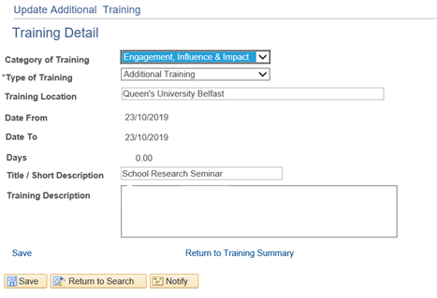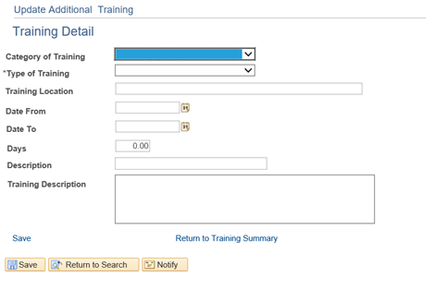
Figure 3. Update Additional Training
In this screen you may enter a number of values to describe the type, dates, duration and description of your additional training, as follows:
a) Category of Training (RDF Domain): is a drop down list, allowing you to choose from the four
domains:
- Knowledge and Intellectual abilities
- Engagement, influence and impact
- Research governance and organisation
- Personal effectiveness
b) Type of Training: is a drop down list, allowing you to choose from:
- Training
- Development
c) Location of Training: allows free text to indicate where the training took place
d) Date From: is entered manually or via a drop down calendar to let you indicate the first training date
e) Date To: is entered manually or via a drop down calendar to let you indicate the last training date
f) Days: are entered as whole or fractions of days. Acceptable fractions are .25 .5 and .75 only. The following is for guide purposes only. If you have any queries about how much time can be allocated you should discuss and agree with your supervisor
Training duration Training Allocation
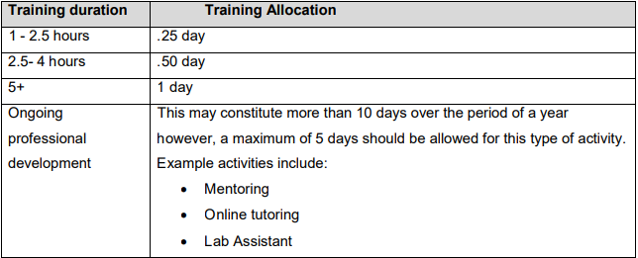
Figure 4. Training duration allocation
g) Description (short): is a field limited to 30 characters. The text entered here will describe the activity and will appear in the Description area of the summary table so you'll probably want to make it something meaningful as far as possible
h) Training Description: is a free text area for you to supply greater detail on the training. You can also note any agreed time allocation for the training with your supervisor. When you are happy with the record you have entered click on the [Save] button to save your changes and then click on the link Return to Training Summary to go to the ‘Training Detail’ screen. If you have already entered additional training, then the screen will show a summary table similar to Figure 4. Each row is an instance of additional training. The columns reflect your entries from the ‘Update Additional Training’ screen (see Figure 3). The additional columns include:
Row No: Sequence number referring to the row in the grid.
Approved: Currently this function is not being used but may be introduced at a later date.
Edit: A button to allow you to change the record. Clicking on this button allows you to navigate to a screen similar to the ‘Update Additional Training’ screen. Note that once approved, the Start Date, End Date and Duration fields cannot be changed except by an administrator from the PSTP Training
team. If the Edit button is not appearing, hover your mouse over the end of the record and the edit and minus button will appear.
Minus Symbol: Used to delete the corresponding row. By using the minus symbol, the record will be removed from the system permanently

