**PG Impact Scholarship Application Guidance**

**The PG Impact Scholarship application is made up of the following components:**

* **Scholarship Application form**

Complete and submit the application form for the PG Impact Scholarship to [pg.impact@qub.ac.uk](mailto:pg.impact@qub.ac.uk) by 17:00 BST on Thursday 9th May. Please note that application for the Scholarship does not constitute application for a Postgraduate Taught course of study at Queen’s.

You can apply for a Postgraduate Taught course of study for 2019 entry [here](https://dap.qub.ac.uk/portal/user/u_login.php).

You are encouraged to apply as early as possible for a course of study at Queen’s, to ensure you have an offer before the deadline for scholarship consideration, at the end of May 2019. Please see Section 4 for further guidance about how to indicate in your course application to the Scholarship application.

Terms and conditions for the Scholarship are available on the scholarship website.

* **Supporting Evidence**

|  |  |
| --- | --- |
| **Criteria for Award** | **Evidence** |
| 1. **Evidence of commitment to personal and professional career development; you have identified and found ways to develop your skills, and found opportunities to put them into practice.** | Video pitch (not more than 2 minutes) to explain why you are the best candidate for this scholarship. |
| 1. **How postgraduate study at Queen’s will contribute to ongoing personal development and achieving your personal and professional ambitions.** | Personal Development Plan (not more than 2 A4 (landscape) pages, completed on template provided in application form) |
| 1. **How you will make a positive impact through delivery of a postgraduate-led initiative at Queen’s.** | In the space provided in the application form, briefly outline a problem that you feel passionate about addressing, and propose an activity, campaign or initiative that you would lead during your studies relating to this problem, which would benefit the postgraduate community at Queen’s, or wider community beyond the University. (Maximum 400 words) |

This document provides guidance for completion and submission of the Supporting Evidence.

In order for your Scholarship application to be considered, all elements (application form and supporting evidence) must be received by the Graduate School ([pg.impact@qub.ac.uk](mailto:pg.impact@qub.ac.uk)) by 17:00 BST on Thursday 9th May 2019.

You must also have completed an application for a taught postgraduate course (Masters level) at Queen’s by that date and time. It is recommended that your application to the Queen’s course is completed as early as possible, to ensure that you can receive and accept an offer for your course by 5pm BST on Friday 31st May 2019. This should include evidence of your English language requirements, if required.

You must also ensure that your undergraduate degree results have been provided to Queen’s University Admissions and Access Service by 1 July 2019, and complete registration for your course prior to the late enrolment date in October 2019.

1. **Guidance on Video Pitch**

Send your video pitch to [pg.impact@qub.ac.uk](mailto:pg.impact@qub.ac.uk). Please send this video to arrive no later than **17.00 hours on Thursday 9th May 2019.**

Please ensure that your video can be opened and viewed by us using VLC media player. VLC media player supports many video file formats, and we would recommend MP4.

We would suggest using the WeTransfer programme [https://wetransfer.com/](https://qmail.qub.ac.uk/owa/redir.aspx?C=y-ceyMJ7Fl0QjVvwhYq5XFuEt-TcrQ6K94ZlxxHIV8BoSc7ZI0TWCA..&URL=https%3a%2f%2fwetransfer.com%2f) to send your video and would ask that you test it to ensure that it can be opened, before sending.

The criteria for this element are not about high quality production of a video – they relate to the quality of content, innovation and the quality of presentation skills.

Criteria for evaluation:

* How the skill is mapped to one of the 5 pillars for postgraduate development
* Evidence that the skill has been developed and applied, and impact
* Evidence of overcoming challenges in developing or applying this skill
* Communication skills demonstrated through video
* Innovation in pitch (delivery or content)

1. **Guidance on Personal Development Planning**

A Personal Development Plan (PDP) sets out what you need to do to achieve your personal, academic and career goals. Engaging with this process can help you to become more motivated and to take charge of your own learning and career development. It shows commitment to ongoing professional development, helps you gain a better understanding of your personal strengths, as well as areas you can improve on.

A typical personal development plan consists of the following categories.

|  |  |
| --- | --- |
| **Aims**  **What will you develop?** | These could include one of the five pillars for postgraduate development (see p2) or a specific behaviour/s within one of the practices. It might be a skill e.g. project management, coaching, or a behaviour e.g. use of eye contact.  It is very important to focus on a few key areas and not to overstretch yourself by creating too many learning objectives. |
| **Methodologies**  **How will you develop?** | This relates to the way/s in which you will develop.  There are two broad categories which determine how you might develop:   1. ‘On the job’, which may relate to your work or within your Masters Degree Programmes (integrated learning).   Examples include:  Projects; making presentations; attending meetings; leading, managing, mentoring and coaching others; attendance at events and activities; student-led initiatives; secondments and placements; shadowing others.   1. ‘Off the job’ in the form of formal and informal training and development interventions.   Examples include:  Training events; online learning; reading; networking events; voluntary work.  It is important to consider your learning preferences (i.e. theoretical, reflective, active) and whether you want to learn according to your preferences or to disrupt your learning by becoming involved in approaches that you are not fully comfortable with. |
| **Timescale**  **What is your timeframe? When are you aiming to do this?** | By what date will you have developed the area of focus? It may be that there are certain things that you want to develop on an ongoing basis, however it is better to set time scales or milestones which then allow you to review your progress. You can set the same goal again if you have not completed the development fully. |
| **Priority Level**  **How important is this right now?** | It is useful to identity a priority rating for each area you wish to develop as this will provide focus in relation to those which are high priority, and those which are desirable. |
| **Support Requirements**  **What support do you need, if any? Who can assist you?** | We often need the support of others in order to develop ourselves. Therefore, it is useful to consider what this support might be and how we can access it. |

**A sample template is provided below. This is the same as the template you are being asked to complete for the Postgraduate Impact Scholarship.**

**The Graduate School’s Five Pillars for Postgraduate Development**

As a postgraduate at Queen’s, you have the opportunity develop these attributes through our combination of specialist disciplinary study, and high-level, transdisciplinary skills training. We align different skills developed for postgraduate students to the five pillars set out below.

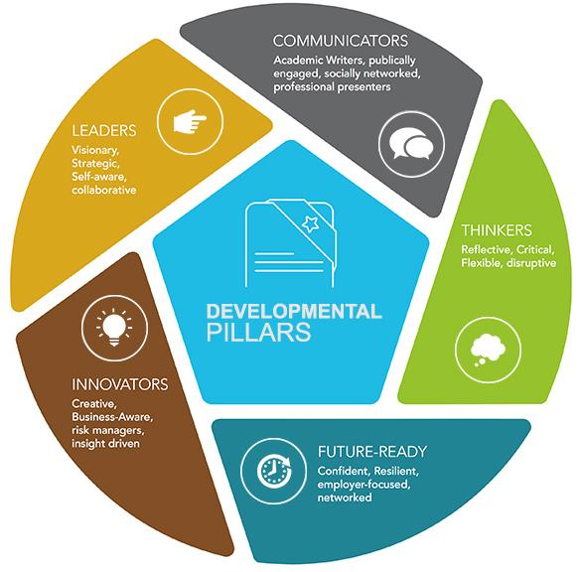

**Advice for Completing the PDP Template:**

* A good Personal Development Plan uses [SMART](https://www.mindtools.com/pages/article/smart-goals.htm) objectives.
* A key element of your development is not only attending training sessions, but finding ways to apply your skills.
* Push yourself out of your comfort zone in terms of activities you try and how you propose to meet learning and development needs. This is where learning happens.
* Do research to make this as specific and relevant as possible. You may find it helpful to use the current [Graduate School Programme](http://www.qub.ac.uk/graduate-school/events/), and any other opportunities you see available to postgraduate students at [Queen’s University Belfast](http://www.qub.ac.uk/graduate-school/events/), to build your Personal Development Plan. This provides examples of the types of training and development opportunities offered through the Graduate School at Queen’s University Belfast, to help you to develop as a Leader, Thinker, Innovator and Communicator who is Future-Ready.
* Consider how many objectives it is realistic to pursue within the context of a Masters degree programme. Quantity is not better than quality.
* Information beyond two A4 pages will not be considered as part of the scholarship application. Font should not be less than 11 point.
* You can also refer to online resources, and opportunities available to you more widely.
* Use the template provided with the Postgraduate Impact Scholarship application form.
* There is a lot of help and support available online for Personal Development Planning. A few that may be useful to you are available at: <https://www.qub.ac.uk/directorates/sgc/careers/ImproveYourEmployability/PersonalDevelopmentPlanningPDP/>

A sample PDP using the Scholarship template is set out in Appendix A.

Criteria for evaluation:

* Identifying needs for skills, knowledge or competence to be developed
* Establishment of SMART objectives for skills development during postgraduate study at Queen’s, including selecting appropriate development activities to meet identified needs

1. **Guidance on a Postgraduate-Led Initiative**

The Graduate School has funding available to assist current postgraduate students to use and develop their leadership skills to benefit the postgraduate community, or impact society more widely. The Postgraduate Impact Scholarship provides up to £400 for you to lead an initiative of your own design while you are a student at Queen’s.

Information about the types of activities that students have undertaken as part of this scheme are available at: <http://www.qub.ac.uk/graduate-school/community-connections/postgraduate-led-initiatives/>

For the Scholarship application, you need to provide a 400-word proposal for this initiative. This does not have to be exactly what you would want to undertake if you were successful, but should give an indication of something you are passionate about, something that will provide a stretch for you in terms of skills development, but that is realistic to undertake within the context of Masters degree studies, with time and resource constraints. Consideration will be given to the identification of the problem, innovativeness of the approach, and potential impact of the initiative.

Criteria for Evaluation:

* Identification of problem
* Realistic and achievable - consideration of time and resource constraints
* Innovative approach and potential impact of initiative

1. **Guidance for Application to a course at Queen’s University Belfast**

* You can apply for a Postgraduate Taught course of study for 2019 entry [here](https://dap.qub.ac.uk/portal/user/u_login.php).
* It is recommended that you apply for a Masters-level course at Queen’s as early as possible, to ensure you receive and accept an offer by 31 May 2019.
* You can identify as part of your course application that you have applied for the PG Impact Scholarship. Ensure that within the online application portal for your course at Queen’s, under ‘Funding Your Studies’ you tick the box ‘I hope to or have already obtained funding for my studies’, and then enter the code **PGImpact19** in the free text box that asks 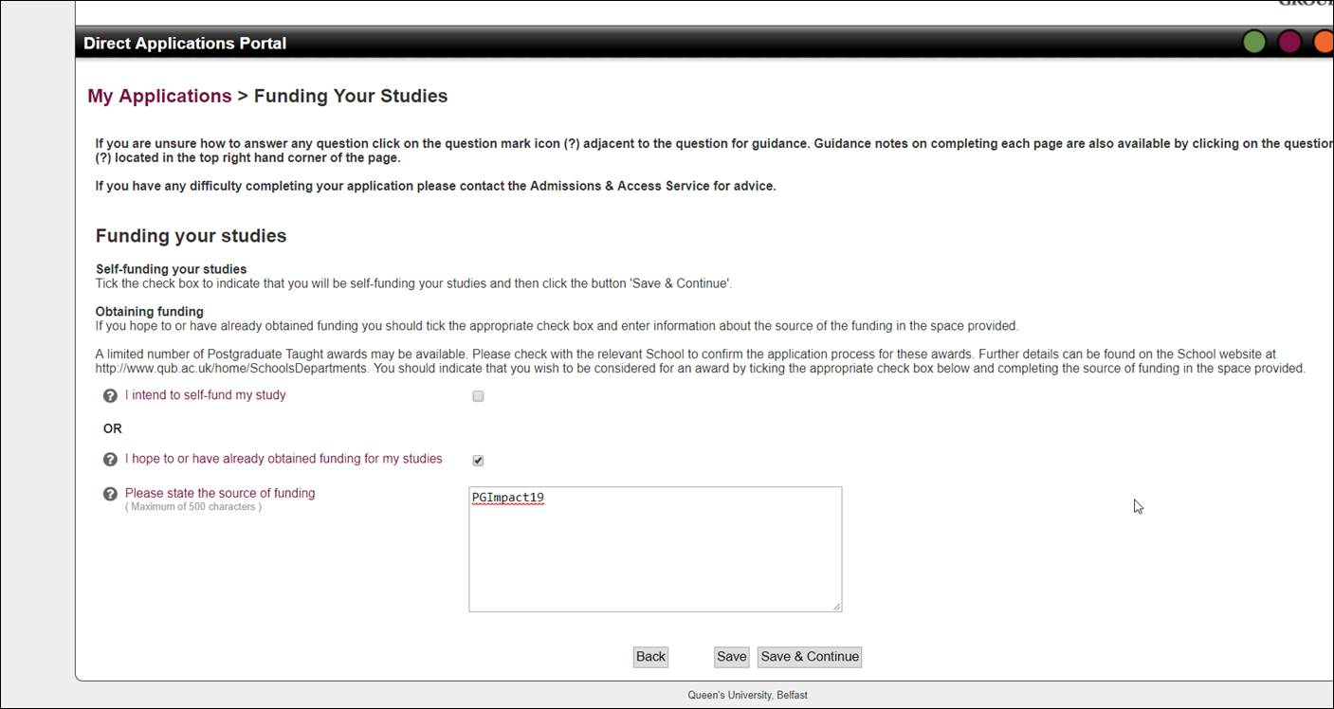for the source of funding.

If you have any queries about your application for a course of studies at Queen’s, please contact the Admissions and Access Service:

Postgraduate Admissions  
Admissions and Access Service  
Queen's University Belfast  
University Road  
Belfast  
BT7 1NN  
Northern Ireland  
  
Tel: +44 (0)28 9097 3004  
WWW: [www.qub.ac.uk](http://www.qub.ac.uk/)  
Email: [pg.apply@qub.ac.uk](mailto:pg.apply@qub.ac.uk?Subject=QUB:%20Message%20from%20Application%20Portal)

**Sample Personal Development Plan (A4 landscape size)**

|  |  |  |  |  |  |
| --- | --- | --- | --- | --- | --- |
| **Identify your learning and development need** | **What will you do to meet this development need?** | **What resources / support will you need?** | **What are your success measures? How will you know you have met your development need?** | **What is your timescale / milestones?** | **Priority Level** |
| *EXAMPLE: Develop my leadership skills* | * *Volunteer to lead a postgraduate-led initiative about …* | * *Seek leadership coaching from a relevant mentor* * *Read up on leadership styles* | * *Project success – what will be achieved* * *Line manager feedback Project team feedback* | *Dec 2018* | *2 – will be advantage in job search* |
| *EXAMPLE: Improve my knowledge of project management* | * *Attend a course in Project Management* * *Attend internal project management workshops* | * *Course funding from employer* * *Support from more experienced colleagues* | * *Satisfactory completion of course* | *Dec 2018* | *1 – will help immediate success on course* |
|  |  |  |  |  |  |
|  |  |  |  |  |  |

**Name:**