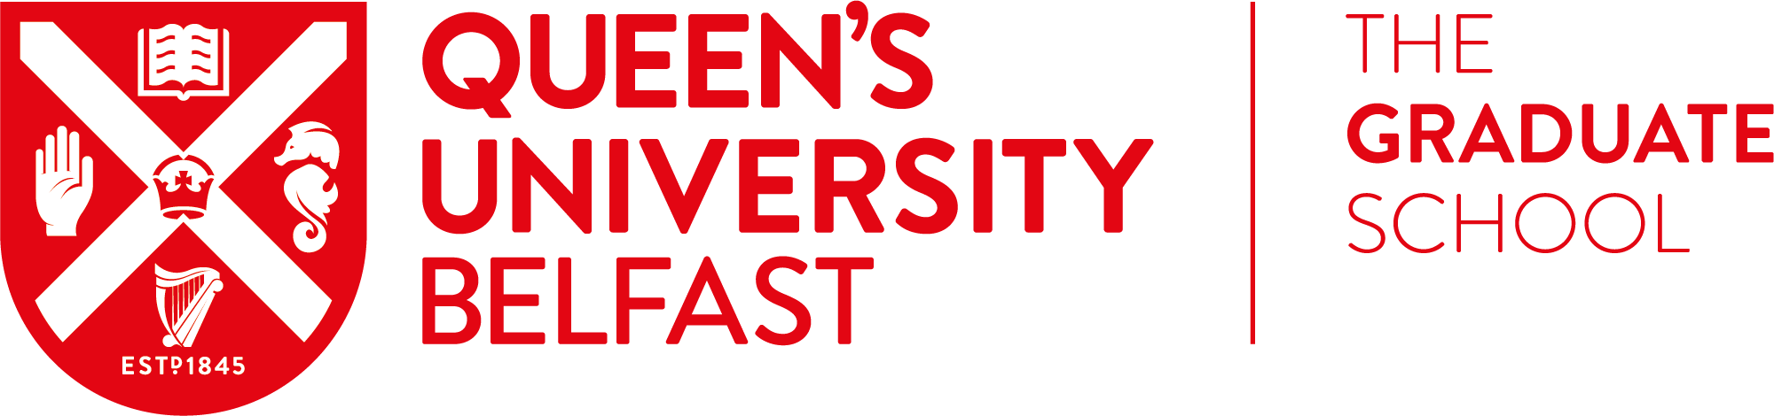

Impact: Global Application Form
Apply to join The Graduate School and RCITY for a semester-long social innovation challenge. The RCITY project is based on the interface between the Shankill and Ardoyne areas of Belfast and is built upon an ethos of respect, regardless of religious or cultural background. The project encourages the participants to be proud of their community’s culture but in the same context respect that of others. Three core themes are embedded throughout the project learning process: Leadership & Skill Base, Employment & Education and Positive Youth.
10 QUB postgraduate students will work in transdisciplinary teams with 10 young people from RCITY. The aim of the project is to create innovative solutions to social challenges and to increase the number of young people from disadvantaged communities who see university as a viable option for themselves.
The programme runs from November 2018 – May 2019. During the first phase, the students & young people will work together in four teams to gain an insight into Design Thinking, build relationships and work on local challenges.
The second phase will see the group travel to South Africa to work alongside young people and students from townships, using design thinking to come up with innovative solutions to challenges the residents of the township face on a daily basis. The two-week challenge will end with a showcase event in Cape Town where the teams will present their prototyped solutions back to the local community and will have the opportunity to work with the residents to implement the solutions.
Phase three will begin on return from South Africa. The teams will work with the community leaders to devise an implementation & operations plan for their solutions, handing it over to the hosts.
It promises to be a lot of fun, but challenging too. You will come away with a better understanding of Design Thinking, deep relationships with the young people and experience in social innovation. There will be opportunities to continue to volunteer post-project.
Impact is open to all postgraduate students – both taught and research.
The form should be completed and emailed to pg.skills@qub.ac.uk by 1pm on the 29th November 2018. You will be notified by Monday 3rd December if you’re invited to interview.

Title:
Forename(s):
Preferred name:
Surname:
Student Number:
School:
Course of Study & expected graduation date:

Contact Details
QUB Email Address:
Daytime telephone number (including code):

Please tell us in 250 words or less:
Q1. Why you want to participate in this programme?

Q2. What do you expect to get out of this programme?

Q3. How will you use the skills developed in the programme in your future?

In order to participate on IMPACT:Global, you need to be able to commit to the full duration of the programme. You must also be a current QUB student during this time and be eligible for travel to South Africa.
The local teams will meet form 5.30pm on the following dates pre-Christmas:
29/11/18, 4/12/18, 12/12/18. We will also be meeting throughout Semester 2; specific dates will be determined in consultation with the teams.
Expected travel dates are Friday 12th April 2019 – Friday 26th April 2019 (inclusive), but may vary slightly depending on flight availability.
Please tick the box to confirm you are available for the above time
Please tick the box to confirm you will be a current QUB student for the duration
of the trip

Travel is subject to visa requirements. Students will be responsible for arranging their own visas for travel to South Africa and should check their eligibility before applying to this programme. If a student is offered a place on this programme but is unable to arrange a visa in time, their place will be offered to another student.
Each student will be required to pay £200 contribution towards the trip.
QUB will cover flights and accommodation and some subsistence. Students must account for one of their own meals per day for the duration. Students are also advised to arrange their own travel insurance.

Please specify any dietary requirements below:

Please provide information on any special requirements or support needed for travel or accommodation below (Please note: Declaring any support needs will nto affect the decision making process):

If you have any questions about the application process, or the wider programme, please get in touch at pg.skills@qub.ac.uk.
There will be a drop in information session in TR6 in The Graduate School on the 13th November 2018 from 12 noon - 1pm.

