Expression of Interest Form
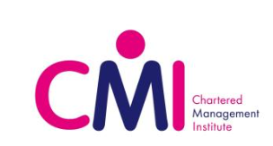

To register your Expression of Interest for CMI, this form should be completed and emailed to gs.cmi@qub.ac.uk.
CMI is designed for postgraduate students who want to develop their leadership and management skills. The level 7 Certificate offers you a unique opportunity to achieve a professional qualification alongside your postgraduate degree, and a step towards becoming a Chartered Manager. The programme is designed to enhance your theoretical understanding and competencies in leadership, project management and entrepreneurial practice in an interactive way that allows you to practice new skills. The level 7 qualification recognises your investment in personal and professional development in strategic thinking at a postgraduate level.
Personal Details
Forename(s):
Preferred name:
Surname:
QUB Student Number
Level of Study: | PhD / Masters / Recent Graduate
Course or Subject:
School:
Year:
QUB Email Address:

We are planning dates for 2020/21CMI delivery. Please tick the CMI Units you are interested in and we will contact you with further information in due course:

CMI Unit | Please Tick
Strategic Leadership
Project Management
Entrepreneurial Practice
All of the above

