

POSTGRADUATE-LED INITIATIVES

NAME:
SCHOOL:
STUDENT NUMBER:
POSTGRADUATE COURSE (PhD/Masters etc.):
YEAR OF STUDY:
EXPECTED DATE OF GRADUATION:
(NB. Must be a current student at time of event)
EMAIL ADDRESS:
TITLE OF PROPOSAL:
DATE(S) OF EVENT/ACTIVITY:
PROPOSAL DETAILS:
Use this section to outline your proposal. Please give as much detail as possible (e.g. timings, estimated attendance numbers, who is involved in organising and/or facilitating the event):

SKILLS AREAS:
Outline how the proposed activity relates to the skills outlined in Postgraduate Pillars – Thinkers, Communicators, Leaders, Innovators & Future-Ready (refer to Appendix 1).

Detailed breakdown of total funding required:
Outline total funding required; Please refer to guidelines for full information. Please not that in line with University business need, the most cost-effective methods should always be used.

TOTAL FUNDING REQUESTED: £
Details of Activity | Number of people | Cost per head  (if applicable) | Total Cost | Other relevant information
ANY OTHER INFORMATION:
Please detail any other relevant information in relation to funding required for this initiative and/or whether alternative source(s) of funding have been or will be sourced:

Statement of Support from Head of School/PG Co-Ordinator
Please outline your reasons for supporting this proposal for funding:

Head of School/PG Co-Ordinator Signature (electronic signature accepted)
Date:

STUDENT SIGNATURE:
DATE:

Please return the completed form by emailing Claire Harris, Claire.Harris@qub.ac.uk

OFFICE USE ONLY:
Date of Receipt:
Summary of outcome: (funding approved etc.)
Processed by:
Date:

POSTGRADUATE-LED INITIATIVES GUIDELINES

You are asked to read these guidelines carefully before you complete the application form for funding.

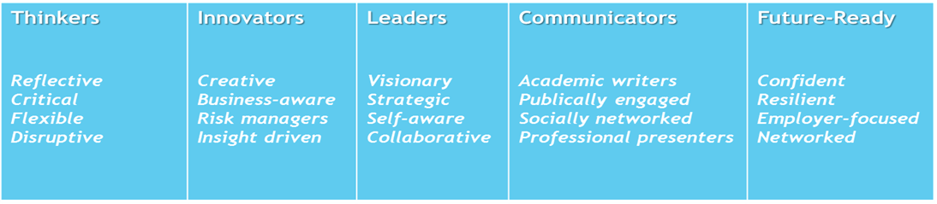
- The event or activity must relate to one or more of the Graduate School Pillars.

- The funding should not be used for direct financial assistance to individuals.

- Please outline in the proposal section of the application form;
  - the type of activity proposed i.e. seminar, conference, training event etc.
  - the main aims and objectives of the activity
  - the target audience
  - approximate number of students who will be attending the activity
  - desired learning outcomes

- As total costs for the proposed initiative may be more than the amount of funding awarded, the support agreed may be a contribution towards the proposal.

- Support from the Graduate School should be acknowledged at any event or in conjunction with any material developed.

- Funding for hospitality costs (i.e. tea, coffee breaks or other refreshments) is restricted to a maximum of £100. Please note that for events lasting more than one-day additional funding for hospitality may be considered (up to £200). Full details must be provided on the breakdown of costs and numbers attending the event.

- Funding for conference support is restricted to £1000 for a one-day conference, support of one guest speaker for a one-day conference. If the conference is more than £1000, a note needs to be included on other sources of possible funding if not all funds included. For conferences lasting more than one-day additional funding may be considered. Full details must be provided on the breakdown of costs and numbers attending the event.

- If your proposal includes a guest speaker, subsistence costs must be in line with QUB Expenses Policy

- Your application must be approved by your Head of School/PG Co-Ordinator. This endorsement must be submitted with your application.

- University premises should be used for all events. A room in the Graduate School may be available to use, please contact graduateschool@qub.ac.uk or telephone 028 9097 2585 for booking queries.

- Funding is not available for any travel costs incurred by postgraduate students who are co-ordinating the event. (i.e. bus, train, flight costs).

- Only activities aimed at and relevant to Postgraduate Students will be considered for funding.

- Successful applicants must submit a short evaluation report after the initiative has taken place.

- If funding is approved, this will be managed by the Graduate School and all payments will be co-ordinated through the Graduate School. Receipts for all monies outlaid on the initiative (in line with the guidelines), must be submitted to the Graduate School.

- Any decisions regarding the approval of funding for a Postgraduate-Led Initiative will be taken by a panel comprising of staff from the Graduate School.

If you wish to discuss your application before submitting please contact:
Claire Harris
The Graduate School
Telephone: (028) 90973568
Email: Claire.Harris@qub.ac.uk

APPENDIX 1:
GRADUATE SCHOOL PILLARS: SKILLS DEVELOPMENT
THINKERS – Reflective, Critical, Flexible, Disruptive

- Takes intellectual risks; challenges the status quo
- Subject specific knowledge
- Makes original contributions to knowledge
- Thinks independently and critically; develops theoretical concepts
- Critically synthesises information from diverse sources

INNOVATORS - Creative, Business aware, Risk managers, Insight-driven

- Develops new ways of working; has novel ideas and realises their potential
- Identifies new trends; creates new opportunities
- Develops convincing and persuasive arguments to defend research
- Recognises the potential for working in sustained partnerships with a range of stakeholders to generate new ideas, insights and maximise the potential for wider societal and economic impact

LEADERS – Strategic, Visionary, Self-aware, Collaborative

- Shows leadership in initiating and managing projects
- Has the ability to lead at all levels, including support others to achieve
- Delivers research projects and results on time and effectively
- Develops awareness of, and helps to achieve, work-life balance for self and colleagues
- Has a strategic approach to research
- Has focus, commitment and ambition, is flexible and responsive to change
- Strong awareness of health and safety issues, confidentiality and ethical requirements in one’s field.
- Leads, motivates and influences where appropriate; persuades through listening and convincing discussion



GRADUATE SCHOOL PILLARS: SKILLS DEVELOPMENT
COMMUNICATORS – Academic writers, Publicly-engaged, Socially Networked, Professional Presenters

- Appropriate communication and dissemination mechanisms for different audiences
- The importance of engaging in the processes of publication and dissemination of research results and impacts
- Communicates effectively in both written and oral modes with a range of audiences formally and informally through a variety of different techniques and media
- Actively works in an inclusive, respectful and constructive way with colleagues, stakeholders and research users
- Recognises and acknowledges the contribution of others and own part in team success
FUTURE READY – Confident, Resilient, Employer-focused, Networked

- Career and employment opportunities inside and outside academia behaviour
- Takes ownership of and manages professional development
- Shows commitment to continuing professional development and enhancing employability
- Maintains and develops relevant skills set and experience in preparation for a wide range of opportunities within and outside academia
- Actively networks for professional and career purposes and seeks to enhance research reputation and esteem

