
Parent’s Parliament
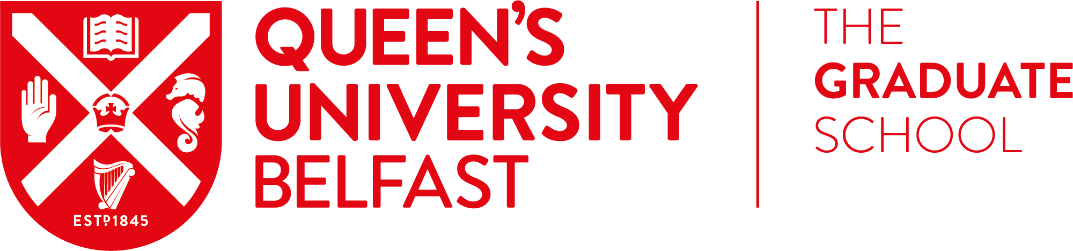


Title
Forename(s)
Preferred Name
Surname
Student Number
School
QUB Email Address
Contact Number

Application Form: Parent’s Parliament 18/19

This is opportunity opened to all postgraduate students.

ParentKind in partnership with the Graduate school, CCEA and the Department of Education are offering 10 students a unique opportunity to be involved the development of a Parent’s Parliament in Stormont.
If selected, you will be trained in De Bono Six Thinking Hats and become certified user.
- You will use this training to facilitate a group during 6 consultation meetings.
- You will attend Stormont for the launch of the new Parent’s parliament.

If you are interested, you must be able to:
- Commit to six evening sessions over the next 12 months. All dates will be confirmed but the first is on December 5th 2018, with the second being held in February 2019.
Transport to and from the venues will be provided.
If you are interested please complete the application form attached and return to pg.skills@qub.ac.uk by Thursday 29 November 2018.

De Bono training will be held on Monday 3rd Dec (am)

Please note by completing this registration form you are committing to completing the programme on ALL dates specified. Applications will be reviewed by a panel of staff within The Graduate School.

Date | Activity | Location | Time
Monday 3rd December | Training | The Graduate School | 10:00-13:00
Wednesday 5th Dec | Parent’s Parliament Meeting | Hamilton Road Community Hub, Bangor County Down | 18:30-21:00
February 2019 | Parent’s Parliament Meeting | TBC | 18:30-21:00

The form should be completed and emailed to pg.skills@qub.ac.uk / or handed into The Graduate School Reception.
Why are you interested in taking part in this programme?
Please outline in more detail.

Declaration
I confirm the information I have provided is true and that I can commit to the training dates as I have outlined:

Signed: ____________________________________________________________________
Date: ______________________________________________________________

- We will notify you to confirm your place.
- If you have any queries, please contact pg.skills@qub.ac.uk.

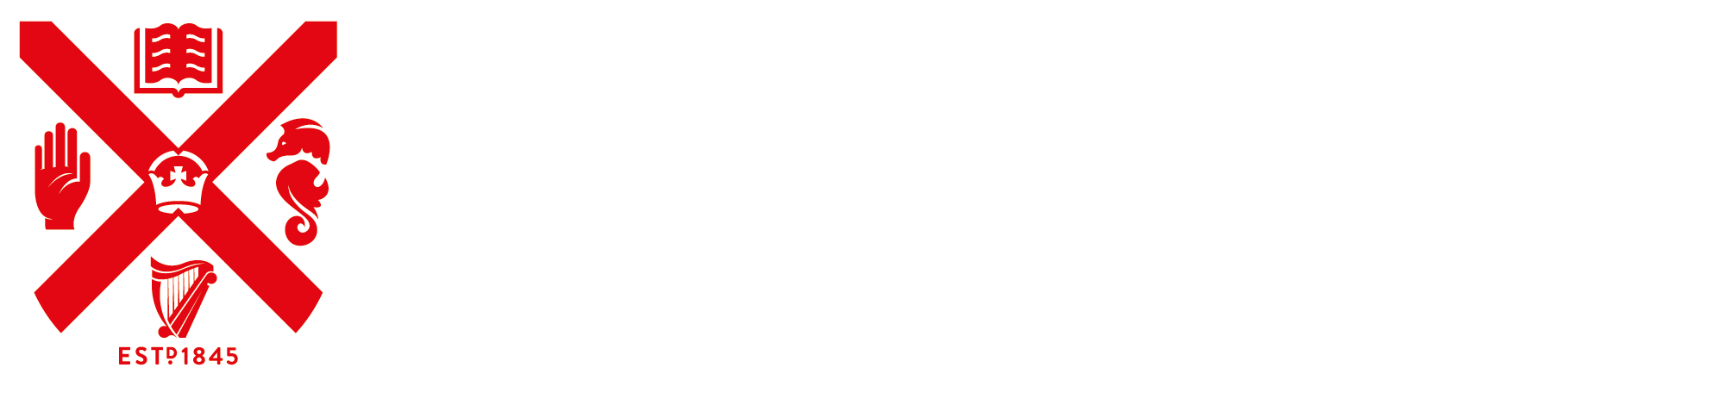

#QUBpostgrad

