

**Relating Environment-use Scenarios in Pregnancy/Infanthood and Resulting airborne material Exposures to child health outcomes – Intensive cohort (RESPIRE-I)**

**Participant Information Sheet (PIS)**

You are being invited to take part in a research study examining the association between perinatal exposure to air pollution and negative health outcomes among pregnant women and their babies. For this, we are recruiting pregnant women and following them from pregnancy recognition up until the newborns are nine months of age. All the information we collect will help us to understand how the exposure to air pollution affects pregnant women’s health and birth weight of newborn babies, which will help us to develop better ways of improving health and well-being. If you have a partner who lives in the same home, we will also ask for their consent to participate as the information collected in the study may be relevant to their own health.

Before you decide whether to take part, it is important for you to understand why the research is being conducted and what it will involve. Please take time to read the following information carefully before deciding whether to take part and discuss it with others including your partner if you wish. Please ask if there is anything that is not clear or if you would like more information. Thank you for taking the time to read this.

**About the research**

* **Who will conduct the research?**

This study is being run by researchers from University of Manchester, School of Medical Sciences, Division of Biology, Medicine and Health at Manchester University NHS Foundation Trust (MFT) with [INSERT RESEARCH SITE NAMEI].

* **What is the purpose of the research?**

The purpose of the study is to better understand how air pollutants may affect your health and that of your child’s during and after pregnancy. With the use of questionnaires, a location diary (e.g how many hours you spend at home) and pollution monitors we hope to estimate your personal exposure to these pollutants.

We are inviting you to take part in this study because you are receiving pregnancy care at our hospital. There will be no detriment to your care should you decline to take part.

* **Am I suitable to take part?**

To take part in the study we would like participants to have been a resident of [insert site location e.g. Manchester] for the three months before pregnancy, with no immediate plans to move during the pregnancy. You may be asked to confirm this when determining your eligibility for the study and/or during the consent.

Unfortunately, if you are a smoker and/or living in a smoking household you would not be eligible to take part in the study. You will be asked if you smoke and/or live in a smoking household when determining your eligibility for the study. This will also be asked as part of the questionnaire. CO testing during clinical visits may also be used to confirm smoking status.

* **Will the outcomes of the research be published?**

The results will be presented at clinical and scientific meetings and will be published in journals read by **healthcare professionals** who care for women during pregnancy and children. The data from the study may be used as part of a PhD and the results published in a thesis. You will not be identified in any of our results.

* **Disclosure and Barring Service (DBS) Check**

Researchers who come into contact with infants at delivery will have undergone an appropriate level of DBS check.

* **Who has reviewed the research project?**

This study has been reviewed by The University of Manchester, Faculty of Biology, Medicine and Health Research Ethics Committee. The North West – Liverpool Central Research Ethics Committee has given a favourable opinion of the study [REC: 24/NW/0212].

* **Who is funding the research project?**

This study has been funded by the Natural Environment Research Council (NERC), UK Research and Innovation (UKRI).

**What would my involvement be?**

* **What would I be asked to do if I took part?**

If you are selected for the research study, you will be contacted by the research team at [INSERT LOCAL SITE NAME] and provided details about enrollment and what will happen if you take part.

As part of the research, you will be asked to:

* Sign a consent form.

**Questionnaires**

* Complete a questionnaire at recruitment, which should take approximately 20 minutes. This questionnaire will include questions about your lifestyle (e.g. working patterns, house type, transport ect.). You do not have to answer all the questions.
* Complete smaller online questionnaires (~5-10 mins), these questionnaires will be completed online (sent via email) towards the end of your pregnancy and at 1 year after birth. Questions included will be taken from the questionnaire you complete at recruitment. You do not have to answer all the questions.
* Complete a questionnaire about your child’s health and development at age 12 months; these questionnaires are not reviewed by pediatricians. If you are concerned about your child’s health or development please see your child’s own doctor.

**Data access**

* Allow us to access your medical records so we can collect data about your health during pregnancy, at delivery and up until 12 months post-delivery.
* Allow us to access medical records of your newborn at birth up until 12 months of age.
* Allow us to collect your demographic information. This will be collected via your medical history records and/or questionnaire.

**Pollution monitoring**

* Allow us to place three air pollution monitoring devices and a WiFi dongle in your house, this will be for a minimum period of two weeks. Installation and removal of these monitors will be completed by a member of the research team at a time convenient for you. The pollution monitors and WiFi dongles are all simple plug-in devices. The pollution monitors will connect to WiFi through the dongle. Installation and removal of sensors should take 30 mins – 1 hour. Information regarding the monitors location will be collected by the research team upon installation.
* In the event that the WiFi dongle does not work, we may ask to use your WiFi. If you are happy to do so, your phone would be used to connect the monitors to your WiFi so we will not need to see your username or password. The monitors do not transmit WiFi passwords back to the server and do not access the network. If you do not wish for your WiFi to be used, an ‘offline’ option is available.
* If any of the monitors or dongle become lost, broken or stolen, please inform a member of the research team at your earliest convenience using the contact details provided or in person. This may result in your monitor being replaced.
* Allow us to place indoor pollution filters in your home whilst the monitors are installed. These will be used for future chemical analysis, assessing the pollution in your home.

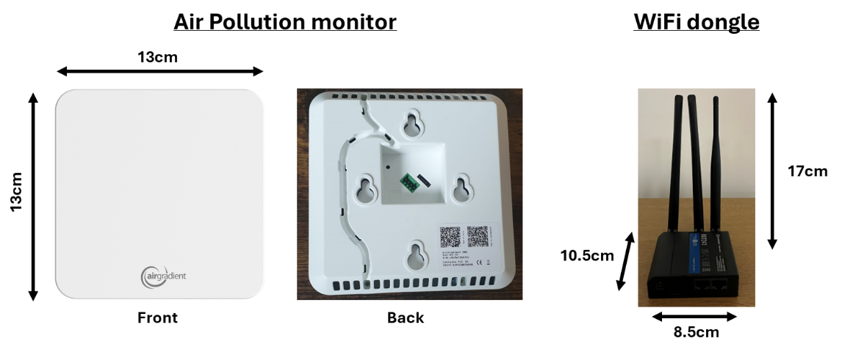

**Location diary**

* Completion of a location diary for a minimum of one weekday and one weekend. This will be required during the same time you have the pollution monitors installed in your home. This diary can be completed online and should take approximately 3 minutes. It will be repeated in late pregnancy and at 12 months after birth.
* Using your location diary and any addresses/ postcode we will be collecting outdoor pollution data using pre-existing sensors. This will not require your involvement.

**Contact details**

* Contact you via email or telephone. Contact would only be required if research progress has been affected, e.g. monitor had been unplugged, assistance needed to complete online questionnaire.

**Study timeline**

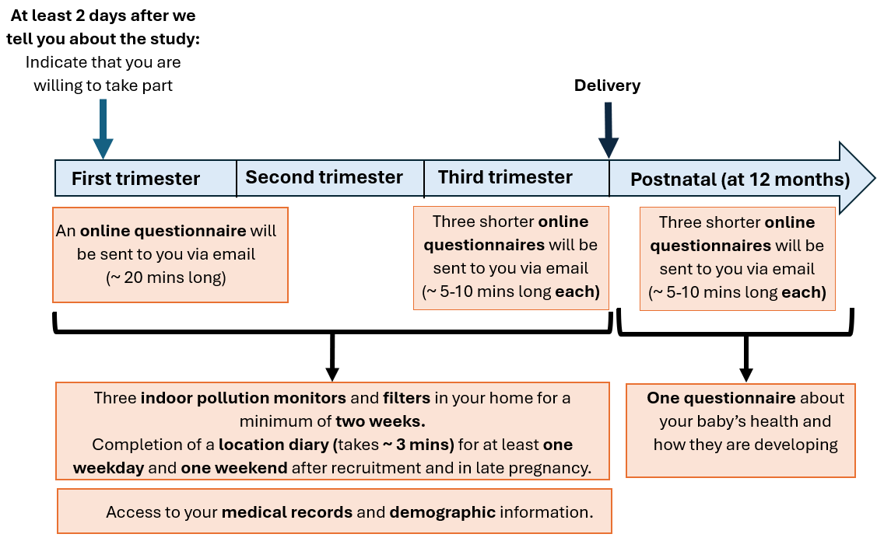

**What are the disadvantages and risks of taking part?**

You may be inconvenienced to fill out a questionnaire at recruitment, this will take around 20 minutes. You will also be asked to fill in a series of smaller online questionnaires (~5-10 minutes) towards the end of your pregnancy and 12 months after birth. You will also be asked to fill in a location diary when pollution monitors are in your home and when repeating online questionnaires. These data will be used to understand potential sources of air pollutant and factors that could affect your exposure to air pollution. We will try our best to provide the questionnaire and location diary in a simple online format so that you do not have to travel to the care center to fill it out. If you do need help filling out the survey, we will provide appropriate support.

You might be inconvenienced by having air pollution monitoring devices placed in your house for a minimum period of 2 weeks. We will have a trained member of staff install the device in logistically appropriate locations. You will reserve your right to withdraw your participation at any point.

We will use your health care data that is collected routinely as part of your visit to antenatal clinic and at delivery. We will keep your data private and confidential, and your data will be used only for research and planning purposes. You have the choice to opt out of the study at any point.

In the unlikely event that something does go wrong and you are harmed during the research you may have grounds for a legal action for compensation against the University of Manchester or the HSC trust but you may have to pay your legal costs. The normal National Health Service complaints mechanisms will still be available to you.

* **What are the possible benefits of taking part?**

The main advantage of taking part is that you will be helping us in our efforts to understand more about how air pollution affects the health of pregnant women and their babies, and how this might be improved for future generations.

* **Will I be compensated for taking part?**

You will be compensated with a £20 electronic shopping voucher for your time.

* **What happens if I do not want to take part or if I change my mind?**

It is up to you to decide whether or not to take part. If you wish to withdraw from the study, please let us know by email, phone or in person. If you do decide to take part you will be given this information sheet to keep and will be asked to sign a consent form. If you decide to take part you are still free to withdraw at any time without giving a reason and without detriment to yourself. However, it will not be possible to remove your data from the project once it has been anonymised as we will not be able to identify your specific data. This does not affect your data protection rights. If you decide not to take part you do not need to do anything further.

* What happens if there are complications in my pregnancy?

Sometimes there are complications in pregnancy that may affect how you feel about continuing in the study. If this happens, we are happy to withdraw you at any time on communication of your wishes and will give you the opportunity to remove your data from the study. There are some rare significant adverse pregnancy outcomes when we will automatically discontinue your involvement in the study, though unless specified by you we will keep existing data collected as part of the overall study and would record the outcome of the pregnancy from routinely collected data held by the hospital.

**Data Protection and Confidentiality**

* **What information will you collect about me?**

Individuals from the University of Manchester, Manchester University NHS Foundation Trust (MFT) and [Insert local site name] will access your medical/hospital record to collect information for the study. You will also provide information through questionnaire completion In order to participate in this research project we will need to collect information that could identify you, called “personal identifiable information”. Specifically, we will need to collect the following information for you and your baby:

* Name
* Address
* Date of Birth
* Phone number
* Email address
* H&C and hospital number
* Ethnicity
* Record of consent
* Addresses, postcodes and unique property reference numbers
* Demographics
* Medical history
* Questionnaire responses
* Air pollution exposure

If you would like more general information on how researchers use data about patients, please visit: [www.hra.nhs.uk/information-about-patients/](http://www.hra.nhs.uk/information-about-patients/).

* **Under what legal basis are you collecting this information?**

We are collecting and storing this personal identifiable information in accordance with UK data protection law which protect your rights. These state that we must have a legal basis (specific reason) for collecting your data. For this study, the specific reason is that it is “a public interest task” and “a process necessary for research purposes”.

* **What are my rights in relation to the information you will collect about me?**

You have a number of rights under data protection law regarding your personal information. For example you can request a copy of the information we hold about you.

If you would like to know more about your different rights or the way we use your personal information to ensure we follow the law, please consult our Privacy Notice for Research at <https://documents.manchester.ac.uk/display.aspx?DocID=37095>.

Sometimes your rights may be limited if it would prevent or delay the research. If this happens you will be informed by the research team.

* **Will my participation in the study be confidential and my personal identifiable information be protected?**

In accordance with data protection law, The University of Manchester is the Data Controller for this project. This means that we are responsible for making sure your personal information is kept secure, confidential and used only in the way you have been told it will be used. All researchers are trained with this in mind, and your data will be looked after in the following way:

* The study team at The University of Manchester and [insert site name here] will have access to your personal information and they will anonymise it as soon as possible. Your name and any other identifying information will be removed and replaced with a random ID number. The local research team will have access to the key that links this ID number to your personal information. Addresses will be converted to unique property reference numbers and retained in the study database to link to external pollution data as it becomes available.
* Your consent form will be retained for 5 years in a locked cabinet at the research site for audit purposes. If you have completed your consent form online, an electronic copy will be stored in the online study database until the end of the study.
* With your consent, we would also like to retain your contact details for 5 years in order to provide you with a summary of the findings for this study and also to inform you about future studies that you may be interested in. If you provide consent for this, your details will be safely stored on research site servers in a digital folder only accessible to the local study team and used only for the purposes described above. If you decide you no longer wish to be contacted for future studies, you may opt-out of this communication at any time.
* Data collected during the study will be anonymised following the completion of all data analysis. Following anonymisation, data will be retained for a minimum of 5 years after publication.
* All clinical, demographic, and questionnaire data will be uploaded onto a secure database managed by the University of Manchester. Research staff at each research site in the study will have access to this database to upload participant data. The data file linking personal information to a participants’ ID number will be stored at each respective research site.
* All data (including clinical, demographic, questionnaire, pollution monitoring, location diary) collected throughout the study will be analysed by the University of Manchester. Data labelled with your ID number may also be securely shared between research sites in the RESPIRE study for further analysis with your consent.
* When you agree to take part in a research study and with your informed consent, the information about you may be provided to researchers running other studies here or at other organisations. With your consent your anonymised information will be shared to support additional research in accordance with The University of Manchester’s Research Privacy Notice**.**
* So that we can provide the shopping voucher as a thank you for your time, your full name and email address will be shared with our Finance department who will send the voucher to you. Your full name and email address will be securely retained by Finance for a period of up to 7 years for audit purposes only and then destroyed. It will not be used for them for any other purpose.
* **Potential disclosures**

If, during the study, we have concerns about your safety or the safety of others, we will inform your care team.

If, during the study, you disclose information about misconduct/poor practice, we have a professional obligation to report this and will therefore need to inform the employer/professional body.

If, during the study, you disclose information about any current or future illegal activities, we have a legal obligation to report this and will therefore need to inform the relevant authorities.

Individuals from the University, the site where the research is taking place and regulatory authorities may need to review the study information for auditing and monitoring purposes or in the event of an incident.

A court can in exceptional circumstances order researchers to disclose confidential information that they have collected as part of research projects. If a court orders disclosure of information collected from you, confidentiality can no longer be maintained.

Please also note that individuals from The University of Manchester, HSC trust or regulatory authorities may need to look at the data collected for this study to make sure the project is being carried out as planned. This may involve looking at identifiable data. All individuals involved in auditing and monitoring the study will have a strict duty of confidentiality to you as a research participant.

**What if I have a complaint?**

* **Contact details for complaints**

If you have a complaint that you wish to direct to members of the research team, please contact:

**Dr Lucy Higgins**

**5TH FLOOR (RESEARCH),**

**ST MARY’S HOSPITAL, OXFORD ROAD, MANCHESTER, M13 9WL.**

**EMAIL: lucy.higgins@manchester.ac.uk**

**TEL NO: +44 (0)161 701 5650**

**If you wish to make a formal complaint to someone independent of the research team or if you are not satisfied with the response you have gained from the researchers in the first instance then please contact**

TheResearch Ethics Manager, Research Office, Christie Building, The University of Manchester, Oxford Road, Manchester, M13 9PL, by emailing: [research.complaints@manchester.ac.uk](mailto:research.complaints@manchester.ac.uk)  or by telephoning 0161 306 8089.

If you wish to contact us about your data protection rights, please email [dataprotection@manchester.ac.uk](mailto:dataprotection@manchester.ac.uk) or write to The Information Governance Office, Christie Building, The University of Manchester, Oxford Road, M13 9PL at the University and we will guide you through the process of exercising your rights.

You also have a right to complain to the [Information Commissioner’s Office](https://ico.org.uk/concerns) about complaints relating to your personal identifiable information. Website: <https://ico.org.uk/make-a-complaint/> Tel: 0303 123 1113

**Patient and Client Council (PCC)**

PCC are also able to provide independent advice on any queries or complaints you may have. Please contact 0800 917 0222 or info.pcc@pcc-ni.net.

**Contact Details**

If you have any queries about the study or if you are interested in taking part then please contact the researcher(s)**.**

**EMAIL: [Change according to each site]**

**TEL NO: [Change according to each site]**