QAMEC FOUNDRY SERVICES

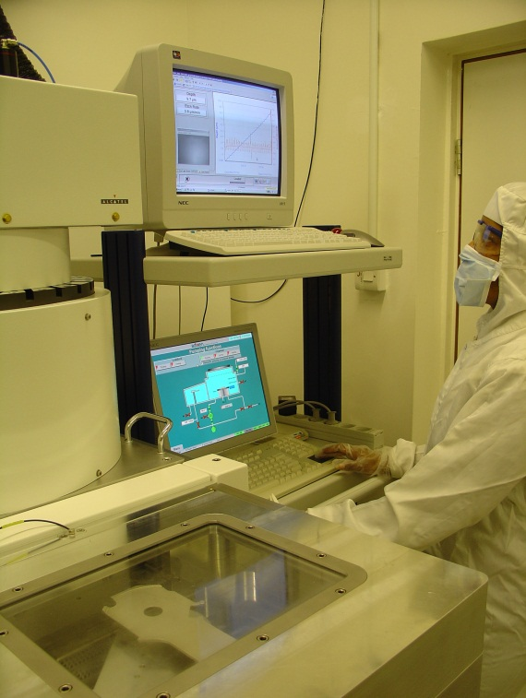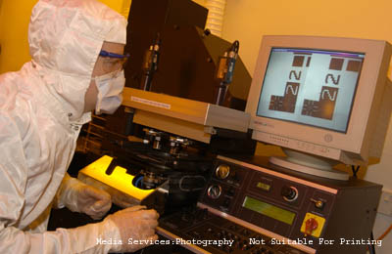
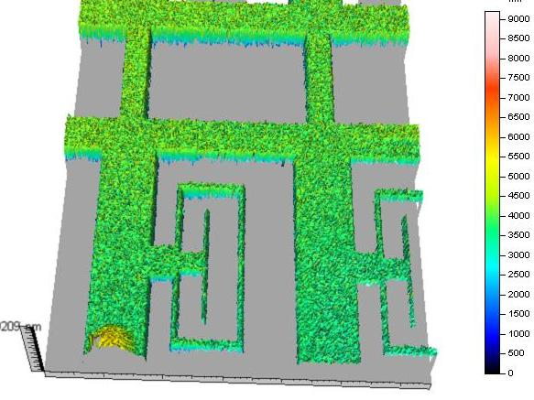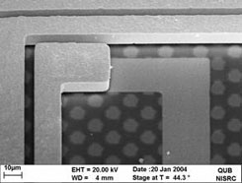
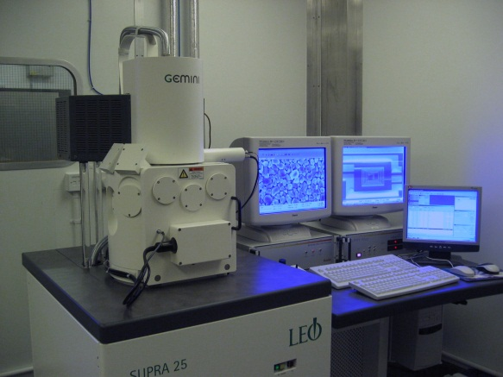

Thin Film Depositions & Diffusion

Process | Diameter | Min Thickness | Max Thickness | Tolerance (+/-) | Notes
Dry Oxidation | 50mm | 24nm | 200nm | 15%
 | 75mm | 24nm | 200nm | 15%
 | 100mm | 24nm | 200nm | 15%
Wet Oxidation | 50mm | 100nm | 6000nm | 5%
 | 75mm | 100nm | 6000nm | 5%
 | 100mm | 100nm | 6000nm | 5%
Undoped LPCVD Polysilicon | 50mm | 50nm | 2500nm | 10% | Deposition temperatures from 540C to 620C available
 | 100mm | 50nm | 2500nm | 10% | Deposition temperatures from 580C to 620C available
 | 150mm | 50nm | 2500nm | 10% | 4 wafer lay flat process
 | 200mm |  |  |  | 2 wafer lay flat process
PECVD Silicon Dioxide/Silicon Nitride | 100mm | 50nm | - | - | Deposition Temperature:  300C for Silicon Dioxide 330C for Silicon Nitride
 | 150mm | 50nm | - | -

DRIE Etch Services
Process | Diameter | MinFeature Size (CD) | Etch depth | Sidewall Angle | Aspect Ratio | Exposed etch area | Refill (Yes/No)
DRIE Silicon Etch | 100mm | 2um | Contact us for engineering consultation
 | 150mm | 2um | Contact us for engineering consultation
 | 200mm | 2um | Contact us for engineering consultation
RIE Oxide / Nitride Etch | 100mm | 2um | Contact us for engineering consultation
 | 150mm | 2um | Contact us for engineering consultation

