Equipment in the NICRF
Index:

General Clinical Equipment
Laboratory Equipment
Specialist Clinical Equipment
  - Nutrition
  - Respiratory
  - Vision
  - Cardiac / Vascular

General Clinical Equipment:
Genius Tympanic Thermometer
The Genius Tympanic Thermometer is a fast, accurate and convenient clinical instrument for measuring patient temperatures by using its proprietary Peak Select System technology to determine the body's accurate temperature directly from the tympanic membrane. It is an ear canal thermometer with measurement site equivalence modes including oral, core and rectal equivalent temperatures.
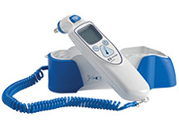
Graseby Volumetric Infusion Pump
Graseby Volumetric Infusion Pumps are for use in the intravenous and intra-arterial delivery of fluid and medications. In addition, they may be used for epidural delivery. Offering versatility and high levels of accuracy, they meet a broad range of infusion applications including blood transfusion. The unique air-in-line removal system provides safe and effective fluid delivery.
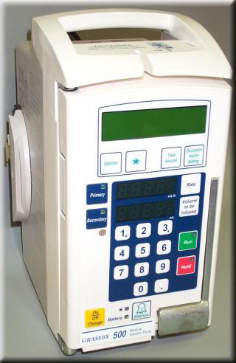

MAC 1600 ECG Analysis System
Used to record ECG signals from surface ECG electrodes. This device can analyse, record and store electrocardiographic information from adult and paediatric populations. This data can then be computer analysed with various algorithms such as interpretive ECG and signal averaging for presentation to the user.
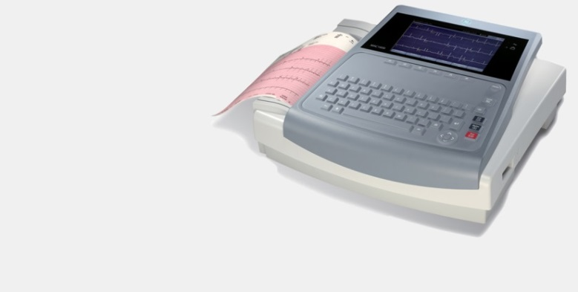

MAC 2000 ECG Analysis System
Used to record ECG signals from surface ECG electrodes. This device can analyse, record and store electrocardiographic information from adult and paediatric populations. This data can then be computer analysed with various algorithms such as interpretive ECG and signal averaging for presentation to the user
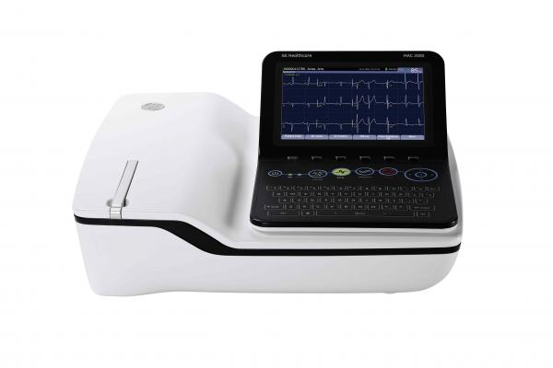

Omron Automatic Blood Pressure Monitor
Fully automatic, clinically validated monitor with dual-sized cuff for comfortable, quick and accurate blood pressure monitoring along with intellisense technology which detects the right inflation pressure automatically.
Hypertension indicator displays a symbol on screen if the unit takes a reading that is higher than the recommended level of 135/85 mmHg.

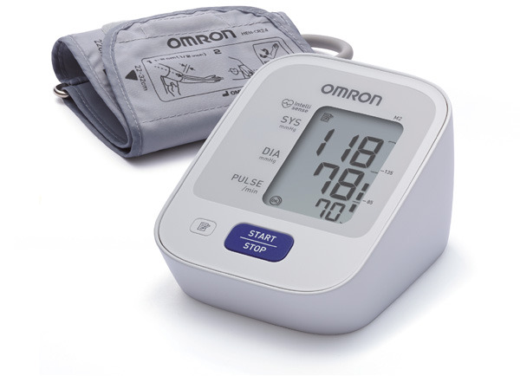
Zoll R-Series Defibrillator
R-Series Defibrillators are designed with easy-to-use technologies to help consistently deliver high-quality CPR, provide optimal defibrillation and pacing treatments for all patients, and manage data to address critical quality improvements.
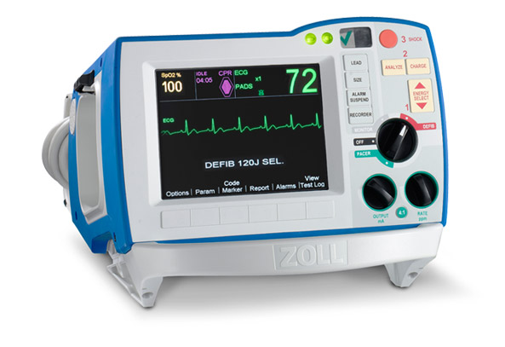

Welsh Allyen spot Vital Signs Monitor:
The Welch Allyn Spot Vital Signs monitor provides vital signs in seconds with hospital-grade technology that’s easy to use and accurate.
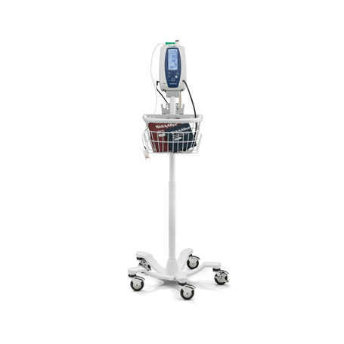

Nihon Kohded Vismo VitalSigns Monitor:
The concept of PVM-2701 is "supreme ease of use." The PVM-2701 provides a solution for hospitals that want to improve quality and streamline operation. PVM-2701 combines high accuracy and simple operation to satisfy every caregiver from expert to trainee.

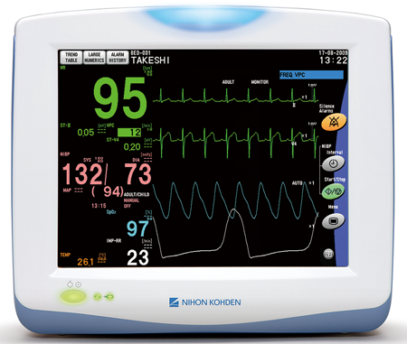

Laboratory Equipment
-20°C Labcold Freezer
-20°C Labcold Freezer is designed to store samples at low temperatures with precise temperature control.
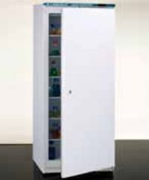

-80°C New Brunswick Freezer
Designed to provide precise, ultra-low temperature environments for cold storage of scientific materials for research purposes.
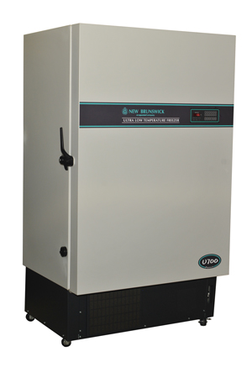
Lab Dancer – vortex.
Attractively designed test tube shaker designed for mixing small test samples (small containers up to 30 mm in diameter, e.g. test tubes, centrifuge tubes, Eppendorf beakers) with a touch function.
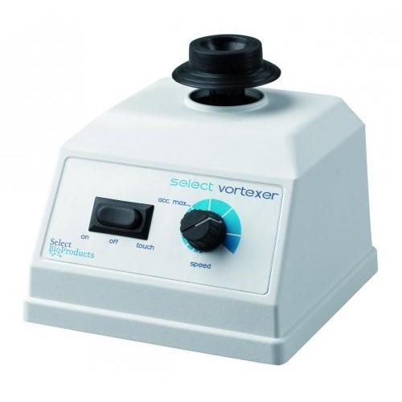

Laboratory Roller Mixer
Roller mixers are designed for use in the laboratory to gently roll bottles to provide mixing at a steady even rate. They are ideal mixers to prevent sedimentation of samples.
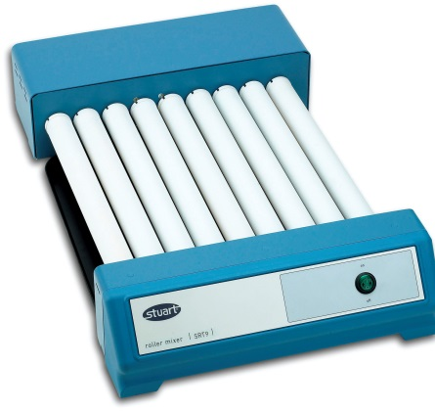

LEC Laboratory Freezer
Perfect for short term sample storage.
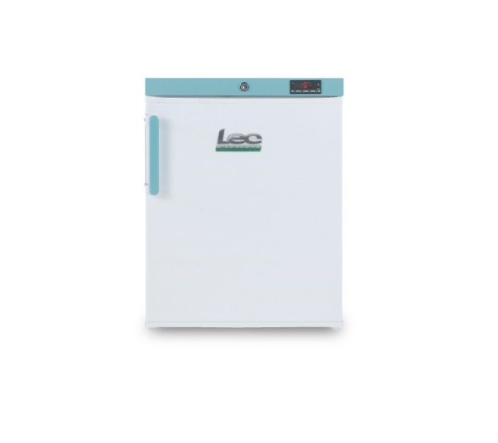

Rotina 380 R Centrifuge
The Rotina 380 R delivers good separation results rapidly and reliably and can be used for thermolabile samples at the required temperature.
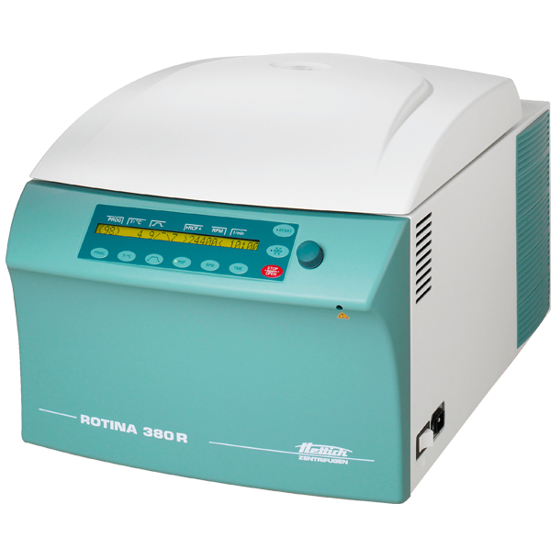

Sartorius Laboratory Scales
Sartorius is a German company and maker of some of the world's finest balances since 1871. The scales excel in speed, accuracy and quality backed by years of experience.
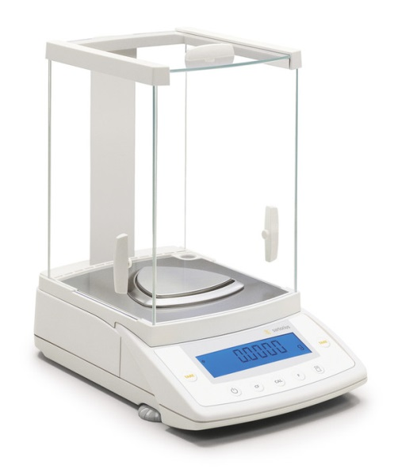

Scotsman Ice Dispenser
Push button ice dispenser.

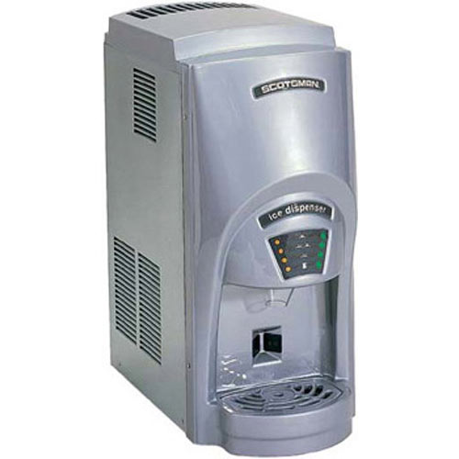

Nutrition

Bodystat Bioelectrical Impedence Monitor (body composition)
Measures body composition by sending a low, safe electrical current through the body. The current passes freely through the fluids contained in muscle tissue, but encounters difficulty/resistance when it passes through fat tissue.
This resistance of the fat tissue to the current is termed 'bioelectrical impedance', and is accurately measured by the bodystat machine.
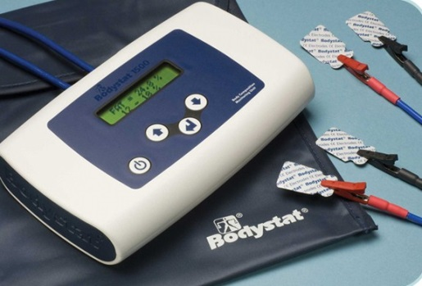

DEXA System (bone mineral density and body composition)
Dual-energy X-ray absorptiometry (DXA) offers precise, comprehensive body composition analysis including bone, lean and fat tissue distribution, as well as bone mineral density (BMD).
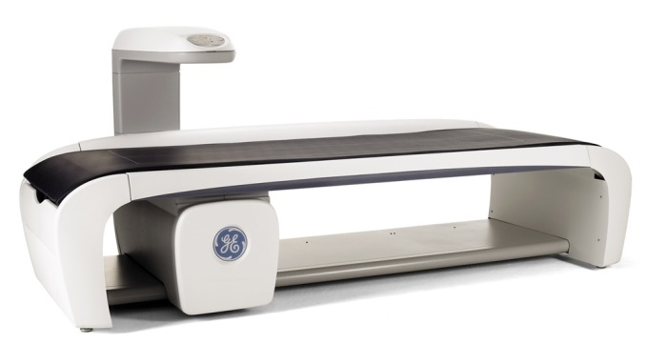

Holtain Skinfold Calipers (skinfold thickness)
This instrument has been specifically designed for the accurate measurement of subcutaneous tissue.
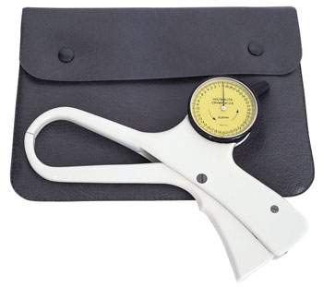

Seca Flexible Tapes (waist and hip circumference)
SECA 201 ergonomic circumference measuring tape – retractable. Able to measure girth with millimetre precision. Unwinds easily and locks in place precisely.
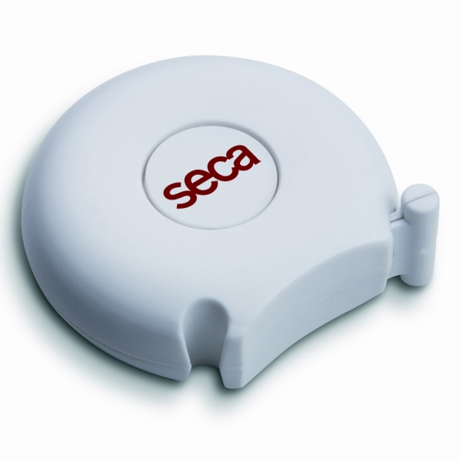

Stadiometers and Weighing Scales (height and weight).
Versatile, low-maintenance and site-independent with economic battery operation.
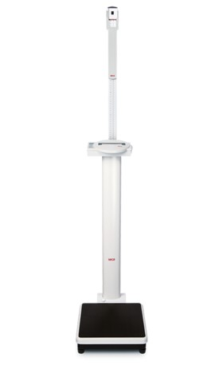
Venous Occlusion Plethysmograph (forearm blood flow): Not currently in use will update to website in need.

**No Photo**

SphygmoCor (central blood pressure and arterial stiffness measurement)
SphygmoCor® technology is used clinically for central arterial pressure waveform analysis to better inform blood pressure management.

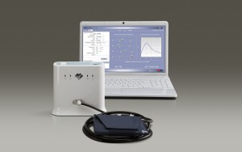
Respiratory
Bronchoscopy: Olympus EVIS LUCERA CV 260 SL.
The Olympus EVIS LUCERA SPECTRUM video system has set a new standard for endoscopic imaging, offering outstanding image quality.
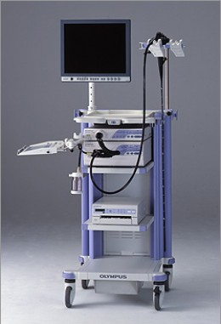

Cardio Pulmonary Exercise Stress Testing Equipment:

Care Fusion JLAB:
Performs breath-by-breath CPET and energy expenditure quickly and easily CPX features automated calibrations, interpretative support, and is extendable to a mobile system.
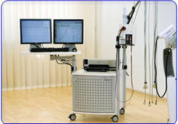

h/p/COSMOS LE 200 CE treadmill:
The classic treadmill for performing cardiopulmonary exercise physiology tests in the least amount of room of the LE series.
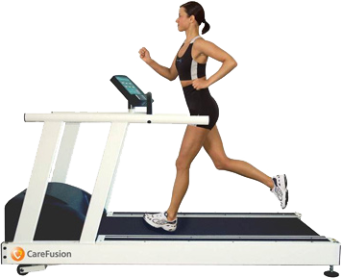

Ergoline Ergoselect:
The classic ergometer for exercise ECGs. Free programming of exercise protocols, intuitive operation and universal interfaces (digital, analog, remote start) for connecting to all ECG recorders and PC ECGs on the market.
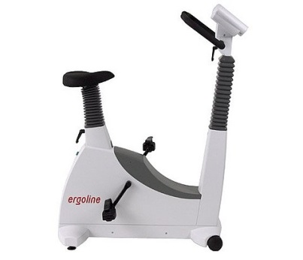

Devilbiss 646 Nebuliser:
Model 646 nebuliser converts liquid into aerosol via a high velocity, compressed air stream. Used in conjunction with a compressor, it delivers consistent aerosol particles to the lungs of asthmatic patients. It has a 5cc capacity and an MMAD of 5 microns. The break-resistant nebuliser easily disassembles for sterilisation and is autoclavable.
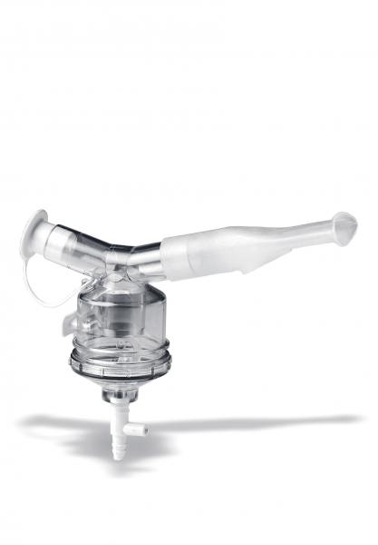

Dosimeter ( MB3 Markos Mefar):
The MB3 provides an accurate, easy-to-use and reliable method for the study, diagnosis and prevention of bronchial asthma.

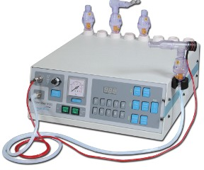
FeNo (NIOX MINO):
NIOX MINO® is the first point-of-care medical device for measuring fractional exhaled nitric oxide (FeNO), thus offering personalized asthma management. It enables healthcare providers to obtain an accurate, quantitative measure of airway inflammation to more effectively diagnose and manage asthma.
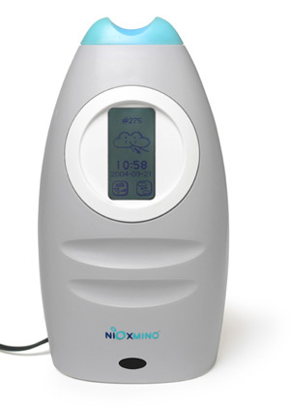

Lung Clearance Index/N₂ Washout:
The EXHALYZER D offer various different kind of spirometry test for neonatal to adult patients. The modular system is easy upgradeable and fully compliant with the ATS / ERS recommendations for infant / paediatric pulmonary function testing.
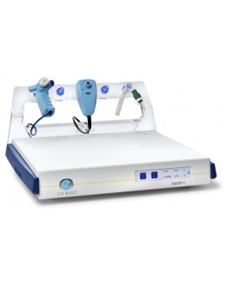
Oximeter (Pulsox-300i)
The Pulsox-300i offers the performance, comfort and memory you demand from a pulse oximeter.
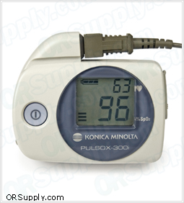

Spirometer Microlab MK8
Microlab spirometer is lightweight, portable and easy-to-use. Spirometry testing of FVC and SVC.
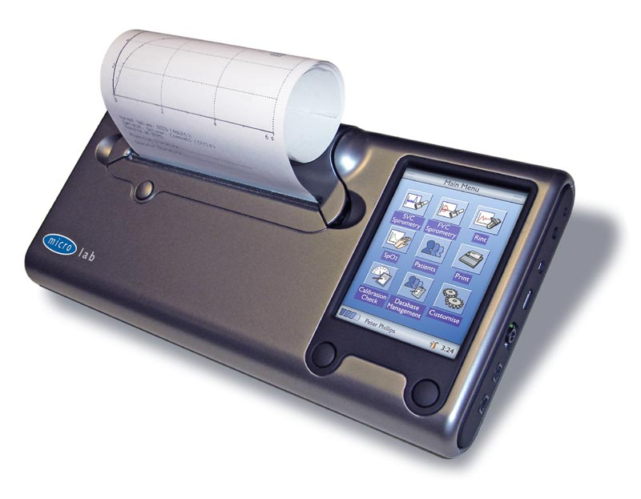

Vision
AdaptDX Adaptometer (measure dark adaptation in participants at risk of developing age-related macular degeneration):
Quickly and easily measures dark adaptation, which is dramatically impaired at the earliest stages of macular degeneration.
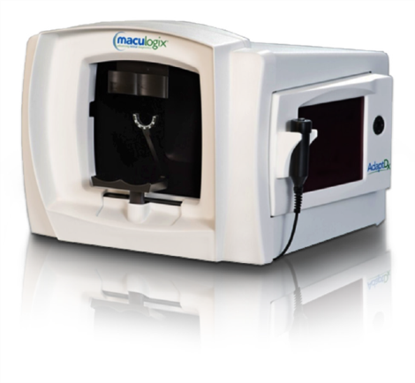

Cannon CF-1 Colour Fundus Camera (limited availability)
Versatile 50° retinal camera with 4 photography modes ; Color. FAG, RedFree and Cobalt. Required pupil diameter as small as Ø 5.2 mm , even Ø 4.3 mm in SP Mode!
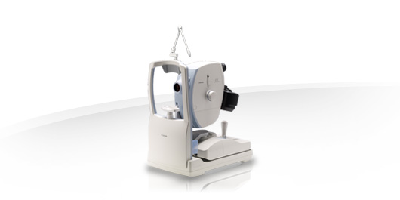

ETDRS LogMAR Chart:

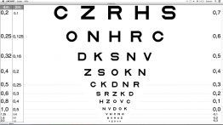

Goldman Tonometer:

Device fixed to a slit-lamp microscope that is used to measure intraocular pressure.
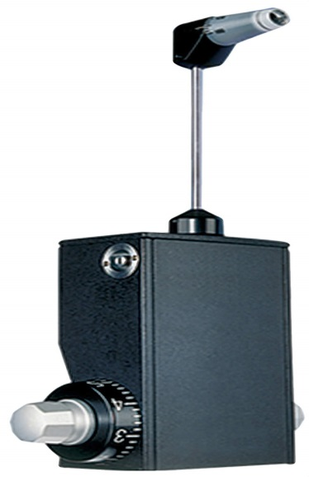

Heidelberg Spectralis HRA and OCT (limited availability):
Multi-modality imaging with SPECTRALIS® is helping drive the development of novel therapeutics and changing the course of patient management in eye care. Using an upgradeable platform approach, SPECTRALIS has enhanced the role of spectral domain OCT by integrating it with confocal scanning laser ophthalmoscopy (cSLO). The combination of these two technologies has enabled new imaging capabilities, such as TruTrack™ Active Eye Tracking, and BluePeak™ blue laser autofluorescence, providing clinicians with unique views of the structure and function of the eye.

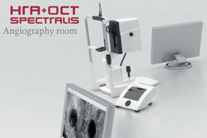
Heidelberg Spectralis HRA and OCT 2:
As above with OCT-angiography and wide-field lens.

Humphrey Field Analyser:
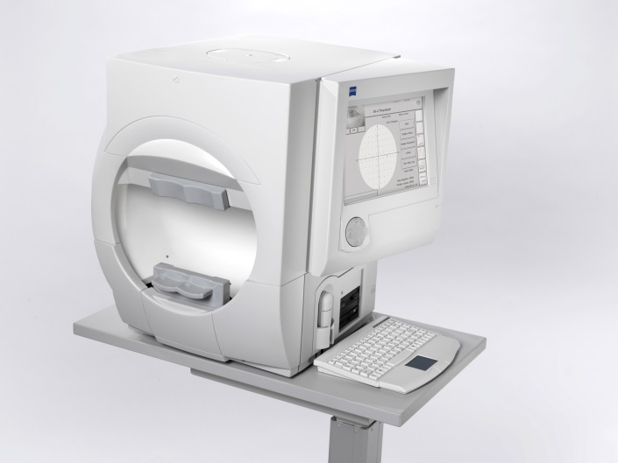
Humphrey automated visual field analysers are the gold standard in perimetric testing. They have a 25 year proven track record in visual field development and research.
Humphrey Matrix 800:
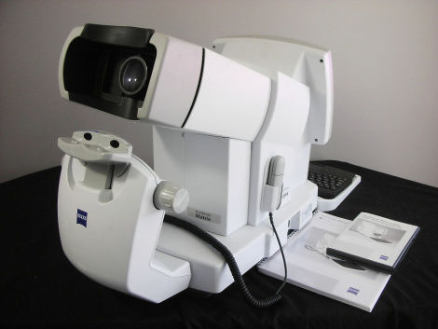
Humphrey Matrix® 800 for early visual field loss detection proven to find early visual field loss quickly and easily.

Indirect Ophthalmoscope + retinoscope (Keeler):
Constitutes a light attached to a headband, in addition to a small handheld lens. It provides a wider view of the inside of the eye. Furthermore, it allows a better view of the fundus of the eye, even if the lens is clouded by cataracts.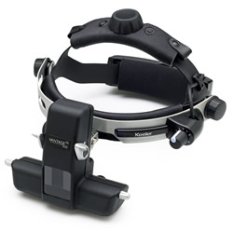
Lensmeter / Focimeter GJD
Ophthalmic instrument used by optometrists and opticians to verify the correct prescription in a pair of eyeglasses, to properly orient and mark uncut lenses, and to confirm the correct mounting of lenses in spectacle frames. Lensmeters can also verify the power of contact lenses, if a special lens support is used.
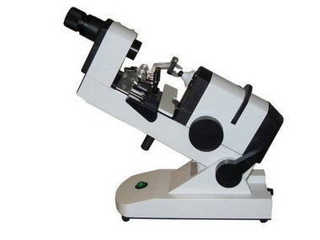

Lenstar Optical Biometer:
Lenstar provides highly accurate laser optic measurements for every section of the eye −from the cornea to the retina.

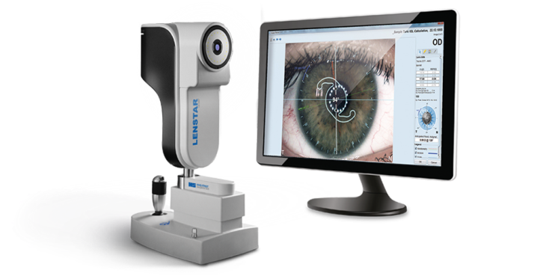
MAIA Microperimeter(x2):
MAIA provides concurrent analysis of structural and functional aspects of the retina. Combining Scanning Laser Ophthalmology (SLO) fundus imaging, retinal sensitivity mapping and fixation analysis in one exam, MAIA microperimetry is a powerful tool to detect, describe and follow up pathologies affecting the macula, where visual acuity and conventional visual fields are inadequate.
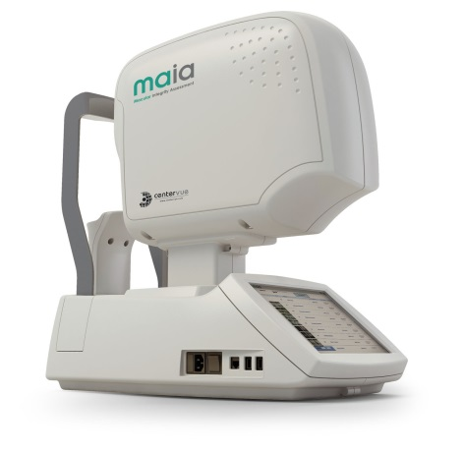

Nidek Autorefractor (limited availability):
The newly designed optical unit allows measurement of the minimum pupil diameter up to 2.0 mm and high-accuracy measurement.

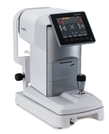
Ocular Response Analyser (limited availability):
Ocular Response Analyzer® (ORA) is the only tonometer that measures Corneal Hysteresis (CH), a superior predictor of glaucoma progression. Corneal Hysteresis is an indication of the biomechanical properties of the cornea differing from thickness or topography, which are geometrical attributes.

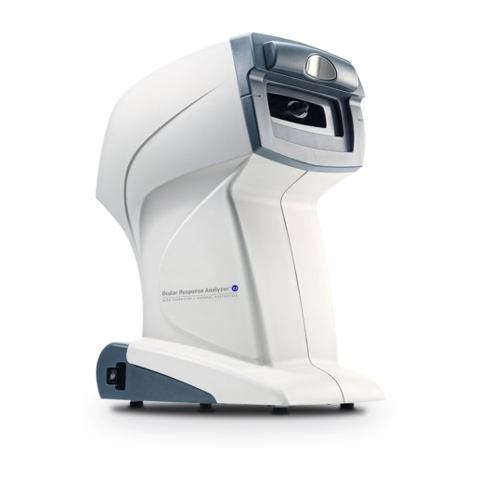

Oculus C-Quant:
The C-Quant makes it possible to measure the amount of stray light in a human eye individually and reliably. The effect of increased stray light in the human eye can be compared to looking through a dirty windshield.
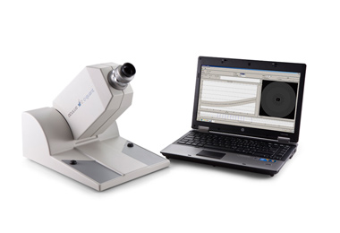

Oculus Pentacam HR:
The Pentacam is a combined device consisting of a slit illumination system and a Scheimpflug camera which rotates around the eye.

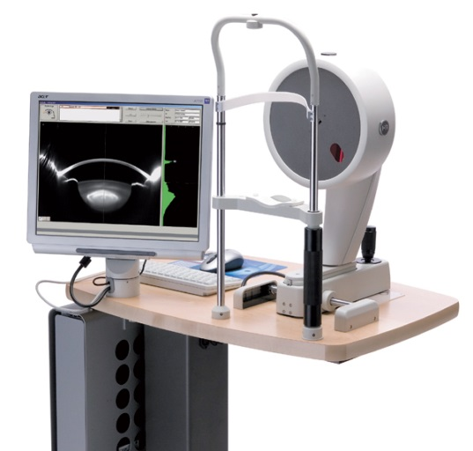

Optos Tx200 Wide-Field Retinal Imaging and Anfiography (limited availability):
Multiple wavelength imaging, including options for color, red-free, fluorescein angiography and autofluorescence. With simultaneous non-contact pole-to-periphery views of more than 80% or 200 degrees of the retina in a single capture.

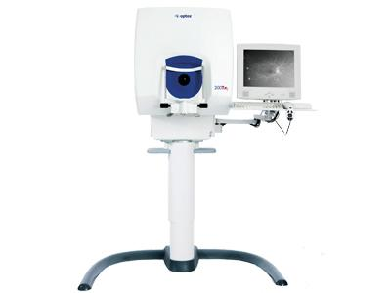
Optos P200DTX:
The compact desktop device offers greater imaging functionality and has introduced a new imaging modality, indocyanine green angiography, used for imaging the choroidal vasculature.
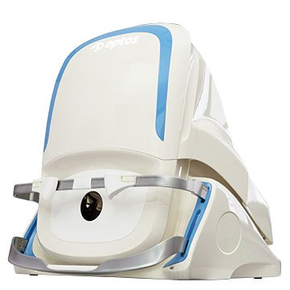

Topcon TRC 50DX: Mydriatic Retinal Camera:
The TRC-50DX series of mydriatic retinal cameras incorporate the latest digital-ready features to provide the most complete retinal image capture device today, including colour, red free, fluorescein angiography, fundus auto fluorescein and indocyanine green angiography.
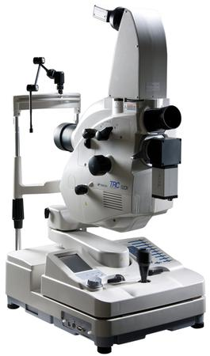
Oculus Oxymap:
The Oxymap T1 was developed to fit the Topcon TRC-50D fundus cameras (above). It is composed of a custom-made optical adapter and two high resolution digital cameras (1600 x 1200 square pixels) which produce quality images in a 50° field of view without sacrificing pixel resolution across the vessels.
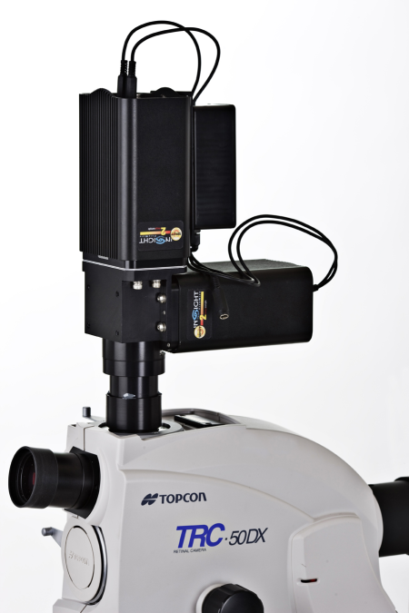
Power Refractor 3:
PowerRef 3 provides dynamic measurements of accommodation in sphere, convergence and pupil size changes in scotopic, mesopic and photopic conditions.
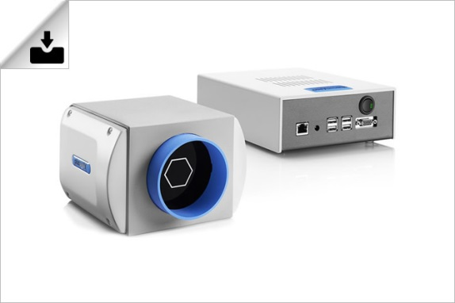
Slit Lamp (CS 990) :
The SL 990 series is characterized by a modern optic project and uses a multi layered anti reflection treatment that ensures a more effective transmission of light, thus improving the optic resolution and contrast by 20%.
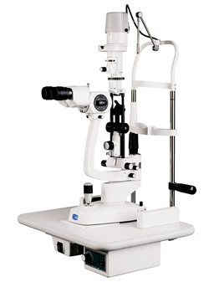

Trial Lens Set and Trail Frame:
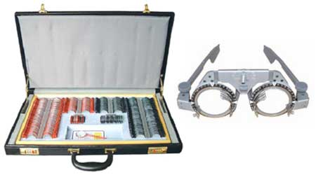

A series of cylindrical and spherical lenses used in testing vision.

Cardiac / Vascular:

Philips CX50 Ultrasound Platform (vascular [carotid intimal media thickness and flow mediated dilatation] and cardiac imaging).
Multi-modality portable ultrasound platform with addition offline analysis package, Qlab version 9 including: IMT (Intimal Media Thickness analysis) and flow mediated dilatation assessment. CMQ (Cardiac Motion Quantification) tool for assessment of cardiac strain deformation.

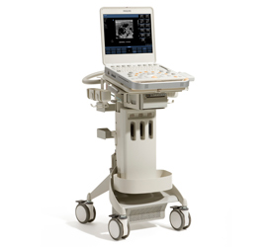
Philips CX50 Ultrasound Platform: Cardiac imaging with online Qlab version 9 including CMQ (Cardiac Motion Quantification tool).
Echocardiography dedicated ultrasound platform with built in Qlab version 9 analysis package. CMQ (Cardiac Motion Quantification) functionality for assessment of strain deformation.

