Northern Ireland Clinical Research Facility (NICRF)

Instructions on including NICRF charges to pFACT costings

- In the ‘Project Proposal Summary’ screen select the Facilities & Equipment Cost link to display the ‘Facilities & Equipment Cost’ window.

- Click the button to add a NICRF study and its associated costs to the project. The ‘Add Facilities & Equipment to project’ window will be displayed.

- Select the drop down list on the ‘Filter by Category’ field and select the NI Clinical Research Facility option.

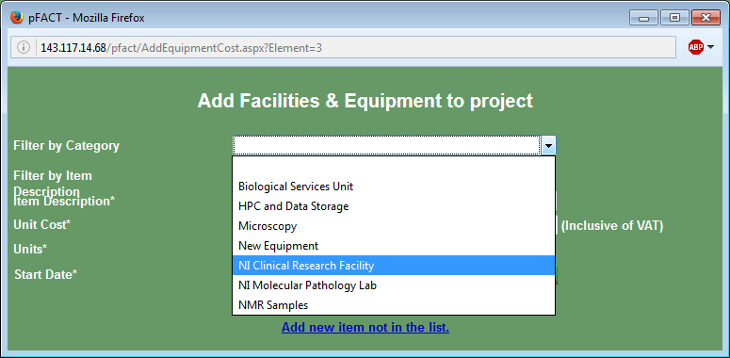

- Select the drop down list on the ‘Item Description’ field and select the study you wish to cost.

- The system will show the cost per hour for the study in the ‘Unit Cost’ field. The number of units to be costed should be entered in the ‘Units’ field. The ‘Start Date’ and ‘End Date’ default to those selected in the project set up. If necessary these can be changed. The button should be selected to add the study to the project record. The button can be used to return to the ‘Facilities and Equipment Cost’ window.

- To amend any study costed in projects, click on the Facilities & Equipment Cost link on the ‘Project Proposal Summary’ screen and then in the ‘Description’ field of the study to be amended. Amend the screen and click and .

To delete a study, click on the underlined ‘Remove’ word to the left of the study in the ‘Facilities & Equipment Cost’ screen. In the screen that opens, enter a reason for removal and click ‘Delete’ and .

